Hazard Identification and Risk Assessment of Mother and Childcare Services in a Tertiary Care Teaching Hospital in Pune, India

INTRODUCTION

Maternal and childcare services are integral to public health, particularly in tertiary care hospitals where the complexity and volume of cases are substantial. The safe delivery of these services is essential for reducing maternal and infant mortality rates, a significant public health concern in India. However, the delivery of maternal and childcare services is not without risk. Hospital-acquired infections, structural hazards, and operational inefficiencies can compromise patient safety, leading to adverse outcomes.
India's healthcare system faces unique challenges in delivering maternal and childcare services, including limited resources, overcrowded facilities, and varying levels of staff competency. The diverse and complex nature of these challenges necessitates a systematic approach to hazard identification and risk management, ensuring that healthcare providers can deliver safe and effective care.

Objective
This study aims to conduct a comprehensive hazard identification and risk assessment (HIRA) of maternal and childcare services in a tertiary care teaching hospital in Pune, India. The study seeks to identify potential hazards, assess their associated risks, and provide actionable recommendations to mitigate these risks, ultimately enhancing patient safety and care quality.

MATERIALS AND METHODS

Study Design
An observational descriptive study design was employed, spanning 18 months from June 2022 to December 2023. The study focused on maternal and childcare services within a tertiary care teaching hospital in Pune, Maharashtra. Departments included in the study were the maternity ward, NICU, PICU, labour room, paediatric ward, and gynaecology/paediatric OPD.

Study Setting
The study was conducted in a tertiary care teaching hospital located in Pune, Western Maharashtra. The hospital serves a large urban population and is a referral centre for high-risk pregnancies and paediatric cases. The selected departments have varying levels of complexity and are critical to the hospital's overall maternal and childcare services.

Data Collection Methods
Data collection was carried out through three primary methods: direct observation, record review, and staff interaction.
- Direct Observation (OB): This method involved observing various departments to assess compliance with infection control practices, safety protocols, and infrastructure conditions. Observations were made regarding the display of signage, availability of personal protective equipment (PPE), and staff adherence to standard operating procedures (SOPs).
- Record Review (RR): This involved reviewing clinical records, biomedical waste management logs, incident reports, and surveillance documents. The record review provided insights into past incidents, trends in hazard occurrence, and compliance with safety protocols.
- Staff Interaction (SI): Interactions with staff were conducted to assess their knowledge, skills, and attitudes toward safety protocols and risk management. These interactions were unstructured interviews with healthcare providers, including doctors, nurses, and support staff, focusing on their experiences with identified hazards.

Hazard Identification and Risk Assessment (HIRA) Framework
The HIRA framework was utilized to identify, categorize, and rank hazards. Hazards were classified into physical, chemical, biological, ergonomic, and psychosocial categories. Each hazard was assessed based on its likelihood of occurrence and the potential severity of its consequences, which included human impact, physical infrastructure, financial costs, and reputational damage. A Likert scale from 1 (negligible risk) to 5 (high risk) was used for scoring, allowing for the prioritization of risks based on their total risk score.

Ethical Considerations
The study was approved by the institutional ethical committee, ensuring that all data collection methods complied with ethical standards. Confidentiality of patient and staff data was maintained throughout the study, and informed consent was obtained from all staff members who participated in interviews.

Study Phases
The study structured its methodology in three comprehensive phases. These are follows:-
- Phase 1: Preparation and knowledge building, including training on healthcare risk management and checklist development validated by experts.
- Phase 2: Direct observations in department tours, creating a list of hazards, and initial risk scoring using a Likert scale ranging from 1 to 5.
- Phase 3: Involved document reviews and staff interviews to provide discrete assessments leading to final risk scores based on a thorough understanding of hazards observed as well as staff insights.

DATA ANALYSIS
Data analysis involved calculating the average risk score for each identified hazard, ranking them to prioritize interventions.

HIRA Steps and Methodology Application
The HIRA checklist incorporated multiple hazard categories, assessing them against established likelihood and consequence scoring systems. Risk analyses were specifically tailored to address not only internal hospital risks but also contextual factors from the Pune Municipal Corporation's data which informed possible natural disasters such as earthquakes and floods.

Risks and Scoring Framework
A comprehensive scoring system evaluated risks based on likelihood (from 1 to 5) and potential human, physical, financial, and reputational impacts, leading to total cumulative risk classifications: Low, Medium and High.

RESULTS

Overview of Identified Hazards

The study identified multiple hazards across the various departments involved in maternal and childcare services. These hazards were categorized into physical, chemical, biological, ergonomic, and psychosocial risks as per ‘appendix A’.

Natural Hazards | 8
Technological Hazards | 10
Human-Cause Hazards | 14
Infrastructure Hazards | 14
Physical Hazards | 5
Chemical Hazards | 6
Biological Hazards | 4
Ergonomic Hazards | 3
Psychological Hazards | 3

This table summarizes the number of hazards identified in each category,

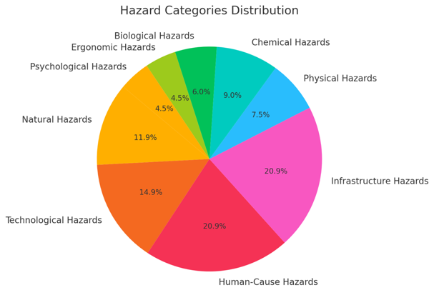
The pie chart illustrates the distribution of different hazard categories identified in the assessment. The largest proportions of hazards fall under Infrastructure Hazards and Human-Cause Hazards, each comprising 20.9% of the total hazards.
This is followed by Technological Hazards at 14.9% and Natural Hazards at 11.9%. Chemical Hazards account for 9.0%, and Physical Hazards make up 7.5%. The smallest categories include Biological Hazards at 6.0%, and Ergonomic and Psychological Hazards, each representing 4.5%.
This distribution highlights the diverse range of hazards present, with particular emphasis on infrastructure and human-related risks.

Summary of hazard ranking and risk classification

The study categorized hazards in the hospital into three risk levels:
- High Risk (Scores 36–100):
  - Hazards with a high likelihood of occurrence and significant impact, requiring immediate risk-mitigation efforts, such as physical fortification, staff training, and resource acquisition.
- Moderate Risk (Scores 26–33):
  - Hazards with a high likelihood but lower impact, prioritized for mitigation after high-risk hazards, depending on available resources.
- Low Risk (Scores 4–23):
  - Infrequent, low-impact hazards, suggesting effective existing mitigation. These are monitored but do not require immediate action.
This classification ensures focused resource allocation and ongoing risk management.

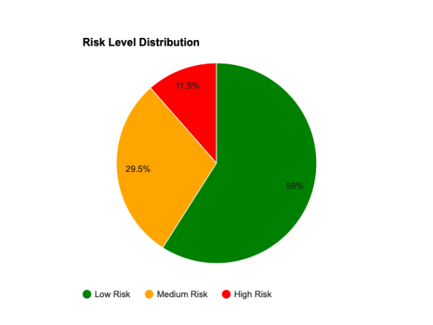

The pie chart provided illustrates the distribution of risk levels identified in the hazard assessment at Pune.
The majority of hazards, 59%, are classified as low risk (green), indicating they are frequent but have minimal impact.
29.5%of hazards fall into the medium risk category (yellow), representing less frequent events with significant potential impacts.
The high-risk category (red), comprising 11.5% of the total hazards, includes rare but potentially devastating events.
This distribution highlights the need for targeted risk mitigation efforts, particularly for high and medium-risk hazards, while maintaining routine vigilance for low-risk events.
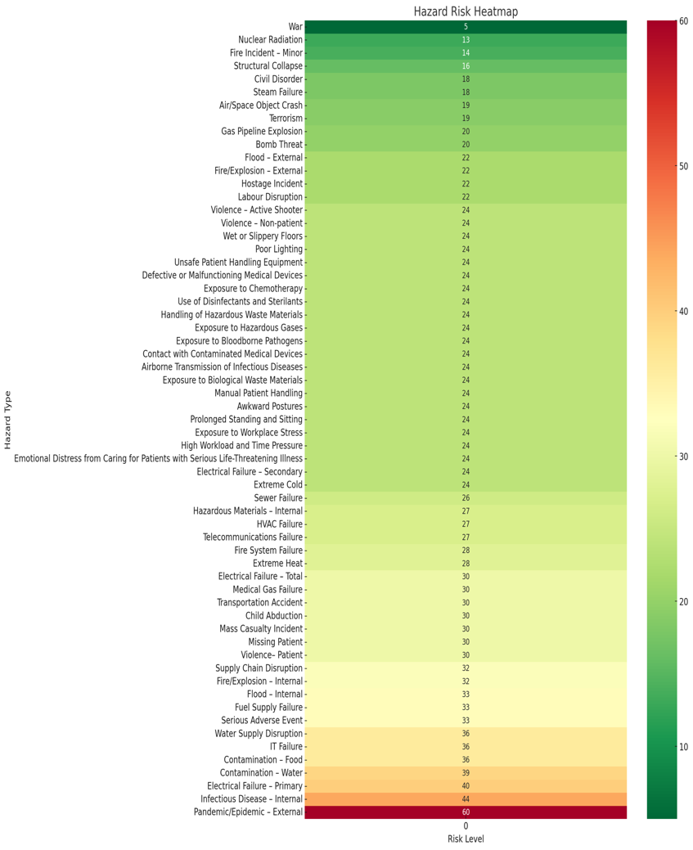
HAZARD RISK HEATMAP

Risk Levels Identified:
- Low-risk events: Frequent occurrences with minimal impact, such as minor fire incidents, slippery floors, and equipment malfunctions.
- Medium-risk events: Less frequent but with significant potential impact, including issues like sewer failure and internal hazardous material incidents.
- High-risk events: Rare but potentially devastating, such as pandemics, electrical failures, or water contamination.

DISCUSSION

- The comprehensive hazard mitigation strategies implemented at CHSC Pune align with findings from other studies in similar healthcare settings. For instance, the focus on fire safety, preventive maintenance, and infection control reflects best practices outlined in studies such as those by Guo et al. (2015), who emphasized the importance of risk management plans in hospital operating rooms to enhance patient and staff safety. Additionally, the use of patient transfer aids and chemical safety protocols is consistent with recommendations from Valentin and Ferdinande (2011), who highlighted the need for robust safety measures in intensive care units.

- Similarly, the proactive approach to environmental hazards, such as the installation of backup generators and regular pest control, mirrors the strategies advocated by Singh et al. (2020) in their study on home healthcare safety, which identified the critical role of environmental controls in maintaining a safe healthcare environment. These comparisons underscore the effectiveness of CHSC Pune's safety measures, which are in line with global best practices and contribute to a safer and more resilient healthcare facility.

STRENGTHS

- State-of-the-Art Infrastructure: Incorporates advanced features like sensor-based hand hygiene stations, clear medication labeling, and dedicated biomedical waste systems.
- Commitment to Patient Safety: Demonstrated through meticulous record-keeping and the adoption of the WHO Surgical Safety Checklist.
- Proactive Risk Mitigation: Engages in regular surveillance and microbiological testing to manage healthcare-associated risks effectively.
- Patient-Centric Approach: Focuses on inclusivity and patient care with features like a Patient Feedback/Suggestion Register and disabled-friendly washrooms.
- Modern Military Hospital Standards: Ensures precision and discipline in SOP adherence and dangerous drug record maintenance, positioning CHSC Pune as a leader in healthcare delivery.

LIMITATIONS

  - Observer Bias: Potential influence of subjective interpretations and biases by the single researcher during data collection and analysis.
  - Limited Generalizability: The study’s focus on a single tertiary care teaching hospital limits the applicability of findings to other settings with different characteristics.
  - Single Researcher Limitations: The breadth and depth of data collection and analysis may have overlooked specific nuances in risk assessment.
  - Time Constraints: The study could not assess the long-term impact or efficacy of implemented interventions due to the limited timeframe.
  - Implication: Despite these limitations, the study offers valuable insights and serves as a foundation for ongoing safety improvements and risk mitigation strategies.

RECOMMENDATIONS

- Develop a Comprehensive Risk Management Plan
  - Outline Key Strategies: Identify and implement strategies tailored to address identified hazards, including preventive measures, mitigation actions, and detailed contingency plans.

  - Scenario Planning: Develop specific action plans for various risk scenarios such as natural disasters, technological failures, and medical emergencies.

  - Resource Allocation: Ensure resources are allocated for quick response and effective management of each scenario, enhancing preparedness.

- Enhance Training and Foster Safety Culture
  - Regular Training Sessions: Conduct ongoing training on infection control, medication management, and emergency response to improve staff competence and confidence.

  - Reporting and Safety Mechanisms: Encourage staff to report near-misses and potential hazards without fear, and establish clear mechanisms for the timely resolution of safety concerns.

- Invest in Ongoing Quality Improvement
  - Performance Monitoring: Continuously monitor and evaluate the hospital’s performance against established safety and quality benchmarks.

  - Implement Evidence-Based Practices: Regularly update procedures and practices based on the latest evidence to maintain the highest standards of patient care and safety.

CONCLUSION
  - Patient Safety Commitment: CHSC Pune demonstrates a strong commitment to patient safety through modern infrastructure and proactive risk mitigation.
  - Advanced Infrastructure: Features include sensor-based hand hygiene stations, clear medication labeling, and dedicated biomedical waste systems.
  - Protocol Adherence: Rigorous adherence to SOPs and meticulous record-keeping, particularly concerning dangerous drugs.
  - Proactive Risk Mitigation: Engages in continuous infection control, regular maintenance of equipment, and has robust emergency protocols in place.

REFERENCES
- American Academy of Pediatrics. Pediatric patient safety in the emergency department. Elk Grove Village (IL): American Academy of Pediatrics; 2019.
- National Institute for Occupational Safety and Health (NIOSH). Workplace violence prevention strategies and research needs. Cincinnati (OH): NIOSH; 2015.
- World Health Organization. WHO recommendations on antenatal care for a positive pregnancy experience. Geneva: World Health Organization; 2016.
- Joint Commission International. International patient safety goals. Oakbrook Terrace (IL): Joint Commission International; 2018.
- Agency for Healthcare Research and Quality (AHRQ). Patient safety culture. Rockville (MD): AHRQ; 2019.
- Bonfant G, Belfanti P, Paternoster G, Gabrielli D, Gaiter AM, Manes M, et al. Clinical risk analysis with failure mode and effect analysis (FMEA) model in a dialysis unit. J Nephrol. 2010;23(1):111–8.
- Kane SN, Mishra A, Dutta AK. Identification of potential hazard using hazard identification and risk assessment. IOP Conf Ser Mater Sci Eng. 2017;263:1–6.
- Purohit DP, Siddiqui DA, Nandan A, Yadav DP. Hazard identification and risk assessment in construction industry. Int J Appl Eng Res [Internet]. 2018 [cited 2025 Oct 30];13(10):7639–67. Available from: http://www.ripublication.com/ijaer18/ijaerv13n10_56.pdf
- Rout B, Sikdar B. Hazard identification, risk assessment, and control measures as an effective tool of occupational health assessment of hazardous process in an iron ore pelletizing industry. Indian J Occup Environ Med. 2017;21(2):56–76.
- Guo L. Implementation of a risk management plan in a hospital operating room. Int J Nurs Sci [Internet]. 2015;2(4):348–54. Available from: http://dx.doi.org/10.1016/j.ijnss.2015.10.007
- Singh A, Jha A, Purbey S. Perceived risk and hazards associated with home health care among home health nurses of India. Home Health Care Manag Pract. 2020;32(3):134–40.
- Valentin A, Ferdinande P. Recommendations on basic requirements for intensive care units: structural and organizational aspects. Intensive Care Med. 2011;37(10):1575–87.
- Vande Voorde KM, France AC. Proactive error prevention in the intensive care unit. Crit Care Nurs Clin North Am. 2002;14(4):347–58.

APPENDIX A

RISK SCORES
Risk assessments are not a precise science; they estimate the probability of future events and their impacts. The data in the following tables should be interpreted as the best estimates rather than absolutes. Furthermore, as the assessment is based on the hazard history of the organisation, separating the original risk from the residual is often impossible after considering non-existent mitigation efforts. As a result, some hazards may reflect an already mitigated risk level, whereas others represent the actual risk. Similarly, sequences may be related to the response rather than the initial hazard.

To ensure as much accuracy as possible within this document, comprehensive research was conducted using several resources,
NATURAL HAZARDS | Likelihood Score | Consequence Components |  |  |  | Total Risk | RISK LEVEL
NATURAL HAZARDS | Likelihood Score | Human | Physical | Financial | Reputation | Total Risk
Contamination – Food | 3 | 4 | 2 | 3 | 3 | 36 | Medium
Contamination – Water | 3 | 5 | 2 | 3 | 3 | 39 | High
Earthquake | 1 | 5 | 5 | 5 | 5 | 20 | Low
Extreme Cold | 4 | 3 | 1 | 1 | 1 | 24 | Medium
Extreme Heat | 4 | 3 | 1 | 2 | 1 | 28 | Medium
Flood – External | 1 | 5 | 5 | 5 | 5 | 20 | Low
Infectious Disease – Internal | 4 | 4 | 1 | 3 | 3 | 44 | High
Pandemic/Epidemic – External | 4 | 5 | 2 | 4 | 4 | 60 | High
TECHNOLOGICAL HAZARDS | Likelihood Score | Consequence Components |  |  |  | Total Risk
TECHNOLOGICAL HAZARDS | Likelihood Score | Human | Physical | Financial | Reputation | Total Risk
air/space object crash | 1 | 5 | 5 | 5 | 4 | 19 | Low
fire/explosion – external | 2 | 2 | 3 | 3 | 3 | 22 | Low
hazardous materials – external | 3 | 3 | 3 | 3 | 3 | 36 | Medium
hazardous materials – internal | 3 | 2 | 4 | 2 | 2 | 30 | Medium
nuclear radiation | 1 | 3 | 3 | 4 | 3 | 13 | Low
Gas pipeline explosion | 2 | 2 | 3 | 3 | 2 | 20 | Low
fire incident – minor | 2 | 2 | 2 | 1 | 2 | 14 | Low
structural collapse | 1 | 4 | 4 | 4 | 4 | 16 | Low
transportation accident | 3 | 3 | 3 | 2 | 2 | 30 | Medium
fire/explosion – internal | 2 | 5 | 4 | 4 | 3 | 32 | Medium

HUMAN-CAUSE HAZARDS | Likelihood Score | Consequence Components |  |  |  | Total Risk | RISK LEVEL
HUMAN-CAUSE HAZARDS | Likelihood Score | Human | Physical | Financial | Reputation | Total Risk
bomb threat | 2 | 2 | 3 | 2 | 3 | 20 | Low
child abduction | 3 | 2 | 2 | 2 | 4 | 30 | Medium
civil disorder | 2 | 2 | 2 | 2 | 3 | 18 | Low
computer virus/  cyber attack | 3 | 1 | 3 | 4 | 4 | 36 | Medium
hostage incident | 2 | 3 | 3 | 2 | 3 | 22 | Low
Labour Disruption | 2 | 2 | 2 | 3 | 4 | 22 | Low
mass casualty incident | 3 | 4 | 1 | 3 | 2 | 30 | Medium
missing patient | 5 | 2 | 1 | 1 | 2 | 30 | Medium
serious adverse event | 3 | 3 | 1 | 3 | 4 | 33 | Medium
terrorism | 1 | 5 | 5 | 5 | 4 | 19 | Low
violence– patient | 3 | 2 | 1 | 2 | 1 | 30 | Medium
violence – non‐patient | 3 | 3 | 2 | 1 | 2 | 24 | Low
violence – active shooter | 2 | 5 | 2 | 1 | 4 | 24 | Low
war | 1 | 2 | 1 | 1 | 1 | 5 | Low
workplace injury | 4 | 2 | 1 | 2 | 2 | 28 | Medium
INFRASTRUCTURE HAZARDS | Likelihood Score | Consequence Components |  |  |  | Total Risk | RISK LEVEL
INFRASTRUCTURE HAZARDS | Likelihood Score | Human | Physical | Financial | Reputation | Total Risk
electrical failure – primary | 5 | 2 | 3 | 2 | 1 | 40 | High
electrical failure – secondary | 3 | 2 | 2 | 3 | 1 | 24 | Medium
electrical failure – total | 2 | 4 | 4 | 3 | 4 | 30 | Medium
fire system failure | 4 | 1 | 2 | 2 | 2 | 28 | Medium
flood – internal | 3 | 2 | 4 | 3 | 2 | 33 | Medium
fuel supply failure | 3 | 2 | 3 | 3 | 3 | 33 | Medium
HVAC failure | 3 | 2 | 2 | 2 | 3 | 27 | Medium
IT failure | 4 | 2 | 3 | 2 | 2 | 36 | Medium
medical gas failure | 3 | 3 | 3 | 2 | 2 | 30 | Medium
sewer failure | 2 | 3 | 4 | 3 | 3 | 26 | Medium
steam failure | 2 | 2 | 3 | 2 | 2 | 18 | Medium
supply chain disruption | 4 | 2 | 2 | 2 | 2 | 32 | Medium
telecommunications failure | 3 | 2 | 2 | 2 | 3 | 27 | Medium
water supply disruption | 3 | 3 | 3 | 3 | 3 | 36 | Medium

Category | Hazard | Likelihood Score | Human | Physical | Financial | Reputation | Total Risk | RISK  LEVEL
I. Physical Hazards | Wet or Slippery Floors | 3 | 2 | 2 | 2 | 2 | 24 | Low
 | Poor Lighting | 3 | 2 | 2 | 2 | 2 | 24 | Low
 | Unsafe Patient Handling Equipment | 3 | 2 | 2 | 2 | 2 | 24 | Low
 | Defective or Malfunctioning Medical Devices | 3 | 2 | 2 | 2 | 2 | 24 | Low
 | Needlestick Injuries | 3 | 3 | 3 | 3 | 3 | 36 | Medium
II. Chemical Hazards | Exposure to Chemotherapy | 3 | 2 | 2 | 2 | 2 | 24 | Low
 | Use of Disinfectants and Sterilant | 3 | 2 | 2 | 2 | 2 | 24 | Low
 | Handling of Hazardous Waste Materials | 3 | 2 | 2 | 2 | 2 | 24 | Low
 | Exposure to Hazardous Gases | 3 | 2 | 2 | 2 | 2 | 24 | Low
 | Hazardous Materials – External | 3 | 3 | 3 | 3 | 3 | 36 | Medium
 | Hazardous Materials – Internal | 3 | 2 | 3 | 2 | 2 | 27 | Low
Category | Hazard | Likelihood Score | Human | Physical | Financial | Reputation | Total Risk
III. Biological Hazards | Exposure to Bloodborne Pathogens | 3 | 2 | 2 | 2 | 2 | 24 | Low
 | Contact with Contaminated Medical Devices | 3 | 2 | 2 | 2 | 2 | 24 | Low
 | Airborne Transmission of Infectious Diseases | 3 | 2 | 2 | 2 | 2 | 24 | Low
 | Exposure to Biological Waste Materials | 3 | 2 | 2 | 2 | 2 | 24 | Low
IV. Ergonomic Hazards | Manual Patient Handling | 3 | 2 | 2 | 2 | 2 | 24 | Low
 | Awkward Postures | 3 | 2 | 2 | 2 | 2 | 24 | Low
 | Prolonged Standing and Sitting | 3 | 2 | 2 | 2 | 2 | 24 | Low
V. Psychological Hazards | Exposure to Workplace Stress | 3 | 2 | 2 | 2 | 2 | 24 | Low
 | High Workload and Time Pressure | 3 | 2 | 2 | 2 | 2 | 24 | Low
 | Emotional Distress from Caring for Patients with Serious Life-Threatening Illness | 3 | 2 | 2 | 2 | 2 | 24 | Low

