Profile of Firearm Deaths Brought to JNIMS
Mortuary, Imphal, Manipur.

Abstract
Background: The present study aimed to outline the profile of deaths due to firearm injuries in Manipur. Materials and Methods: It was a cross-sectional retrospective study. All the cases of firearm fatalities brought to the Mortuary, Department of Forensic Medicine and Toxicology, JNIMS, Porompat, Imphal, Manipur, from January 2015 to December 2019, a complete 5 years period, were included in the study. Results: Out of the total 997 cases brought for autopsy during the period, 100 cases (10.03%) were deaths due to firearm injury. The most frequent age groups were 21-30 and 31-40 years with 32% and 41% respectively. Among the victims, 94% were males and 06% were females. In terms of manner of death, 87% of the cases were of homicides followed by 10% of suicides and 03% were accidental. Rifled firearm was used in 95% of the cases and multiple shots were present in 58% of the cases. Most of the victims were civilians (41%). Conclusion: In the present study, majority of the victims were males of productive age group having multiple shots and most of them were homicidal deaths with rifled firearms being used in most of the cases.
Key words: Firearm injury, firearm fatalities, rifled firearm, homicide, suicide.
Introduction
The magnitude and prevalence of firearm violence makes it an essential public health concern. Every day, many people die due to firearm related injuries all over the world. The death due to firearm injury can be both intentional and accidental. There are wide variations in firearm-related death rates between the different world regions and between individual countries. Though in western countries, suicidal fatal firearm injury is very common, in this region of the world, it is mostly used in homicide cases only.¹ Manipur is a remote mountainous small north-eastern state of India with close proximity to golden triangle regions, it’s international border with Myanmar is 398km in length which is porous and unfenced mostly. It has a history of separatist violence and various illicit activities including drugs and firearm trafficking. The offensive and defensive use of firearms can take many specific forms depending on the context of their use. Firearms can also be used by criminals in cases of extreme brutality to send a message, not only to direct criminal opponents, but also to catch the attention of the general public as well as State authorities. Moreover, drug markets across the globe also create demands for firearms since firearms are a tool for drug criminals to use for offensive, defensive, and reputational purposes within the drug market.² Nevertheless, gun-related suicide is a silent epidemic, often overlooked in the broader gun violence debate.³
However, violence by firearms is prevalent all over the world in some or other form or in one or other way, it is still preventable if the trend and risk factors associated with firearm injuries are amended promptly, documented and addressed strictly. Thus, it can help in reducing the firearm related deaths burden in the society.
Materials and Methods
The present study was carried out as a cross-sectional retrospective study in the Department of Forensic Medicine and Toxicology, JNIMS, Imphal, Manipur. All the cases of firearm fatalities brought to the mortuary of the Department of Forensic Medicine and Toxicology, JNIMS, Porompat, Imphal, Manipur, from January 2015 to December 2019, a complete 5 years period, were included in the study. They were analysed statistically categorizing into various parameters in the form of various tables, charts and bars.
Inclusion criteria: All firearm death cases brought to the mortuary during the above mentioned period.
Exclusion criteria: Unidentified bodies.
Results
Out of the total 997 cases brought for autopsy during the study period, 100 cases (10.03%) were deaths due to firearm injury. Majority of the victims, 94% of the cases (n=94), were males and only 6 cases (06%) were females. The commonest victimized age-group was 21-40 years with 73 cases altogether (73%) as shown in Table 1. Most of the cases occur in summer season with 35% of the cases as shown in Fig. Coming to the manner of death, majority of the cases were homicidal (87 %) followed by 10% of suicide and 03% of the cases were accidental deaths and rifled firearms outnumbered shotguns with 95% and 05% in each case respectively as shown in Table 2. Amongst the 87 cases of homicide, 83 cases (95.4%) used rifled firearms; whereas, amongst the 10 cases of suicide, 9 cases (90 %) used rifled firearms.
As far as number of shots is concerned, multiple entrance wounds were present in 58 cases (58%) and in 42% of the cases (n=42) single entrance wound was present. Out of the total 87 cases of homicide, 56 cases (64.37%) had multiple entrance wounds and 31 cases (35.63%) had single entrance wound; on the other hand, amongst the 10 suicidal cases, 8 cases i.e. 80% of the cases had single entrance wound and only 2 cases (20%) had multiple entrance wound. But, in the accidental cases, all the 3 cases had single entrance wound (Table 3). Considering the range of firing, majority of the cases (84%) were shot from distant range with a total of 84 cases out of the 100 cases; whereas, 8 % of the cases (n=8) were shot from a close/near range followed by 8% cases (n=8) of contact shots. Amongst the 87 homicidal cases, 82 cases (94.3%) were shot from distant range and only 5 cases (5.7%) were shot from close or near range and there was no contact range shot in homicide. On the other hand, in suicide, 80 % of the cases (n=8, out of 10 cases) were contact shots and 20 % of the cases (n=2) were fired from close or near range; there was no case of distant range shot. Accidental deaths were either distant range shots or close/ near range shots with 2 cases (66.7%) and 1 case (33.3%) respectively; there was no case of contact shot in accidental cases too as in case of homicides (Table 4).
The most common victims in the present study were civilians (41%) with a total of 41 cases followed by law enforcing agents and militants with 32% and 27% respectively; whereas, the commonest assailants were militants with 47% (n=47) followed by law enforcing agents with 17 cases (17%) and in 24% of the cases the assailants were not known. In a particular one case, the assailant happened to be the own brother of the victim himself (civilian) and the incident occurred so following a domestic violence between the two brothers. Maximum number of incidents in the present study occurred in Chandel district with 23 cases followed by Noney and Senapati districts with 21 and 19 cases respectively, all of which are remote places. Fig No.1.
In consideration of the distribution of entrance wound in relation to body parts, entrance wounds were present in multiple parts of the body in 50% of the cases while 24% of the cases had entrance wound on head and neck followed by 15 % cases on chest and 6% cases on abdomen. Least number of entrance wound was found on the limbs with only 5% of the cases Fig.No.2.

Table 1: Age and sex wise distribution of cases
Age in years | Number of males | Number of females | Total number
0-10 | 0 | 0 | 0
11-20 | 6 | 1 | 7
21-30 | 32 | 0 | 32
31-40 | 40 | 1 | 41
41-50 | 10 | 1 | 11
51-60 | 5 | 3 | 8
61-70 | 1 | 0 | 1
Above 70 | 0 | 0 | 0
Total | 94 | 6 | 100

Table no 2: Type of firearm in relation to manner of death.
Type of firearm | Homicidal | Suicidal | Accidental | Total
Rifled | 83 | 9 | 3 | 95
Smooth bore | 4 | 1 | 0 | 5
Total | 87 | 10 | 3 | 100

Table no 3: Number of entrance wound in relation to manner of death.
Number of shot | Homicidal | Suicidal | Accidental | Total
Single | 31 | 8 | 3 | 42
Multiple | 56 | 2 | 0 | 58
Total | 87 | 10 | 3 | 100

Table no 4: Range of fire in relation to manner of death.
Range | Homicidal | Suicidal | Accidental | Total
Contact | 0 | 8 | 0 | 8
Close or near | 5 | 2 | 1 | 8
Distant | 82 | 0 | 2 | 84
Total | 87 | 10 | 3 | 100

Fig No.1: District of incident 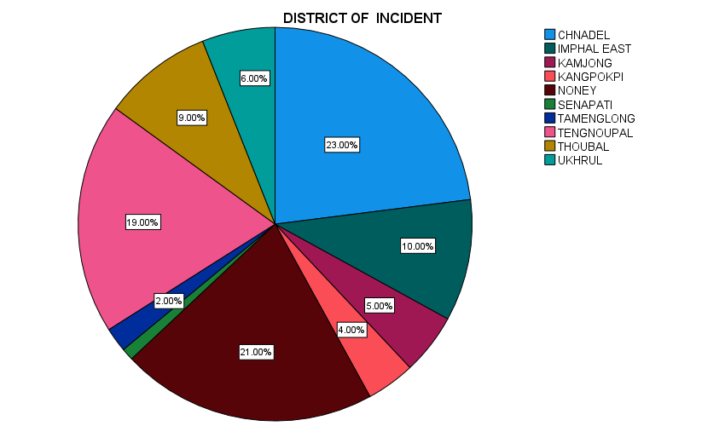
Table No 5: Type of victim and assailant
Type of victim | Number | Type of assailant | Number
Civilian | 41 | Civilian | 1
Law Enforcing Agent | 32 | Law Enforcing Agent | 17
Militant | 27 | Militant | 47
Total | 100 | Self | 11
 |  | Unknown | 24
 |  | Total | 100
Fig No.2: Distribution of entrance wound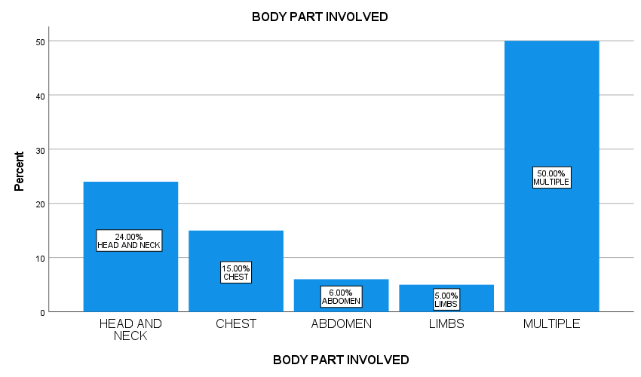
Discussion
There is a variation in the incidence of firearm injuries from city to city, region to region and in different countries. This variation is seen depending on the availability of firearm weapons and legislative infrastructure of the region. In the present study, incidence of firearm fatalities was 10.03% of total medico-legal autopsies. This is considerably high as compared to studies from other states and cities of India and some other countries. The frequency of firearm related deaths were 1.5% in Delhi, Kohli A et al⁴. 2.09% in study done by Kumar A et al in Kanpur, 1.5% in study done by Sachan R et al⁵ in Varanasi, Similarly in other study by Myint S et al⁷ Bangkok, Thailand, the incidence was 2.01%. This difference could be explained by the separatist violence resulting in insurgency and counter insurgency activities in Manipur along with other illicit activities such as drugs and firearm trafficking due to the largely unfenced porous border. However, in Karachi, Pakistan, Mirza F et at⁸ observed incidence of death due to firearm were 47.05%.
In the present study, male preponderance was observed. 94% of cases were male and most commonly affected age group were 21- 40 years 73%. Similarly, Myint S et al⁷ noted 91.3% male and most affected age range of 21- 40years. Age range of 21- 40 years, is the most productive and most active phase of life. They are also short tempered, aggressive and emotional than other extreme age groups, thus they are
In our study, most of the victims were homicidal deaths with 87% of the cases. This result was similar to other the Indian studies done by Kumari S et al⁹, Kohli A et al⁴ and Sachan R et al⁵ with 88.34%, 92.60% and 92% respectively reported as homicidal deaths. Similarly in another study conducted in Karachi by Mirza F et al⁸ 98.62% were declared homicidal deaths. However, according to different studies conducted in developed countries Fowlera KA et al¹⁰ in the United States, Toygar et al¹¹ and Canturk et al¹² in Turkey, most of the victims were suicidal firearm deaths with 62%, 41.80% and 32.85% respectively. In the present study there were 10% cases of suicides of which 90%(n-8) of the cases were law enforcing agent. Easy access to firearm weapons and mental burden while delivering services could be main reason behind increase in suicidal pattern among security personals.
On autopsy examination, rifled firearm injuries outnumbered shotgun injuries. In 95% of the cases rifled firearm had been used in the present study. Which is similar to Hussain Z et al¹³ and Kohli A et al⁴ with 96.40% and 82.2% respectively reported as rifled firearm injury in their studies. Partially with Thube et al.¹⁴ This is probable because rifled firearms are the weapon of choice for offence. However, in-contrast to the studies of Akakpo PK et al¹⁵ and Kumari S et al⁹ shotgun out numbered the rifle firearm injuries with 85% and 60% injury were found due to shotgun respectively.
In the studies conducted by Kumari S et al,⁹ Sachan R et al,⁵ Shashikant et al¹⁶ and Satyakam J et al¹⁷, observed single entry wound in majority of the victim. On the contrary, in our study, 58% of victim had multiple entrance wound. Out of the 87 homicidal cases, 56 (64.37%) had multiple entrance wound and 31(35.63%) had single entrance wound. Probable explanation could be that firearm user targets the site, in homicidal cases the assailant may use more than one shot to ensure death of the victim whereas in suicide cases the victims intends not more than one shot neither gets chance for another. Similarly, Patowary et al¹ also noted 31.48% of single entry wound in homicidal cases. In suicidal cases 80% had single entrance wound and 20% were multiple entrance wound. In the study by Myint S et al⁷ also noted single entry (87.5%) and multiple entry wounds (12.5%) in suicidal cases.
Out of total 100 cases, in the present study firearm entrance wounds were found involving more than one region of the body in 50 cases. However, in the remaining 50 cases, in 58% (n-24) of the cases entrance wound were found in head and neck region followed by thorax region with 30% (n-15) and least involved were the limbs 10% (n-5). Somewhat similar to our study, according to the study of Shirza N et al¹⁸ while discussing different region of the body involved in firearm victims they found multiple regions were affected in almost half the cases (48%), with second most affected region were head & neck along with trunk followed by extremities.
Majority of cases in our study were homicidal followed by suicidal deaths and most of the shots were aimed from distant with 84% of which 97.62%(82) cases were homicidal and 02.38%(2) cases were accidental deaths. Similarly, in the study conducted by Juglan S et al¹⁹ also noted majority of the victims of homicidal cases had distant shots. In present study, homicidal and accidental cases had a distant or near/close shot and in suicidal cases, contact/near shots were observed. There is strong relation between range of fire and manner of death in our study.
Maximum of the victim in the present study were civilian with 41%of cases, followed by law enforcing agent and militant with 32% and 27% respectively. Manipur is among the disturbed region in India due to its separatist violence, illicit activities and unfenced porous border so there is a conflict going and none are immune in conflict zone.
Conclusion
Gun violence causes irreparable harm to a community. Firearm injury reflects socio-economic and existing law and political situation of a state. Violence by firearm is preventable if the risk factors associated with firearm are documented, addressed and the existing law are amended promptly. Preventive measures such as proper psychological evaluation with mental support, improvement of socioeconomic and re-evaluation of existing laws and political system to build an improved and effective framework for prevention of gun violence may help to reduce the burden of violent deaths due to firearm injury.
Conflict of interest: None
Source of funding: Self
Ethical clearance: Yes, from Ethical Committee of Jawaharlal Nehru Institute of Medical Sciences, Porompat, Imphal, Manipur University.

References:
1. Patowary AJ. Study of pattern of injuries in homicidal firearm injury cases. J Indian Acad Forensic Med.2005; 27(2): 92-95.
2. United Nations. Firearms and Drugs: Partners in Transnational Crime Joint Issue Paper UNODC – Flemish Peace Institute; 2024;12-13.
3. Gun Deaths by Country 2024: Behind the Numbers [cited 2025 Feb 4]. Available from: https://www.southwestjournal.com/world/gun-deaths-by-country/#google_vignette
4. Kohli A, Aggarwal NK. Firearm fatalities in Delhi, India. Leg Med (Tokyo). 2006;8(5):264-8.
5. Sachan R, Kumar A. Verma A. Frequency of Firearm Injuries. Deaths and Related Factors in Kanpur, India: A Original Study with Review of. Int J Meical Toxicology and Forensic Med. 2013;(3):88-95.
6. Kumar A, Pandev SK, Chaurasia N. Epidemiological and Medico-legal Study of Unnatural Death Cases Due to Firearm Injury in Varanasi, Uttar Pradesh. India lnt J Sci Res.2015;4(6):1294-6.
7. Myint S, Worasuwanarak W, Rerkamnuavchoke B, Peonim V. A retrospective study of fatal firearm injuries on autopsy cases at Ramathibodi Hospital Bangkok. Proceedings of the 2nd ASEAN Plus Three Graduate Research Congress (2ndAGRC). 2014 February:813-19.
8. Mirza CF, Khan AW, Malik L, Parveen M. An Autopsy Based Study of Pattern of Firearm Injuries in Karachi, Pakistan. Emergency Med. 2013;3(6):1-3.
9. Kumari S, Rajput AS, Agarwal A, Arif A, Chaturvedi RK. Medico-legal Aspects of Firearm Injury Cases in Agra Region. J Indian Acad Forensic Med. 2014;36(4):387–90.
10. Fowlera KA, Dahlberga LL, Haileyesusb T, JlA. Firearm injuries in the United States. Prev Med. 2015;79:1-27.
11.Toygar M, Turker T, Eroglu M, Kaldirim U, Poyrazoglu Y, Eyi YE. An analysis of firearms-related deaths between 1993-2010: a retrospective study. Ulus Travma Acil Cerrahi Derg. 2013 Nov;19(6):536-42.
12. Canturk G, Canturk N, Odabasi AB, Erkol Z, Bosgelmez M. Autopsy findings of suicidal deaths committed by firearms in Ankara. Turkey. Med Sci Law. 2007;49(3):207-12.
13. Hussain Z, Shah MM, Afridi HK, Arif M. Homicidal deaths by firearms in Peshawar: an autopsy study. J Ayub Med Coll Abbottabad. 2006;18(1):44–7.
14. Thube HR, Chikhalkar BC. A study of fatal gunshot injuries over two years in Mumbai, India. Indian Journal of Forensic and Community Medicine. 2017;4(3):154-7.
15. Akakpo PK, Awlavi K, Agyarko-Wiredu F, Derkyi-Kwarteng L. A 6 Year Analysis of Fatal Gunshot Injuries in the Central Region of Ghana. J Forensic Crime Stn. 2018;2.
16. Shashikant VK, Dayanand VK, Bhalge U, Pandey SK, Pathak M. Pattern of Fatal Firearm Injuries Pertaining to Manner of Death: An Original Research Article. Indian J Med Toxicol. 2020;14(1):38–43.
17. Satyakam J, Mukesh S, Kuldeep S. Critical analysis of firearm wound characteristics in victim brought for autopsy at LHMC, New Delhi: A 20-years retrospective study. Eu J of Med Sci. 2023;5(4):103-10.
18. Shirza N, Kishwar N, Rabia I. Small arms, major transgressions: Exploring homicidal deaths by firearms in the city of Faisalabad, Pakistan. Prof Med J. 2020;27(10):2170-5.
19. Juglan S, Mustaria PKS, Singh S. pattern of firearm injuries: A five year retrospective study at a tertiary care centre in central India. J Indian Aca Forensic Med toxicol.2014;14(4):305-11.

