Date: 22-09-2024 Ref.: UGS-2409-11000

Journal Management System – Statement of Work

Overview
It is a comprehensive journal/article management system.

Deliverables
Upon successful completion of the project, Ujudebug will furnish a PDF document containing all the necessary project credentials. Ujudebug will offer bug fixes and technical support for a duration of 3 months from the date of completion of the project.

Key people
Project Lead (Ujudebug): Spandan Keot (+91-8011624355)
Point of Contact (Ujudebug): Udit Choudhury (+91-6900916150)
Point of Contact (____________): ______________ (+91-_______________)

In scope
Modules:
- Admin Web Panel:
  - Login from the website using the admin’s credentials.
  - Admin will get the following:
    - Researchers:
      - Admin will add new researchers by providing name, designation, email, phone no, password.
      - Block researchers if necessary.
      - Update profile or change passwords.
    - Authors:
      - View list of all authors who signed up from the website
      - Block any author if necessary
      - View all articles submitted by the author.
    - Articles:
      - View list of all articles submitted by authors.
      - Assign more than one researcher on any article (The assigned researchers will get an email as well as the author at this point).
      - Delete article of necessary.
      - View articles’ review status (For example how many of the assigned researchers and approved or rejected the article)
  - Upload gallery images and delete images if necessary.
  - Categories: For any article the author can add categories to it.
  - Editorial Board:
    - Add new profile for editorial board by providing name, email, password, designation and a small description.
  - Add Members (Life time or current).
  - Add article. (If article is submitted by admin then they needs to assign a different editor to the article)
  - Once an article is published only admin will be able to edit the article.

- Reviewer Web Panel
  - Login using the credentials provided by admin.
  - Change their own password
  - View all the articles that are assigned to them by admin.
  - Mark each article as Approved or Rejected or Re-write.
  - The researcher has to add a remark (Text) and an optional document instructing the author where change is needed.
  - Add article. (Admin needs to process accordingly)

- Editor Web Panel
  - Login using the credentials provided by admin.
  - Change their own password.
  - View all articles assigned to them and also view all the reviewers assigned to the article.
  - View status of reviewer and send them an automated mail to remind them to review the article by clicking a button.
  - Upload (PDF) a new and edited format of the article if necessary.
  - Once an editor approves a button will activate in the author’s panel asking to pay the amount to publish an article.
  - Once the author has submitted a proof of payment; the editor can mark the payment as received after manually verifying the payment proof.
  - Add article. (If article is submitted by admin then they needs to assign a different editor to the article)

- Author Web Panel
  - Register from the website by providing email and password or signup using gmail account.
  - Upload an article by providing:
    - Title (Text)
    - Thumbnail Image (Optional)
    - Synopsis (They will get a word-like editor where they can add images and text to the article)
    - File (Pdf, Docx).
    - Add Co-Authors:
      - Name, designation and email.
      - The Co-authors will receive an automated mail stating that they have been added as co authors to an article.
      - By clicking on the provided link they can either approve or change their name if necessary.
      - If they find any issues with the article they need to manually send an email to the editor of the article describing the issue.
  - List of all the article they submitted and how many of them are approved.
  - View the remark added by any researcher if any article they provided needs to be Re-Written.
  - Payment: Once an article is reviewed and editor has approved the article; the author needs to manually pay the amount mentioned and upload a proof of payment (Picture).
  - Once an article is published the author will not be able to change anything.

- Main Web Website
(NOTE: Screenshots provided are only for reference)
  - Home page will have a similar look as the image provided. Where a viewer can search an article by providing the title of the article.

    - In the header the user will get About:
      - About the website (static page)
      - About IJHRMLP (Static page)
      - Editorial Board (List of editors by admin)
      - Members (provided by admin)
    - Published Articles
    - Authors
      - Instructions for authors
      - Author Login/ Register page
    - Reviewers
      - Guideline for reviewers
      - Reviewer login
    - Gallery.
    - Publication Ethics. (Static page)
    - About the publication company. (Static page)
    - View article by publication year.

    - Metrics: 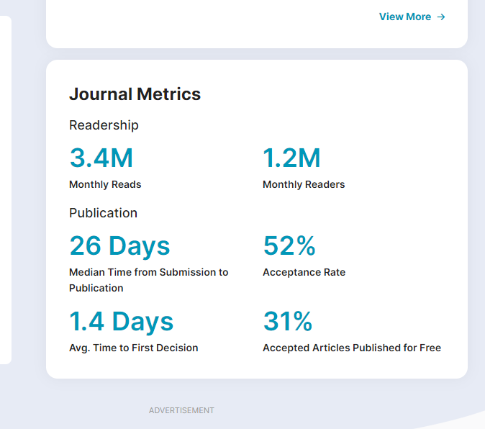
    - Recent Articles (Auto Scroll):

    - Articles:
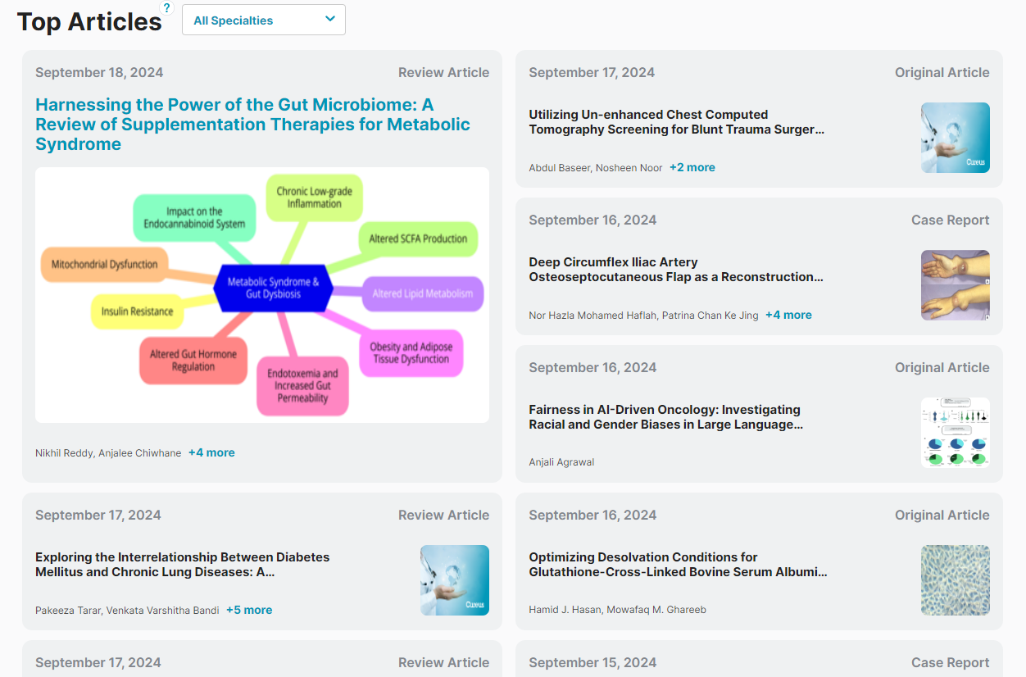
  - Article Page: The page will be similar to the screenshot and the viewer will get the flowing tabs: Articles, Author details, Metrics.

    - The user can download the pdf of the article uploaded by the author as well as share the link of the article to facebook and twitter.

    - Article metrics:
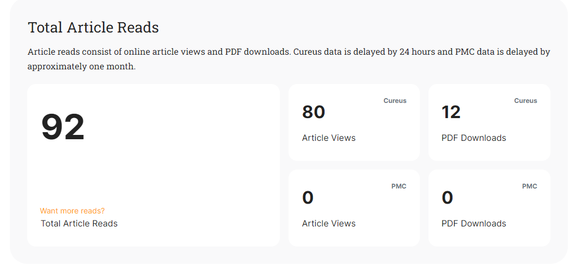

  - List of editors:


Out of scope
Source code of this project is out of scope from this estimate or Statement of work, if source code/complete ownership is needed one needs to pay extra. Any additional requirements other than the ones mentioned above are out of scope and may be billed extra.

Timeline

The deliverables for this project will be completed within 40 days from the commencement of the project, but it depends upon your phase approval acknowledgment to our team.

Dependencies

• Availability of client resources for system testing and validation.
• Timely provision of required information and access permissions by the client.
• Successful completion of mobile app development and integration.

For UJUDEBUG For ____________________

Terms and Conditions

1. Please mention all your required functionality, features before confirming/starting the project. We reserve the right to take or discard any further changes you demand after that.
2. Solution will be completely online-based and will be provided with login credentials for regular operations.
3. Time for delivery:
i) Time for delivery will be calculated on confirmation of the order.
ii) We shall deliver the project at the agreed delivery date to you. Our compliance with the delivery date is conditional upon your fulfilment of contractual obligations, including but not limited to the Software Requirement specification document, permissions, and advance payments (if applicable). If you fail in such fulfilment then the delivery date shall be extended accordingly.
iii) If a delivery is delayed due to circumstances for which the customer is liable then a new delivery date will be calculated.
4. Payment Terms:
i) Advance for confirmation of the order -
-For project costs below Rs 1 lakh, 50 percent
- For project costs above Rs 1 lakh, 30 percent
ii) Next instalment after completion of 50% of the project -
On completion of 50% of the project, you need to pay the 2nd instalment for your project. However, before payment or moving ahead please check that all promised (50%) functionality is present for the same.
-For project costs below Rs 1 lakh, 20 percent
- For project costs above Rs 1 lakh, 40 percent
iii) Rest Amount to be paid on or before 21 days of completion of the project. (*otherwise, project/website/application/software may get deactivated/suspended). We request you to process the invoice with in that time else there will be a 1.5% interest charge per month on late invoices.
Please make the payment only after checking all the features on your project/ website/ application/ software.
Payment Structure -
-For project cost below Rs 1 lakh -> 50:20:30
-For project cost above Rs 1 lakh -> 30:40:30
*Payment is non-refundable
5. Our technical support is free for two months (60days).
6. Final Price is subject to change depending upon the features and functionalities.
7. Annual Maintenance Contract (AMC): Your project have AMC (Annual Maintenance Contract) or Yearly Renewal Charges, please contact our customer service for that. AMC (Annual Maintenance Contract) will only be valid for error/issue/bugs present on the project, it doesn't include any additional features or upgrades. AMC cost for your project will be 10% of the total project cost.
8. Additional Maintenance requirements will cost extra that is depending upon the time and complexity of the task
9. If you need the source code for your project then discuss or mention it before starting your project. We charge an additional amount for the source code. To give an approximate idea, source code cost ranges from 1.5X to 3X depending on the project to project
10. One-year domain and hosting/server service will be provided free of cost (if already mentioned by the executive). It needs to be renewed every year.
11. The customer shall not be entitled to use or resell the Projects for any other purposes than what it is intended for.
12. Any additional agreements, provisions, amendments, and supplements to these conditions shall not be valid unless made in writing and signed by both parties.
13. All disputes are subject to Sonitpur jurisdiction only.

