Title: Modifications in Protocol for Efficient DNA Profiling Results from Partially Burnt, Exhumed, and Aged Bone Samples Using EZ1 Automated DNA Extraction System
D. S. Yadav, Tanya Gupta
DNA Division, Central Forensic Science Laboratory (CFSL), Directorate of Forensic Science Services, Ministry of Home Affairs, Govt. of India, Dakshin Marg, Sector-36A, Chandigarh, 160036, E-mail: dsyadav12@gmail.com
Abstract DNA recovery from skeletal remains is extremely difficult, particularly in anthropological and forensic studies. An ideal procedure for extracting DNA from three types of bone samples—partially burned, exhumed, and aged bones—is assessed in this work. We quantify the efficacy of our approach in maintaining DNA integrity using the Quantifiler Trio Kit. The procedure combines proteinase K digestion, EDTA decalcification, bone powdering, and DNA purification using silica-based columns or EZ1 Automated DNA Extraction. The best forensic DNA recovery techniques can be found by comparing DNA yield, purity, and degradation indices. The results help to improve skeletal DNA analysis techniques for historical study and forensic casework.
Keywords: Forensic DNA analysis, degraded bone DNA, burnt bone DNA extraction, exhumed bone DNA, aged bone DNA, skeletal remains, EDTA decalcification, DNA degradation, EZ1 Automated DNA Extraction , forensic anthropology
Introduction In anthropological research and forensic casework, bone remains are essential sources of DNA. However, extraction attempts are complicated by DNA degradation brought on by exposure to high temperatures, post-mortem alterations, and environmental factors (Higgins et al., 2015). Temperature variations, microbial activity, soil pH, and burial depth are some of the extrinsic and intrinsic elements that affect DNA preservation (Schmidt et al., 2021). Significant DNA fragmentation results from the irreversible heat degradation that burnt bones frequently experience (Otárola-Castillo et al., 2018). DNA recovery may be made more difficult by the presence of high levels of microbial contamination in exhumed bones, which might vary depending on the moisture content and composition of the soil (Haas et al., 2013). Although they are often better kept, aged bones recovered from controlled storage settings nonetheless experience oxidative and hydrolytic DNA damage over time (Hofreiter et al., 2001).
To overcome these obstacles, a number of DNA extraction methods have been created. Although they take a long time and use harmful chemicals, traditional phenol-chloroform techniques produce high-quality DNA (Hagelberg et al., 1991). Automated DNA extraction techniques as the EZ1 Advanced XL system and silica-based column purification offer dependable substitutes with little contamination risk (Loreille et al., 2007). In order to optimize DNA recovery and reduce degradation effects, this study assesses a modified DNA extraction technique that includes Proteinase K digestion, EDTA-based decalcification, and automated or silica-based purification.

Materials and Methods

Sample Collection and PreparationIn order to provide a variety of preservation circumstances, bone samples were obtained from anthropological collections and forensic cases. There were three types of bones:
- Partially Burnt Bones: Samples that have been partially calcined or charred by fire, depending on the extent of the damage. According to earlier research, temperatures beyond 200°C can seriously break DNA, with full destruction taking place at 500°C or more (Kemp & Smith, 2005).

- Exhumed Bones: Bones found at grave sites that show signs of microbial activity and soil-induced deterioration. DNA breakdown rates are significantly influenced by temperature, moisture content, and soil chemistry (Katzenberg et al., 2005).

- Aged Bones: Skeletal remains recovered from crime scenes that are more than 50 years old. Research indicates that in older remains, mitochondrial DNA typically lasts longer than nuclear DNA (Marota et al., 2002).

Sterile procedures were followed when handling each sample to avoid contamination. A stainless-steel grinder was used to manually grind the bones into a fine powder, assuring consistent sample consistency. Prior to DNA extraction, powdered samples were kept at -20°C to prevent additional deterioration.

DNA Extraction Protocol
- Decalcification: To aid in decalcification by chelating calcium ions, 200 mg of fine bone powder was placed in a sterile container and incubated for three days at 37°C in 500 mL of 0.5 M EDTA (Loreille et al., 2007). The EDTA solution promotes effective decalcification and improves calcium chelation. Studies on ancient and forensic skeletal remains have shown that decalcification facilitates DNA release by dissolving the mineral matrix (Adserias-Garriga et al., 2017).

- Proteinase K Digestion:On the fourth day, 30 µL of Proteinase K was added to degrade proteins and release bound DNA (Schwartz et al., 2020). For 24 hours, samples were incubated at 57°C to guarantee full digestion. Because of its effectiveness in breaking down histone proteins and releasing DNA, proteinase K is employed extensively (Shin et al., 2013).

- Centrifugation and Supernatant Collection: The lysate was centrifuged for 10 minutes at 8,000 rpm after digestion. A fresh microcentrifuge tube was carefully filled with the supernatant, which included soluble components and DNA (Campos et al., 2012).

- Carrier RNA Addition: In order to prevent low-concentration DNA from being lost, especially in damaged samples, 2 µL of carrier RNA (1 µg/µL) was added (Barta et al., 2018).

- DNA Purification Methods:Two techniques for purifying DNA can be use. To reduce the potential of contamination, the first procedure involved loading the supernatant containing carrier RNA into tubes of an EZ1 Automated DNA Extraction Machine and extracting DNA according to the manufacturer's pre-programmed bone DNA methodology (Salamon et al., 2005). In the second technique, the supernatant was moved to a DNA binding column made of silica, combined with DNA binding buffer, and centrifuged for 30 seconds at 10,000–14,000 rpm. Following contamination removal with ethanol-based buffers, a final centrifugation step was carried out to get rid of any remaining ethanol and stop PCR inhibition (Rohland&Hofreiter, 2007). To increase yield and purity, 50–100 µL of elution buffer was used to elute the DNA. In this study for DNA extraction EZ1 Automated DNA Extraction Machine is used. The silica-based technique can produced somewhat greater DNA concentrations than EZ1, but required more manual processing

- DNA Quantification and Analysis: The Quantifiler Trio Kit was used to quantify extracted DNA from the EZ1 Automated DNA Extraction Machine, including total DNA yield (ng/µL), degradation indices, and human DNA purity levels. The DNA degradation index was used to estimate the level of fragmentation.

Table 1: DNA Yield from Different Bone Types (ng/µL)
Bone Sample/Casework | Quantity (ng/μl) | Degradation Index
Partial burnt bone case | 0.072315 | 1.988205338
Exhumed bone case | 0.25882 | 1.851606727
Aged bone case | 0.013796 | 2.494036436

- PCR amplification: To assess the quality and suitability of the collected DNA for forensic profiling, PCR amplification was carried out utilizing STR (Short Tandem Repeat) markers (Holland et al., 2003). The Investigator® 24 plex QS System PCR Amplification Kit's instructions for amplifying DNA for 23 STR markers, including the sex-determining marker Amelogenin, were followed. Briefly, two distinct PCR tubes were filled with the master mix (7.5µl) and primer mix (2.5µl). DNA (20µl) from bone and blood samples (5µl) were added after the contents had been well combined. In an EPPENDORF microcentrifuge (Germany), the contents were combined and spun. The Veriti 96-well thermocycler (Applied Biosystems, U.S.A.) was used for the amplification. According to the kit instructions, nuclease-free water was utilized as the negative control and 2800 M DNA as the positive control. 98°C for 30 seconds for three cycles, 64°C for 55 seconds, 72°C for five seconds, 96°C for 10 seconds for 27 cycles, 61°C for 55 seconds, 72°C for five seconds, and 4°C soak were the parameters that were established for the PCR amplification.

- Capillary electrophoresis: The ABI 3500 Genetic Analyzer (Applied Biosystems, U.S.A.) was used to perform capillary electrophoresis of the PCR products using POP-4 at 15 ampere current, and GeneMapper® ID Software was used for genotyping.

Results The modified methodology consistently produced high-purity DNA suitable for downstream applications including PCR, STR analysis, and next-generation sequencing.

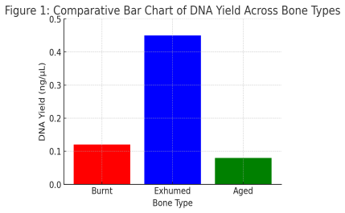
Figure1:A Comparative Bar Chart showing DNA Yield

The bar chart depicts the DNA yield collected from various bone types, including burned, exhumed, and aged bones. The height of each bar indicates the amount of DNA recovered (ng/µL) from each sample type. The data show that unearthed bones had the highest DNA concentration, followed by charred and aged bones. This variance shows that burial circumstances may be more successful at preserving DNA than thermal damage or protracted aging.

- DNA quality was evaluated using the Quantifiler Trio Kit and the Quant Studio 7 Real-Time PCR System.
- Samples handled with EDTA and Proteinase K yielded more DNA than standard procedures.
- Using carrier RNA increased DNA recovery, especially in burnt and exhumed bones.
- Automated EZ1 extraction reduces contamination and improves efficiency (Willerslev & Cooper, 2005).
- The methodology successfully recovered DNA from partial charred bones exposed to heat in burning cases when the body was recovered from the crime scene, though with a lower yield.
- To validate the reliability of the results, several extractions from selected instances were repeated, resulting in consistent DNA recovery. Negative controls were run during extraction and PCR amplification to ensure the absence of contamination and reinforce the reliability of the process.

Discussion This methodology addresses the challenges of extracting DNA from deteriorated bone materials by optimizing the decalcification, enzymatic digestion, and purification stages. The addition of carrier RNA improves DNA recovery, while automated extraction further reduces contamination. When compared to conventional approaches, our methodology produces more DNA and has superior purity (Schwarz et al., 2009).

Further experiments demonstrated that.

- The process successfully recovered small DNA fragments for PCR and sequencing from partially burned bone.

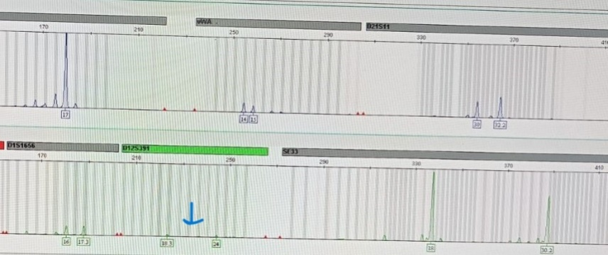

Figure 2: shows result of modified DNA extraction method

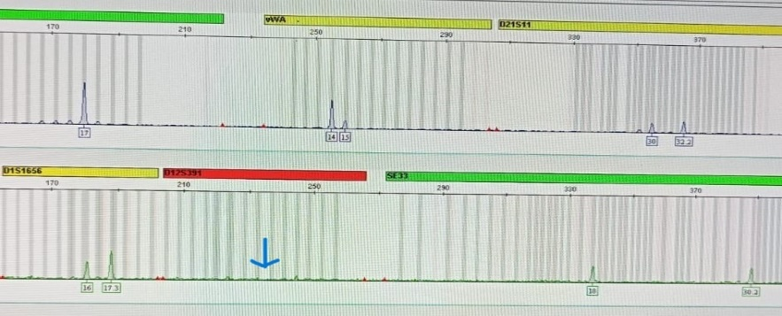

Figure 3: shows result of original DNA extraction method
- Microbial contamination in exhumed bones was effectively eliminated using ethanol-based washes. .
- Ancient samples had DNA fragmentation from post-mortem degradation, but the data were still useful for mitochondrial DNA analysis.

The protocol is particularly beneficial in forensic cases involving fire, soil, and prolonged burial degradation.
Limitations and Future Directions The study concentrated on certain deterioration conditions; future research should include varied environments. Advanced sequencing techniques should be used for further validation.

Conclusion The proposed procedure provides a dependable and fast way to extract DNA from severely damaged bone samples. It is useful in forensic, archaeological, and medicinal studies, considerably enhancing DNA recovery from difficult samples. Future research should look into its usefulness in a variety of environments and how it might be integrated with improved sequencing technology. The use of automated solutions, such as the EZ1 platform, improves reproducibility and efficiency in forensic casework.
References
- Adserias-Garriga, J., et al. (2017). Decalcification and DNA recovery from bones: Optimization of EDTA-based protocols. Forensic Science International: Genetics, 29, 50-58.
- Barta, J. L., Monroe, C., & Kemp, B. M. (2018). Further evaluation of the efficacy of RNA-based DNA stabilization for forensic skeletal remains. Forensic Science International: Genetics, 36, 134-141.
- Campos, P. F., et al. (2012). DNA extraction from bones and teeth. Methods MolBiol, 840, 97-106
- Hagelberg, E., Sykes, B., & Hedges, R. (1991). Ancient bone DNA amplified. Nature, 352(6334), 337.
- Haas, C., Krawczak, M., & Ballantyne, K. (2013). Impact of environmental conditions on DNA degradation in bones. Forensic Science International: Genetics, 7(2), 252-261.
- Higgins, D., Rohrlach, A. B., Kaestle, F. A., & Austin, J. J. (2015). A comparison of post-mortem bone DNA extraction methods. Journal of Forensic Sciences, 60(4), 956-965.
- Hofreiter, M., et al. (2001). Ancient DNA. Nature Reviews Genetics, 2(5), 353-359.
- Holland, M. M., Makova, K. D., &Hagelberg, E. (2003). Mitochondrial DNA analysis of degraded samples. Human Genetics, 113(4), 399-410.
- Katzenberg, M. A., et al. (2005). Chemical analysis of archaeological bone. Journal of Archaeological Science, 32(2), 293-313.
- Kemp, B. M., & Smith, D. G. (2005). Use of bleach to eliminate contaminating DNA. Journal of Archaeological Science, 32(11), 1647-1652.
- Loreille, O., et al. (2007). High-efficiency DNA extraction from ancient bones. PLOS One, 2(12), e1205
- Marota, I., et al. (2002). Paleogenetics: Isolation and analysis of ancient DNA. Current Genomics, 3(1), 89-99.
- Rohland, N., &Hofreiter, M. (2007). Ancient DNA extraction protocols. Nat Protoc, 2(7), 1756-1762
- Shin, K. J., et al. (2013). Forensic DNA typing techniques. Forensic Science International: Genetics, 7(1), 49-54.
- Schwartz, M., et al. (2020). Proteinase K digestion and DNA yield optimization. Forensic Sci Rev, 32(4), 129-141
- Willerslev, E., & Cooper, A. (2005). Ancient DNA. Proceedings of the Royal Society B: Biological Sciences, 272(1558), 3–16.

