Management of Radicular cyst by surgical enucleation with bone graft and platelet-rich-fibrin
Dr. Rakesh Kumar Medhi¹, Dr. Dilip Goswami²
¹Lecturer, Department of Periodontics and Oral Implantology, Regional Dental College and Hospital, Guwahati, Assam, India, 781032
²Professor & HOD, Department of Periodontics and Oral Implantology, Regional Dental College and Hospital, Guwahati, Assam, India, 781032
Abstract
Radicular cysts, also known as periapical cysts, are an inflammatory form of odontogenic cyst that usually has no symptoms and is connected to the root of a non-vital tooth. They show up as oval or pear-shaped unilocular radiolucency in the periapical area on radiography. Since cyst development is the last phase of inflammation following a periapical infection, it frequently happens later in life. Sometimes a radicular cyst in the maxilla might extend to the maxillary sinus. Endodontic therapy, enucleation with primary closure, or extraction of the troublesome tooth are among the treatment options. Therefore, the current study reports a case that was successfully treated with endodontic therapy and surgical enucleation, followed by the implantation of platelet-rich fibrin (PRF) and demineralized freeze-dried bone allograft (DFDBA).
Keywords: Radicular cyst, Periapical cyst, Enucleation, Bone graft, Platelet-rich-fibrin
Introduction
The radicular cyst also termed as periapical cyst is the most prevalent odontogenic cyst, accounting for more than half of all oral cysts. A cyst is a pathological cavity in the bone or soft tissue, with a well-defined outer wall of connective tissue and inner wall of epithelial tissue. The periapical cyst, or radicular cyst, is the most prevalent odontogenic cyst, accounting for more than half of all oral cysts, typically treated surgically to minimize recurrence and often arising from the inflammatory response to pulpal necrosis in non-vital teeth, most commonly found in the maxillary anterior region. A periapical or radicular cyst arises from epithelial cell rests of Malassez which proliferate by an inflammatory process originating from pulpal necrosis of a non-vital tooth. This condition is usually asymptomatic but can result in a slow-growth tumefaction in the affected region. Bhaskar¹ and Shear² reported that the incidence of radicular cysts is found to be highest among patients in their third decade of life and greater among men than women. Shear² also reported that they have particularly high incidence in the maxillary anterior region, presumably as a result of trauma. A case report is presented of an individual with an infected radicular cyst.
Case presentation
A 60-year-old female patient was reported to Dept of Periodontics & Oral Implantology of Regional Dental college in November, 2020, with a chief complaint of pain related to the right first quadrant. She gave a history of swelling along with pus discharge from gums since last 6 months. On clinical examination, there was no cystic fluctuant swelling associated with 11, 12, 13 (Fig. 1a.). Vitality test gave a negative response in relation to 11 and 21. An Intra oral Periapical Radiograph (IOPA) in relation to 11, 12, 13 and on the basis of clinical, radiological a provisional diagnosis of Radicular cyst was made. An endodontic therapy was planned with respect to 11, 12, 13 (Fig.1b.). However, there was persisting periapical radiolucency irt 11, 12, 13; hence surgical enucleation of the cyst through a buccal approach was planned. Patient was informed about the procedure and a written consent was obtained.
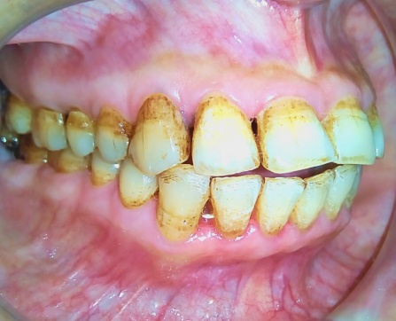
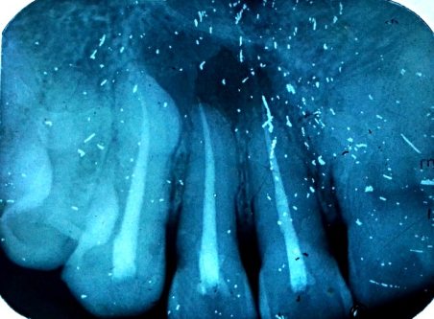

Fig.1b. IOPA after endodontic treatment
Fig.1a. No evident external swelling

After administration of local anaesthesia (Xicaine, ICPA Healthcare products Ltd.), following crevicular incision around 11, 12, 13, a full thickness mucoperiosteal flap was elevated as shown in Fig. 2a. Cyst enucleation was carried out in toto with the help of Curettes (Fig.2b.). The cystic lining was removed and complete debridement was done with copious irrigation. This further aided in adequate visualization of root apex. Hemostasis was achieved with the use of sterile gauzes. Following enucleation, the cavity was examined, revealing expansion of the cyst palatally as well as in the direction of the nasal floor (Fig.2b.). Enucleated cyst was sent for histopathological examination which confirmed the diagnosis of Radicular cyst. After complete enucleation of cystic lining, demineralized freeze-dried bone allograft (DFDBA) was placed sandwiched between 2 layers of Platelet rich fibrin (PRF) as shown in Fig..2c.2d.2e. For preparation of PRF, 5 ml of whole venous blood was collected in two sterile Vacutainer tubes without adding anticoagulant. The Vacutainer tubes were then centrifuged for 10 min at the speed of 3000 rpm.
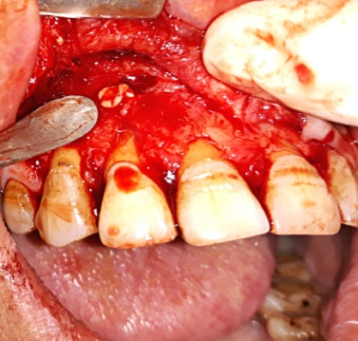
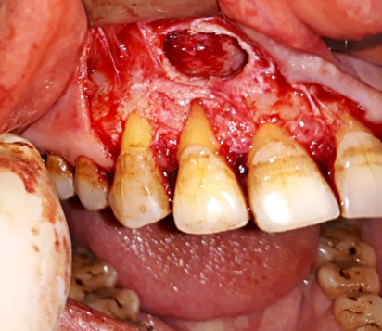
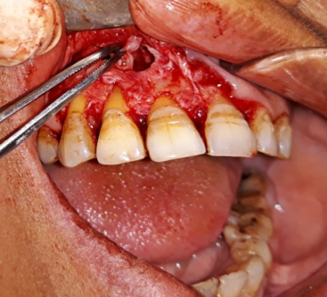

Fig.2c. Placement of PRF
Fig.2b. Debridement of cystic cavity
Fig.2a. Removal of cystic lining

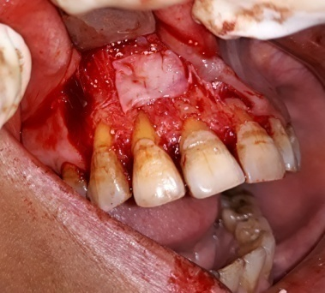
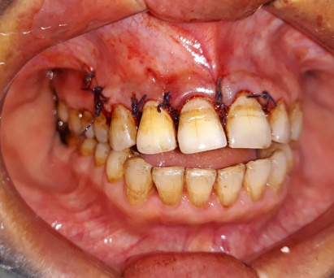
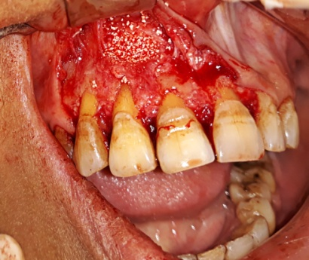

Fig.2f. Suture placed
Fig.2e. Placement of PRF membrane
Fig.2d. Placement of Bone graft

The flaps were sutured with a 3‑0 silk suture (Ethicon, Division of Johnson and Johnson Ltd.) (Fig.2.f). The patient was prescribed broad spectrum antibiotics and analgesics, and was also asked to maintain oral hygiene. The patient returned to remove the sutures after 1 week with uneventful soft tissue healing and no reported complications. (Fig. 7). At the end of one-year, palatal swelling subsided completely. An Intra oral Periapical Radiograph in relation to 11 and 21 (Fig. 3b) reveals complete resolution of the cystic lesion.
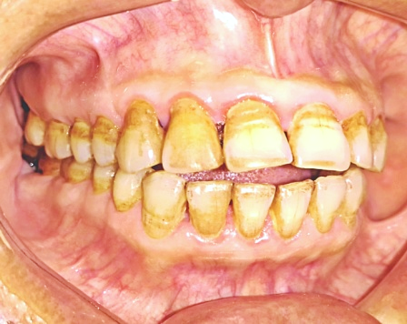
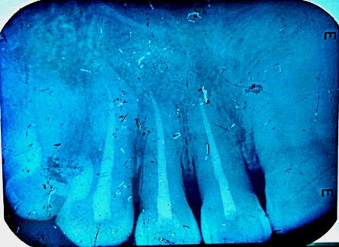

Fig.3b. Postop IOPA reveals complete resolution
Fig.3a. Postop follow up after 1 year

Discussion
Periapical cyst are inflammatory jaw cysts that are present at the apex of infected teeth with necrotic pulp. Nowadays, they are referred as radicular cyst or true cyst. Radicular cysts make up about 52%- 68% among all the cysts. Anterior maxilla is more common affected as compared to mandible³⁻⁴. It is present as the swelling of the jaw and associated with the loosening of the tooth. Displacement of the adjacent teeth and root resorption of the affected teeth have also been reported⁴. Cystic lesions are most commonly treated pathologies via surgeries. most reliable and effective methods to treat radicular cysts. Surgical enucleation and curettage have been carried out since many ages. Though the method of enucleation is proposed for smaller cysts, it should be also used whenever possible as it’s proved to have superior advantages over marsupialization: a surgical method used commonly for treating large cysts. The most common disadvantage includes recurrence and spillage of intracystic contents due to incomplete enucleation. This can be overcomed by ensuring techniques that allows complete or in toto enucleation of cysts⁵. Nowadays, Guided tissue regeneration techniques i.e. use of bone graft and barrier membranes in addition to endodontic surgeries has been used to promote bone healing⁶. PRF is an autologous biomaterial with absence of risk such as rejection/allergy, so freshly prepared PRF from patient’s whole blood was utilized for graft⁷⁻⁸. PRF reduces post operative pain and it encourages healing of the wound. Considering the literature we had carried out this case with conventional endodontic therapy along with cyst enucleation with placement of DFDBA bone graft to enhance bone regeneration combined with Platelet Rich Fibrin (PRF).
Conclusion
The clinical case reported was managed successfully by endodontic therapy with emphasis on thorough debridement and disinfection of the root canal system which was followed by surgery. The authors recommend non-surgical management of large periapical lesions in view of clinical evidence present. However, in specific situations where the size and extent of the lesion is of critical importance, surgery is a viable option with good prognosis. An endodontist should have thorough knowledge about materials and various treatment options involved in management of such a case.
References
1. Bhaskar SN: Periapical lesion-types, incidence and clinical features. Oral Surgery, Oral Medicine and Oral Pathology, 1966; 21(5):657-671.
2. Shear M, Seward GR: Cysts of the Oral Regions. 3rd Edn. (Indian); Varghese Publication House, Mumbai, 1996; pp:136-170.
3. Rajendran R, Sivapathasundharam B. Shafer’s Textbook of Oral Pathology. 6th ed. New Delhi: Elsevier; 2009. p. 487-90. 2.
4. Shear M. Cysts of the Oral Regions. 3rd ed. Boston: Wright; 1992. p. 136-70
5. Effective management of large radicular cysts using surgical enucleation vs. marsupialization - two cases report. Fawzi R, Carine T. Int. Arab J. Dent. 2010; 1: 44–51.
6. Mastromihalis N., Goldstein S., Greenberg M., Friedman S. Applications for guided bone regeneration in endodontic surgery. N. Y. State Dent. J. 1999; 65:30–32.
7. Lauritano D, Avantaggiato A, Candotto V, Zollino I, Carinci F. Is platelet-rich fibrin really useful in oral and maxillofacial surgery? Lights and shadows of this new technique. Ann Oral Maxillofac Surg. 2013; 1:25.
8. Simonpieri A, Del Corso M, Vervelle A, Jimbo R, Inchingolo F, Sammartino G, et al. Current knowledge and perspectives for the use of platelet-rich plasma (PRP) and platelet-rich fibrin (PRF) in oral and maxillofacial surgery part 2: Bone graft, implant and reconstructive surgery. Curr Pharm Biotechnol. 2012;13: 1231–56.

