Title:A Study on the Calibre of the component vessels of the Circle of Willis of the Human Brain in the population of Assam.
Author’s Names:Karim A.Farheen¹,Talukdar L.Kunja²,Sarma Joydev³
Authors Affiliations and Correspondence address:
1.Dr.Farheen A.Karim,Assistant Professor,Dept.of Anatomy,Gauhati Medical College,Guwahati-781032.Assam.India.
Postal address:Dr.Farheen A.Karim,House No:18,Hemgiri Path,South Sarania,Ulubari,Guwahati-781032,Assam,India.
e-mail address:atia_farheen@rediffmail.com. Mobile No:9864026625
2.Dr.Kunja Lal Talukdar,Professor,Dept.of Anatomy,Gauhati Medical College,Guwahati-781032,Assam,India.
Postal Address: Dr.Kunja Lal Talukdar,Professor,Dept.of Anatomy,Gauhati
e-mail address:drkltalukdar@gmail.com Mobile No:09435545919.
3.Dr.Joydev Sarma,Professor ,Dept. Of Anatomy,Silchar Medical College,Assam,India.
e-mail address:joydevsarma@gmail.com Mobile No:09864268078
Abstract:
Background and Aim:The arteries of the circle of Willis(CW) of the human brain shows considerable variations of calibre and pattern;hence, the study aims to determine the length and external diameters of the arteries constituting the CW in the population of Assam.Materials and methods: 41 brains with intact CW within 6 hours of death were acquired from autopsies done in the Department of Forensic Medicine.Brains fixed in 10% formalin were finely dissected to measure the calibres using Vernier Calipers.Data collected was statistically analysed using SPSS(Statistical Package for Social Sciences) software.Results:The external diamerters and lengths of the arteries of the CW were determined and described through standard statistical methods.Statistically significant difference of calibres between the paired vessels of the CW were only found in lengths of A₁(precommunicating segment of Anterior Cerebral artery) and the external diameters of PCoA(Posterior communicating artery) of both sides.Conclusion:The study may be helpful to neurosurgeons and neurologists in Assam in planning and executing treatment of its population.
Keywords:Vernier Calipers, Lengths of Vessels in CW ,External diameters of vessels in CW.
Running Title:Circle of Willis of human brain: It’s Calibre in the population of Assam.

INTRODUCTION: The brain is absolutely dependant on a continuous supply of oxygenated blood¹.Two pair of major arteries-right and left vertebrals;right and left internal carotids deliver all their blood almost exclusively to the brain².The circulus arteriosus(circle of Willis) is a large arterial anastomoses that unites the internal carotid and vertebrobasilar systems.It lies in the subarachnoid space within the deep interpeduncular cistern and sorrounds the optic chiasma,the infundibulum and other structures of the interpeduncular fossa.Anteriorly,the anterior cerebral arteries,which are derived from the internal carotid arteries are joined by the small anterior communicating artery.Posteriorly, the two posterior cerebral arteries which are formed by the division of basilar artery are joined to the ipsilateral internal carotid artery by the posterior communicating artery³.This arterial circle equalizes the pressure of the blood flow to the two sides of the brain as it’s the main collateral channel⁵.It provides alternative routes,when one of the major arteries leading into it is blocked ⁶ .There is considerable individual variation in the pattern and calibre of vessels that make up the circle of Willis.³The calibres of the different segments of the circulus arteriosus vary so much that no two circles are completely identical.⁴
Higher percentage of abnormality of length and diameter of the vessels of the circle of Willis has been reported in the mentally ill and those with cerebrovascular catastrophe indicating a possible linkage.⁷Different distributions of variations of circle of Willis may partially explain the different incidences of some cerebrovascular diseases in different ethnic or racial groups.⁸
This study aims to study the calibre ie.length & external diameter of both sides of the component arteries of circle of Willis in the population of Assam.To the best of our knowledge,this study is first of its kind in this region.
Figure 1 The Circle of Willis.
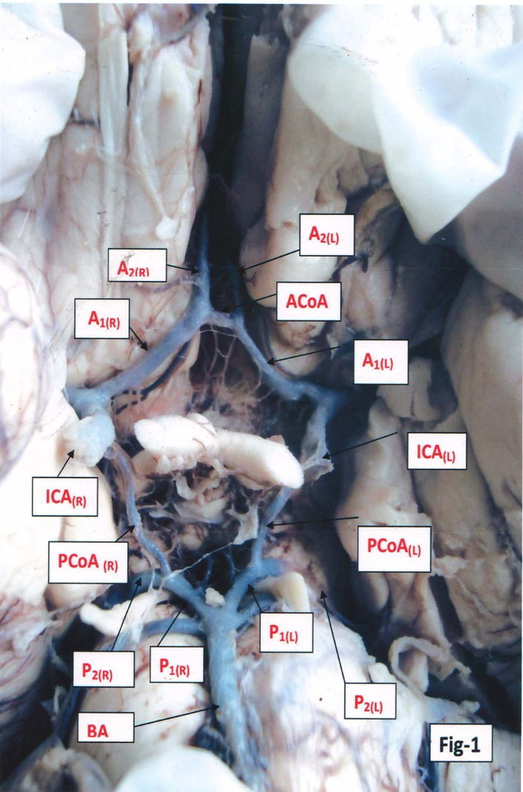

MATERIALS AND METHODS: The study was conducted in the Department of Anatomy,Gauhati Medical College and Hospital(GMCH).As GMCH is a Referral hospital,dead bodies from all over Assam are brought here,so they are thought to represent the population of Assam. Ethical clearance was obtained from Institutional Ethical Committee of Gauhati Medical College for the study. Specimens of brains were collected from autopsies done in the Dept.of Forensic Medicine,GMC within 6 hours following death.Study of those CW were excluded where the morphology of CW were affected by Cranial Trauma,Cerebral hemorrhage,Cerebral neoplasm or head shot. 41 brains were collected randomly(including 6 of females) .Brains were fixed in 10% formalin.CW were dissected out and calibres were measured using Vernier Calipers . Fixed reference points in the CW were used to measure external diameters and lengths of each arterial segment:-
1. External Diameter was measured by taking 3 observations and calculating their average.
Right &Left ICA (Internal Carotid Artery) within 0.5-10mm from their distal points.
Right & Left A₁(pre-communicating segments of Anterior Cerebral Artery) & P₁(pre-communicating segments of Posterior Cerebral Artery) within 0.5-10mm from their origins.
Right & Left A₂(post-communicating segments of Anterior Cerebral Artery) & P₂(post-communicating segments of Posterior Cerebral Artery) within 0.5-10mm from their origins.
ACoA(Anterior communicating artery),Right & Left PCoA(Posterior communicating artery) within 2mm from their both ends and one in their midpoints.
2.Length was measured by taking following reference points.
Right & Left A₁ segments from their point of origins from corresponding ICA(s) to their point of terminations at their junctions with the ACoA.
Right & Left PCoAs from their point of origins to their corresponding point of terminations.
Right & Left P₁ from their point of origins to the point of their junctions with the corresponding PCoAs.
STATISTICAL ANALYSIS: Data was collected in MS Excel Sheet and analysed using SPSS (Statistical Package for Social Sciences )software.
Statistical tests used were Mean,Median,Standard Deviation (SD),Standard Error of Mean (S.E.M), Students Paired t test(t value),Degree of freedom(Df). A P value $<$ 0.05 is taken as statistically significant.

Figure 2: Vernier Calipers.
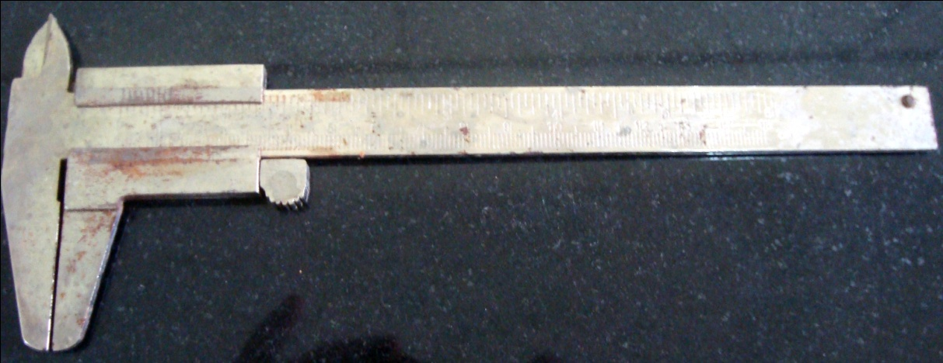
Table-1 Descriptive Analysis of External Diameters (mm)of the Arteries of Circle of Willis.
CW arterial segment | Mean | S.E.M | Median | SD | Minimum | Maximum
ACoA | 1.56 | 0.12 | 1.40 | 0.68 | 0.40 | 3.10
PCoA_{(R)} | 1.43 | 0.15 | 1.30 | 0.78 | 0.10 | 3.10
PCoA_{(L)} | 1.07 | 0.11 | 1.10 | 0.58 | 0.20 | 2.50
P_{1(R)} | 1.67 | 0.12 | 1.75 | 0.73 | 0.20 | 3.40
P_{2(R)} | 1.63 | 0.12 | 1.60 | 0.61 | 0.20 | 2.90
P_{1(L)} | 1.81 | 0.11 | 1.85 | 0.65 | 0.20 | 3.30
P_{2(L)} | 1.74 | 0.12 | 1.90 | 0.64 | 0.10 | 3.10
A_{1(R)} | 1.93 | 0.12 | 1.85 | 0.68 | 1.0 | 3.40
A_{2(R)} | 1.85 | 0.11 | 1.75 | 0.62 | 1.0 | 3.80
A_{I(L)} | 2.01 | 0.14 | 2.0 | 0.83 | 0.60 | 4.70
A_{2(L)} | 1.81 | 0.11 | 1.85 | 0.65 | 0.50 | 3.10
ICA_{(R)} | 3.36 | 3.36 | 3.45 | 0.95 | 1.00 | 5.00
ICA_{(L)} | 3.34 | 3.34 | 3.4o | 0.69 | 2.00 | 4.40

Table-2 Descriptive Analysis of Lengths(mm) of the arteries of the circle of Willis
CW arterial segment | Mean | SEM | Median | SD | Minimum | Maximum
ACoA | 2.86 | 0.20 | 2.70 | 1.23 | 0.50 | 6.60
PCoA_{(R)} | 10.89 | 0.69 | 10.80 | 3.97 | 2.30 | 19.40
PCoA_{(L)} | 10.79 | 0.57 | 11.00 | 3.26 | 0.90 | 19.40
P_{1(R)} | 5.32 | 0.39 | 4.90 | 2.23 | 1.80 | 12.50
P_{1(L)} | 5.85 | 0.60 | 5.40 | 3.42 | 1.40 | 23.00
A_{1(R)} | 11.75 | 0.64 | 11.30 | 4.04 | 1.00 | 27.40
A_{1(L)} | 10.88 | 0.64 | 11.10 | 4.05 | 1.00 | 27.10

Table-3: Paired t- test of both sides of the corresponding arterial segments of the circle of Willis of the population of Assam.
S No | Measures(mm) | t value | Df | P value(two tailed)
1. | Diameter of PCoA | 2.123 | 33 | 0.041
2. | Diameter of A₁ | -0.325 | 40 | 0.747
3. | Diameter of A₂ | 0.292 | 38 | 0.772
4. | Diameter of P₁ | -0.674 | 40 | 0.504
5. | Diameter of P₂ | 0.292 | 38 | 0.772
6. | Diameter of ICA | -0.052 | 40 | 0.959
7. | Length of PCoA | 0.138 | 31 | 0.891
8. | Length of A₁ | 2.286 | 39 | 0.028
9. | Length of P₁ | -0.677 | 31 | 0.503

RESULTS:The data on the diameters and lengths of the branches of arteries of the circle of Willis have been statistically determined and described in Table Numbers 1 and 2 respectively.The diameters and lengths of arteries of both sides of the corresponding arterial segments of the circle of Willis have been compared through Students paired t test assuming a level of statistical significance of P value less 0.05 in Table 3.There is a statistical significant difference between diameters of both sided PCoA (t=2.123;P=0.041) and the lengths of both sided A₁(t=2.286,P=0.028) .The average diameter of the right PCoA(1.34±0.75) was greater than of the left PCoA(1.08±0.56) and the average length of right A₁(11.75±4.04) was greater than of the left A₁(10.88±0.56).

DISCUSSION:
Present study showed that the length and diameter of the arteries forming the circle of Willis is variable which is similar to a Dissection Study on the length and external diameters of arteries of the CW by Kamath S ⁷.Similarly a Magnetic Resonance Angiography Study on the morphology of CW by Krabbe- Hartkamp MJ⁹stated that the collateral potential of the circle of Willis is believed to be dependant on the presence and size of its component vessels, which vary among normal individuals.

The blood supply of left half of the brain on the whole is less complete than to the right side according to Windle,¹⁰;Mitterwallner,F.¹¹The present study similarly showed statistically significant greater diameters on the right PCoA segments.However on the contrary Orlandini,G.E.¹² found that the arteries to be larger on the left side of the circle of Willis.Warwick and Williams¹³ found that the composite vessels of the circle of Willis in a majority of cases have a greater length and smaller diameter in the right half of the circle In the present study only length of the right A₁ statistically significantly longer.S.Kamath⁷ found abnormal narrowing on the right half of the circle of Willis to be a more common occurrence .
Limitation of the study is the potential minor changes in the diameter of vessels during time.Lacunae of the study lies in the fact that we could not find enough valid statistical evidence that differences in calibres of the CW are similar among different populations done by other researchers or not .There should be cautious interpretations of the results of the quantative measurements of the calibres of the arterial segments as the dissection studies have not been correlated with other advanced imaging modalities like Magnetic Resonance Angiography on live subjects

CONCLUSION:
The study showed that there are individual variations in the length and external diameters of the component arterial segments of the CW.Only the diameter of right PCoA and length of the right A₁segment were statistically greater than of the left half of the CW. .A knowledge about the length and external diameters of the arteries of the CW in the population of Assam may be helpful in doing neurovascular surgeries ie.shunt operations.It may also through a light to differences in neurological deficits ie.stroke in different racial populations or ethnic groups.More extensive studies in this field of topic are desirable for more substantial and concrete results.
Conflict of interest:No conflict of interest associated with this work.
Source of Funding: Study has been self funded by by Dr.Farheen A.Karim.
Authors Contributions:We declare that this work done by the authors named in this article and all liabilities pertaining to the claims relating to the content of this article will be borne by the authors.The study was conceived and designed by Dr.Farheen A.Karim,Dr.Kunja Lal Talukdar and Dr.Joydev Sarma.The data was collected and analysed by Dr.Farheen A.Karim.

Bibliography:
1.M J Turlough FitzGerald,Gregory Gruener,Estomiah Mtui.Clinical Neuroanatomy and Neuroscience.5th ed.Elseviers Saunders,Philadelphia,2007:53
2.Maria A.Patetas,Leslie P.Gartner.A textbook of Neuroanatomy.Blackwell Publishing,Oxford,2006:99
3.Susan Standring.Gray’s Anatomy.40th ed.Churchill Livingstone,London,2008:251-252.
4.Lazorthes G,Gouza A,Santini JJ,Salamon G.Le cercle arteriel du cerveau(circulus arteriosus cerebri) Anat Clin.1979;1:241-257
5.Inderbir Singh.Textbook of Human Neuroanatomy.9th ed.Jaypee,New Delhi,2014:41-42.
6.John A.Kiernan.Barr’s The Human Nervous System An Anatomical Viewpoint.8th ed.Lippincott Williams & Wilkins,Philadelphia,2005:415-418.
7.Sylvia Kamath.Observations on the length and diameter of vessels forming the circle of Willis.J.Anat.(1981),133,pp.419-423.
8.Behzad Efthekar.Are the distributions of variations different in different populations?-Results of an anatomical study and review of literature.BMC Neurol 2006;6:22.doi:10-1186/1471-2377-6-22.
9.Krabbe-Hartkamp MJ,Circle of Willis:Morphologic variations on three-dimensional time-of-flight.Magnetic Resonance Angiograms.Radiology.1998 Apr,2007(1):103-11.
10.Windle,B.C.(1887).On the arteries forming the circle of Willis.Journal of Anatomy and Physiology 22,289-293.
11.Mitterwallner,F.von(1995).Variationen statistische Untersuchungen an den Baselen Hirngefassen. Acta Anatomica 24,51-57.
12.Orlandini,G. E .(1970).The ratified circumference of the principal arteries of the base of the brain.Archivio italiano di anatomia e di embriologica 75,49-79.
13.Warwick,R. & Williams,P.L.(ed)(1973).Gray’s Anatomy,35th ed.,p.957.

Ethical Clerance
