A study on adult community-acquired pneumonia and its drug-resistance pattern from a tertiary care hospital of Northeast India.
Dr Deepjyoti Kalita*, Dr Sangeeta Deka**, Dr Naba Kumar Hazarika***
{* Corresponding Author, Associate Professor of Microbiology, Fakhruddin Ali Ahmed Medical College, Jotigaon, Barpeta, PIN-781314,Assam, email: dkalita@gmail.com (m): 9864064072}
{** Assistant Professor of Microbiology, F.A.A. Medical College, Barpeta}
{*** Ex Professor and Head of Microbiology, Gauhati Medical College, Guwahati}

Abstract:
Community-acquired pneumonia (CAP) remains a common illness with significant mortality & morbidity all over the world. Nearly half of the cases of CAP pathogen cannot be identified and the empiric management of CAP has been complicated by the emergence of high rates of antimicrobial resistance in many major pathogens worldwide
This study was carried out as a pilot study (prelude to a Govt. of India funded bigger study) to find out bacteriological profile and antimicrobial resistant pattern of adult CAP cases attending a tertiary care hospital of Northeast India. Sputum from clinically and radiologically diagnosed adult CAP patients of our tertiary care teaching hospital were processed according to standard bacteriological techniques.
Out of 94 samples 55 (58.5%) yielded significant isolates including Streptococcus pneumoniae (42.1%) and Klebsiella pneumoniae (28.1%). There was one case of Mycoplasma pneumoniae isolation as well. S.pneumoniae was predominant in outdoor and mild cases while Gram negatives (e.g. Klebsiella) were more in indoor and in association with risk factors (diabetes, old age etc). Only 25% of S. pneumoniae isolates were sensitive to betalactam antibioitic. As all isolates are gaining moderate to high level drug resistance the need of an appropriate infection control measures and antibiotic policy is essential

KEY WORDs:
CAP, Community acquired-pneumonia, Adult-CAP, Pneumococci, Streptococcus pneumoniae, Drug resistant pneumococci, antibiotic resistance, antibiotic abuse, antibiotic policy

Introduction:
Community-acquired pneumonia (CAP) remains a common but a serious illness with significant mortality and morbidity globally. Pneumonia is the sixth leading cause of death, and the number one cause of death from infectious diseases in the United States.¹ There, every year, about 5-10 million cases of CAP are reported, leading to as many as 1.1 million hospitalization and 45,000 deaths.² The problem is much worse in developing countries where pneumonia is the most common cause of hospital attendance in adults. Though the definite statistics is lacking in India, it can be easily said that CAP is a leading cause of death here.³The etiology of CAP has been under constant study in different local settings from the last decade. But it appears that no two studies of the aetiology of CAP are same. These studies showed appreciable differences in the frequencies of causative agents, which seem related to seasonal, geographical, and racial factors. ^{4, 5} Despite considerable improvement and extensive use of variety of diagnostic testing procedures, responsible pathogens remain uncertain in as many as 50% of CAP cases.^{1,5} even, in those where pathogens are identifiable, few days delay is inevitable in the process of identification of the causative microbes. Due to this the antibiotic treatment for CAP empirically relies on epidemiological data regarding the causative pathogen in a particular geographic area.⁶ This is more so as the relative frequency of aetiological agents varies among different geographical area.³ Thus it appears crucial that large tertiary care centers determine the peculiar microbial pattern prevalent in their own CAP patients.⁷ Common CAP agents include Streptococcus pneumoniae (30-40% overall), Haemophilus influenzae, Staphylococcus aureus, Moraxella catarrhalis, Gram negative enteric bacilli (GNEB) like Klebsiella, E coli etc, atypical agents like Mycoplasma pneumoniae, Chlamydia pneumoniae, Chlamydia psittaci, Coxiella burnetti, Legionella, viruses etc. ^{1, 4}
The empiric management of community-acquired respiratory tract infections such as community-acquired pneumonia has been complicated by the emergence of high rates of antimicrobial resistance in three major pathogens: Streptococcus pneumoniae, Haemophilus influenzae, and Moraxella catarrhalis. Of these, only S. pneumoniae has been the focus of numerous recent studies, perhaps because of its greater virulence and extraordinary rise in antibiotic resistance level in relatively short period.⁹ Although several factors have been proposed to explain the increase in DRSP (Drug resistance streptococci pneumoniae) worldwide, antibiotic consumption is increasingly recognized as the leading force. Certain observation like high prevalence of DRSP (>50%) in regions known for liberal use of antibiotics (Spain, USA, Hong Kong), similarity of antibiotic resistance profile with locally used common antibiotics (selection of resistant subpopulation).¹⁴ Observation of resistance reduction, on decreasing concerned antibiotic use, make this theory more probable.¹⁵
Aim:
This study was carried out to study the bacteriological profile and antimicrobial resistant profile of adult CAP cases attending a tertiary care hospital of Northeast India
Method:
The study lasted from October 2005 to September 2006 at Gauhati Medical College. A total of 94 adult CAP patients (Clinically and Rediologically proven) from Medicine, Respiratory medicine, and Intensive Care Units were taken
Inclusion criteria were - New or progressive pulmonary infiltrate on a chest radiograph obtained within 24 hours of presentation and/ or Clinical finding of a) at least one of the major criteria: cough, sputum production, or temperature > 37.8°C, or b) at least two of the minor criteria: pleuritic chest pain, dyspnea, altered mental status, pulmonary consolidation by physical examination and WBC count of > 12,000 cells/ μl.^{6, 39, 175} Adopted exclusion criteria were- Earlier hospitalization within the previous 3 weeks; Presence of an emerging alternative diagnosis (e.g., pulmonary or septic emboli, pulmonary edema, or malignancy) during follow-up; Presence of tuberculosis or post obstructive pneumonia due to lung cancer; Presence of severe immunosuppression including severe neutropenia, HIV infection, etc.
Subjects were categorized as per ATS/IDSA guidelines to mild (Outdoor patients), moderate (indoor admitted) and severe (ICU admitted) CAP cases. Subjects were instructed and proper sample were collected and sent to bacteriology lab as early as possible. In the lab, Gram stain smear was prepared and checked to assess suitability of sputum sample for culture. Sample were homogenized with dithiothreitol (Mucasol) and inoculated on Blood Agar, MacConkey Agar Chocolate agar media and CVNG (Crystal violet, Nalidixic acid and Gentamicin) agar. A portion of sputum sample was also inoculated onto PPLO (pleuro-pneumonia like organism) biphasic media initially and then onto Mycoplasma agar for identification of Mycoplasma pneumoniae. Isolation and identification was performed using standard microbiological techniques with special attention to quality control aspects. For Mycoplasma, isolates from local Veterinary Institute was put to use for quality control. Identified pathogens were further tested for antibiotic susceptibility by Kirby-bauer disc diffusion method strictly adhering to guide lines laid down by NCCLS/CLSI.¹³ Reference strains (ATCC strains) available in Microbiology Department of our Institute were put to use for quality control purpose
All results (profile of pathogens, antibiotic susceptibility/resistance pattern etc.) were analyzed in the back drop of relevant epidemiological information already collected e.g. Risk factor, co-morbid illness, antibiotic use, previous hospital admission etc. Standard statistical package were put into use for the purpose.
Results:
Out of 94 total cases, 70 (74.47%) were males while 24 (25.53%) were females (Table1), female ratio was 2.9: 1 The overall mean age of the cases was 46.23 years with standard deviation (SD) 13.55.
Table 1.
Group | Mean age in years | Standard deviation
Male (n=70) | 46.53 | 13.67
Female (n=24) | 45.49 | 13.46
Outdoor patients (n=64) | 44.03 | 13.49
Indoor patients (n=24) | 52.08 | 12.42
ICU patients (n=6) | 46.67 | 13.68
Over all (n=94) | 46.23 | 13.55

Clinical presentation is shown in table 2
Table 2: Clinical presentations of 94 cases of adult CAP
Clinical Findings | Number of subjects | Percentage
Cough | 94 | 100%
Expectoration | 89 | 94.68%
Fever (> 37.8°C) | 81 | 86.17%
Chest pain | 52 | 55.32%
Difficulty in respiration | 24 | 25.53%
Alt. mental status | 7 | 7.45%
Clinical consolidation | 57 | 60.62%
Hemoptysis | 4 | 4.26%

Severity of illness is shown in table 3
Table 3: Severity of illness in 94 cases of adult CAP *
Age group in years | Mild CAP  (Outdoor treated) | Moderate CAP  (Indoor treated) | Severe CAP  (ICU treated) | Total
20-29 | 9 | 1 | 1 | 11
30-39 | 16 | 2 | 0 | 18
40-49 | 18 | 7 | 2 | 27
50-59 | 11 | 6 | 2 | 19
60-69 | 6 | 5 | 1 | 12
70-79 | 4 | 3 | 0 | 7
Total | 64 (68.09%) | 24(25.53%) | 6 (6.38%) | 94 (100%)
* As per ATS guidelines.¹
Culture results:
56 isolates could be identified with profile as depicted in table 4. Out of the total of 56 organisms isolated, Streptococcus pneumoniae (see fig 1) was the most common organism numbering 24 (42.9%). Klebsiella pneumoniae with 16 (28.6%) isolates was the next common organism followed by Staphylococcus aureus with 8 (14.3%) isolates and Moraxella catarrhalis (see fig 2 and fig 3) with 5 (8.93%). β-hemolytic Streptococcus, Escherichia coli and Mycoplasma pneumoniae were isolated once (1.79%) each.
Table 4: Profile of isolates in adult CAP subjects
Organism isolated | Number of isolate | Percentage
Streptococcus pneumoniae | 24 | 42.9
Klebsiella  pneumoniae | 16 | 28.6
Staphylococcus aureus | 8 | 14.3
Moraxella catarrhalis | 5 | 8.93
β-hemolytic Streptococcus | 1 | 1.79
Escherichia coli | 1 | 1.79
Mycoplasma pneumoniae | 1 | 1.79
Total | 56 | 100

Fig: Streptococcus pneumoniae isolate showing clear Optochin sensitivity
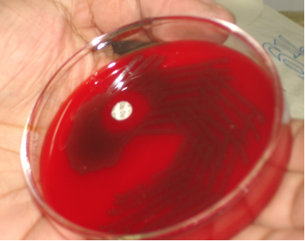

Fig 2. PPLO Biphasic media showing growth of Mycoplasma
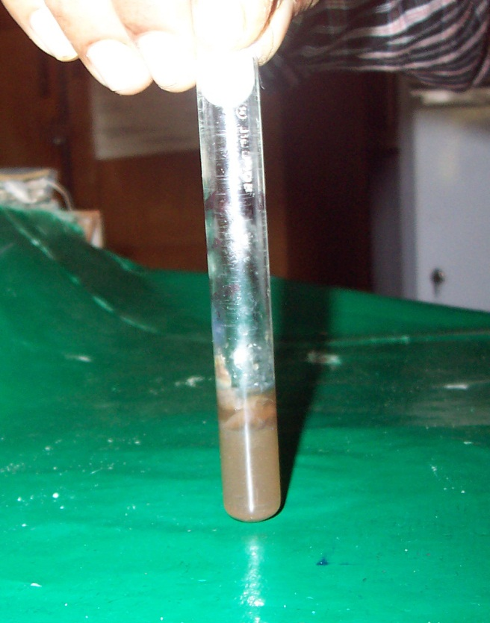

Fig 3. RBC overlay on growth in PPLO agar, showing hemolysis around the colonies of Mycoplasma pneumoniae (under transmitted light)
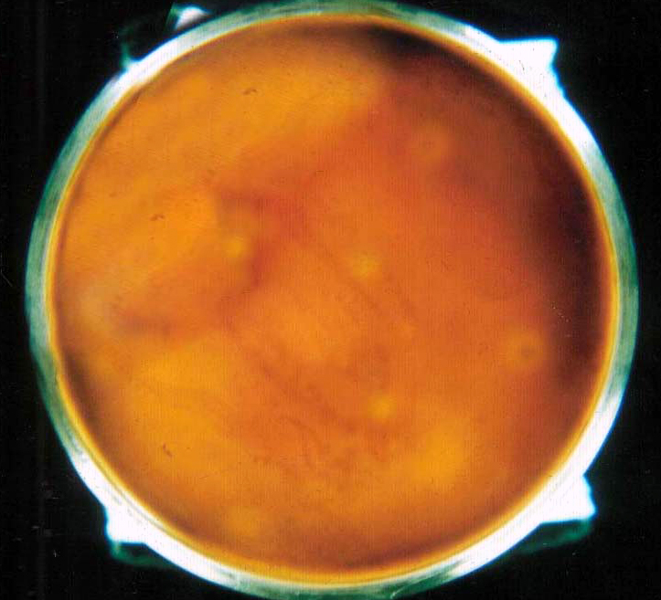

SEVERITY OF ILLNESS AND ISOLATED PATHOGENS
Table 5 shows isolation of pathogens in relation to the severity of illness. In outdoor treated mild CAP cases, Streptococcus pneumoniae was isolated in the highest number of 18 (52.9%) followed by 8 (23.5%) Klebsiella pneumoniae, 4 (11.8%) Moraxella catarrhalis, 2 (5.88%) Staphylococcus aureus etc.
In Inpatient treated moderate CAP cases Klebsiella pneumoniae was predominant with 7(41.2%) isolates, followed by Streptococcus pneumoniae and Staphylococcus aureus with 4 (23.5%) isolates each.
In ICU treated severe CAP cases 2 (40%) each of S pneumoniae and Staph aureus, and 1 (20%) Klebsiella pneumoniae were isolated
Table 5. Isolation of pathogens in 3 different grades of illness severity
Organism  Severity | S P (%) | Kleb (%) | S A (%) | M C (%) | β-HS (%) | EC (%) | MPn (%) | Total organism (%)
Outdoor cases (mild CAP) | 18  (52.9) | 8  (23.5) | 2  (5.88) | 4  (11.8) | 1  (2.94) | 0 | 1  (2.94) | 34  (100)
Indoor cases (moderate CAP) | 4  (23.5) | 7  (41.2) | 4  (23.5) | 1  (5.9) | 0 | 1  (5.9) | 0 | 17  (100)
ICU cases (Severe CAP) | 2  (40) | 1  (20) | 2  (40) | 0 | 0 | 0 | 0 | 5  (100)
Total | 24  (42.9) | 16  (28.6) | 8  (14.3) | 5  (8.93) | 1  (1.79) | 1  (1.79) | 1  (1.79) | 56  (100)
(Abbreviation used: - SP=Streptococcus pneumoniae, Kleb=Klebsiella pneumoniae, SA=Staphylococcus aureus, MC=Moraxella catarrhalis, β-HS=β-hemolytic streptococcus, EC=E coli, MPn= Mycoplasma pneumoniae)
Relation with co-morbid illness
Table 6
Organisms  Risk factors | S P  (%, p value) | Kleb  (%, p value) | S A  (%, p value) | M C  (%, p value) | β-HS (%) | EC (%) | MPn (%)
Smoking | 16  (43.2, 0.8679 ) | 13  (35.1, 0.1145) | 2  (5.4, 0.795) | 2  (5.4, 0.2092) | 1  (2.7) | 1  (2.7) | 1  (2.7)
Alcoholism | 6  (33.3, 0.4040) | 6  (33.3, 0.498) | 2  (11.1, 0.6956) | 0 | 1  (5.6) | 1  (5.6) | 1  (5.6)
Diabetes | 0 | 5  (55.6, 0.0092) | 2  (22.2, 0.1666) | 0 | 1  (11.1) | 0 | 0
Old age | 0 | 4  (80, 0.01) | 1  (20, 0.3478) | 0 | 0 | 0 | 0
Chronic lung disease | 2  (25, 0.2502) | 2  (25, 0.7828) | 0 | 3  (37.5, 0.0024) | 0 | 0 | 0
Previous hospitalization | 14  (50,  0.2276) | 7  (25, 0.6118) | 2  (7.1, 0.1520) | 3  (10.1, 0.6088) | 0 | 0 | 0
Prior antibiotic exposure | 19 (38.8, 0.2444) | 16 (32.7, 0.499) | 6  (12.20,  2842) | 3  (6.1,  0.901) | 1  (2) | 1  (2) | 0
Precedent viral fever | 0 | 0 | 2  (100, 0.0001) | 0 | 0 | 0 | 0
CVS disorder | 0 | 0 | 0 | 0 | 0 | 0 | 0
Renal disease | 0 | 0 | 0 | 0 | 0 | 0 | 0
IVDU | 0 | 0 | 0 | 0 | 0 | 0 | 0

(Abbreviation used: - SP=Streptococcus pneumoniae, Kleb= Klebsiella pneumoniae, SA=Staphylococcus aureus, MC=Moraxella catarrhalis, PA=Pseudomonas aeruginosa, β-HS=β-hemolytic streptococcus, EC=E coli, MPn= Mycoplasma pneumoniae, IVDU=Intravenous drug users)

Radioloical finding
Table 7: Pathogen in relation to radiologic findings in 94 CAP patients
Organism  Chest X-ray  Finding | S P | Kleb | S A | M C
No abnormality | 1 | 1 | 0 | 1
X-ray not available | 2 | 2 | 1 | 0
Alveolar infiltrate | 11 | 5 | 2 | 1
Interstitial infiltrate | 0 | 0 | 0 | 0
Mixed infiltrate | 9 | 7 | 3 | 3
Bilateral lesion | 7 | 7 | 3 | 1
Right sided lesion | 8 | 4 | 1 | 1
Left sided lesion | 6 | 1 | 1 | 2
Lobar lesion | 13 | 2 | 2 | 0
Patchy lesion | 8 | 10 | 3 | 4
(Abbreviation used: - SP=Streptococcus pneumoniae, Kleb= Klebsiella pneumoniae, SA=Staphylococcus aureus, MC=Moraxella catarrhalis,)

NITROCEFIN DISC TEST FOR β-LACTAMASE PRODUCTION
All Staphylococcus aureus and Moraxella catarrhalis strains, isolated in this study, were β-lactamase producing. ( see Table 8)
Table 8: Results of Nitrocefin disc test for β-lactamase enzyme
Organism | Positive result (%) | Negative result (%)
Staphylococcus aureus | 8 (100) | 0 (0)
Moraxella catarrhalis | 5 (100) | 0 (0)

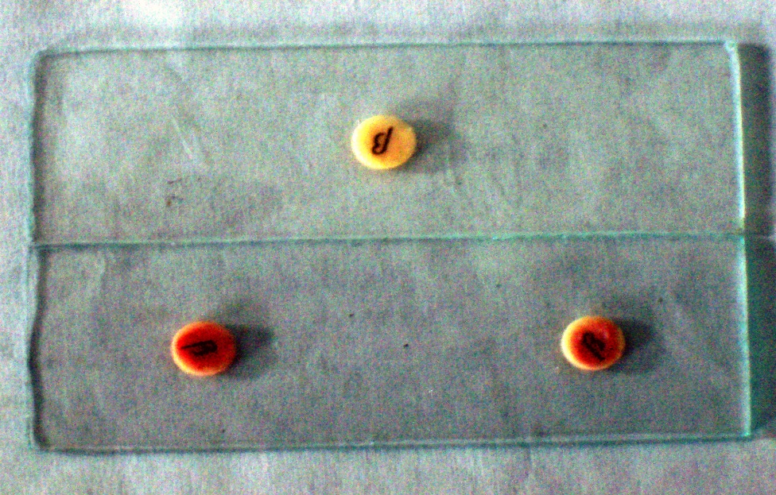

Antibiotic susceptibility testing
S pneumoniae
Table9: Antibiogram of Streptococcus pneumoniae
Streptococcus pneumoniae
Antibiotic | Sensitive (%) | Intermediate (%) | Resistant (%)
Oxacillin 1 μg | 6 (25.0)  18.75  18.75  18.75 |  | 18 (75.0)
Chloramphenicol | 14 (58.33) | 1 (4.17) | 9 (37.55)
Tetracycline | 5 (20.83) | 12 (50) | 7 (29.17)
Erythromycin | 15 (62.5) | 2 (8.33) | 7 (29.17)
Clindamycin | 20 (83.33 ) | 1 (4.17)  ) | 3 (12.5)
Linezolid | 24 (100) | 0 | 0
Ciprofloxacin | 8 (33.33) | 10 (41.67) | 6 (25)
Levofloxacin | 10 (41.67) | 10 (41.67) | 4 (16.67)
Moxifloxacin | 23 (95.83) | 1 (4.17) | 0
Ofloxacin | 8 (33.33) | 7 (29.17) | 9 (37.5)
Amoxyclav | 13 (54.17) | 3 (12.5) | 8 (33.33)
Co-trimoxazole | 0 | 0 | 24 (100)
Vancomycin | 24 (100) | 0 | 0

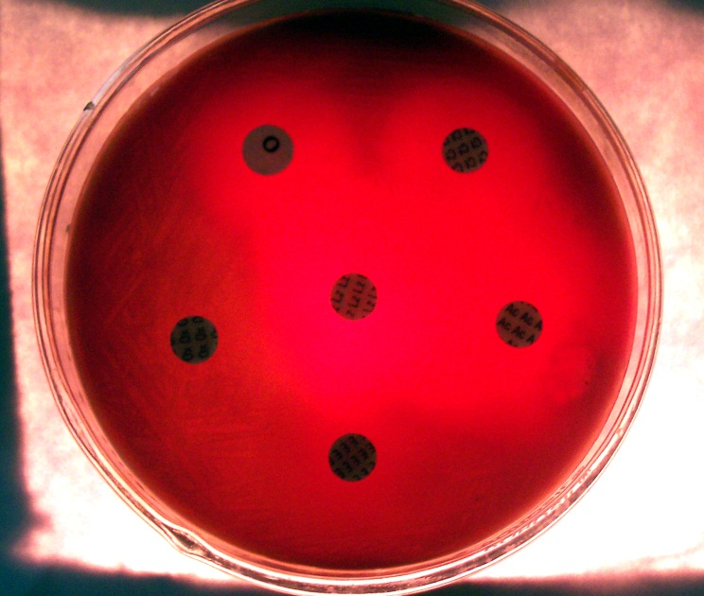
β-LACTAM ANTIBIOTIC RESISTANT STREPTOCOCCUS PNEUMONIAE AND FACTORS THAT INCREASES ITS RISK OF INFECTION ¹
Table 10
Risk factors | β-lactam resistant Streptococcus pneumoniae (n=18) | Percentage | p value
β-lactam therapy in last 3 months | 10 | 55.56 | 0.0097
Old age | 4 | 22.22 | 0.2058
Alcoholism | 4 | 22.22 | 0.7716
Multiple medical comorbidities | 0 | 0

Klebsiella
Table 11
Klebsiella pneumoniae
Antibiotic | Sensitive (%) | Intermediate (%) | Resistant (%)
Ciprofloxacin | 4 (25) | 8 (50) | 4 (25)
Levofloxacin | 10 (62.5) | 3 (18.75) | 3 (18.75)
Cefotaxime | 9 (56.25) | 4 (25) | 3 (18.75)
Ceftriaxone | 6 (37.5) | 5 (31.25) | 5 (31.25)
Cefoxitin | 8 (50) | 3 (18.75) | 5 (31.25)
Piperacillin-tazobactam | 5 (31.25) | 6 (37.5) | 5 (31.25)
Ticarcillin-clavulanate | 3 (18.75) | 4 (25) | 9 (56.25)
Amikacin | 15 (93.75) | 0 | 1 (6.25)
Gentamicin | 5 (31.25) | 3 (18.75) | 8 (50)
Imipenem | 16 (100) | 0 | 0
Cefepime | 14 (87.5) | 0 | 2 (12.5)

Staphylococcus aureus
Table 12: Antibiogram of Staphylococcus aureus isolates
Staphylococcus aureus
Antibiotic | Sensitive (%) | Intermediate (%) | Resistant (%)
Oxacillin 1 | 7 (87.5) |  | 1 (12.5)
Penicillin | 0 | 0 | 8 (100.0)
Tetracycline | 4 (50) | 1 (12.5) | 3 (37.5)
Erythromycin | 4 (50) | 3 (37.5) | 1 (12.5)
Clindamycin | 7 (87.5) | 1 (12.5) | 0
Linezolid | 8 (100.0) | 0 | 0
Ciprofloxacin | 7 (87.5) | 0 | 1 (12.5)
Levofloxacin | 6 (75) | 1 (12.5) | 1 (12.5)
Moxifloxacin | 8 (100) | 0 | 0
Amoxy-clav | 4 (50) | 2 (25) | 2 (25)
Co-trimoxazole | 0 | 0 | 8 (100)
Vancomycin | 8 (100) | 0 | 0
Amikacin | 6 (75) | 2 (25) | 0

Moraxella catarrhalis
Table 13: Antibiogram of Moraxella catarrhalis isolates
Moraxella catarrhalis
Antibiotic | Sensitive (%) | Intermediate (%) | Resistant (%)
Penicillin | 0 | 1 (20) | 4 (80)
Tetracycline | 3 (60) | 1 (20) | 1 (20)
Cefotaxime | 3 (60) | 2 (40) | 0
Ceftriaxone | 3 (60) | 2 (40) | 0
Ciprofloxacin | 3 (60) | 2 (40) | 0
Levofloxacin | 3 (60) | 2 (40) | 0
Moxifloxacin | 5 (100) | 0 | 0
Amoxy-clav | 1 (20) | 2 (40) | 2 (40)
Co-trimoxazole | 0 | 0 | 5 (100)
Cefuroxime | 0 | 2 (40) | 3 (60)
Amikacin | 3 (60) | 1 (20) | 1 (20)
Azithromycin | 5 (100) | 0 | 0

Discussion
74.47% (70/94) of subjects were male and 25.53 (24/94) were female with male: female ratio being 2.92: 1. Similar observation was made by Kurashi et al (1992) with a ratio of 3:1.⁵ Other studies with approximately similar male: female ratio includes Ishida et al (1998) (2.6:1) Madhu et al (1990) (2.6:1) and Bansal et al (2004) (2.5:1).^{3, 91,} The overall mean age of the cases was 46.23 years with standard deviation (SD) 13.55. Similar observation was noted down by Jokinen et al (2000), Bansal et al (2004) etc.
Cough was observed in 100% of patients in this study while it associated with expectoration in 94.68% of cases. Fever was observed in 86.17%. Other frequent complains include clinical consolidation in 60.62%, chest pain 55.32%, difficulty in respiration in 25.53%, altered mental status in 7.45% and hemoptysis in 4.26%. (Table 3) These were in conformity with findings by many others e.g. Bansal et al (2004), Dey et al (1997) etc.
Of the total 94 samples, 55 (58.51%) samples showed growth of pathogenic bacteria, while from 39 (41.49%) samples no pathogen could be detected. From 53 (96.36%) samples single pathogen was isolated, and 2 (3.64%) samples yielded multiple pathogen (2 each) (Table 5). Sopena et al (1999) could detect pathogen from 58% samples.⁸⁶ Ozyilmaz et al (2005) found significant growth 59.4% of sputum samples.⁷⁹ Jokinen et al (2000) were successful in detecting pathogen from 60% of their patients.⁸⁴
Peñafiel et al (2003) had an isolation rate of only 25%.⁸⁰ For Venkatesan et al (1990) the isolation rate was 43%. ⁹⁵ Bansal et al (2004) detected pathogen in 75% samples .³ Lieberman et al had a detection rate of 80.6 %( 1996).⁵⁹
The present study showed the dominance of Streptococcus pneumoniae (42.1%) in sputum of patients with Community-acquired pneumonia (Table 6). This finding corroborates closely with the following studies carried out on CAP patients. (Table 14)
Table14: Similar isolation rate of Streptococcus pneumoniae in various studies
Study | Isolation rate of S pneumoniae
Bansal et al (2004).³ | 35.8%
Lim et al (2001).⁸² | 48.0%
Jokinen et al (2000).⁸⁴ | 41.0%
Lieberman et al (1996).⁵⁹ | 42.8%
Berntsson et al (1995).⁸⁷ | 54.3%
Present study (2005-2006) | 42.1%
Some other studies reported a lower isolation rate of S pneumoniae (Table 15)
Table 15: Studies with lower isolation rate of S pneumoniae
Study | Isolation rate of S pneumoniae
Peñafiel et al (2003)⁸⁰ | 10.5%
Ishida et al (1998)⁵ | 23.0%
Ruiz et al (1998)⁷ | 29.0%
Dahmash et al (1994)⁶⁹ | 12.0%
Chan et al (1992)⁹² | 12.0%
Kurashi et al (1992) ⁹¹ | 25.6%

Klebsiella pneumoniae emerged as the second most common pathogen isolated in the present study with isolation rate of 28.1% (16 isolates) (Table 6). This rate approximately tallies with study by Bansal et al (2004) where Klebsiella isolation rate was 22%.³ Fieldman et al (1995) also found it in a rate of 30.9%.⁶⁷ But in various other studies this finding in CAP patients was low or nil. Ishida et al (1998) found it only at 4.3%.⁵ Karalus et al (1991) had this rate at 2%.⁹³ Wattanathum et al (2002) and Lim et al (2001) did not find any in their study populations. ^{6, 82} Similary Jokinen et al (2000) and Sopena et al (1999) also had 0% isolation rate each. ^{84, 86}
Staphylococcus aureus was detected in 6 (10.5%) cases in our study. (Table 6).This was closely similar to study by Dahmash and Choudhury (1994) who had an isolation rate of 9%.⁶⁹ Fieldman et al (1995) found this rate at 7.13%.⁶⁷ But in some other studies, isolation rate of S aureus was less or nil. Peñafiel et al (2003) had this in a rate of 4.2%.⁸⁰ Berntsson et al (1995) had a rate less than 1%.⁸⁷.Wattanathum et al (2002) could not isolate any Staphylococcus aureus.⁶ Ishida et al (1998) also did not find any S aureus.⁵
Moraxella catarrhalis was detected from 5 (8.77%) cases in the present study. (Table 6). This rate was close to the study by Ozyilmaz et al (2005) who had a rate of 12.2%.⁷⁹ But Lim et al (2001) had this rate at 2% only. ⁸² Jokinen et al (2000) could find it in less than 3%.⁸⁴ Bansal et al (2004) did not find any Moraxella catarrhalis in their study.³
There was no Haemophilus influenzae isolation in the present study, though it is known to be one of the principal pathogens for CAP world wide. Bansal et al (2004) and Almirall et al (2000) also did not find any Haemophilus influenzae in their subjects.^{3, 85} Other studies on CAP had Haemophilus influenzae isolation in significant proportion ranging from 2.3% to 44.9% — Sopena et al (1999) documented an isolation rate of 2.3%.⁸⁶ Lieberman et al (1996) the rate was 5.5%.⁵⁹ Isolation rate for study by Lim et al (2001) was 7%.⁸² Ruiz et al (1998) could isolate this in 11% cases.⁷ Ostergaard et al (1993) isolated it in 17.5% patients.⁸² Ozyilmaz et al (2005) had an isolation rate of 44.9%.⁷⁹ Overall the reason for non isolation of Haemophilus influenzae could be multiple. In studies like Ostergaard et al (1993), this bacterium was isolated from tracheal aspirate only and it could not be grown from sputum samples.⁸⁸ Being a fragile organism, the delay during the processing of sputum could be a valid reason of its non isolation in many instances. A sustained carbon dioxide supply in consistent strength (10-15%) during incubation is very vital for H influenzae growth.¹⁷⁴ As we could use only candle jar and not standard CO₂ incubator, chance of isolation of this pathogen was substantially reduced. Also Blood agar prepared from sheep blood is considered very restricting for Haemophilus influenzae growth, as sheep blood contain NADase (Nicotinamide adenine dinucleotidease) which can be detrimental to its growth by breaking down scanty NAD present in sheep blood.¹⁷⁴ This could be another reason why no Haemophilus influenzae was isolated in the present study, where we used sheep blood in preparing blood agar and chocolate agar media..
Mycoplasma pneumoniae was isolated only once (1.75%) using PPLO biphasic and PPLO agar media. (Table 6).Our finding was similar to findings by Sopena et al (1999) with a rate of 1.3%.⁸⁶ and Dahmash and Choudhury (1994) with a detection rate of 1.6%.⁶⁹ But the observation of the present study was in sharp contrast with various other studies on CAP. Bansal et al (2004) found this in 15% cases.³ Other examples include — Luna et al (2000) had this at 13%.⁸³ Jokinen et al (2000) detected it in 9% cases.⁸⁴ Lieberman et al (1996) had a rate of 29.2%.⁵⁹ Berntsson et al (1995) detected M pneumoniae in14% cases.⁸⁷ Overall almost all these studies utilized serological method for Mycoplasma pneumoniae antibody detection, which has got a proven much higher sensitivity, compared to attempting culture in PPLO agar (as was done in the present study).¹¹
It is evident from of the present study that diabetes is significantly associated as a risk factor/comorbidity with isolation of Klebsiella pneumoniae (55.6%, p-value=0.0092) in CAP patients. (Table 8). Klebsiella pneumoniae isolation is also statistically significant in elderly people. (80%, p-value= 0.01). Moraxella catarrhalis isolation in chronic lung diseased cases were found to related significantly (37.5%, p-value=0.0024). Also Staphylococcus aureus CAP is significantly associated with precedent/ concurrent viral fever (80%, p value=0.0001). Other factors like Smoking, Alcoholism, previous hospitalization and antibiotic exposure were not associated with type of organism isolated in statistically significant manner. (Table 8). But it is worth mentioning that the number of cases for p value estimation was too less and hence these conclusion from the present study needs confirmation with a study on higher number of cases. Ruiz et al (1999) found that presence of comorbidities like, cardiac illness, chronic lung disease, renal insufficiency, toxic liver disease, chronic neurologic illness, diabetes, and malignancy active within the last year, was associated with an increased risk of infection (odds ratio 4.4) with GNEB in CAP patients. American Thoracic Society Guidelines for initial management of adults with CAP and Feldman et al (1989) advocates an association of GNEB causing CAP and advanced age.^{1, 71}Verduin et al (2002) states that, in more than 70% cases predisposing factors like respiratory impairment (mainly COPD), malignancy, neutropenia etc are present in pneumonia by M catarrhalis.³⁸The BTS guidelines for the management of CAP in adults states that S aureus induced CAP patients, coincident influenza type symptoms are reported in 39% cases and evidence of coincident influenza virus infection is found in 39% of those admitted to hospital, and 50% of those admitted to an ICU.⁴
Due to increased and indiscriminate use of antibiotics, there has been an emergence of antibiotic resistance. This equally holds good for both community-acquired and nosocomial infections. This phenomenon of drug resistance varies from microorganism to microorganism and from one place to another. In this study, in vitro susceptibility of isolates were tested against a battery of antibiotics, both new and old generation, using Kirby Bauer disc diffusion technique as per guide lines laid down by NCCLS.¹³
75% of the pneumococci isolates were found to be resistant to β-lactam antibiotics while only 25% came out to be susceptible. (Table 11) This high level resistance was corroborated by following studies on respiratory infection. Song et al (2004) found 52.4% pneumococcus isolates with reduced susceptibly to penicillin.¹⁵ Mendes et al (2003) found a reduced susceptibility rate of 42.1% in pneumococcus isolates from CAP cases.¹⁵ Ho et al (2001) documented a resistance rate of 60.6%.¹⁸ Doern et al (2001) found it to be 55.7%.¹⁹ In study by Felmingham et al (2000) on CAP patients resistance rates were >50%.¹⁴ For Hsueh et al (1999) 61% of the isolates were non susceptible to penicillin. ¹⁷ Ewig et al (1999) in a study on CAP patients found 49% of pneumococci resistant to penicillin.⁹⁸ On the other hand, low level of resistance was recorded by many studies. Jacobs et al (2003) had this rate at 18.2%.¹⁵ Kanungo et al (2002) found non-susceptibility at 11.6%.¹² Another study Kanungo et al (2001) found 7.3% of isolates to be intermediately resistant to penicillin. ¹⁷ Benbachir et al (2001) 30.4% of the isolates were nonsusceptible to penicillin G.¹⁷ Lalitha et al (1999) documented 4.6% of isolates to be of intermediately resistant to penicillin.¹⁴ Zhanel et al (1999) in a study on CAP patients found Penicillin-intermediate and resistant isolates at rates of 14.8 and 6.4% respectively. ¹⁷ It is worth mentioning that, the high level of resistance to β-lactam antibiotic in this study needs further confirmation by estimation of MIC level for proper comparison with other studies.

Conclusion:
The findings in this study revealed that Streptococcus pneumoniae and Klebsiella pneumoniae are the principal pathogen of Community-acquired pneumonia. Other agents like Staphylococcus aureus (especially with history of precedent viral infection) and Moraxella catarrhalis (more in patients with chronic lung disease) may cause CAP at times.
Antibiotic susceptibility patterns of the isolates clearly suggest existence of drug resistant pathogen of CAP in our setup. The findings, of large proportion of β-lactam antibiotic resistant Streptococcus pneumoniae as well as a possible MRSA in a community infection such as CAP, are alarming. Antibiotic resistance in Gram negative isolates were also in high proportion. Indiscriminate use of antibiotic in our setup could be one of the principal reasons for this scenario. Rational and proper use of antibiotics would definitely contribute in controlling infections.
Given these findings and the fact that study on CAP in our setup is limited, much more studies. Detection of viral pathogens also needs to be emphasized, especially in the background of the current threat of impending influenza pandemic. This will go a long way in understanding proper nature of CAP as well as its causative agents. This type of study will also help in formulating management guidelines and antibiotic policy for effective management and proper antibiotic therapy in our CAP patients, as in the advanced countries like the USA and the UK.
Bibliography
- American Thoracic Society. Guidelines for the Management of Adults with Community-acquired Pneumonia Diagnosis, Assessment of Severity, Antimicrobial Therapy, and Prevention. Am J Respir Crit Care Med.2001 Jun;163(7):1730-54
- Shah P B, Giudice J C, Griseback Jr R, Morley T F, Vasoya A. The newer guideline for the management of Community-acquired pneumonia. J Am Osteopath Assoc. 2004 Dec;104(12):521-526
- Bansal S, Kashyp S, Pal L S, Goel A. Clinical and bacteriological profile of community acquired pneumonia in Shimla, Himachal Pradesh. Indian J Chest Dis Allied Sci. 2004;46:17-22
- British Thoracic Society Standards of Care Committee. BTS guidelines for the management of community acquired pneumonia in adults. Thorax.2001 dec;56(Suppl4):iv1-iv64.[online] Available from: http://www.brit-thoracic.org.uk/iqs/dlsfa.list/dlcpti.175/guidelines_since_1997.html
- Ishida T, Hashimoto T, Arita M, Ito I, Osawa M. Etiology of Community-acquired pneumonia in hospitalized patients: A 3 year prospective study in Japan. Chest. 1998 Dec;114(4):1588-93
- Wattanathum A, Chaoprasong C, Nunthapisud P, Chantaratchada S, Limpairojn N, Jatakanon A et al. Community-Acquired Pneumonia in Southeast Asia:The Microbial Differences Between Ambulatory and Hospitalized Patients. Chest. 2003 May;123(5):1512-19.
- Ruiz M, Ewig S, Marcos M A, Martinez J A, Arancibia F, Mensa J et al. Etiology of community acquired pneumonia: Impact of age, co-morbidity and severity. Am J Respir Crit Care Med. 1999;160:397-405
- Mandell L A. Community-acquired pneumonia: Etiology, epidemiology and treatment. Chest.1995;108:35S-42S
- Doern G V, Jones R N, Pfaller M A, Kugler K. Haemophilus influenzae and Moraxella catarrhalis from Patients with Community-Acquired Respiratory Tract Infections: Antimicrobial Susceptibility Patterns from the SENTRY Antimicrobial Surveillance Program. Antimicrob Agents Chemother.1999 Feb;43(2):385-389
- Karlowsky J A, Critchley I A, Blosser-middleton R S, Karginova E A, Jones M A, Thornsberry C et al. Antimicrobial Surveillance of Haemophilus influenzae in the US during 2000–2001 leads to detection of clonal dissemination of beta lactamase negative and ampicillin-resistant strain. J Clin Microbiol. 2002 Mar;40(9):1063-66
- Collier L, Balows A, Sussman M, editors. Topley & Wilson’s Microbiology and Microbial infections. Vol-2 & 3, 9th ed. London: Hodder Arnold; 1998
- Kanungo R, D’Lima D, Rajalakshmi B, Kumar A, Badrinath S. Emerging antibiotic resistant Pneumococci in invasive infections in south India. Indian J Pharmacol. 2002;34:38-43
- National Committee for Clinical Laboratory Standards. Performance Standards for antimicrobial susceptibility testing. 8th Informational Supplement. M100 S12. National Committee for Clinical Laboratory Standards, 2002. Villanova, Pa
- Garcı´a-Rey C, Aguilar L, Baquero F, Casal J, Dal-Re R. Importance of local variations in antibiotic consumption and geographical differences of erythromycin and penicillin resistance in streptococcus pneumoniae. J Clin Microbiol. 2002 Jan;40(1): 159–164
- Kristinsson K G. Effect of antimicrobial use and other risk factors on antimicrobial resistance in pneumococci. Microb. Drug Resist.1997;3:117-123
- Woodhead M. Community-acquired pneumonia in Europe: causative pathogens and resistance patterns. Eur Respir J 2002; 20: Suppl. 36, 20s–27s
- Kobzik L. The lung. In: Cotran S R, Kumar V, Collins T, editors. Robbins pathologic basis of disease, 6th ed. Philadelphia: W.B. Saunders Company;2005.p.697-755
- Puchelle E, Zahm J M, Girard F. Relationship to sputum properties in chronic bronchitis. Eur J Respir Dis. 1980;61:254-61
- Cammer P. Studies on the removal of inhaled particles from the lung by voluntary coughing. Chest. 1981;80(Suppl):S1824
- Burnett D. Immunoglobulins in the lung. Thorax. 1986;41:337
- Ammon A J, Hong R. Selective IgA deficiency: presentation of 30 cases and a review of the literature. Medicine. 1971;50:223-25
- Burnett D. Defensins: ancient but potentially dangerous weapons in the armoury. Thorax. 1992;47:195
- Woods D E. Bacterial colonization of respiratory tract: clinical significance. In: Pennington JE, editor. Respiratory infections: Diagnosis and management, 3rd ed. New York: Raven press;1994.p. 35-41
- Niederman MS. Gram-negative colonization of the respiratory tract: pathogenesis and clinical consequences. Semin Respir Infect. 1990 Sep;5(3):173-84
- Johanson W G, Higuchi J H. Bacterial adherence epithelial cells in bacillary colonization of the respiratory tract. Am Rev Respir Dis. 1980;121:55-63
- Rutland J, deLongh R U. Random ciliary orientation, a cause of respiratory tract disease. N Eng J Med. 1990;323:1681-84
- Shanley J D. Mechanism of injury by viral infection in lower respiratory tract. Rev Med Virol. 1995;5:41-50
- Buckley H. Immunodeficiency diseases. JAMA. 1992;268:2797-806
- Floreani A A, Buchalter S E. Chronic bronchitis. In: Penington J E, editor. Respiratory infections: Diagnosis and management, 3rd ed. New York: Raven press;1994.p.149-192
- Schlesinger R B. The interaction of inhaled intoxicants with respirator tract clearance mechanism. Rev Toxicol. 1990;20:257-68
- Marrie T J, Campbell G D, Walker D H, Low D E. Pneumonia. In: Kasper D L, Fauci A S, Longo D L, Braunwald E, Hauser S L, Jameson J L, editors. Harrison’s principles of internal medicine, 16th ed. New York: McGraw-Hills;2005.p.1528-41
- Bartlett JG, Dowell SF, Mandell LA, File TM Jr, Musher DM, Fine MJ. Practice guidelines for the management of community-acquired pneumonia in adults. Infectious Diseases Society of America. Clin Infect Dis. 2000;31:347-382. Epub 2000 Sep 07.
- Krivan H C, Roberts D D, Ginsburg V. Many pulmonary pathogenic bacteria binds specifically to the carbohydrate sequence Gal Nac ß – 1 – 4 Gal found in some glycolipids. Proc Natl Acad Sci USA. 1988;85:6157-61
- Jerdrzejas M J. Pneumococcal virulence factors: structure and function. Microbiol Mol Biol Rev. 2001 Jun;65(2):187-207
- Kim P E, Musher D M, Glezen W P. Association of invasive pneumococcal disease with season, atmospheric conditions, air pollution, and isolation of respiratory viruses. Clin Infect Dis. 1996;22:100-6
- Banerjee A, Kalghatgi A T, Saiprasad G S, Nagendra A, Panda B N, Dham S K et al. Outbreak of Pneumococcal Pneumonia among MilitaryRecruits. MJAFI. 2005;61(1):16-21
- Jorden J Z, Slack M P E. Haemophilus influenzae, Then and now (a review). Eur J Clin Microbiol Infect Dis. 1995;14:935-48
- Verduin C M, Hol C, Fleer A, Dijk H V, Belkum A V. Moraxella catarrhalis: from Emerging to Established Pathogen. Clin Microbiol Rev. 2002 Jan;15(1):125-144
- Fang GD, Fine M, Orloff J, Arisumi D, Yu VL, Kapoor W et al. New and emerging etiologies for community-acquired pneumonia with implications for therapy. A prospective multicenter study of 359 cases. Medicine. 1990 Sep;69(5):307-16
- Farr B M, Kaiser D L, Harrison B D. Prediction of microbial aetiology at admission to hospital for pneumonia from the presenting clinical features. Thorax. 1989;44: 1031-5
- Lieberman D, Schlaeffer F, Lieberman D, Horowitz S, Horovitz O, Porath A. Mycoplasma pneumoniae community-acquired pneumonia: a review of 101 hospitalized adult patients. Respiration. 1996;63(5):261-6.
- Waites K B, Talkington D F. Mycoplasma pneumoniae and its role as a Human Pathogen. Clin Microbiol Rev. 2004 Oct;17(4):697-728
- Arancibia F, Bauer TT, Ewig S, Mensa J, Gonzalez J, Niederman MS, Torres A. Community-acquired pneumonia due to gram-negative bacteria and pseudomonas aeruginosa: incidence, risk, and prognosis. Arch Intern Med. 2002 Sep 9;162(16):1849-58.
- Mensa J, Martinez J. Community-Acquired Pneumonia due to Gram-Negative Bacilli. Clin Pulm Med. 2001 Jan;8(1):5-12
- Levison ME, Kaye D. Pneumonia caused by gram-negative bacilli: an overview. Rev Infect Dis. 1985 Nov-Dec;7 Suppl 4:S656-65
- Hatchette T F, Gupta R, Marrie T J. Pseudomonas aeruginosa Community-Acquired Pneumonia in Previously Healthy Adults: Case Report and Review of the Literature. Clin Infect Dis. 2000 Nov 29;31:1349-56
- Donwitz R G, Mandell G L. Acute pneumonia. In: Mandell G L, Bernett J E, Dolin R editors. Mandell, Douglas & Bernett’s Principles and Practice of Infectious Diseases.Vol-1, 5th ed. New York: Churchill Livingstone; 2000. p.717-743
- Marques M B, Weller P F, Parsonett J, Ransil B J, Nicholson J, Weller A. Phosphatidylinositol-specific phospholipase C, a possible virulence factor of Staphylococcus aureus. J Clin Microbiol. 1989;27:2451-54
- Muller P M, Low D E, Green K A, Simor A E, Loeb M, Gregson D et al. Clinical and Epidemiologic Features of Group A Streptococcal Pneumonia in Ontario, Canada. Arch Intern Med. 2003;163:467-472
- Jack R W, Tagge J R, Bibek R. Bacteriocins of Gram-positive bacteria. Microbiol Rev. 1995;59:171-200
- Chen M, Hsueh P, Lee L, Yu C, Yang P, Luh K. Severe Community-Acquired Pneumonia due to Acinetobacter baumannii. Chest. 2001 Oct;120(4):1072-77
- Cassell GH, Drnec J, Waites KB, Pate MS, Duffy LB, Watson HL, McIntosh JC. Efficacy of clarithromycin against Mycoplasma pneumoniae. J Antimicrob Chemother 1991;27(Suppl A):p.47-59.
- Blanquer J, Blanquer R, Borras R, Nauffal D, Morales P, Menendez R et al. Aetiology of community acquired pneumonia in Valencia, Spain: a multicentre prospective study. Thorax. 1991;46:508-511
- Niederman MS. Pathogenesis of airway colonization: lessons learned from studies of bacterial adherence. Eur Respir J 1994; 7:1737-1740

Conflict of interest: None
IEC clearance: Obtained

