A RANDOMIZED CONTROL STUDY OF TROCHANTERIC FRACTURES TREATED WITH PROXIMAL FEMUR LOCKING COMPRESSION PLATE (PFLCP) VERSUS DYNAMIC HIP SCREW (DHS)

INTRODUCTION
Trochanteric fractures are usually the fractures of older population , with greater loss of skeletal mass . They account for 45% of total hip fractures¹ . With the increase in average life expectancy, the proximal femoral fractures have been marked as one of the biggest problems of the contemporary civilization. These fractures unite readily with conservative methods , but with complications like malunion, coxa vara deformity, limb shortening and limp.

Various operative procedures with different implants have been described for the treatment of intertrochanteric fractures.The long list of devices is itself a testimony that none of the devices is ideal to treat all types of fractures in this region. The Dynamic Hip Screw (DHS) is one of the most widely used implant for intertrochanteric fractures which has stood the test of time. However , comminuted unstable fractures , fractures with extension into piriformis fossa , and combined intracapsular and extracapsular fractures treated with DHS are generally prone to complications² .The Locking Compression Plates are being used for various complex fractures in different anatomic regions ,and despite their promising results , until recently ,locking plates had not been used in treatment of unstable proximal femur fractures The Proximal Femoral Locking Compression Plate (PFLCP) was introduced in the 21st century as a new implant that allows angular – stable plating for the treatment of complex comminuted and osteoporotic fractures. The PFLCP is a newer addition in the array of implants for proximal femur fractures.

However , there is scarcity of literature comparing DHS with PFLCP in the treatment of intertrochanter fractures. Hence , we conducted a Randomised control study to evaluate the operative procedures, clinical outcomes and radiological outcomes in trochanteric fractures treated with DHS and PFLCP

PATIENTS/METHODS

We conducted a Randomised control study in the Department of Orthopaedics of Gauhati Medical College and Hospital, Guwahati from December 2011 to December 2013.

The inclusion criteria were :

1. Only those who gave consent.

2. Adult patients (Age > 18 years)

3. Closed trochanteric fractures.

4. Competent neurological and vascular status of the affected limb.

5. Ipsilateral knee, Ankle, contralateral hip joint functionally good enough,

not to exert a serious adverse effect on the rehabilitation process.

6. Only patient with a near normal daily activities of life.
7. No associated fracture in same limb

8. Patients who can meet the medical standards for routine, elective surgery.

The study included 52 patients, admitted either through the out patient department or through emergency department of the hospital.26 patients were operated with DHS and other 26 with PFLCP.
The subjects were randomized using online statistical computing web program - http://www.randomization.com/

All patients were admitted and immediately given emergency care. The level of fracture was determined and were classified according to AO. The patient was prepared for elective surgery after performing the routine preoperative investigations and pre anaesthetic evaluation. Spinal anaesthesia was given to the patients and closed reduction done using fracture table and C-arm. Once acceptable reduction was achieved , the operative part was scrubbed, painted and draped for surgery. If reduction wasn’t achieved despite several attempts, open reduction was performed. Standard lateral approach incising the iliotibial band and splitting the vastus lateralis parallel to the skin incision was used to expose the trochanter. As per the randomistion data for that particular case, DHS or PFLCP was used to stabilize the fracture after achieving good reduction. The procedure and techniques were followed as per the AO guidelines. The procedures were performed confirming AP and lateral images using C-arm. After the implantation, 14 size negative suction drain was put and the tissues were closed in layers.

Sitting up in bed was encouraged on the first post operative day. Quadriceps exercise and range of movement exercises of the hip and knee started on the first day after surgery within limits of pain. The general supportive measures were taken and stitches were removed on tenth post operative day. Early ambulation was encouraged usually after 5-6 days. Depending on the age, fracture pattern, stability of fracture fixation, toe touching to partial weight bearing was allowed till first follow up (6 wks). Then unprotected full weight bearing was allowed after reviewing radiograph. Follow up was carried out at 6, 12, 16, 24 weeks and then at two monthly intervals.All statistical analyses were conducted with SPSS for windows (version 18.0, chicago, il), and p values of <0.05 were considered significant.

RESULTS
The youngest patient was of 23 yrs and the oldest was 78 yrs of age. The mean age was 55.84 years.The maximum numbers of cases were observed between 61-70 years. The male to female ratio was found to be 1.6:1 . The fractures were more commonly encountered on the left side (53.84%). There were no bilateral cases.The commonest mode of injury in our patient was fall on ground (63.46%) either by slipping, stumbling or missing a step. The other modes were – road traffic accident (RTA), fall from height and assault. The fractures were classified according to AO classification system (1979).Following nine types of fractures were encountered in different proportions. Most of the cases (75%) were operated in 3-7 days following injury. The mean time interval between surgery and trauma was 5 days.
The operative time was calculated from starting of the skin incision till last skin stitch was made.The mean operative time of surgery in the PFLCP group was found to be 93.07 minutes and in the DHS group was found to be 57.69 minutes. The above two values were tested statistically by unpaired t test to find out whether the difference is statistically significant or not. The p value was 0.00427, which is statistically significant. The average blood loss in the PFLCP group was found to 305.76 ml.The average blood loss in the DHS group was found to be less, i.e 230.65 ml .The above two values were tested statistically by unpaired t test to find out whether the difference is statistically significant or not. The p value was 0.000317, which is statistically significant.

The mean duration of hospital stay in the PFLCP group was found to be 8.19 days and in the DHS group was found to be 7.73 days. Harris Hip Scoring system was used to evaluate the functional result in our study. Patients who had a normal range of motion, minimum limp, no pain and who rarely used a cane, were graded as having excellent result (score 90-100). Patients who had a normal range of motion but a noticeable limp and occasional mild pain and who used a cane were graded as having good result (score 80-90). Patient who had a limited range of motion, a noticeable limp, moderate pain and who use two canes or walker were graded as having fair result (score 70-80). Patient who had pain on any motion and who were in a wheelchair or were non ambulatory were graded as having poor result (score < 70). We obtained excellent result in 59.61% of cases, good result in 26.93% of cases, fair in 9.61% of cases and poor result in 3.84% of cases in the total study group. In the PFLCP group, excellent results were in 53.84% of cases, good results in 34.61, fair results in 7.69% and poor result in 3.84% cases each. In the DHS group, excellent results were in 65.38% of cases, good result in 19.28% of cases, fair result in 11.53% and poor result in 3.84%% cases each. No mortality was recorded in our series. No general complication from surgery like septicaemia, deep vain thrombosis, pulmonary emboli, CVA etc. was encountered. Unspecific hip pain was noticed in 2 cases of PFLCP and 1 case of DHS. Superficial wound infection was seen in 2 cases of PFLCP and 1 case in DHS group.The difference in the functional result between the two groups was not statistically significant.

The criteria of Anderson et al (1975) were taken into account to assess the union of the fracture. A fracture was defined as healed when there was obliteration of fracture line and evidence of bridging trabeculae. The union rate was 100% in the PFLCP group, with no delayed or non unions in the study , and there was 1 case of non union in DHS group. The time taken for union in the PFLCP group ranged from 15 to 22 weeks with a mean of 18.03 weeks. The time taken in the DHS group for radiological union ranged from 15 to 22 weeks, with a mean of 17.56 weeks. There was 1 case of Implant cutout , Medialization and Non union each , in DHS group. Varus deformity was seen in 2 cases of PFLCP and 1 in DHS group.

DISCUSSION

Agreement has been achieved on the significance of restoring stability and early mobilisation during the treatment of pertrochanteric fractures. The successful restoration of stability and early mobilisation reduce the morbidity/mortality rates associated with prolonged immobilisation. Moreover, they can improve functional recovery by avoiding malunion and encouraging mobility. The best treatment module to achieve this outcome for these fractures remains controversial. Although DHS is one of the standard treatments, high failure rates of sliding hip screws in unstable fractures have been reported. The PFLCP has been introduced as a new implant that allows angular – stable plating for the treatment of complex comminuted and osteoporotic fractures.
In our study, the mean operative time in the PFLCP group (93.07 min.)and In the DHS group was 57.69 min. The above two values were tested statistically and the difference was found to be statistically significant (p-value was 0.00427) Various studies in the literature have reported the operative time of different procedures in proximal femoral fractures.(Table 1)
AUTHORS | YEAR | OPERATION | MEAN TIME (min.)
Bridle³ et al. | 1991 | DHS | 42.5
Goldhagen et al.⁴ | 1994 | DHS | 47
O’Brien et al^{.5} | 1995 | DHS | 47
Habernek et al. | 2000 | DHS | 27
Little et al.⁶ | 2008 | DHS | 40.4
Guo-Chun Zha⁷ | 2011 | PFLCP | 35.5
Present study | 2013 | PFLCP | 93.07
Present study | 2013 | DHS | 57.69
Table 1
The increased operative time with PFLCP is may be because the surgeon is handling a new technique with new implant
There have been a few studies in literature that have estimated the amount of blood loss in different procedures for proximal femoral fractures. Little et al ⁶(2008), Guo-Chun Zha et al ⁷ studied the intra operative blood loss in DHS and PFLCP . Intra operative blood loss was measured in our study. The average blood loss in the PFLCP group was found to be 305.76 ml, and in the DHS group was found to be less, i.e 230.65 ml. The above two values were tested statistically and the difference was found to be statistically significant (p-value was 0.000317). In our study, out of 26 cases of PFLCP, 6 cases were transfused with 1 unit of blood. In the DHS group 2 cases were transfused with 1 unit of blood each.. Little et al ⁶(2008) stated that blood transfusion was needed in 23 cases of DHS out of 98 cases It may be explained by the minimal soft tissue dissection and less operative time in the DHS group. (Table 2)

AUTHORS | INTRA OPERATIVE BLOOD LOSS
Little et al ⁶ (2008) DHS | 160 ml
Guo-Chun Zhaet al⁷(2011) PFLCP | 150 ml
Present study PFLCP | 305.76 ml
DHS | 230.65 ml
Table 2

When we compare our series to previously done studies regarding intra- operative blood loss ,we find increased blood loss with PFLCP group , probably because of increased operative time and more soft tissue dissection.

Functional results of the procedures were evaluated using Harris Hip Scoring System. We obtained excellent result in59.61% of cases, good result in 26.93% of cases, fair in 9.61% of cases and poor result in 3.84% of cases in the total study group. In the PFLCP group, excellent results were in 53.84% of cases, good results in 34.61%, fair results in 7.69% and poor result in 3.84% cases each . In the DHS group, excellent results were in 65.38% of cases, good result in 19.28% of cases, fair result in 11.53% and poor result in 3.84%% cases each. Kyle et al ¹(1979) obtained good to excellent result in 89% , fair in 5% and poor in 6% of cases of DHS. (Table 3)

AUTHORS | EXCELLENT AND GOOD FUNCTIONAL RESULT
Kyle et al ¹(1979) | 89%
P. Kamboj MS et al (2007) | 80%
Present study PFLCP | 88.45%
DHS | 84.66%
Table 3

When we compare our series to previously done studies regarding functional result, we find comparable result.
There were 2 cases of superficial wound infection in PFLCP group and 1 case in DHS group in our study.

AUTHORS | IMPLANTS | INFECTION RATE
Larsson et al⁸ (1990 | DHS | 1.8%
Birdle et al (1991) | DHS | 3.9%
Butt et al⁹ (1995) | DHS | 4%
Hebernek et al (2000) | DHS | 2.4%
Guo-Chun Zha et al ⁷(2011) | PFLCP | 1.81%
Present study | PFLCP | 7.69%
Present study | DHS | 3.84%
Table 4

find increased rate with PFLCP group , probably because of increased operative time and increased blood loss. (Table 4)
Union of the fractures - The criteria of Anderson et al (1975) were taken into account to asse When we compare our series to previously done studies regarding infection rate,we ss the union of the fracture. All the fractures in PFLCP group and 25 cases in DHS group united within 6 months of follow up, with an average of 17.8 weeks. The time taken for union in the PFLCP group ranged from 15 to 22 weeks with a mean of 18.03 The time taken in the DHS group for radiological union ranged from 15 to 22 weeks, with a mean of 17.56 weeks .The two groups were tested using the unpaired t test to bring about the presence of a significant difference, if any between the means of time for union in the two groups. The p value was 0.185, which is considered insignificant. Rao et al ¹⁰(1983), Nakata et al ¹¹(1994) reported average time for union in DHS to be 18 and 10.6 weeks respectively. Habernek et al (2000) calculated the mean time for union in their study using with DHS to be 12 weeks. Guo-Chun Zha et al ⁷(2011) found union rate of the PFLCP for pertrochanteric fractures in 95%, 98% and 100% at the 3-month, 6-month and 1-year follow-up check-up. (Table 5)

TIME FOR UNION
Authors | Implants | Union time
Rao et al ¹⁰(1983) | DHS | 18 weeks
Birdle et al (1990) | DHS | 24 weeks
Nakata et al ¹¹(1994) | DHS | 10.6 weeks
Habernek et al (2000) | DHS | 12 weeks
Present study | PFLCP | 18.03 weeks
Present study | DHS | 17.56 weeks
Table 5

When we compare our series to previously done studies regarding union of fracture, we find comparable result.

Most authors reported no cases of non union in their series (Boldin et al¹² (2002), Tyllianakis et al¹³ (2004), Fogagnolo et al ¹⁸(2004), Ulfin et al (2007)). However, Gadegone et al¹⁹ (2006) had one case of non union out of hundred. They attributed this to primary over distraction in a high trochanteric fracture. Kamboj et al (2007) also reported 1 case of non union and 2 cases of delayed union out of 30 cases in their series. Guo-Chun Zha et al ⁷(2011) reported 1 case of nonunion in 110 patients treated by PFLCP. We encountered 1 case of non union in DHS group and no case in PFLCP group. (Table 6)

AUTHORS | IMPLANTS | NONUNION RATE
Boldin et al¹² (2002), | DHS | -
Tyllianakis et al ¹³(2004), | DHS | -
Fogagnolo et al ¹⁴(2004), | DHS | -
Gadegone et al ¹⁵(2006) | DHS | 1%
Kamboj et al (2007) | DHS | 3.33%
Guo-Chun Zha et al ⁷(2011) | PFLCP | 0.9%
Present study | PFLCP | -
Present study | DHS | 3.84%

Table 6
When we compare our series to previously done studies regarding non-union , we find comparable results.

LIMITATINOS
Our study had few limitations. The study was limited to 52 subjects with 26 in each group, and we would wish to recommend a study with a larger group and a longer duration to have a better evaluation of the outcome. The surgeon was new to the operative techniques and principles of PFLCP, whereas he was well versed using a DHS. Hence there could be a technical bias favoring DHS. A future study at a later date when the surgeon becomes used to PFLCP, would negate this bias. The study included patients only from the northeast who have different demographic characteristics, and the results cannot be applied to whole of India. A multicentre study involving different regions of India, would be desirable to be applied to a larger population.

CONCLUSION
In Trochanteric fracture of femur, the two groups of implant, PFLCP and DHS provides excellent results in terms of fracture union as well as functional outcome. In our study there were marginally better functional results of DHS than that of PFLCP. But these differences could not be stressed much, due to small sample size and the difference was statistically insignificant. Both the implants- PFLCP and DHS are associated with low but comparable complications. The average operative time and intra operative blood loss was more in the PFLCP group compared to the DHS group and it was found to be statistically significant. A thorough knowledge of the concept, features and the procedure of application of PFLCP is very important.
References
1.Kyle RF, Gustillo RB, Premer RF. Analysis of six hundred and twenty two intertrochanteric
hip fractures. J Bone Jt Surg 1979;61-A:216
2.Hasenboehler EA, Agudelo JF, Morgan SJ, Smith WR, Hak DJ, Stahel PF. Treatment of complex proximal femoral fractures with the proximal femur locking compression plate. 2007 Aug;30(8):618-23
3. Bridle SH, Patel AD, Bircher M, Calvert PT (1991) Fixation of intertrochanteric fractures of
the femur- A randomized properctive comparison of the Gamma nail and the Dynamic hip
screw. JBJS 73-B: 330-334.
4. Goldhagen PR, O’Connor DR, Schwarze D, Schwarrze E. (1994) A prospective comparative study of the compression hip screw and the gamma nail. Jr Orth. Trauma. 8(5):367-372.
5. O’Brien PJ, Meek RN, Blachut PA, Broekhuyse HM, Sabharwal S (1995). Fixation of intertrochanteric hip fractures-gamma nail versus dynamic hip screw, a randomized prospective study. Canad. Jr. Surg. 38(6):516-520
6. Little N.J., Verma V., Fernando C. , Elliott D.S. , Khaleel A. ,. (2008). A prospective trial comparing the Holland nail with dynamic hip screw in the treatment of intertrochanteric fractures of the hip. JBJS 90 –B (8) 1073-1078.
7. Guo-Chun Zha a,b, Ze-Lin Chen b, Xiao-Bo Qi b, Jun-Ying Sun.(2011). Treatment of pertrochanteric fractures with a proximal femur locking compression plate. Injury, Int. J. Care Injured 42 (2011) 1294–1299
8. Larsson S, Friberg S, Hansson LI (1990). Trochanteric fractures, mobility, complication and mortality in 607 cases treated with the Sliding Screw Technique. Clin. Orth. Rel. Res. 260:232-241
9. Butt MS, Krikler SJ, Ali MS (1995), Comparison of dynamic hip screw and gamma nail-a prospective randomized controlled trial. Injury 26 (9): 615-618.
10 Rao JP, Banzon MT, Weiss AB, Rayhack J. (1983) Treatment of unstable intertrochanteric fractures with anatomic reduction and compression hip screw fixation. Clin. Orth. Rel. Res. 175:56-71
11.Nakata K, Ohzono K, Hiroshima K, Toge K (1994). Serial change of sliding in intertrochanteric femoral fractures treated with sliding screw system. Arch Orthop Trauma Surg. 113:276-280.
12. Boldin C., Seibert FJ., Fankhauser F., Peicha G., Grechenig W., Szyszkowitz R. (2003) . Actra Orthop Scand 74(1): 53-8.
13. Tyllianakis M., Panagopoulos A. , Papadopoulos A. , Papasimos S. , Mousafiris K. (2004). Treatment of extracapsular hip fractures with the proximal femoral nail (PFN): long term results in 45 patients. Acta Orthop Belg. 70(5):444-54.

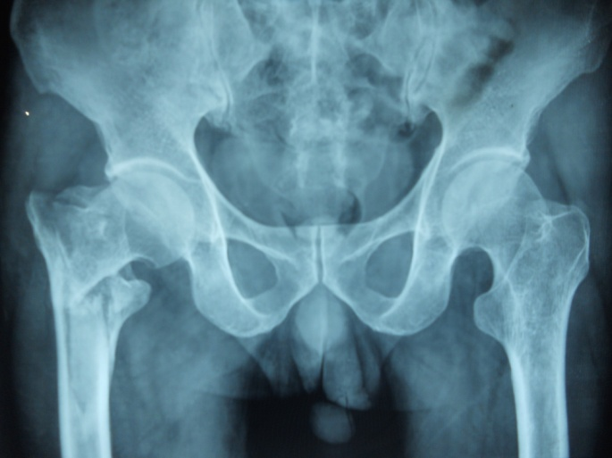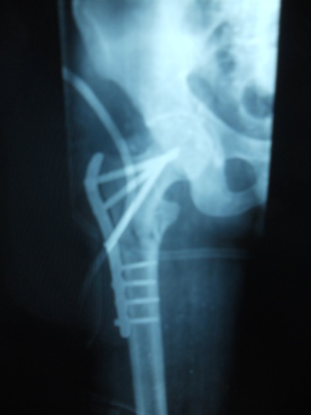
Pflcp pre – op and Post - op

Figure 1

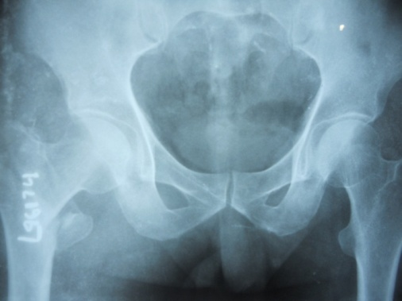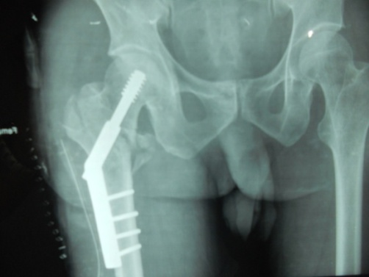
DHS pre and post-op

P
Pre

Figure 2

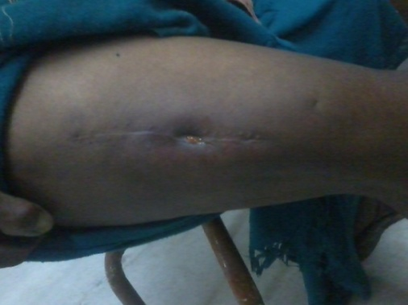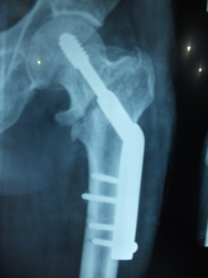
DHS non-union
PFLCP Superficial infection

Figure 3 Figure 4

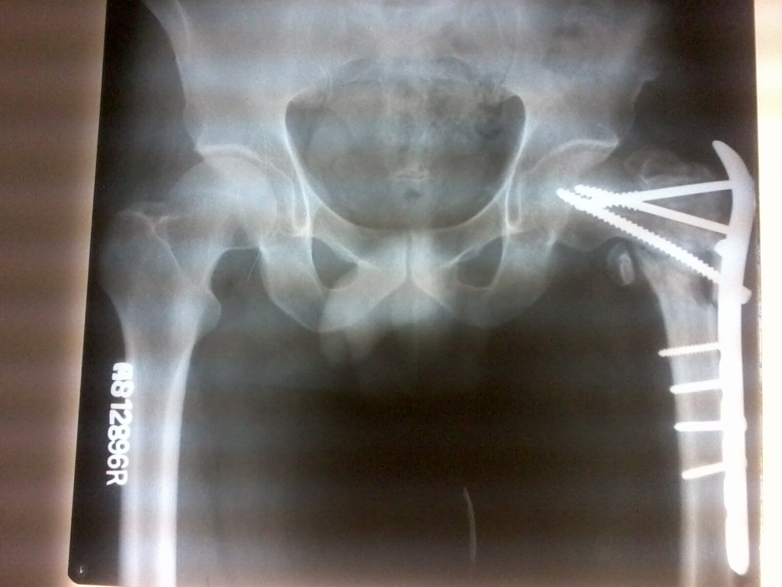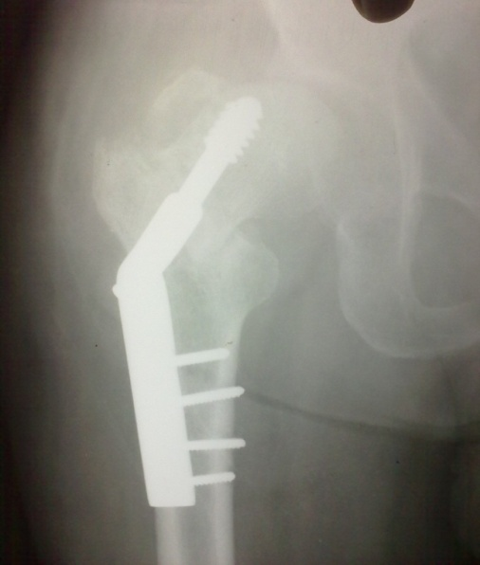
DHS screw cutout
PFLCP varus malunion

Figure 5 Figure 6

