Primary bone lymphoma: A retrospective histopathological study at tertiary care hospital of north- eastern region

ABSTRACT:
Background and aim: PBL is a rare condition and accounts for 5-7% of primary malignant bone tumors and 5% of extranodal lymphomas. Because of the rarity of this tumor, we report our institute experience in this retrospective study.
Method: We retrospectively analysed the data for PBL in the department of Pathology Gauhati Medical College, Guahati from August 2010 to July 2015. Biopsy specimen were received, stained with H & E stain and subsequently IHC was performed to confirm the diagnosis of Bone Lymphoma.
Results: Total 10 cases were diagnosed as NHL. There was male preponderance and most of the patients were of elderly age group. On IHC, 9 cases were diagnosed as DLBCL while one case was diagnosed as ALCL.
Conclusion: Although rare,most of the primary bone lymphoma are diffuse large B-cell lymphoma. A proper clinical history with radiological correlation is necessary to differentiate primary lymphoma from secondary involvement of extraskeletal lymphoma. Immunohistochemistry is important tool to differentiate NHL from other malignant tumours of bone.
KEYWORDS: Non-Hodgkin Lymphoma, Immunohistochemistry, Extranodal lymphoma, Radiology (CT/MRI)
INTRODUCTION:
Primary bone lymphoma is defined as a lymphoma that is confined to the bone or bone marrow without evidence of concurrent systemic involvement. It is a rare condition and accounts for 5 - 7% of primary malignant bone tumours and 5% of extranodal lymphomas and <1% of all non hodgkin’s lymphoma ¹.
PBL (NHL) of bone can be difficult to diagnose without high level of suspicion. The disease affects the middle aged to elderly population with median age of 48 years but also described in pediatric patient. The most common presentation of patient with PBL is bone pain, and less frequent presentations include a palpable mass and bone fracture or neurologic symptoms ². The metaphyses of bone is a common location of PBL.
Many PBL patients have had early clinical stage disease and most important prognostic factor has been the disease stage. Clinical staging was determined according to the revised American Joint Comittee of Cancer (AJCC) staging system for lymphoid neoplasm ³. Histopathologically the majority of PBL cases have been DLBCL according to the WHO classification.
MATERIAL AND METHODS:
We retrospectively searched the data for primary bone lymphoma in the departments of pathology , radiology and orthopaedics from August2010 to July 2015. Patients bio-data, clinical profile and histological diagnoses were also analysed . CT,MRI of the chest , abdomen and pelvis did not show any primary nodal origin or distant metastasis . In our department biopsy specimens were received in 10% formalin, decalcified and processed. the sections were stained with H & E stain. Immunohistochemistry was then performed to confirm the diagnosis of bone lymphoma.
OBSERVATION AND RESULTS:
A total 10 cases were diagnosed as Primary bone lymphoma. Retrospective study revealed male & female ratio was 4:1 . Pain was the most common presenting feature followed by swelling and pathological fracture. Seven cases occurred at 5th decade, one each at 2nd, 4th and 6th decade respectively. Solitary bone lesion was present in nine cases while one had multiple lesions. All cases showed destructive lesion with soft tissue involvement in three cases. Diaphysis of bone was involved in 3 cases and metaphysis was involved in 7 cases. Long bones were involved in 9 cases (5 cases in femur, 3 in tibia, 1 in humerus )and 1 case in pelvis. On histopatholoical examination 9 cases were found to be diffuse large B-cell lymphoma (Figure 1) which was confirmed by IHC reported as CD45,CD20 positive (Figure 2) and CD3, CD99 and S1OO negative. 1 case was found to be Anaplastic large cell lymphoma on HPE (Figure 3) and was confirmed by IHC as CD30,EMA,CD45 positive (Figure 4) and CD3,CD20,CD99 negative.
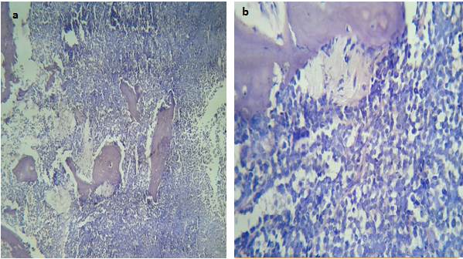
Figure 1: PBDLBCL shows (a) diffuse growth pattern of the lymphoma cells and permeate between the trabeculae (H & E,100X) (b) diffuse sheets of large atypical cells with multi lobated nuclei and fine chromatin (H & E, 400X)
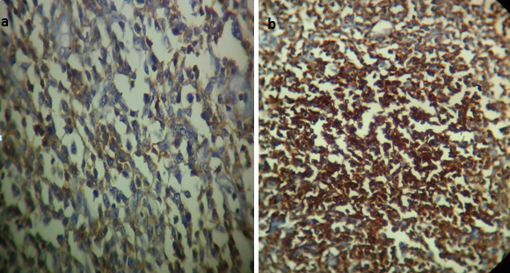
Figure 2: IHC staining showing membranous positivity in DLBCL of bone (400X) (a) CD45 (b) CD20
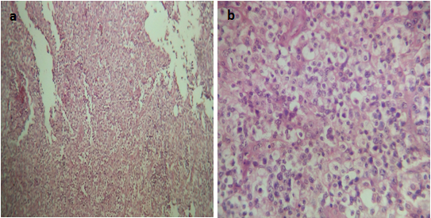
Figure 3: ALCL shows (a) diffuse growth pattern of tumour cells (H & E,100X) (b) large cells with pleomorphic nuclei and multiple prominent nucleoli (H & E,400X)
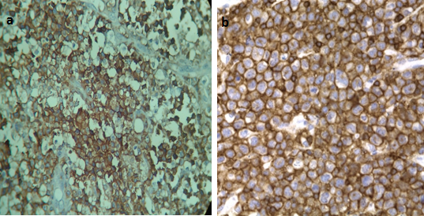
Figure 4: IHC staining showing membranous positivity in ALCL of bone (400X) (a) CD30 (b) EMA
DISCUSSION:
The presentation of NHL as a localised bone tumour is relatively uncommon. Primary bone lymphoma was first described by Oberling ⁴ in 1928. In 1939, Parker and Jackson ⁵ described 17 cases of "primary reticulum cell sarcoma of bone" and established primary lymphoma of bone (PLB) as a distinct clinical entity.
Age distribution: The age of the diagnosed cases of lymphoma of bone ranged from 13 to 55 years with median age of 48 yrs ⁶. Our retrospective study reveal 7 cases occurred at 5th decade one each at 2nd, 4th and 6th decade respectively with median age of presentation in the 5th decade.
Gender distribution: Most reports in the literature suggest a slight male predominance of 1.5:1 ⁶. In our present study, we also observed male predilection of ratio M : F = 4:1.
Clinical features: The most common presenting symptom of PBL is pain in the long bone that is unrelieved by rest. Patients also presented with palpable mass, swelling limb, night pain, pathological fracture and neurological symptoms. Our retrospective study revealed that pain was the most presenting feature followed by swelling. One patient presented with pathological fracture.
Site of involvement: In our study, long bones are involved in all cases involving metaphysis. When compared to other literature, long bones were more commonly involved site in NHL bone ^{6,7}.
Diaphysis of bone was involved in 3 cases and metaphysis was involved in 7 cases. Long bone were involved in 9 cases (5 cases in femur, 3 cases in tibia, 1 case in humerus) and 1 case in pelvis.
DLBCL is the most commom type of NHL which accounts for 55% of all NHL in Indian population ⁸. DLBCL is characterised by the proliferation of large neoplastic B cell, with Nuclear size equal to or exceeding normal macrophage nuclei or more than twice the size of a normal lymphocyte that has a diffuse growth pattern . DLBCL comprises centroblastic, immunoblastic, T-cell/Histiocyte rich and anaplastic morphological variant ⁹. Although most primary bone lymphoma are DLBCL with a rare occurence of follicular, marginal zone, anaplastic large cell, hodgkin and T-cell lymphoma.
Most PBDLBCL show diffuse growth patern. Lymphoma cell permeate between the trabeculae and medullary fat. The lymphoma consists of diffuse sheets of large atypical cells or a mixture of small to large cell with large multi lobated nuclei, fine chromatin, and inconspicuous to prominent nucleoli (Figure 1) which was confirmed by IHC (Figure 2).
The ALCL tumor consist of large cell with pleomorphic nuclei and prominent multiple nucleoli (Figure 3). Most lymphoma are positive for CD30 and some of T-cell markers, and CD45 and EMA (Figure 4).
Differential diagnosis: Differential diagnoses for PBL was considered for chronic osteomyelitis, primary bone sarcoma, leukemic infiltrate, including Ewing sarcoma, mesenchymal chondrosarcoma, metastatic neuroblastoma, and small-cell osteosarcoma, metastatic sarcomas/ carcinoma/ melanoma.
Chronic osteomyelitis: The mixed cell infiltrate of tumour cell and clinico-radiological appearances help to differentiate lymphoma from diagnosis of chronic osteomyelitis. Moreover CD30 & EMA will be negative in osteomyelitis.
Ewing sarcoma: On IHC, CD 99 showed negativity and CD45,CD30,EMA positivity in our case, ruled out ES.
Mesenchymal chondrosarcoma: Absence of chondroid differentiation S-100 negativivity and CD45 & CD20 positivity help to differentiate lymphoma from diagnosis of Mesenchymal chondrosarcoma.
Metastatic carcinoma/Metastatic melanoma: Both the tumours were ruled out as Keratin & S-100 negative and CD30 positive on IHC.
However, the finding in the present study like DLBL as more common variant among primary bone lymphoma was similar to the finding observed by X Frank Zhao et. al ¹⁰, Dong F et. al ¹¹, Hayase E et. al ², Dai Maruyama et. al ¹ and Desai et. al ¹² (Table 1).
Table 1: Percentage of PBL (DLBCL) in our study compared with other studies
Different studies | DLBCL (%) | Total lymphoma case
X. Frank zhao et. al (2015) | 10  (100%) | 10
Dong F et. al (2015) | 11  (84.6%) | 13
Hayase E et. al (2015) | 11  (64.7%) | 17
Dai Maruyama et. al (2007). | 19  (68%) | 28
Desai et. al.(1991) | 17  (68%) | 25
Present study | 9  (90%) | 10

Primary bone ALCL are uncommon, only a few case reports and a small case series have been reported in the literature ^{13, 14}. In our retrospective study we reported only 1 case as primary ALCL with clinico-radiological correlation. Most PBDLBCLs are treated with combined radiotherapy and chemotherapy with good prognosis¹⁵.
CONCLUSION:
The present study revealed that Diffuse large B-cell lymphoma is the commonest primary bone lymphoma . CT, MRI of the chest, abdomen and pelvis is an important diagnostic point for Primary bone lymphoma. Hence clinico-pathological (HPE and immunohistochemistry) and radiological correlation played an important role in the retrospective analysis of such rare tumour.
CONFLICT OF INTEREST:
There is no conflict of interest associated with this work.
ETHICAL CLEARANCE:
The study was approved by Institutional Ethical Committee of Gauhati Medical College and Hospital, Guwahati.
REFERENCES:
- Maruyama D, Watanabe T, Kobayashi TBY, Kim SW and Tanimoto K. Primary bone lymphoma: a new and detailed characterization of 28 patients in a single-institution study. Jpn. J. Clin. Oncol. 2007;37(3):216-223.
- Hayase E, Kurosawa M, Suzuki H, Kasahara K, Yamakawa T, Yonezumi M, Suzuki S and Teshima T. Primary bone lymphoma: a clinical analysis of 17 patients in a single institution. Acta Haematol 2015;134:80-85.
- Rosai and Ackerman's Surgical Pathology. 10th edition. Edinburgh (United Kingdom): Mosby Elsevier; 2011.
- Oberling C. Les reticulosarcomes et les reticuloendotheliosarcomes de la moelle osseuse (sarcomes d’Ewing). Bull Assoc Fr Etude Cancer. (Paris) 1928;17:259–96.
- Parker F and Jackson H. Primary reticulum cell sarcoma of bone. Surg Gynecol Obstet 1939;68:45–53.
- Bhagavathi S and Fu K. Primary Bone Lymphoma. Arch Pathol Lab Med 2009;133(11):1868-1871.
- Heying FH, Hogendoorn PCW, Kramer MHH, Hermans J, Kluin-Nelemans JC, Noordijk EM and Kluin PhM. Primary non-Hodgkin's lymphoma of bone: a clinicopathological investigation of 60 cases. Leukemia 1999;13:2094-2098.
- Nimmagadda RB, Digumarti R, et al. Histopathological pattern of lymphomas and clinical presentation and outcomes of DLBCL: A multicenter registry based study from India. Indian J Med Paediatr Oncol 2013;34:299-304.
- Gurbuxani S, et al. DLBCL - More than a diffuse collection of large B cells: An entity in search of a meaningful classification. Arch Pathol Lab Med 2009;133:1121-34.
- Zhao XF, Young KH, Frank D, Goradia A, Glotzbecker MP, Pan W et al. Pediatric primary bone lymphoma–diffuse large B-cell lymphoma: morphologic and immunohistochemical characteristics of 10 cases. Am J Clin Path 2007;127:47-54.
- Dong F, Chen YP, Wang JJ, Jing HM, Ke XY, Zhongguo shi yan xue ye xue za zhi/ Zhongguo Bing li Sheng li xue hui. Clinical analysis of 13 patients with primary bone lymphoma. J Exp Hematol 2015;23(2):420-424.
- Desai S, Jambhekak NA, Soman CS and Advani SH. Primary lymphoma of bone: A clinicopathologic study of 25 cases reported over 10 years, J Surg Oncol 1991; 46(4):265–269
- Nagasaka T, Nakamura S, Medeiros LJ, Juco J, Lai R. Anaplastic large lymphomas presented as bone lesions: a clinicopathological study of six cases and review of literature. Mod Pathol 2000;13(10):1143–1149.
- Gudgin E, Rashbass J, Pulford KJ, Erber WN. Primary and isolated anaplastic large cell lymphoma of the bone marrow. Leuk Lymphoma 2005;46(3):461–463.
- Beal K, Allen L, Yahalom J. Primary bone lymphoma: treatment results and prognostic factors with long term follow up of 82 patients. Cancer 2006;106(12):2652–2656.

