COMPARATIVE STUDY OF GUGULIPID AND ORAL TETRACYCLINE IN THE MANAGEMENT OF MODERATE TO SEVERE ACNE VULGARIS
DR(Mrs)PADMAJA SAIKIA¹

ADDRESS FOR CORRESPONDENCE-
¹(Associate Professor,Department of Dermatology and Venereology,Gauhati Medical college,Guwahati)
DR(Mrs) Padmaja Saikia,
Rajgarh road,anil nagar,byelane 2,guwahati,Assam(india)
Email-padmajasaikia4@gmail.com
Phone number-9864077967

ABSTRACT
Acne vulgaris is a common disorder virtually affecting every adolescent. It is a condition of varied severity,running a chronic course of relapse and remission.
AIMS: To study the therapeutic efficacy of Gugulipid and to compare that with Tetracycline hydrochroride, in management of moderate to severe Acne vulgaris.
METHODS: 90 patients with moderate to severe Acne vulgaris were enrolled in the study and divided into two groups , group A and group B.Group A received Gugulipid and Group B received Tetracycline Hydrochloride.The patients were evaluated at the end of 6wks and then at the end of 12wks. Follow up was done every monthly for another 3 months to look for any side effects and relapse of the condition.
RESULTS: There were 45 patients in each group. 4 patients(8.9%) in Group A and 11 patients(24.4%) in Group B had execellent response at the end of 6wks. 10 patients(22.2%) in Group A and 2 cases of Group B(4.4%) showed no change of the condition. 3 patients(6.7%) in Group A and 2 patients(4.4%) in Group B had worsening of the condition.Side effects of the drugs were minimal in both the groups and 19(42.2%) cases in Gugulipid receiving group and 8 cases(17.8%) in Tetracycline receiving group had relapse during the follow up period.
CONCLUSION: Tetracycline was found to be superior to Gugulipid in this study. But Gugulipid is also having signigicant efficacy in Acne management. This drug can be considered for Acne management, though not as a specific drug, but as a supportive therapy.
Key words: Gugulipid, Tetracycline , Acne vulgaris ,Comparative study.

INTRODUCTION:
Acne is a chronic inflammatory disease of the pilosebaceous unit,characterized by formation of comedones, erythematous papules and pustules (F.S.G. Ebling, Cunliffe 1988).¹
It affects mostly the teenagers, starting in adolescence and gets resolved by mid twenties (Cunliffe 1975).²
Four major aetiological factors are involved in pathogenesis of Acne vulgaris-
a.)Increased sebum production
b.)Abnormality of microbial flora
c.)Hyperkeratinization of pilosebaceous duct
d.)Production of inflammation
Acne is a polymorphic condition, running a chronic course. It has variable severity in different person or in the same person at different time, occurs in milder form in some and severe in others. There are different grading system of severity of Acne. Different modalities of treatment is available, both topical and systemic for management of Acne.
Tetracycline is an established antibiotic for Acne. According to Greenwood R ,et al(1983) patients who require antibiotics, should be given 1gm per day of Tetracycline. Tetracycline is bacteriostatic specially in larger doses(Marples R et al, 1971)³.With 1gm per day doses for a period of 6 months relapse rate is quite less than with smaller doses(Greenwood R et al,1983)⁴.
Gugulipid is the standardized extract of the oleoresin of Commiphora mukul⁵. Commiphora mukul is a plant product, a versatile indigeneous drug claimed by Ayurvedic system of medicine, to be highly effective in the treatment of various clinical disorders like rheumatism, arthritis,neurological disease and a few skin diseases(Nada Karni 1958)⁶.This drug has marked cholesterol and lipid lowering action and is used in disorders of lipid metabolism.Gugulipid is hypothesised for use in acne by action of reducing sebum probably by its systemic hypolipidemic action⁷.Secondly, its marked anti-lipolytic activity as proved in rats probably inhibits the lipolysis of triglycerides by bacterial lipases to free fatty acid.Gugulipid has marked anti-inflammatory action(Gujral et al 1960)⁸.Keeping in mind, its hypolipidemic, anti-lipolytic and antibacterial property, few studies are available, where this drug Gugulipid has been tried in management of Acne vulgaris.One study was taken up by Dr. Jaideep Dogra et al in India(IJDVL 1990)⁹ and the result was encouraging.However no such study was carried out in this part of the country.So, this study was taken up to know the efficacy of Gugulipid in the management of Acne vulgaris, at the same time comparing its effect with Tetracycline hydrochloride.
MATERIALS AND METHOD
This study was carried out solely on clinical basis. Patients with moderate to severe degree Acne vulgaris attending OPD of GMCH, during the period Sep 1991 to Aug 1992 were enrolled in the study. Patients were divided into two groups, Group A and Group B. Group A received Gugulipid 25mg(Guglip),three times daily the group B received Tetracycline hydrochloride 250mg 6hrly.
Follow up was done at the end of 3 wks. Overall result of treatment was noted after 6wks. At the end of 6wks,if no change of the condition or there is worsening, treatment was stopped and patient is put on other conventional treatment.If there is improvement then same treatment is continued for another 6wks and thereafter patients were followed up monthly for 3months to look for any side effects and any relapse.Investigations were repeated at 6wks and any alteration noted.Patients were explained and counselled about the course of treatment and necessity of proper follow up.Thorough history taking , a brief general and systemic examination was done. Acne grading was done according to Samuelson Nine grade global acne scale¹⁰. According to this scale Acne vulgaris is graded as follows:-
Grade I :- Sparse comedones with little or no inflammatory process noticeable.
Grade II :- Moderate numbers of comedones with little or no inflammatory process present.
Grade III :-Comedones with some inflammatory papules present.
Grade IV :- Comedones with several superficial pustular and inflammatory lesion present.
Grade V:- Profuse comedones with a few papulo-pustular lesion present.
Grade VI:- Moderate numbers of small superficial pustular and inflammatory lesions with some comedones present.
Grade VII:- Profuse, small superficial pustular and inflammatory lesions with comedones present.
Grade VIII:-Deep, pustular lesions present and predominate.
Grade IX:- Deep cyst or inflammatory nodules present.
Patients with Grade IV onwards were considered to be moderate to severe acne patients.

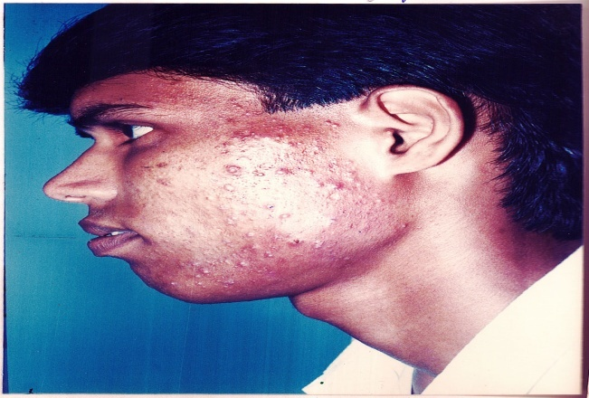
Figure showing Patient with grade VII acne vulgaris

INVESTIGATIONS:- Done prior to starting therapy and at the end of 6wks.Investigations were-
a.Blood for TLC ,DLC, ESR, Hb%
b.Routine urine and stool examination
c. Serum bilirubin,SGOT,SGPT
d. In Gugulipid receiving group- serum cholesterol
TREATMENT AND FOLLOW UP:
Gugulipid(Guglip) was prescribed in a dose of one tab(25mg) three times daily. Tetracycline hydrochrolide capsule (250mg) was prescribed 6 hourly daily. No topical therapy was prescribed. Patients were advised to maintain the facial hygiene.Patients were evaluated every 3weekly and overall result of treatment was recorded after 6wks. Degree of improvement was noted according to the following grading(Joel S. Samuelson, 1985)¹⁰.

Excellent: Decrease of three or more grade numbers with reduced redness and tenderness
Good: Decrease of two grade numbers with reduced redness and tenderness.
Moderate: Decrease of one grade numbers with reduced redness and tenderness.
None: No change.
Worse: Increase of one or more grade numbers or increased redness or tenderness with same grade numbers.
RESULTS AND OBSERVATION:
Data obtained from the study were noted and analysed as shown in the following tables:
Out of 15000 patients attending Dermatology OPD, GMCH, 90 had moderate to severe degree Acne Vulgaris i.e. 0.6%.
Table no. I: Table showing different age groups with number of patients in respective groups:
Different age groups in years | No. of patients in each group out of total 90 | Percentage
0 - 9 | - | -
10-19 | 48 | 53.3
20-29 | 40 | 44.4
30-39 | 2 | 2.2
Maximum number of patients as seen from the table were in 10-19years age group i.e. 48 patients(53.3%). The age group 20-29 years had 40 patients(44.4%). No patient was found in the 0-9 years group whereas 30-39 years group had only 2 patients(2.2%).
Table II: Table showing sex distribution of the patients with percentage
Total number of patients | 90 | Percentage
Total number of male patients | 35 | 38.9
Female patients | 55 | 61.1
Total number of male patients as noted from the above table is 35(38.9%) and that of female patient is 55(61.1%).
Table III: Table showing number of patients with different grades of acne with percentage:
Grades of acne | Number of Patients | Percentage
Grade IV  Grade V  Grade VI  Grade VII  Grade VIII  Grade IX | 3  29  39  11  6  2 | 3.3  32.2  43.3  12.2  6.7  2.2
The grade VI had maximum number of patients which was 39(43.3%) out of 90.Next to this was grade V acne where there were 29(32.2%) patients.Likewise grade VII included 11(12.2%) patients.Grade VIII had 6(6.7%) patients.Grade IV had 3(3.3%) patients and in grade IX there were minimum number of patients i.e. only 2(2.2%).
Table IV: Table showing response to Gugulipid and Tetracycline at the end of 6wks.
Different response at the end of 6wks | Gugulipid | Tetracycline hydrochloride
Different response at the end of 6wks | No. of patients with percentage | No. of patients with percentage
Excellent  Good  Moderate  No change  Worsening | 4(8.9%)  8(17.8%)  20(44.4%)  10(22.2%)  3(6.7%) | 11 (24.4%)  16 (35.6%)  14 (31.1%)  2 (4.4%)  2 (4.4%)
At the end of 6weeks therapy 4(8.9%) patients in Gugulipid receiving group had excellent response whereas in the Tetracycline receiving group it was 11(24.4%). 8(17.8%) patients in Gugulipid receiving group had good response whereas it was 16(35.6%) in tetracycline receiving group. 20(44.4%) patients showed moderate response in Gugulipid receiving group and it was 14(31.1%) in the Tetracycline receiving group. 10(22.2%) patients in Gugulipid receiving group showed no change and it was 2(4.4%)in the tetracycline receiving group. 3(6.7%) patients in Gugulipid receiving group had worsening while in tetracycline receiving group it was 2(4.4%).

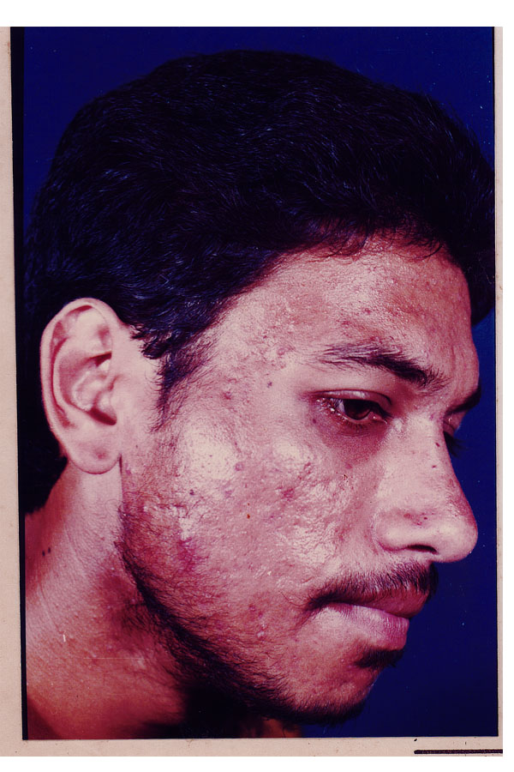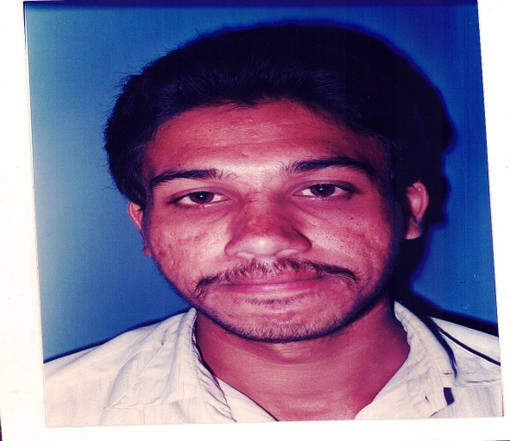

Figure showing pretreatment and posttreatment response with Gugulipid(end of 3 months)

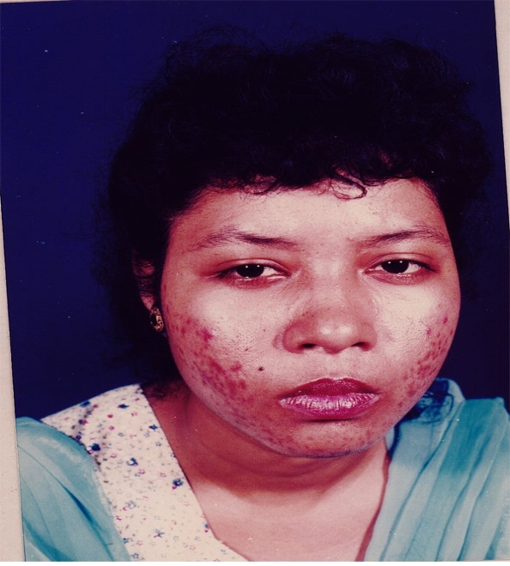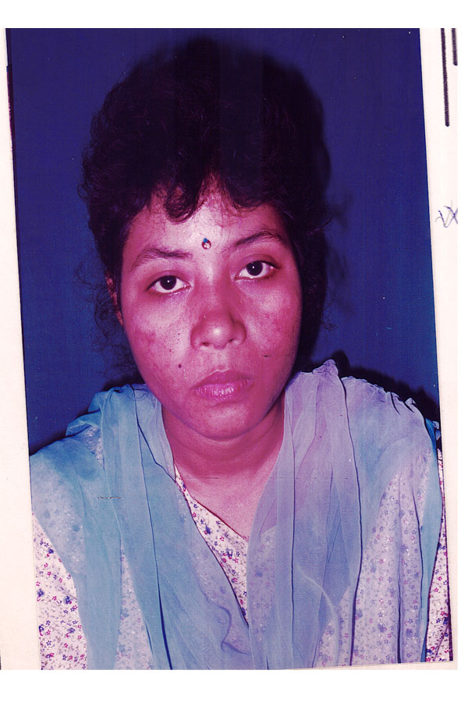
Figure showing patient with gradee VII acne before and after treatment with tetracycline(end of 6 weeks).

Table V: Table showing various adverse effects complained by patients receiving either Gugulipid or Tetracycline hydrochloride:
Adverse effect | Gugulipid |  | Tetracycline
Adverse effect | No. of patients | Percentage | No. of patients | Percentage
Nausea  Vomiting  Abdominal pain  with diarrhoea  Giddiness  Drug rash  Vulvo-vaginal candidiasis  Gram negative folliculitis | -  -  1  -  1  -  1 | -  -  2.2  -  2.2  -  2.2 | 4  1  -  1  -  1  - | 8.9  2.2  -  2.2  -  2.2  -
It was seen that in the Gugulipid receiving group 1(2.2%) patient had abdominal pain with diarrhoea, 1(2.2%) patient developed rashes and another 1(2.2%) patient developed gram negative follicullitis. In the Tetracycline receiving group 4(8.9%) patients had nausea, 1(2.2%) had vomiting, 1(2.2%) had giddiness and lastly 1(2.2%) patient developed vulvo-vaginal candidiasis.
Table VI: Table showing number of patients with relapse of acne vulgaris after completion of therapy
Drugs | No. of patients | Percentage
Gugulipid  Tetracycline hydrochloride | 19  8 | 42.2  17.8
It is seen from the table that in 19(42.2%) patients receiving gugulipid had relapse of acne after stopping the drug whereas in the tetracycline receiving group, 8(17.8%)patients had relapse.
DISCUSSION-
The present study comprises of treatment of moderate to severe form of acne vulgaris with a newer drug gugulipid and comparing it with the results of treatment of similar number of cases with conventional established drug Tetracyline hydrochloride.
Incidence of cases with moderate to severe form of Acne vulgaris requiring treatment attending Dermatology OPD,was found to be 0.6%.
AGE INCIDENCE-
Age of patients in this series ranged from second decade to fourth decade .Maximum number of cases(53.3%) were in the age group of 10-19 years(Table-1).There was no patients in the age group 0-9 years.In(30-39 years) group ,only 2.2% cases were found .These observations are consistent with those observed by W.J.Cunliffe,who mentioned that ,age of onset of Acne ,in most cases is in early teens.Peak severity is seen between 17- 19 years of age.Thereafter Acne declines gradually,to get disappeared by the age of 25 years.According to him 5% of females and 1% of males will have Acne till the age of 40 years.
In a review article given by Adhoc Committee in 1975,it has been mentioned in different studies that persons susceptible to have Acne vulgaris were selected in between 10-45 years,thereby excluding infants,young children and the elderly¹¹.This is also,almost similar with the age incidence observed in the present study.
SEX DISTRIBUTION
In this series ,out of total 90 patients 35 were males (38.9%) and 55 were female patients(61.1%),making a male female ratio of 7:11.Usually,it has been observed that,there is no sex difference for acne,both male and female are equally affected.But in this study,female outnumbered male.This discrepancy may be due to greater concern of females for their appearance,for which reason,they come for treatment more commonly,than male cases.Again,this female preponderance cannot be accepted as an established fact,instead as an incidental finding, as this study is limited to a relatively fewer number of cases.
AWARENESS FOR FACIAL HYGIENE
Most of the patients were not aware of importance of using soap or any other cleanising agents.Some of them even applied greasy cosmetics or did not even clean their face after any cosmetic application.
TREATMENT
In our study in group A ,4 patients(8.9%) showed excellent result ,whearas in group B same response was seen in 11 patients(24.4%).
8 patients (17.8%) in group A had good result,whereas 16 cases (35.6%) of Tetracycline receiving group demonstrated same result.20 patients (44.4%) of Gugulipid receiving group had moderate response whereas 14 patients(31.1%) of group B,had the same response.
10 patients(22.2%),showed no response even after 6 weeks of Gugulipid therapy whereas in the other group 2patients(4.42%) showed no demonstrable changes.
In the Gugulipid receiving group 3 patients (6.7%) had worsening of their acne whereas in the Tetracycline revieving group 2 patients(4.4%) worsened.
In an earlier work,on Gugulipid carried out in India(1990),taking 30 patients with moderate to severe form of Acne vulgaris,30% of the cases showed excellent result,while 46.66% showed good response and 23.33% showed a moderate response⁹.
In another study,it was found that with Tetracycline, the percentage reduction in the inflammatory lesions was 65.2% as compared to 68% with Gugulipid; on comparison, this difference was statistically insignificant (P>0.05)¹².
INCIDENCE OF RELAPSE
In our study it was observed that ,relapse is higher in the Gugulipid receiving group(20%).There was worsening or relapse of the lesions within a very short period of stopping the drug.In contrast with Tetracycline,relapse rate was relatively low(8.9%).Besides this,there is comparitivly a longer remission period,before relapse occurs.
In previous study, only three patients (10%) reported relapse when examined at 3 months follow up⁹.
In one more study, out of 20 patients, follow-up at 3 months showed a relapse in 4 cases on tetracyline and 2 cases on gugulipid¹².
SIDE EFFECTS
In present study side effects of tetracycline receiving group include nausea(8.9%),vomiting(2.2%),giddiness(2.2%), and vulvovaginal candidiasis(2.2%).
Earler study by Lt. Edmund .R.Hobbs et al (1982) also reported the following adverse effects,of tetracycline hydrochloride,when given for 6 months.
In present study side effects of Gugulipid includes abdominal pain and diarrhoea(2.2%),drug rash(2.2%).
But in earlier work on Gugulipid , Twelve patients (40%) reported 2-4 semi-formed stools while on the drug⁹.

CONCLUSION-
Acne vulgaris is a very common problem affecting predominantly the teenagers.It runs a chronic course,with variable severity.In some individuals,it can run quite a prolonged course,requiring treatment from time to time. In this study,Tetracycline Hydrochloride has shown better response with earlier remission,low relapse rates and less adverse effects.Gugulipid which is mainly used for its lipid lowering action,is showing some beneficial effect in management of Acne,which is not negligible.As patients with Acne ,need various modalities of treatment from time to time,this drug can be of help,though not as a specific drug,but can be added as a supportive therapy.
Conflict of interest: None declared.
Ethical clearance: Taken.
Source of funding: None declared.
Declarations:
(1) The article is original with the author(s) and does not infringe any copyright or violate any other right of any third parties;
(2) The article has not been published (whole or in part) elsewhere and is not being considered for publication elsewhere in any form, except as provided herein;
(3) All author (s) have contributed sufficiently in the article to take public responsibility for it and
(4) All author (s) have reviewed the final version of the above manuscript and approve it for publication.
REFERENCES-
.
1. F.J.G Ebling and W.J.Cunliffe-Textbook of dermatology 3.1915,1988.

2..Cualiffe w.j. and Cotterill J.A.-The Acne London W.B.Saunders,1975
3.Leyden JJ, Marples RR, Mill OH and Kligman AM : Topical antibiotics and topical antimicrobial agents in acne therapy, Acta Derm Venerol, 1980; 60 (Suppli 89) : 75
4.Acne: Double Blind Clinical and Laboratory Trial of Tetracycline, Oestrogen-Cyproterone Acetate, and Combined TreatmentR Greenwood et al. Br Med J (Clin Res Ed) 291 (6504), 1231-1235. 1985 Nov 02.

5. Satyavti GV, Dwarkanath C and Tripathi SN Experimental studies on the hypocholesterolemic effect of Commiphora mukul, Ind J Med Res, 1969; 57 : 1950
6.Nadakarni A.k.: “The Indian Materia Medica” 160-170,popular book depot,Bombay,1954.
7. Kapoor NK and Nityanand S : Effect of guggul steroids on cholesterol biosynthesis in rats, Ind J Biochem Biophy, 1978; 15 : 77.

8.Gujral et al.-Indian Jour. Physiol and Pharmacol,4:267
9.Dr Jaideep Dogra et al.-Indian Journal of Dermatology Venereology Leprology.56:381:1990.
10. Samuelson JS : An accurate photographic for grading acne : Initial use in a double blind clinical comparison of Minocycline and Tetracycline, J Amer Acad Dermatol, 1985; 12 : 461.

11. Adhoc Cmmmittee report-Review article,Arch Dermatal,Vol IIIM1630,1975.

12.Dogra J. Nodulocystic acne: oral gugulipid versus tetracycline.. J Dermatol. 1994 Oct;21(10):729-31.

