DIRECT PULP CAPPING WITH MINERAL TRIOXIDE AGGREGATE - A NOVEL MATERIAL
Shekhawat Krutika¹, Kataki Rubi², Bora Proxima ³, Bhuyan A.C⁴
ABSTRACT
Pulp capping in carious teeth has been considered unpredictable and therefore contraindicated. A recently developed material, mineral trioxide aggregate (MTA), resists bacterial leakage and may provide protection to the pulp, allowing repair and continued pulp vitality in teeth when used in combination with a sealed restoration. The aim of this case report was to determine the clinical and radiographic success rate of vital pulp therapy with mineral tri oxide aggregate (MTA) in human mature permanent molar teeth. Carious pulpal exposure was treated by direct pulp capping with MTA, followed by a base of light cure glass ionomer cement and restored with composite. Clinical and radiographic examinations were carried out periodically . Results: After 9 months clinical and radiographic follow-up, it was found that the procedure had successful outcome. Although the results favored the use of MTA in carious permanent teeth by vital pulp therapy but more studies with larger sample and a longer recall period are needed to justify the use of this novel material for treatment of reversible pulpitis in permanent teeth.
INTRODUCTION
Preservation and maintenance of pulpal vitality is one of the main objectives in endodontics. Earlier, the placement of a medicament or material against a direct pulpal exposure during caries excavation has been considered controversial, and instead conventional endodontic therapy has been recommended¹⁻⁵. Clinicians have used many materials and techniques for direct pulp capping procedures, including calcium hydroxide, hydrophilic resins, resin modified glass ionomer cements, tricalcium phosphates and, more recently, mineral trioxide aggregate (MTA).. Direct pulpal exposures can be a challenging problem during excavation in a carious field. A diagnosis of reversible pulpitis before treatment is necessary for a successful outcome, but a definitive pulpal diagnosis often is difficult to establish^{6.} Success rates with direct pulp capping in a carious tooth have varied depending on the technique and materials. In humans, success rates range from 30 to 85 percent in two- to 10-year retrospective studies^{4,6-10}.
MTA is a bioactive silicate cement that has been shown to be an effective pulp-capping material in canine models and in nonhuman primates¹¹⁻¹³. The material is successful because of its small particle size, sealing ability, alkaline pH when set and slow release of calcium ions¹⁴. Investigators have reported that MTA induces pulpal cell proliferation^{15,16}, cytokine release¹⁷, hard tissue formation¹⁸ and the synthesis of an interface with dentin that resembles hydroxyapatite in composition^{14.} The material is nonabsorbable, sets in the presence of moisture, has a relatively high compressive strength and has a sustained high alkaline pH¹⁹.

Address for Correspondence: ¹Post Graduate Student(Corresponding Author).
Department Of Conservative Dentistry And Endodontics.
Regional Dental College,Guwahati,Assam.
Mobile: 9954232356
Email address: shekhawatkrutika@gmail.com
²Professor
Department Of Conservative Dentistry And Endodontics.
Regional Dental College,Guwahati,Assam.
³Post Graduate Student
Department Of Conservative Dentistry And Endodontics.
Regional Dental College,Guwahati,Assam.
⁴Head of the Department
Department Of Conservative Dentistry And Endodontics.
Regional Dental College,Guwahati,Assam.

CASE REPORTS.
The first case concerned a 15 years old female patient complaining of discomfort of tooth 36 upon contact with cold food, drinks and air. On examination , deep carious lesion was seen . The tooth tested vital to EPT and cold test (Endo-Frost, Roeko, Langeman, Germany) with no lingering pain and was negative on percussion. Radiograph showed evidence of deep caries in close proximity to the pulpal chamber with no evidence of either thickened periodontal ligament (PDL), furcation radiolucency, internal resorption or periradicular pathosis. Clinically, teeth had no mobility and periodontal probings within normal range with no evidence of sinus tracts or swelling.
The second case is 21 years old male patient who presented with a deep carious lesion on tooth 46. There was no history of pain and the tooth tested vital to EPT and cold test (Endo-Frost, Roeko, Langeman, Germany) with no lingering pain and was negative on percussion. Radiograph showed evidence of deep caries in close proximity to the pulpal chamber with no evidence of either thickened periodontal ligament (PDL), furcation radiolucency, internal resorption or periradicular pathosis. Clinically, teeth had no mobility and periodontal probings was within normal range with no evidence of sinus tracts or swelling.
CLINICAL PROCEDURES.
After thorough clinical examination of the patient, an anaesthetic (lidocaine 2% with epinephrine 1:200000) was injected and a rubber dam was put in place. Following removal of carious tooth structure pin point haemorrhage was noted. Since the pulp tissue was vital clinically with no history of lingering pain, so treatment plan was decided to cap the pulp directly with MTA. Toileting of the cavity was done with NaOCl(2.5%) for to achieve haemostasis, clearing and disinfecting the cavity. Water was sprayed at the exposure site with two way syringe and then the area was air dried. After the haemostasis was obtained MTA was mixed according to manufacture’s instructions (ProRoot MTA, Dentsply Tulsa Dental, Tulsa, Okla.) and 1.5 to 3.0 mm thick layer of the cement was placed directly over the exposure site and surrounding dentin leaving 1 to 2 mm of dentin and enamel available circumferentially for the future bonded restoration. After placing the MTA, a flat, water moistened cotton pellet was placed directly over the material and a temporary dressing was placed .
FINAL RESTORATION .
Three months later both the cases tested vital to EPT and cold test (Endo-Frost, Roeko, Langeman, Germany) with no lingering pain and was negative on percussion. The temporary dressing was partially removed leaving a thin liner so as not to disturb the pulp cap and restored by an etch and rinse adhesive and a nano hybrid composite resin (Filtek TM Nano –hybrid universal restorative,3M ESPE)
At a follow up visit after 9 months both cases were clinically normal and again tested vital to EPT and cold test (endo-frost, roeko, langeman, germany) with no lingering pain and was negative on percussion. Radiograph showed evidence of deep caries in close proximity to the pulpal chamber with no evidence of either thickened periodontal ligament (pdl), furcation radiolucency, internal resorption or periradicular pathosis. clinically, teeth had no mobility and periodontal probings within normal range with no evidence of sinus tracts or swelling.
DISCUSSION
Although there were only a two cases, the results of this study in which we used MTA as a direct pulp-capping agent when following the protocol described for a two-visit sequence show that this procedure can achieve a long-term favorable outcome. The important controlled variables included complete caries removal, visible hemostasis, verified MTA setting and placement of a bonded hydrophilic resin and composite.
The physical characteristics and bioactive properties of MTA were a critical contributing factor to the success of this study¹⁴⁻¹⁹. The cement is hygroscopic, and its ability to set is not affected by the presence of blood or serum fluids²⁰. The high alkalinity of MTA, its calcium release and sustained pH of 12.5 most likely prevented further microbial growth of residual microorganisms that were left after caries excavation. The high pH also extracts growth factors from adjacent dentin that are thought to be responsible for promoting dentinal bridging²¹. Furthermore, the release of calcium ions by MTA generates a reactionary interfacial layer of hydroxyapatite on its surface when it comes in contact with tissue fluids, and their presence also may contribute to reparative dentin formation¹⁴. The close physiochemical seal of dentin by MTA, determined to be 0 micrometers in resin replica models²², provides a more insoluble barrier against microleakage than does calcium hydroxide, which can show gaps at the dentin interface of 7 to 15 µm when placed under composite restorations²³.

Traditionally, dentists place pulp-capping agents over the exposure site and a small area of surrounding dentin. In our case we placed MTA over the exposure site and the entire floor or wall of the restoration preparation to allow a 1.5- to 3.0-mm thickness of the mater. After applying MTA, we trimmed and shaped the material with spoon excavators to expose 1.0 to 2.0 mm of peripheral dentin and enamel and then used a small moist cotton pellet to clean it to ensure an adequate surface area for bonding on the second visit. The outcome shows that the human pulp has an innate healing capacity that can be enhanced using objective and conservative caries removal, a bioactive pulp-capping material and a sealed restoration. The high occurrence of pulpal repair and pulp-capping success appears to be more favorable in teeth of younger patients; success can be attributed to the presence of larger apical foramina and greater vascularization of the pulp, in which active immune cell surveillance may increase chances for repair and intensify vital pulpal maintenance⁹.
CONCLUSION
The use of MTA, careful caries removal, NaOCl hemostasis/disinfection, and a hydrophilic resin and composite is part of a reliable two-visit pulp-capping protocol for direct carious exposures when the pulpal diagnosis is no more severe than irreversible pulpitis. It promotes remineralization of dentine, preserves pulp vitality and promotes pulp healing. MTA has been identified as a revolutionary material which has the potential maintaining pulp vitality in patients judiciously selected for direct pulp capping . However further studies are required to extend the furtherscope of this material for clinical applications .

FIG 1a (preoperative Xray)
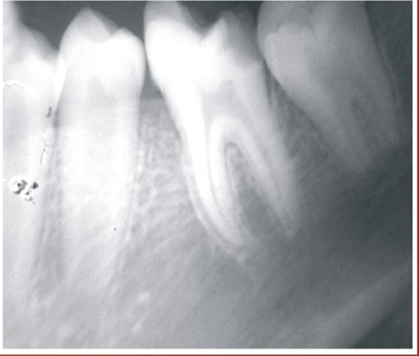
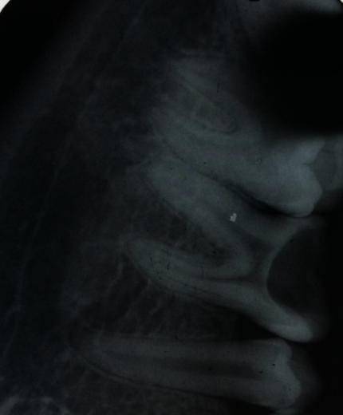
FIG 2 a (post operative 9 months follow up)
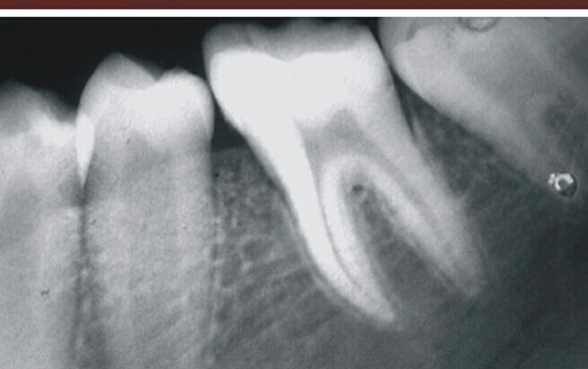
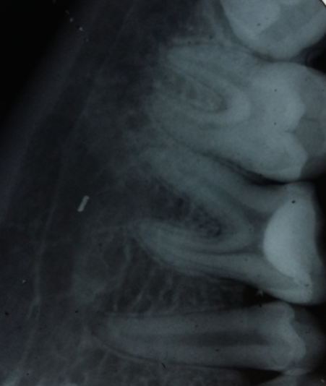

REFERENCES
1. Tronstad L, Mjör IA. Capping of the inflamed pulp. Oral Surg Oral Med Oral Pathol Oral Radiol Endod 1972;34(3):477-485.
2. Langeland K. Management of the inflamed pulp associated with deep carious lesion. J Endod 1981;7(4):169-181.
3. Bergenholtz G. Advances since the paper by Zander and Glass (1949) on the pursuit of healing methods for pulpal exposures: historical perspectives. Oral Surg Oral Med Oral Pathol Oral Radiol Endod 2005;100(2 suppl):S102-S108.
4. Al-Hiyasat AS, Barrieshi-Nusair KM, Al-Omari MA. The radiographic outcomes of direct pulp-capping procedures performed by dental students: a retrospective study. JADA 2006;137(12):1699-1705.
5. Ward J. Vital pulp therapy in cariously exposed permanent teeth and its limitations. Aust Endod J 2002;28(1):29-37.
6. Hørsted P, Søndergaard B, Thylstrup A, El Attar K, Fejerskov O. A retrospective study of direct pulp capping with calcium hydroxide compounds. Endod Dent Traumatol 1985;1(1):29-34.
7. Baume LJ, Holz J. Long term clinical assessment of direct pulp capping. Int Dent J 1981;31(4):251-260.
8. Barthel CR, Rosenkranz B, Leuenberg A, Roulet JF. Pulp capping of carious exposures: treatment outcome after 5 and 10 years—a retrospective study. J Endod 2000;26(9):525-8.
9. Auschill TM, Arweiler NB, Hellwig E, Zamani-Alaei A, Sculean A. Success rate of direct pulp capping with calcium hydroxide [in German]. Schweiz Monatsschr Zahnmed 2003;113(9):946-952.
10. Matsuo T, Nakanishi T, Shimizu H, Ebisu S. A clinical study of direct pulp capping applied to carious-exposed pulps. J Endod.
11. Camilleri J, Pitt Ford TR. Mineral trioxide aggregate: a review of the constituents and biological properties of the material. Int Endod J 2006;39(10):747-754.
12. Ford TR, Torabinejad M, Abedi HR, Bakland LK, Kariyawasam SP. Using mineral trioxide aggregate as a pulp-capping material. JADA 1996;127(10):1491-1494.
13. Junn DJ. Quantitative assessment of dentin bridge formation following pulp-capping with mineral trioxide aggregate (master’s thesis). Loma Linda, Calif.: Loma Linda University; 2000.
14. Sarkar NK, Caicedo R, Ritwik P, Moiseyeva R, Kawashima I. Physioch
15. Moghaddame-Jafari S, Mantellini MG, Botero TM, McDonald NJ, Nör JE. Effect of ProRoot MTA on pulp cell apoptosis and proliferation in vitro. J Endod 2005;31(5):387-391.
16. Takita T, Hayashi M, Takeichi O, et al. Effect of mineral trioxide aggregate on proliferation of cultured human dental pulp cells. Int Endod J 2006;39(5):415-422.emical basis of the biologic properties of mineral trioxide aggregate. J Endod 2005;31(2):97-100.
17. Andelin WE, Shabahang S, Wright K, Torabinejad M. Identification of hard tissue after experimental pulp capping using dentin sialoprotein (DSP) as a marker. J Endod 2003;29(10):646-650.
18. Koh ET, Pitt Ford TR, Torabinejad M, McDonald F. Mineral trioxide aggregate stimulates a biological response in human osteoblasts. J Biomed Mater Res 1997;37(3):432-439.
19. Torabinejad M, Hong CU, McDonald F, Pitt Ford TR. Physical and chemical properties of a new root-end filling material. J. Endod 1995;21(7):349-353.
20. Torabinejad M, Higa RK, McKendry DJ, Pitt Ford TR. Dye leakage of four root end filling materials: effects of blood contamination. J Endod 1994;20(4):159-163.
21. Tomson PL, Grover LM, Lumley PJ, Sloan AJ, Smith AJ, Cooper PR. Dissolution of bio-active dentine matrix components by mineral trioxide aggregate. J Dent 2007;35(8):636-642.
22. Torabinejad M, Smith PW, Kettering JD, Pitt Ford TR. Comparative investigation of marginal adaptation of mineral trioxide aggregate and other commonly used root-end filling materials. J Endod 1995; 21(6):295-299.
23. Goracci G, Mori G. Scaning electron microscopic evaluation of resin-dentin and calcium hydroxide-dentin interface with resin composite restorations. Quintessence Int 1996;27(2):129-135.

