FINE NEEDLE ASPIRATION CYTOLOGY (FNAC) OF THYROID NEOPLASMS – ANALYSIS OF 47 CASES

ABSTRACT :
Background – evaluation of diagnostic value of fine needle aspiration cytology in diagnosis of neoplastic lesions of thyroid gland. Materials and method- it is a crossectional study of 47 neoplastic lesions of thyroid out of 343 thyroid FNAC. Results were analysed according to the Bethesda classification . Histopathological diagnmosis were considered the gold standard. Results- Total 47 neoplastic cases were analysed. Female to male ratio was 4.2:1, and common age group was 21-40 years.Twoenty cases(42.55%) were diagnosed as follicular neoplasms ,22 cases(46.81%) as malignant and 5 cases(10.64%) as suspicious for malignancy.Papillary carcinoma was most commonly encountered malignant neoplasm (31.91%). Cytologic diagnosis were compared with corresponding histologic ones whenever possible. FNAC achived a diagnostic accuracy of 95.0% and false positive rate of 5.0% .
Conclusion- FNAC is highly accurate first line diagnostic technique for the evaluation of neoplastic lesions of thyroid.
Key words : FNAC, thyroid neoplasm, histopathology, diagnostic accuracy
INTRODUCTION: Thyroid is an endocrine gland and can be affected by various disorders of endocrine, inflammatory or neoplastic origin. Thyroid nodules are common clinical findings and have a reported prevalence of 4-7% of adult population. However fewer than 5% of adult thyroid nodules are malignant and the vast majority is non neoplastic lesions or benign neoplasms. It is preferred to operate only on those patients with suspicious of cancer, thereby avoiding unnecessary surgery and possible injury of the recurrent laryngeal nerve.¹ A cytological diagnosis of malignancy allows the patient to be informed that an operation for cancer is likely and preoperative staging procedure to be carried out.²
FNA biopsy is the most preferred test and has improved the selection of patient for thyroid surgery.^{3,4} Incidence of malignancy at thyroidectomy has increased from 5-10% to 30-50% over the recent years following the use of FNA.⁵ Confirmation of clinically obvious malignancy in particular anaplastic carcinoma and malignant lymphoma, spares the patients additional invasive diagnostic procedure. A cytological diagnosis allows preoperative irradiation or palliative therapy. FNAC is also valuable in metastatic disease, both to identify metastatic tumors in the thyroid and to diagnosed distant metastasis of thyroid cancer.²
MATERIALS AND METHODS: This is a crossectional study that provides cytomorphological analysis of thyroid neoplasms at Gauhati medical college and hospital Assam, India, from September 2011 to August 2014. Ethical clearance was obtained from hospital administration . All total total 47 neoplastic lesions out of 343 thyroid swellings(both neoplastic and non neoplastic lesions)were analysed. All cases within age group 0 to >60 years, both sexes are included in the study and all non tumorous benign lesions and inconclusive aspirates were excluded from the study.
FNAC was performed using a 22 gauge needle. An average two passes was performed and minimum 4 slides were prepared. Two slides were air dried and stained by Giemsa stain, while the remaining two slides were fixed in equal parts of ether alcohol mixture and then stain with PAP (Papanicolau) stain. Smears showing enough cellular material to provide a diagnosis were considered satisfactory. In this study FNAC results were correlated with histological findings, whenever available.
All data collected were thoroughly cleaned and entered in to MS- Exel spread sheet and analysis were carried out. Statistical analysis was done to find out the diagnostic accuracy of the FNAC. Association between the variables were calculated by students exact test & “p” value of <0.05 was taken as being significant.

RESULTS :
Total numbers of thyroid neoplasms – 47, out of 343 thyroid FNAC are analysed. Highest numbers of cases are seen in the age group of 21 to 40 years of age group (table no.1). Highest relative frequency of thyroid neoplasms, 0.468 can be seen in the age group 21 to 40 years with a simple frequency 22 and percentage of frequency 46.800 (table no.2). In male highest relative frequency 0.444 can be seen in the age group both in “21 to 40” and “41 to 60” years with a simple frequency 4 and percentage of frequency 44.500;(table no.3) (Fig.1). In female highest relative frequency 0.474 can be seen in the age group 21 to 40 years with a simple frequency of 18 and percentage of frequency 47.400; (table no.4)(Fig1). Most common diagnosis is follicular neoplasms followed by papillary carcinoma (table no.5)(Fig.2). Biopsy was available in 20 cases for histopathological examination, out of these a sum of 19 cases were consistent with cytological diagnosis with mean 3.800, standard deviation 4.817, standard error of mean 2.154 which is seen in the . Whereas in one case histopathological diagnosis was inconsistent with cytological diagnosis with mean 0.200, standard deviation 0.447, standard error of mean 0.199 ( table no.7 and fig.no.4). In thyroid neoplasmas we got 7(True negative) cases of benign neoplasms(cytologically and histologically benign), 12(True positive) cases of malignant neoplasm(cytologically and histologically malignant), 1 false positive (F.P) case, no false negative (FN) case was detected. This gives diagnostic accuracy of 95% and 5% F.P. rate. In this study we got P< 0.001 ; t = 6.809 for thyroid neoplasms in male and female which is statistically significant.

.

DISCUSSION: In the present study most cases of thyroid neoplasms were found in the 21-40 years age group which is similar to studies done by E.A Sinna(2012)¹ and Gunvanti Rathod(2012).⁶ (table no.8). In our study we found female predominance. Thirty nine female cases and 9 male cases were found, giving the female: male ratio=4.2.1 (t = 6.089, p <0.001). E.A Sinna and Gunvanti Rathod reported F:M ratio 5.2:1 and 4:1 respectively which are similar to the present study. (table no.8).
Thyroid nodule presents a very common clinical problem and the differential diagnosis include cancer.⁸ Here we recorded the diagnosis as per the criteria laid down in the standardized nomenclature of the Bethesda system. According to Bethesda system of categorization, “follicular neoplasm”/“suspicious for FN”, “suspicious for malignancy” and “malignant” categories were included in our study and analysed. “Benign” and “atypical follicular lesion of undetermined significance” were excluded.
In the present study we got total 47 neoplasms out of these 20 cases (42.55%) were follicular neoplasm, 15 cases (31.91%) were papillary carcinoma, 5 cases (10.64%) suspicious of malignancy, 2 cases (4.26%) were medullary carcinoma, 5 cases were (10.64%) anaplastic carcinoma.
Overall we got 42.55% cases of follicular neoplasm, 46.81% cases of malignant neoplasm and 10.64% cases of suspicious of malignancy. Santosh Mandal (2013)⁹ reported out of 93 neoplastic lesions 38.71% follicular neoplasms (F.N), 12.90% suspicious for malignancy, 48.39% malignant neoplasms. E. A. Sinna (2012)¹ reported out of 121 neoplastic lesion of thyroid, 40.5% follicular neoplasms(F.N)., 24.79% suspicious for malignancy, 34.7% malignant neoplasms. Hyder Ali (2012)¹⁰ reported 18.66% of suspicious for malignancy and 7.8% malignant neoplasms. Findings of the present study correlated well with other studies.(table no 9)
Out of 47 cases of thyroid neoplasms histopathology was available in 20 cases (42.5%) . Of these 20 cases,10cases were follicular neoplasms[7 cases(70%) were follicular adenoma and 3 cases(30%) were follicular carcinoma](Fig.6,7,10); 8 (40%) cases were papillary carcinoma(Fig.8,9,11); one case (5%), suspicious for malignancy proved as papillary carcinoma on histopathology. One case (5%) cytologically diagnosed as follicular neoplasm was inconsistent and proved as adenomatoid nodule on histopathology. Medullary carcinoma and anaplastic carcinoma biopsy specimen were not available for histopathological examination (HPE).
Out of 11 cases of follicular neoplasms available for histopathogy 10 cases were consistent, one case (5%) cytological diagnosis was inconsistent and diagnosed as adenomatoid nodule on histopathology (False positive). This gave 5.0% false positive (FP) rate. Which is similar to other study which cite F.P. rate 0-9%.^{11,12}
In the category of follicular neoplasm or suspicious for follicular neoplasm (F.N/SFN), percentage of malignancy risk was 27.27%. Only one out of 5 cases of suspicious for malignancy was available for histopathology and it was turned out as papillary carcinoma giving malignancy risk 100% in this category. Eight cases were available for histopathologcal examination (HPE) in “malignant” category. All 8 cases (100%) were malignant (papillary carcinoma) on histopathology (H.P) giving malignancy rate 100%. Findings of malignancy rate are compared with S.Kumar Mandal et al (2013)⁹ (table no.10).
In this study diagnostic accuracy of FNAC in thyroid neoplasms was 95% which is comparable to other studies (table 11).
In the present study it was noted that fine needle aspiration cytology of thyroid gland has certain limitations on account of an intermidiate/suspicious diagnosis. Intermediate FNAC results and cytodiagnostic error are unavoidable due to overlapping cytological features, particularly among hyperplastic adenomatoid nodules, follicular neoplasms, and follicular variant of papillary carcinoma.¹⁴In the present study among the follicular neoplasms 3 cases were malignant (F.carcinoma) and 7 cases were benign (follicular adenoma) on histopathology. It was not possible to group them in either benign or malignant cytologically. This was mainly due to the limitation of thyroid cytology to distinguish follicular adenoma from follicular carcinoma. The diagnosis required a detailed histopathological examination for vascular and capsular invasion which is possible only on histopathology of biopsy specimens. As the risk of malignancy in intermediate /suspicious category is high, surgical removal of the thyroid swelling should be considered strongly in these cases.
Inadequate samples /haemorrhagic aspirates also another diagnostic difficulty we faced for which we had to repeat the procedure. Because of high vascularity of the gland, large area of cystic degeneration most of the time blood was aspirated and smears were hypocellular. The use of ultrasound guided (USG) FNA improves sample acquisition and can reduce the sampling error. The cytopathologist should be aware of the potential diagnostic pitfalls and the interpretational error that can be reduced further if the aspirate are obtain from different portion of the nodule/swelling with the use of the ultrasound guided FNA procedure, with expert cytopathologist to perform and interpret the aspirates.
CONCLUSION: FNAC is a highly accurate initial diagnostic test for evaluation of patients with neoplastic lesions. Multiple passes from different sites and ultrasound guided FNAC are advisible and smears should be viwed with caution to avoid false positive diagnosis and unnecessary surgical procedure.

References:
- E.A. Sinna, N. Ezzat. Diagnostic accuracy of fine needle aspiration cytology in thyroid lesions. Journal of the Egyptian National Cancer Institute (2012) 24, 63-70.
- Orell SR, Sterrett GF, Whitaker D. Fine needle aspiration cytology 4th edition. New Delhi: Elsevier Health Sciences; 2005.
- Ersoy E, Taneri F, Poyraz A, Cihan A, Dursan, OnuK EA. Accuracy and significance of the fine needle aspiration cytology and frozen section in thyroid surgery. Endocrine Regulation 1998; 32: 187-191.
- Gharib H, Goellner JR, Johnson DA. Fine needle aspiration cytology of the thyroid – A 12 years experience with 11,000 biopsies. Clin Lab med 1993; 13(3): 699-709.
- Handa U, Garg S, Mohan H, Nagarkar N. Role of fine needle aspiration cytology in diagnosis and management of thyroid lesions. Journal of cytology 2008; 25 (1): 13-17.
- Gunvanti B. Rathod, Pragnesh Parmar. Fine needle aspiration cytology of swellings of head and neck region. Indian Journal of Medical science, vol.66, no. 3 and 4, March and April 2012.
- Sunita Bamanikar et al. Cyto-histology and clinical correlation of thyroid gland lesions: A 3 year study in a tertiary hospital. Clinical cancer Investigation Journal year: 2014/volume: 3/issue:3/page: 208-212.
- T.W. Furlanetto, S Peccin M.A. de O Schneider et al prevalence of thyroid nodule in 40 years old or old woman. Rev Assoc. Med Bras, vol.46, No.4,331-334, 2000.
- Santosh Kumar Mondal et al. The Bethesda system for reporting thyroid fine needle aspirates. A cytologic study with histologic follow-up. J cytol. 2013 Apr-Jun; 30(2): 94-99.
- Heydar Ali Esmaili and HassanTaghipour. Fine Needle Aspiration in the Diagnosis of Thyroid Diseases: An Appraisal in our Institution. International scholarly Research Network ISRN Pathology, volume 2012, Article ID 912728 4 pages. Doi: 10.5402/2012/912728.
- Layfield LJ, Reichman A, Bottles K, Giuliano A. Clinical determinants for the management of thyroid nodule by fine needle aspiration cytology. Arch Otolaryngol Head and Neck surgery 1992; 182: 717-21.
- Liel Y, Ariad S, Barchana M, Long term follow up of patient with initially benign thyroid fine needle aspiration. Thyroid 2001; 11:775-8.
- Arup Sengupta et al. Fine needle aspiration cytology as the primary diagnostic tool in thyroid enlargement. Journal of natural science, Biology and Medicine/January 2011/vol2/issue1.
- Bagga PK, Mahajan NC. Fine needle aspiration cytology of thyroid swellings: How useful and accurate is it? Indian Journal of Cancer / October-December 2010/volume 47/issue 4.

Table 1: Number of thyroid neoplasms in different age group in male and female
Thyroid Neoplasms
Age in years | Number of cases
Age in years | Male | Female
0 to 20 | 0 | 4
21 to 40 | 4 | 18
41 to 60 | 4 | 15
More than 60 | 1 | 1
Sum | 9 | 38
Mean | 2.25 | 9.5
SD | ±2.062 | ±8.266
SEM | ±1.031 | ±4.133
N | 4 | 4

Table 2: Distribution of frequency of different types of thyroid neoplasms
Class interval  in years | Thyroid neoplasms
Class interval  in years | F  (Frequency) | Fr  (Relative frequency) | f%  (Percentage of frequency)
0 to 20 | 4 | 0.085 | 8.500
21 to 40 | 22 | 0.468 | 46.800
41 to 60 | 19 | 0.404 | 40.400
Above 60 | 2 | 0.043 | 4.300
Sum | 47 | 1.000 | 100.000

Table 3: Frequency distribution of thyroid neoplasms in different age groups in male
Class interval  in years | Thyroid neoplasms in male
Class interval  in years | F  (Frequency) | Fr  (Relative frequency) | f%  (Percentage of frequency)
0 to 20 | 0 | 0.001 | 0.200
21 to 40 | 4 | 0.444 | 44.500
41 to 60 | 4 | 0.444 | 44.500
More than 60 | 1 | 0.111 | 11.200
Sum | 9 | 1.000 | 100.000

Table 4: Frequency distribution of thyroid neoplasms in different age groups in female
Class interval  in years | Thyroid Neoplasms in female
Class interval  in years | F  (Frequency) | Fr  (Relative frequency) | f%  (Percentage of frequency)
0 to 20 | 4 | 0.106 | 10.600
21 to 40 | 18 | 0.474 | 47.400
41 to 60 | 15 | 0.394 | 39.400
More than 60 | 1 | 0.026 | 2.600
Sum | 38 | 1.000 | 100.000

Table 5: Numbers of different type of thyroid neoplasms
Neoplastic lesions of thyroid
Cytodiagnosis | Number of case
Follicular neoplasm | 20
Papillary Carcinoma | 15
Suspicious of malignancy | 05
Medullary carcinoma | 02
Anaplastic carcinoma | 05
SUM | 47

Table 6: Various thyroid neoplasms according to age group
Cytodiagnosis | Age group |  |  |  |  | %
Cytodiagnosis | 0-20 | 21-40 | 41-60 | >60 | Total | %
Follicular neoplasm | 04 | 09 | 07 | 00 | 20 | 42.55
Suspicious for malignancy | 00 | 02 | 03 | 00 | 05 | 10.64
Papillary carcinoma | 00 | 11 | 04 | 00 | 15 | 31.91
Medullary carcinoma | 00 | 00 | 02 | 00 | 02 | 4.26
Anaplastic carcinoma | 00 | 00 | 03 | 02 | 05 | 10.64
Total | 04 | 22 | 19 | 02 | 47 | 100

.Table 7: Histopathological consistency with cytodiagnosis in thyroid neoplasms
Histopathology consistency with cytodiagnosis
Cytodiagnosis | Cytopositive cases  N=47 | HPE available  Cases  N=20 | HPE consistent with cytodiagnosis | HPE inconsistent with cytodiagnosis
Follicular neoplasms | 20 | 11 | 10 | 01
Papillary carcinoma | 15 | 08 | 08 | 00
Suspicious malignancy | 05 | 01 | 01 | 00
Medulary Carcinoma | 02 | 00 | 00 | 00
Anaplastic carcinoma | 05 | 00 | 00 | 00
SUM |  |  | 19 | 1
Mean |  |  | 3.800 | 0.200
SD |  |  | ±4.817 | ±0.447
SEM |  |  | ±2.154 | ±0.199
(N.B. There are 10 cases of follicular neoplasms in which HPE is consistent with cytodiagnosis. Out of these 10 cases, 7 are adenomas and 3 are carcinomas.)

Table:8 Comparision of percentage of age and sex involvement with other authors
Category | E.A Sinna  (2012)¹ | Gunvanti Rathod  (2012)⁶ | Sunita Bamanikar  (2014)⁷ | Present study  (2015)
Age group | 30-40 Years | 31-40 Years | 21-40Years | 21-40 years
Sex ratio (M:F) | 1:5.2 | 1:4 | - | 1: 4.3

Table 9: Comparison of percentage of different category of thyroid neoplasms with
other studies.
Diagnostic category | Santosh Mandal (2013)⁹ | Hyder Ali (2012)¹⁰ | EA Sinna (2012)¹ | Present study
 | No of neoplasms = 93 | No of neoplasms = | No of neoplasms = 121 | No of neoplasms = 47
SFN/F.N | 38.71% | - | 40.5% | 42.55%
S.M | 12.90% | 18.66% | 24.79% | 10.64%
Malignant | 48.39% | 7.8% | 37.7% | 46.81%

Table 10: Comparisons of percentage of rate of malignancy with other authors.
Diagnostic category | S. Kumar Mandal (2013)⁹ | Present study
Follicular neoplasm or suspicious for follicular neoplasm | 30.6% | 27.27%
Suspicious for malignancy | 75% | 100%
Malignant | 97.8% | 100%
Findings are comparable with our study.

Table:11 Comparison of diagnostic accuracy with other studies.
Authors | Diagnostic accuracy
Arup Sengupta et al (2011)¹³ | 97%
HeydarAli, HassanTaghipur (2012)¹⁰ | 93.6%
E.A. Sinna, N. Ezzat (2012)¹ | 98.8%
Sunina Bamanikar (2014)⁷ | 94.2%
Present study (2015) | 95%
.

Fig. 1: Frequency distribution of thyroid neoplasms in different age group in male and
female

Fig. 2: Pai chart showing numbers of different type of thyroid neoplasms

Fig 3: Pai chart showing percentage of cases of follicular adenoma and follicular carcinoma (follicular neoplasms)

Fig. 4: Consistency of histopathological diagnosis with cytological diagnosis with inconsistent case

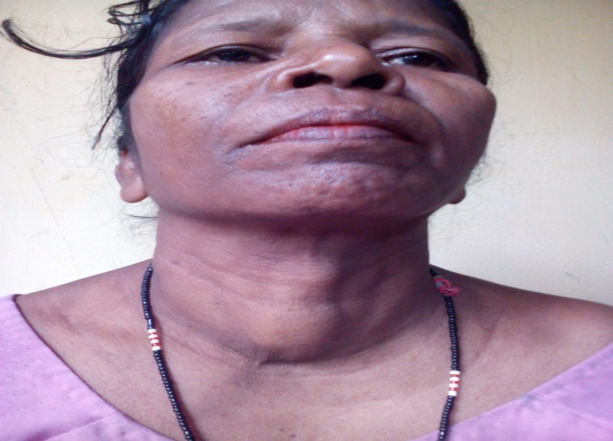
Fig.5: Clinical photograph of a patient with thyroid gland swelling

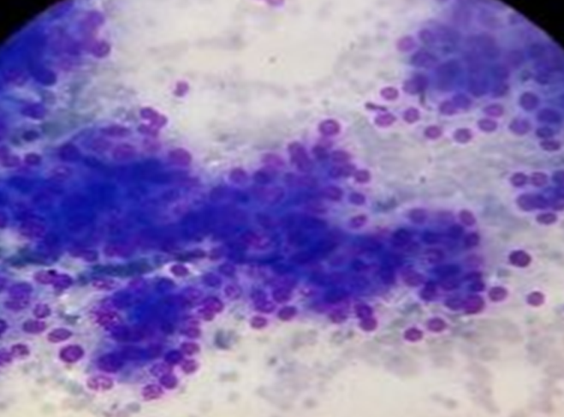
Fig.6: Cytological smear of follicular neoplasm of thyroid gland(MGGX100)

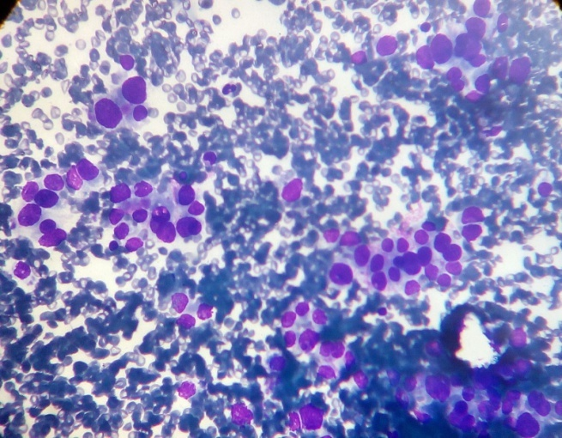
Fig.7: Cytological smear of follicular neoplasm of thyroid(MGGX400)
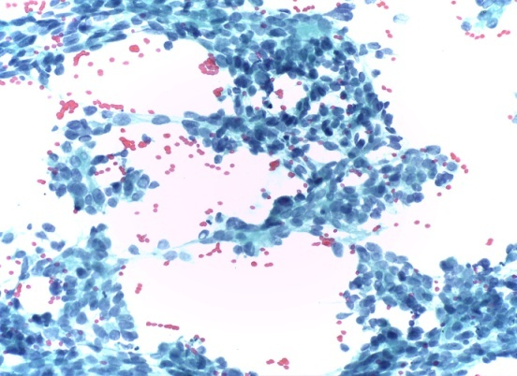
Fig.8: Cytological smear of papillary carcinoma thyroid(Pap x100)
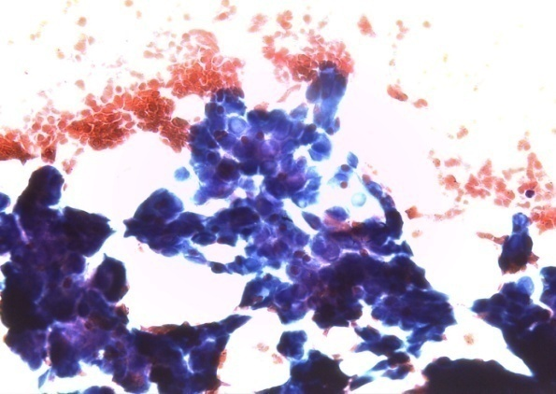

Fig.9: cytological smear of papillary carcinoma thyroid(Pap x400)

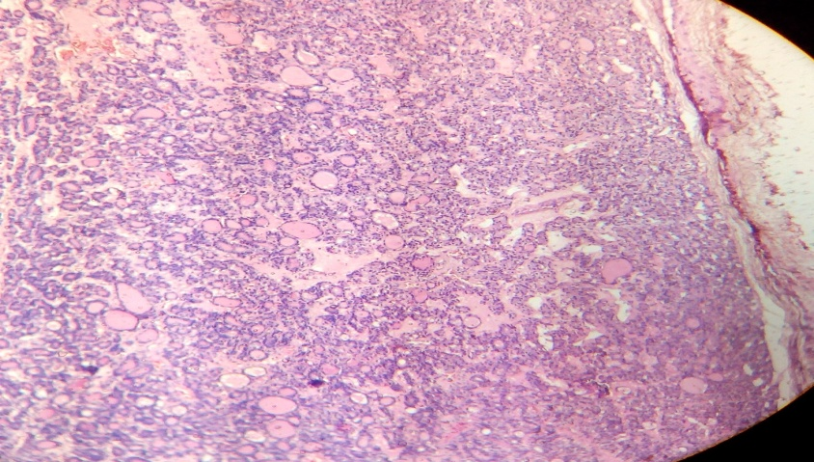
Fig.10: Tissue section from follicular adenoma(H&E x100)
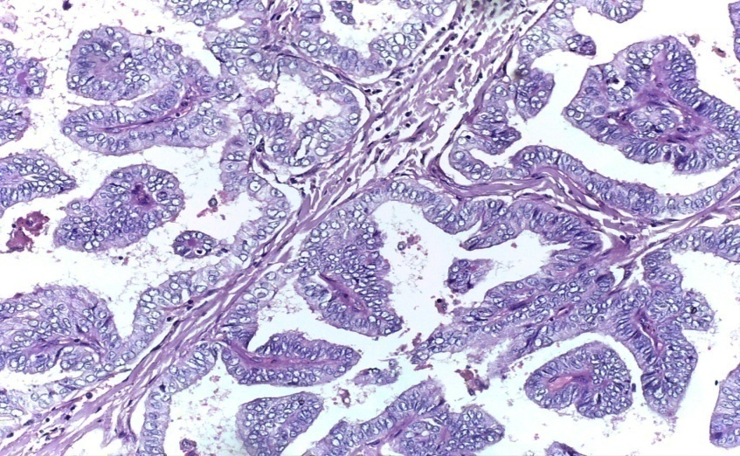
Fig.11: Tissue section from paoillary carcinoma thyroid(H&E x400)

