Abstract:
Root canal anatomy plays a significant role in endodontic success and failure. Endodontic failures can be attributed to inadequacies in shaping, cleaning and obturation, iatrogenic events, re-infection of the root canal system etc. Endodontic failures must be evaluated so a decision can be made among nonsurgical retreatment, surgical retreatment, or extraction. Surgical procedure can be a traumatic experience with many disadvantages like pain, edema, and other post operative complications which can hamper the patient’s daily activities. The goals of nonsurgical retreatment are to remove materials from the root canal space if present, address deficiencies or repair defects that are pathologic or iatrogenic in origin. It offers the patient a ray of hope to save a root canal treated tooth that would otherwise be destined for extraction. Hence a nonsurgical retreatment wherever feasible with an emphasis on effective sealing of infected root canal should be better attempted. This article will focus on some clinical case reports that produced successful results in nonsurgical endodontic retreatment.
Key words: Endodontic failures, deficiencies , obturation , complications.

Introduction:
Root canal system anatomy plays a significant role in endodontic success and failure¹.Proper diagnosis is a very important part in any endodontic procedure.There are many cases of failure of endodontic therapy. These cases include iatrogenic procedural errors(perforations,ledges, separation of instruments), missed canals, canals that are poorly shaped and obturated, overextrution of filling material as well as inadequate canal preparation and compaction of the root canal filling. In order to plan treatment effectively, the clinician must be aware of these etiologic factors which would otherwise lead to persistence of the pathosis. Endodontic failures must be evaluated so a decision can be made among nonsurgical retreatment, surgical retreatment, or extraction.²⁻³. Nonsurgical endodontic therapy requires the need to regain access to the apical area of the root canal space in the previously treated tooth. After that , all the principles of endodontic therapy apply to the completion of the retreatment case. Coronal access needs to be completed , all root canal fillings need to be removed, canal obstructions must be managed, and impediments to achieving full working length must be overcomed.⁴ Nonsurgical endodontic retreatment procedures have enormous potential for success if proper guidelines for case selection are followed and the most relevant technologies, best materials and precise techniques are utilized.⁵⁻⁷

CASE REPORTS:

Case I: A 38 year old male patient reported to our department of Conservative Dentistry and Endodontics, Regional Dental College, Guwahati with pain and palatal swelling in relation to the upper right front teeth. IOPA radiograph revealed incomplete obturation and periapical radiolucency in relation to upper right front teeth (Figure 1) . He gave history of trauma to the upper anterior teeth in a fall 4 years back. He had developed palatal swelling and undergone endodontic therapy.The patient remained asymptomatic till reappearance of the palatal swelling, which precipitated him to visit the hospital. The root canal system of both the teeth were accessed and the old gutta percha removed (utilizing Gates Glidden drills, hand instrumentation with Hedstrom files and Canalsolv gutta-percha solvent). The canals yielded purulent fluid exudate. After one hour following drainage and irrigation ,frank discharge subsided and the access preparations were sealed with a temporary filling material (Cavit).
Working lengths were determined for all three teeth electronically and radiographically (Figure 2 ) following endodontic principles. The canals were prepared by a step-back technique with K-type files (Dentsply Maillefer, Ballaigues, Switzerland). The irrigants (3% sodium hypochlorite and 0.2% chlor-hexidine) were delivered carefully and passively. Ave prep was used to remove the smear . After chemomechanical preparation, Metapex (calcium hydroxide plus iodoform) was introduced into the canal as an intracanal medicament and retained for 2 weeks. Finally, when the tooth became clinically asymptomatic the root canal systems were obturated with gutta-percha and zinc oxide eugenol sealer using lateral compaction technique ( Figure 3).
Six months post operative periapical radiographs reveals significant reduction in size of the lesion and appearance of new trabecular pattern in the region (Figure: 4).

CASE II:

A 45-year-old male patient reported to the department of Conservative Dentistry and Endodontics, Regional Dental College, Guwahati. Intraoral periapical radiograph confirmed that the patient had a deficient previous root canal treatment on the mandibular right first molar, with incomplete root canal fillings on both mesial and distal roots. ( Figure : 1) . The tooth was tender on percussion.

All the caries and the former composite coronal restoration material was removed from the pulp chamber along with the removal of remaining debris, sealer and gutta-percha from the root canals. The access cavity was refined with an Endo Access bur number A0164 (Dentsply Maillefer, Switzerland) .Debridement was done after removing the gutta-purcha using canalsolv and H files. The pulp chamber was thoroughly rinsed with 3% sodium hypochlorite solution . Working lengths were determined for all three teeth electronically and radiographically (Figure 2 ).The canals were prepared initially using K files till no. 25 after which hand protaper files are used and prepared till F 2. Canals were intermittently and copiously irrigated with 2 ml of 3% sodium hypochlorite after each instrument change. Irrigation with NaOCl alternated with 17% EDTA solution is done during and after the instrumentation, to remove the smear layer. After completing cleaning and shaping of all the root canals, final irrigation with sodium hypochlorite, sterile saline and 2% chlorhexidine solution in each root canal was performed. The canals were dried with sterile paper points and an interim dressing of calcium hydroxide(Avue cal) was placed as medication in each root canal for 2 weeks.
In the second appointment, the calcium hydroxide dressing was removed. The canals were irrigated again, dried with sterile -paper points and the gutta-percha master cones (F2), were inserted to the working length for each root canal. Each selected master cone was then placed into the corresponding root canal with zinc oxide eugenol sealer. Then, a post obturation radiograph was taken (Figure 3) . The permanent restoration of tooth was made with amalgam restoration .The patient was reviewed after 3 months, and no pathology was detected radiologically and clinically (Figure 4) .

CASE III:

A 38 year old male patient reported to our department of Conservative Dentistry and Endodontics, Regional Dental College, Guwahati. He complained of pain in respect to upper right central incisor . On clinical examination the tooth was found to be tender on percussion. Only less than 25% of coronal tooth structure was found to be visible clinically( Figure 1) . Intraoral periapical radiograph was taken and it was found that previous root canal treatment on the upper right central incisor was deficient ( Figure 2) .
The access cavity was refined with an Endo Access bur number A0164 (Dentsply Maillefer, Switzerland) and the old gutta percha removed (utilizing Gates Glidden drills, hand instrumentation with Hedstrom files and Canalsolv gutta-percha solvent). Working lengths were determined electronically . The canal was prepared by a step-back technique with K-type files (Dentsply Maillefer, Ballaigues, Switzerland). The irrigants (3% sodium hypochlorite and 0.2% chlor-hexidine) were delivered carefully and passively. Ave prep was used to remove the smear . After chemomechanical preparation and drying of root canal system, calcium hydroxide (Avue cal) was introduced into the canal as an intracanal medicament and retained for 2 weeks. Finally, the root canal systems of the incisors were obturated with gutta-percha and zinc oxide eugenol sealer using a lateral compaction technique (Figure 3). When the patient was recalled after 1 month for clinical and radiographical evaluation it was found that the tooth was asymptomatic. After which a cast metal post and core ( Figure: 4 ) was fabricated and restored with a porcelain fused to metal crown(Figure 5).

DISCUSSION:

The three cases presented here were unsuccessful because of incomplete three dimensional sealing of the root canal system . Each of these cases required unique treatment considerations for achieving endodontic goal. Case 1 required an additional change of calcium hydroxide over a 2 week period before noting elimination of the patient’s symptoms. Case 2 and Case 3 highlighted patients with long-standing symptoms with a long history of numerous repeated nonsurgical retreatment attempts.
Patients increasingly expect to retain their natural dentition and are often reluctant to have teeth extracted. Endodontic retreatment may offer the patient a second chance to save a root-treated tooth that would otherwise be destined for extraction.The basic requirement for successful root canal treatment is to seal the root canal system completely through a complete mechanical and chemical debridement of the entire root canal, followed by three-dimensional obturation with an inert filling material and a final coronal restoration, thereby preventing reinfection⁸. Many reports have shown a higher success rate when nonsurgical retreatment techniques are employed and, secondly, surgical success is significantly higher when it is preceded by a nonsurgical retreatment⁹.
Anatomically, apical deltas are present in the apical two-thirds of root canal systems that may harbour bacteria and their toxins when the tooth has a nonvital pulp. If the remaining bacteria, their by-products and necrotic material are not removed by cleaning and shaping procedures they will be responsible for the persistence of the periapical lesion. In the cases presented above, calcium hydroxide was placed as intracanal medicament in the root canals for two weeks, in order to kill the micro-organisms which were not eliminated by the irrigation protocol. Calcium hydroxide is indisputably the most appropriate intracanal medicament for teeth with periapical lesions, as it removes micro-organisms and promotes repair by controlling the inflammatory action (calcium proteinate bridge formation ), neutralizing osteoclasts acid products (acid hydrolases and lactic acid), inducing cellular differentiation (alkaline phosphatase activation and calcium de-pendent ATPases) and neutralization of exotoxins¹⁰.
Nonsurgical endodontic retreatment of the above mentioned cases are being performed to overcome the evasive surgical retreatment in terms of functional and psychological effect on patients.

CONCLUSION:

Regardless of the enormous potential for endodontic success, certain teeth exhibit post-treatment disease. Many endodontically failing teeth are either surgerized or extracted. This article has identified a variety of successfully retreated endodontically failing teeth role of nonsurgical endodontic retreatment in preserving strategic teeth. Proper selection of cases and careful treatment planning sets the stage for a successful outcome.

REFERENCES:

1.Ruddle CJ.Endodontic failures: the rationale and application of surgical retreatment, Revue D’Odonto Stomatologie. 1988, 17:6, pp. 511-569
2. Stabholz A, Friedman S: Endodontic retreatment- case selection and technique. Part 2: treatment planning for retreatment. 1988, J Endod 14:12, pp. 607-614
3. Kvist T, Reit C: Results of endodontic retreatment: a randomized clinical study comparing surgical and nonsurgical procedures, J Endod. 1999, 25:12, pp. 814-817
4. Stephen Cohen,Kenneth M.Hargreaves.Pathways of the Pulp. Page 954, 9th edition . 2006
5. Blum JY, Machtou P, Ruddle CJ, Micallef JP: The analysis of mechanical preparations in extracted teeth using protaper rotary instruments: value of the safety quotient, J Endod.2003 29:9, pp. 567-575.
6. Ruddle CJ: Nickel-titanium rotary instruments: current concepts for preparing the root canal system, Australian Endodontic Journal.2003, 29:2, pp. 87-98.
7. Ruddle CJ: Microendodontic nonsurgical retreatment, in Microscopes in Endodontics, Dent Clin North Am, W.B. Saunders, Philadelphia, July 1997, 41:3, pp. 429-454
8. FJ Vertucci. Root canal morphology and its relationship to endodontic procedures. Endodontic Topics. 2005;10:3–29.
9. Bergenholtz G, Lekholm U, Milthon R, Heden G, Odesjo B, Engstrom B (1979) Retreatment of endodontic failures.Scandinavian Journal of Dental Research . 87 , 217–24.
10. Soares J, Santos S, Silveira F, Nunes E. Nonsurgical treatment of extensive cyst-like periapical lesion of endodontic origin. Int Endod J. 2006;39:566–75.

IMAGES:
CASE: I
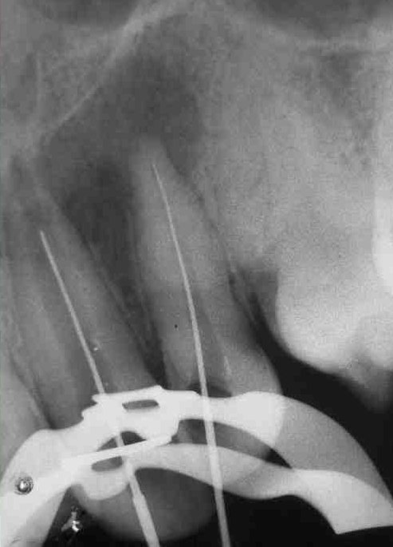
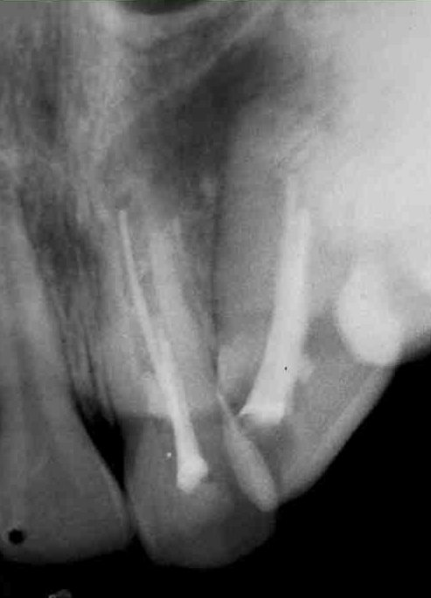

Figure : 1(preoperative) Figure: 2 (Working Length determination)

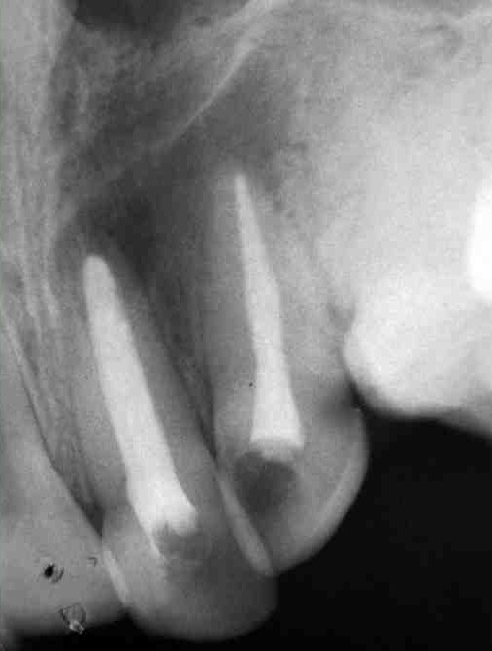
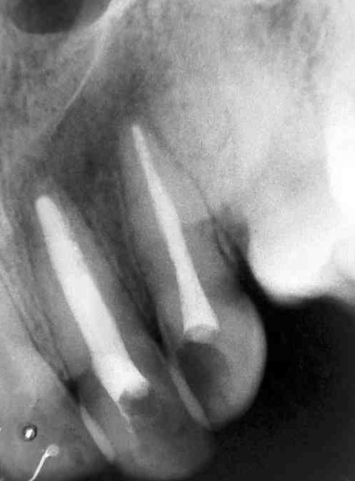

Figure : 3 (Obturation completed) Figure: 4( Follow up after 6 months)

CASE: II

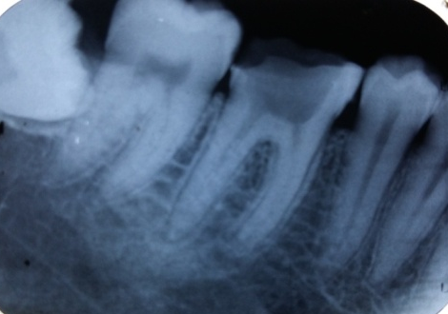
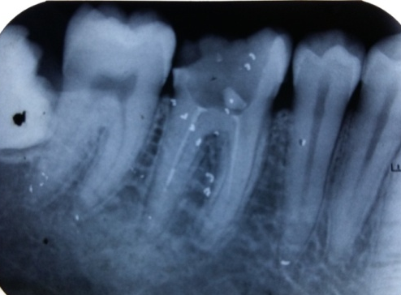

Figure : 1(preoperative) Figure 2: (After debridement of the canals)

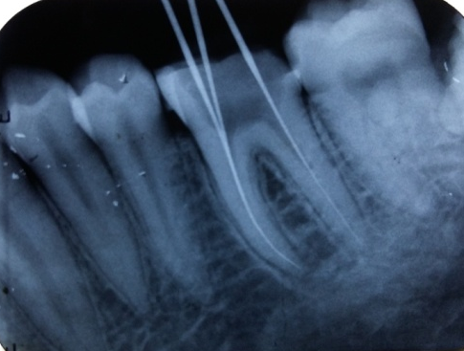
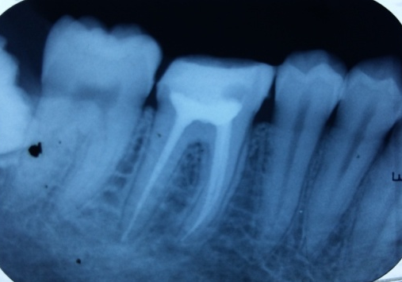

Figure: 4 ( Working length determination) Figure 3: (Post operative radiograph)

CASE III:

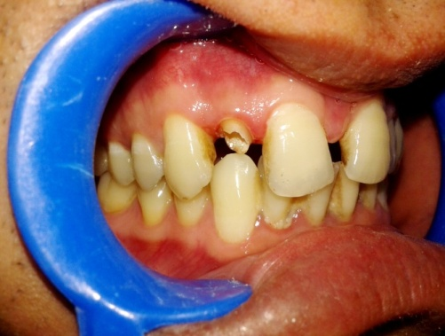
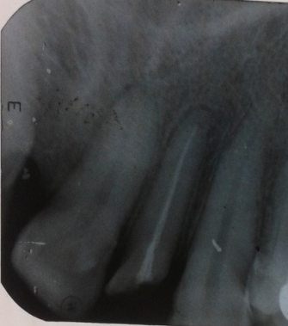

Figure:1(preoperative clinical) Figure :2( pre operative radiograph)
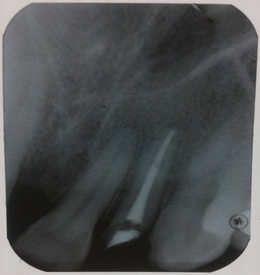

Figure: 3( post obturation radiograph)
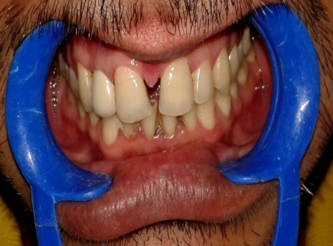
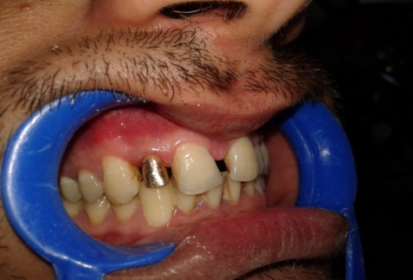

Figure:4(cast post fabricated and luted) Figure :5 ( Luted with porcelain fused to
metal crown)

