INTRODUCTION
Burn patients form a sizable section of acute emergency admissions. In India, there are 70,000 to 80,000 burn admissions annually. Thus the high incidence makes burn an endemic health hazard.
As per incidence, the developing countries outrun the developed countries. Burns happen to be common in the rural areas with accidental burn leading the list, followed closely by the suicidal and homicidal burns. Burns, with a clear female preponderance over males, also have a significant seasonal variation being more common in the winter months.
The present study has been designed to analyze the epidemiology of fatal burn cases.
Management of burn entails the collective effort from surgical units and intensive therapy. This has made necessary for the development of specialized burn units in several hospitals. Thus this study will explore the problems against the backdrop of our health care setup and will probably help to formulate the strategies for the prevention of unnatural deaths due to burns.

MATERIALS & METHODS
- STUDY AREA: Burdwan Medical College & Hospital (BMC&H)
- STUDY POPULATION: All the fatal burn cases being reported for autopsy at Police Morgue, Burdwan Medical College.
- STUDY PERIOD: Commencing from Feb-2010 & continuing till Jan-2011
- SAMPLE SIZE: All the cases of fatal burn examined at autopsy at the Mortuary, BMC
- SAMPLE DESIGN: In the present study, all the fatal burn cases examined at the Mortuary for autopsy will be selected following the inclusion and exclusion criteria fixed for this study.
*Inclusion criteria: Subjects with only burn injuries in fresh bodies.
*Exclusion criteria: Mixed injuries, decomposed bodies.
- STUDY DESIGN:
- Retrospective studies in fatal burn cases reported for autopsy in previous three years.
- Cross-sectional prospective study of all the fatal burn cases examined.
- PARAMETERS TO BE STUDIED:
  - Socio-demographic profile of the victims of burn (From the history taken from the police officials and the relatives accompanying the victim).
  - Body surface area in square metres.
  - Percentage of burn (Calculated using the Rule of Nine).
  - Interval between the incident of burn and report to hospital (From the inquest report).
  - Duration of hospital stay in hours (From the information of death).
  - Interval between sustaining burn and death (from the inquest and the information of death).
- STUDY TOOLS:
- Predesigned pretested proforma to collect data.
- Recording of autopsy findings in standard formats
[PM Report vide West Bengal form number 5372]
- STUDY TECHNIQUE:
Retrospective studies are used to determine the fatal burn cases in the last three years, 2007- 2009. Cross-sectional prospective studies are used to determine all the fatal burn cases reported at the Burdwan Medical College Police Morgue from February 2010 to January 2011.
- DATA ANALYSIS METHOD: Data entry will be done right after capture of relevant data for a given subject is complete. Logistic regression, Discriminant function and Multivariate analysis by ‘SPSS software for WINDOWS’ will be used for data-analysis.

RESULTS & ANALYSIS
- FATALITY DUE TO BURNS IN THE YEARS 2007, 2008 & 2009
- The total number of cases examined in the years 2007, 2008 and 2009 were 1938, 2021 and 2007 respectively. Among all these cases, the total number of victims due to fatal burn injuries in the years 2007, 2008 and 2009 were 209 (10.78%), 259 (12.81%) and 239 (11.91%) respectively.
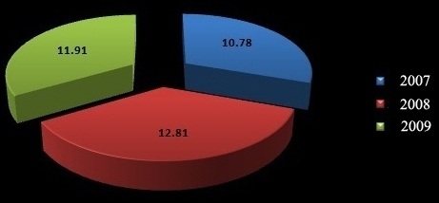
Figure 1: Yearly distribution in percentages of the total number of deaths due to fatal burn injuries.

- GENDER DISTRIBUTION OF THE FATAL BURN CASES IN THE YEARS 2007, 2008, 2009 AND THE PRESENT STUDY PERIOD
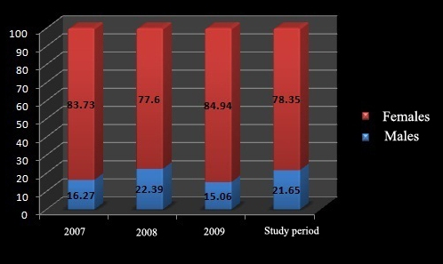
Figure 2: Gender distribution.

- AGE DISTRIBUTION OF THE FATAL BURN CASES IN THE PRESENT STUDY PERIOD

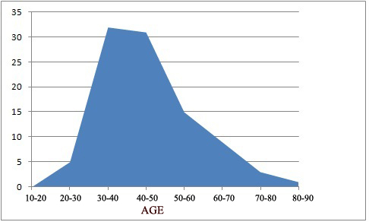
Figure 3: Age distribution in the study period.

- DISTRIBUTION BY RELIGION OF THE FATAL BURN CASES IN THE YEARS 2007, 2008, 2009 AND THE PRESENT STUDY PERIOD.
  - In the years 2007- 2009 and the present study period, 209, 259, 239 and 97 were the victims due to fatal burn injuries respectively.

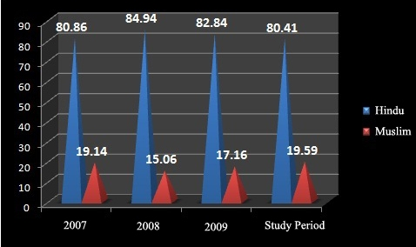
Figure 4: Distribution as per religion in percentages.
  - DISTRIBUTION BY RESIDENCE (URBAN / RURAL) OF THE FATAL BURN CASES IN THE YEARS 2007- 2009 AND THE PRESENT STUDY .
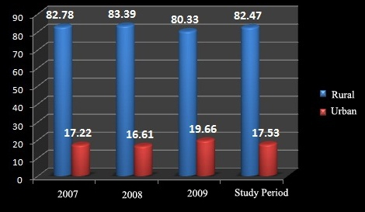
Figure 5: Distribution as per residential status in percentages.
- DISTRIBUTION BY SEASONAL VARIATION (MONTHWISE) OF THE FATAL BURN CASES IN THE YEARS 2007, 2008, 2009 AND THE PRESENT STUDY PERIOD (FEBRUARY, 2010 TO JANUARY, 2011).
.

Period | 2007 |  | 2008 |  | 2009 |  | Present Study
Month | Number | Percentage | Number | Percentage | Number | Percentage | Number | Percentage
JAN | 29 | 13.86 | 21 | 8.11 | 19 | 7.95 | - | -
FEB | 16 | 7.66 | 20 | 7.72 | 15 | 6.28 | - | -
MAR | 20 | 9.57 | 28 | 10.81 | 19 | 7.95 | - | -
APR | 15 | 7.18 | 31 | 11.97 | 17 | 7.11 | 13 | 13.402
MAY | 21 | 10.05 | 12 | 4.63 | 26 | 10.88 | 9 | 9.28
JUN | 20 | 9.57 | 31 | 11.97 | 22 | 9.205 | 9 | 9.28
JUL | 13 | 6.22 | 16 | 6.18 | 23 | 9.62 | 14 | 14.43
AUG | 5 | 2.39 | 17 | 6.56 | 15 | 6.28 | 11 | 11.34
SEP | 12 | 5.74 | 22 | 8.49 | 17 | 7.11 | 8 | 8.25
OCT | 12 | 5.74 | 17 | 6.56 | 20 | 8.37 | 9 | 9.28
NOV | 23 | 11.004 | 18 | 6.95 | 17 | 7.11 | 12 | 12.37
DEC | 23 | 11.004 | 25 | 9.65 | 29 | 12.13 | 12 | 12.37
Table 1: Distribution of the victims of burn injury according to the seasonal variation.

- MANNER OF BURN INJURY AS DETECTED FROM THE INQUEST REPORT IN THE PRESENT STUDY PERIOD.

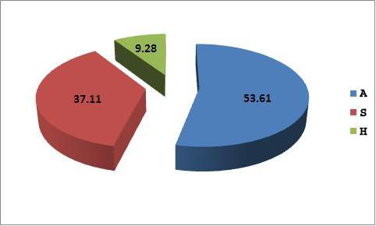
A: Accident
S: Suicide
H: Homicide
Figure 6: Distribution as per manner of death.
- THE VARIOUS TRENDS OBSERVED IN DOWRY DEATHS IN THE PRESENT STUDY PERIOD (FEBRUARY, 2010 TO JANUARY, 2011).

  - Out of total 97 victims of fatal burn injury, 24 females died within 7 years of their marriage (dowry death). This is shown in Figure 7.
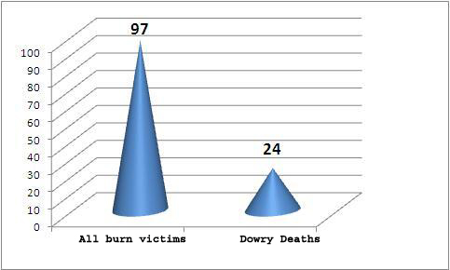
Figure 7: Dowry deaths as compared to the total burn victims.

DOWRY DEATH TRENDS
Total  Deaths | Percentage | Mean  Age | Religion |  | Place |  | Manner
Total  Deaths | Percentage | Mean  Age | Hindu | Muslim | Rural | Urban | A | S | H
24 | 24.74% | 24.79 | 87.5% | 12.5% | 83.33% | 16.67% | 33.33% | 37.5% | 29.17%
A: Accident
S: Suicide
H: Homicide
Table 2: Dowry death trends in the victims of fatal burn injuries.

- THE TIMES OF INCIDENT IN THE PRESENT STUDY PERIOD (FEBRUARY, 2010 TO JANUARY, 2011).
  - For convenience, we divided an entire day i.e. 24 hours into four quadrants, 6 hours each. The distribution of victims of fatal bun injury is depicted in Table 3.
Groups | Time Periods | Number of victims | Percentage
A | 12.01 a.m.-6.00 a.m. | 13 | 13.40%
B | 06.01 a.m.-12.00 noon | 25 | 25.77%
C | 12.01 p.m.-6.00 p.m. | 28 | 28.87%
D | 6.01 p.m.-12.00 midnight | 31 | 31.96%
TOTAL |  | 97
Table 3: Distribution of victims as per time of incident and their percentages.

- TIME OF SURVIVAL AFTER SUSTAINING BURN INJURIES
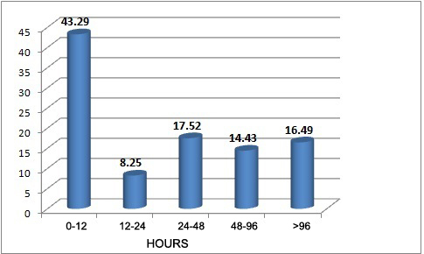
Figure 8: Percentage of time of survival.
- CORRELATION BETWEEN TIME OF SURVIVAL AND PERCENTGE OF BURN

Correlations
 |  | time | percentage
time | Pearson Correlation | 1 | -.352**
time | Sig. (2-tailed) |  | .000
time | N | 97 | 97
percentage | Pearson Correlation | -.352** | 1
percentage | Sig. (2-tailed) | .000
percentage | N | 97 | 97
**. Correlation is significant at the 0.01 level (2-tailed).
Table 4: Correlation between time of survival and percentage of burn.

DISCUSSION & CONCLUSIONS

In the retrospective study conducted from 2007-2009, shown in Figure 1, the percentage of deaths due to fatal burn injuries was reported to be 10.78%, 12.81% and 11.91% respectively. However, in a study conducted in the eastern zone of India (West Bengal) by S. Chakraborty and others, the mortality rate due to burns was found out to be 23.5% (1), a bit higher than the percentage derived from our study. This difference may be due to the fact that we have excluded the cases of fatal burn injury which were decomposed and which sustained multiple injuries other than the burns. Moreover, the victims of pure burn injuries were only taken into consideration in our study i.e. the victims dead due to scalds, electrical burns and lightning or radiation burns were excluded.
Figure 2 shows the gender distribution in our study group. The mean percentage of males and females in our study group is 18.84% and 81.15% respectively. Almost similar trends were noticed in a study carried out in an Apex centre in North India by Batra (2). This may be due to the fact that women are more susceptible to burn injuries, as they are nervous and sensitive in nature (3). This may be also due to gender difference, socio-cultural factors and dowry problems. Secondly most of the women are housewives and they come more in contact with fire mostly in the kitchens and other household practices (4). Further, it is also seen that in accidental fires, chance of escape from serious burn injuries are more for males than the females as they also withstand burn injuries better than the females. Further, fire is a common suicidal arm for women in our country.
As evident from Figure 3, most of the victims were of the age group of 20-40 years. These findings are also consistent with the study of Batra in North India, who reported that 75% of the affected belonged to the age group of 21-40 years and also with the study in Imphal where the age group most involved was 21-30 yrs with an incidence of 38.46% (5). The high figures in females of this age group appear to be due to the fact that most women of this age group work in the kitchens (6). Also the females in this age group commit suicides many a times by burning themselves on various familial and other reasons. The high figures in males in this age group might have certain bearing on the nature of the job performed by them. Fatal burn injuries in very old people are comparatively less common obviously due to their less vulnerability.
Figure 4 depicts that the total number of victims of Hindu religion affected in the years 2007-2009 and the present study period were 80.86%, 84.94%, 82.84% and 80.41% respectively. The study by Pathak et al in Vadodara city showed that of all those who were affected, 82.91% were of the Hindu religion (7). These findings are supported by the fact that in the district of Burdwan as per the census 2001 the ratio between the Hindus and the Muslims is 2.67:1 (8).
In our study group, the mean rural and urban residences are 82.24% and 17.75% respectively (Figure 5). Chamania et al figured out that the process of fatal burn injury was more common in rural India (9). Findings of our study closely tally with the findings of a study in North India by Batra et al (Rural deaths-75%) (2). Ghaffar et al also showed that the total deaths in rural India constituted 68.4% of the total deaths due to burn injuries (10). Inadequate power supply in the rural areas leading to the use of kerosene lamps for lighting, weakly designed kerosene stoves, polyester mixed fabrics worn by the rural women, ill-designed huts and scanty medical facilities all contribute to the increased number of fatal burn injuries in the rural population.
Table 1 show that the death due to the fatal burn injuries is more in the winter months. Findings of our study are consistent with the study by Ekrami et al, where burns were found to be more in the winter (33.6%), followed by autumn (25.6%), spring (21%) and summer (19.6%) (11). Greater number of victims in the winter months (January-32.30%, December-10.76%, November-7.69%) was also seen in the study at Imphal by Nabachandra et al. (5). This may be due to the use of fire for warming in the winter days.
Figure 6 shows that the total number of deaths due to fatal burn injuries is maximum due to accidents (53.61%), followed by suicides (37.11%) and homicide (9.28%). A study at North India showed that the manner of deaths due to fatal burn injuries were accidents (50.7%), followed by the suicides (47.8%) and homicides (1.5%) (2). A study by Subrahmanyam et al also portrays the manner of deaths due to burn injuries as accidents (43.6%), suicides (24.3%) and homicides (7.8%) (12). Studies at central India (10) and eastern provinces (1) clearly pointed out that the deaths due to fatal burn injuries (accidental in manner) were 75.8% and 61.4% respectively.
In our study, 24.74% of the total deaths due to fatal burn injuries were due to dowry death (Figure 7). Reports submitted by the National Crime Records Bereau in the year 2010 depicted that 30% of the total deaths due to burn injuries constituted dowry deaths (13). Low educational levels of women, poor implementation of existing laws, lack of establishment of voluntary associations to decrease the importance of dowries and the absence of community level programmes may be the contributing factors to the rising toll of dowry deaths in India (14). Table 2 depicts the various trends of dowry deaths observed in India. In our study, of the total deaths due to dowry, 37.5% were suicidal in manner, 33.33% accidents and the rest 29.17% were homicidal. The results are similar to the study of Amanda Hitchcok in Lucknow, which reported that most of the dowry deaths in India were suicidal (15).
Table 3 points out to the time of sustaining the burn injuries. It was found out that most of the burn injuries (31.96%) were sustained between 06.00 p.m. to 12.00 midnight. Our results are contrary to the observations by Nabachandra et al, who reported that 53.84% of the injuries were sustained at daytime and the rest 46.15% at night (5). This may be due to the fact that people are usually occupied in their work during daytime and therefore the burns are sustained in the course of their activities. However, in our study the increased toll at the night time may be due to ill designed lamps by spilling of kerosene, mosquito nets catching fire from the bedside lamps, unsafe cooking media and in the process of warming themselves in the cold winter months.
Figure 8 depicts the time of survival after sustaining burn injuries, where 43.29% died within 12 hours, 8.25% within 12-24 hours, 17.52% within 24-48 hours, 14.435% within 48-96 hours and the rest 16.49% survived for more than 96 hours. Of the entire victims 15.46% died within one hour of sustaining the fatal burn injuries. These observations are in conformity with the study by Majumder who reported that maximum number of deaths (35%) were within first 12 hours after sustaining the injury (6). 12% died within 12-24 hours, 10% within 24-48 hours, 8% within 48-96 hours and the rest 28% after 96 hours. The victims who succumbed within one hour, sustained extensive burn injuries involving wide body surface area and of more severe degrees. In 16.49% who died after 96 hours, even though they received reasonably good treatment and attention, the cause of death being several factors in addition to the direct affects of burning.
Table 4 shows the correlation between the percentage of burn and the time of survival after sustaining the burn injury. It was seen that with increased percentage of burns, the time of survival of the victims decreased. The results of our study are consistent with a study from Nigeria which shows decreased survival periods with increased burned surface areas (16).

Legislation, health promotion and appliance design have reduced the incidence of burns, with regulations regarding flame-retardant clothes and furniture, the promotion of smoke alarms, the design of cookers and gas fires, the almost universal use of cordless kettles, and the education of parents to keep their hot water thermostat to sixty degree Celsius all playing their part (17). A vast spectrum of injuries can arise from a burning accident, from the trivial to some of the most dramatic injuries that humans survive. The management of the major burn injury represents a significant challenge to every member of the burns team – burns doctors, anaesthesists, ward and theatre nurses, physiotherapists, occupational therapists, dietitians, bacteriologists, physicians, psychiatrists, psychologists and the many ancillary staff whose cleaning and supply services are vital to the successful running of a burn unit. A large burn injury will have a significant effect on the patient’s family and friends and the patient’s future.

REFERENCES
- Chakraborty S, Bisoi S, Chattopadhyay D. A study on demographic and clinical profile of burn patients in an Apex Institute of West Bengal. Short Communication. 2010 September 29; 54(1): p. 27-9.
- Batra AK. Burn mortality: recent trends and sociocultural determinants in rural India. Burns. 2003 May; 29(3): p. 270-75.
- Mukherjee JB. Injury and its Medico-legal aspects. In Karmakar RN, editor. Forensic Medicine and Toxicology. 3rd ed. India: Academic Publishers; 2007.
- Haralkar JS, Tapare VS, Rayate MV. Study of socio-demographic profile of burn cases admitted in Shri. National Journal of Community Medicine.2011; 2(1).
- Memchoubi P, Nabachandra H. A Study of Burn Deaths in Imphal. JIAFM. 2007; 29(4).
- Majumder BC. A medicolegal study of the cases of burn injuries including the histopathological changes occurring in the pituitary and adrenal cortex. 1981.
- Pathak A, Sharma S. The Study of Un-Natural Female Deaths in Vadodara City. J Indian Acad Forensic Med. ; 32(3).
- National Informatics Centre(Burdwan District Unit). [Online]. Available from: http://www.bardhaman.nic.in.
- Chamania S. Training and burn care in rural India. Indian Journal of Plastic Surgery.2010; 43(3): p. 126-30.
- Ghaffar UB, Husain M, Rizvi SJ. Thermal Burn: An Epidemiological Prospective Study. J Indian Acad Forensic Med. ; 30(1).
- Ekrami A, Hemadi A, Latifi M, Kalatar E. Epidemiology of hospitalized burn patients in Teleghani Hospital during 2003-2007. Bratisl Lek Listy. 2010; 111(7): p. 384-88.
- Shanmugakrishnan RR, Narayanan V, Thirumalaikolundusubramanian P. Epidemiology of burns in a teaching hospital in south India. Indian Journal of Plastic Surgery. 2008; 41(1): p. 34-37.
- Disposal of Cases by Courts. 2010.
- Kumar V, Kanth S. Bride burning. The Lancet. ; 364: p. 18-19.
- Hitchcock A. World Socialist Web Site. [Online].; 2001. Available from: http://www.wsws.org.
- Olaitan PB, Jiburum BC. Analysis of burn mortality in a burns centre. Annals of Burns and Fire Disasters. 2006 June; 19(2).
- Tyler M. Burns. In 24th , editor. Short Practice of Surgery.: Hodder Arnold; 2004. p. 266-78.

