“A PROSPECTIVE STUDY FOR EVALUATION OF CLINICAL AND FUNCTIONAL OUTCOMES OF OPEN REDUCTION AND INTERNAL FIXATION IN FRESH DISPLACED PILON FRACTURES”

KIRAN SONOWAL¹, ASSOCIATE PROF. CHINMOY DAS ² PROF P. K.BHATTACHARYYA³
(Department of Orthopaedics, Gauhati Medical College and Hospital, India)

Abstract:
There are several methods for treatment of pilon fracture. We propose to evaluate the clinical and functional outcome in terms of union of the fracture, mobilisation, weight bearing, infections and wound coverage after open reduction and internal fixation in closed fresh displaced pilon fracture with the help of distal tibial locking compression plate. Even though we have conducted this study to compare our results with the various national and International studies.
Method:- We have conducted a prospective study for 40 cases of Fresh displaced tibial pilon fractures in patients aged between 18yrs - 65yrs attending the OPD and Emergency department of Orthopaedics, Gauhati Medical College & Hospital, Guwahati who met the inclusion criteria outlined below. Patients were treated by open reduction and internal fixation of the fractures with Distal Tibial lock plate with or without Fibula plating.
Results:- Patient were followed up for two years evaluated by AOFAS score and compared with standard study. From our study we have obtained 21(52.5%) of patients have Excellent result, 10(25%) of patients have Good, 7(17.5%) patients have Fair and 2(5%) have poor result.
Conclusion:- Restoration of length, articular reduction, articular congruity, axial and rotational alignment with better soft tissue handling are key to excellent functional results following fractures of tibial pilon. Final outcome depends upon chondral damage, residual articular displacement, soft tissue scarring and early mobilization.The functional result is directly proportionate to the anatomical reduction and fixation during operation and inversely proportionate to the fracture comminution.
Keywords: Pilon, articular surface, AOFAS, articular congruity, Distal tibial lock plate.

Introduction:- Pilon fractures often present a challenge to the orthopaedic surgeon. ‘Destot’ first used the term pilon fracture in 1911. The tibial pilon¹ comprises anatomically the distal end of the tibia including the articular surface. The three- dimensional configuration of this region appears to be designed to increase the area of the articular surface, reducing the stress on the ankle joint. By convention, all fractures of the tibia involving the distal articular surface should be classified as tibial pilon fractures, except for medial or lateral malleolar fractures and trimalleolar fractures where the posterior malleolar fracture involves less than 1/3 of the articular surface. Tibial pilon fractures represent <1% of lower extremity fractures and 5-7% of all tibial fractures. The treatment of this type of fracture is of current research interest, since there is no universally agreed treatment method. The choice of treatment must take into account not only the stabilization of the fracture, but also the management of the soft tissue injury which is a frequent cause of subsequent complications. Great attention must be given to the accurate reconstruction of the articular surface to avoid the development of arthritis of the ankle joint. The greatest challenge to the orthopaedic surgeon lies in the relatively tight soft tissue around the ankle. Successful treatment of displaced pilon fractures requires a thorough understanding of the injury, proper timing of treatment, and use of the proper implant placed in the correct location. Open reduction and internal fixation with distal tibial locking compression plate for pilon fracture with or without fibula fracture fixation may show excellent outcome. The purpose of this study is to throw light to the ongoing controversies about the choice of treatment modality, choice of implant and surgical approaches with the aim of increasing the functional outcome reducing the danger of skin complication like infection, sloughing and necrosis and ultimately giving the patient with least morbidity post operatively.
MATERIAL AND METHOD
We conducted a prospective study for 40 cases of Fresh displaced tibial pilon fractures in patients aged between 18yrs - 65yrs attending the OPD and Emergency department of Orthopaedics, Gauhati Medical College & Hospital, Guwahati who met the inclusion criteria outlined below.

INCLUSION CRITERIA
- Those patient who were admitted from from 1st April 2014 to 31st March 2015 are included.
- Patients who gave written and informed consent .
- All displaced tibial-Pilon fractures in patients aged 18-65yrs.
- Closed fracture and Gustilo- Andersion type I compound pilon fracture with closed fibula fracture
- Duration of injury < 2 weeks
- Competent neurological and vascular status of the affected limb.
- Ipsilateral hip, knee, and contralateral lower limb functionally good enough, so as not to exert a serious adverse effect on the rehabilitation process.
- Only patients with a near normal daily activities of life
- Patients who meet the medical standards for routine elective surgery.
EXCLUSION CRITERIA
- Patients who do not give consent.
- Patients age <18 years and >65 years.
- Inability to take part in post operative rehabilitation.
- All compound fractures except Gustilo-Anderson Type 1 fractures
- Medical contraindications to surgery
- Duration of injury > 2 weeks
- Associated ipsilateral or contralateral major limb injury affecting treatment or rehabilitation protocol.
- Doubtful neurovascular status of the limb.
- Previous distal tibial abnormalities ( infection, tumour)
- Patients with multiple major bone fractures
Choice of implants and Approaches
AO LCP medial distal tibial plate were selected in 43B and 43C fractures with medial comminution. In these cases we used Antero-medial approach for better visualization of fracture.
AO LCP lateral distal tibial plate were selected in 43B and 43C with anterior and anterolateral comminution. In these cases we used Anterolateral approach.
Associated fibular plating were done in cases where - Fibula fracture is above the ankle joint line, associated with syndesmotic
.
OBSERVATION AND RESULT
Our study was conducted from 1st April 2014 to 31st March 2015. We came across 40 cases of pilon fractures.
All the patients were followed up for a minimum period of six months and maximum period for 18 months. Follow up was carried out at 4, 6, 12, 16, 20 weeks and then at 6 monthly intervals. Full assessment was done at the end of 4 months from the date operation in all cases.
MODE OF INJURY

AO CLASSIFICATION OF FRACTURES
The most common pattern of fracture was AO 43B2 (32.5%)
Table : AO classification of fractures
Fracture pattern | No. of patients | Percentage
43B1 | 5 | 12.5%
43B2 | 13 | 32.5%
43B3 | 5 | 12.5%
43C1 | 9 | 22.5%
43C2 | 6 | 15%
43C3 | 2 | 5%
Total | 40 | 100

COMMENCEMENT OF PARTIAL WEIGHT BEARING
In our study we have allowed to bear partial weight at an average of 6.8 weeks, min. 6 wks and max. 12 weeks. Full weight bearing was allowed at 16-20 weeks.
UNION
Overall average union time is 17.16 weeks(16-20 weeks).
RANGE OF MOTION OF ANKLE
We have evaluated the patient for ankle range motion at union. We observed 8(20%) patient presented with > 30⁰, 27(67.5%) patients shows 15⁰-29⁰ and 5 (12.5%) patients shows <15º.
AOFAS SCORE RESULT
The functional result at union, as assessed by the AOFAS scoring system showed that the average in our series is 83.37 (min 58 and max. 90).
CLINICAL RESULTS
Functional results are evaluated according to American Orthopaedics foot and ankle society score. Majority (n=21, 52.5%) of the patients in the study had excellent functional results.
Table:- Functional results
Function | Excellent | Good | Fair | Poor
No. of patients | 21(52.5%) | 10( 25%) | 7(17.5%) | 2(5%)
l
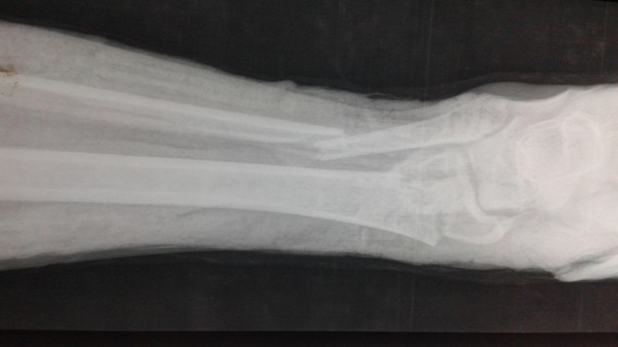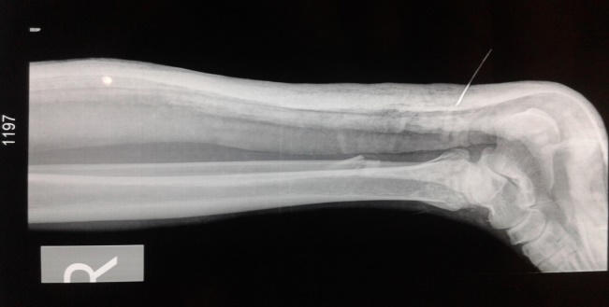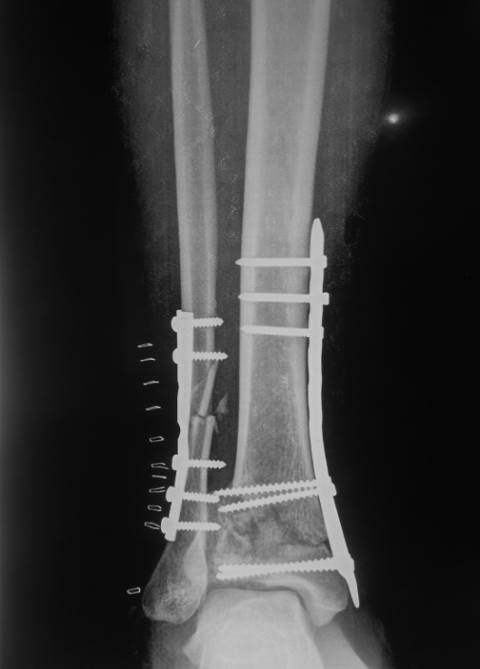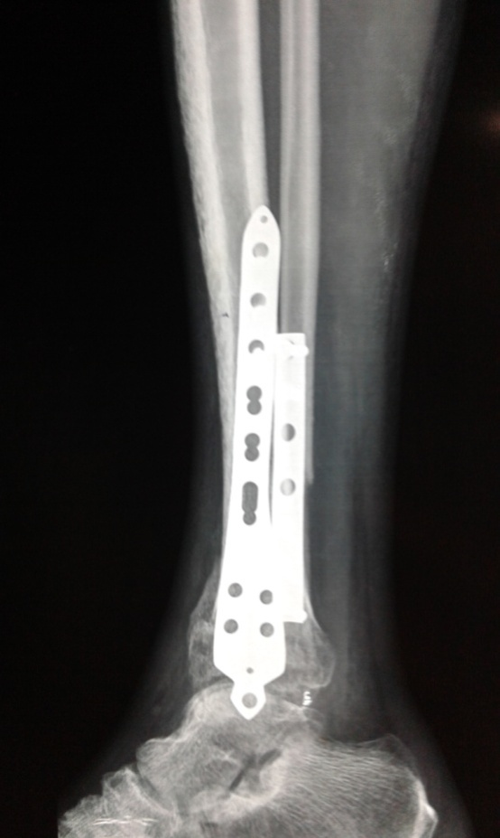

COMPLICATION
In our study we came across our fair share of complications. There are 2 (5%)cases of superficial infection and 1 (2.5%) deep infection. There are 2 (5%) cases which went for delayed union. 1 (2.5%) case of non-union where there is no signs of union seen till 9 months of surgery. There were 2 (5%) cases of malunion with 10⁰ varus angulation. No case of ankle instability was present in our study. There were only 5 (12.5%) patients who had restriction below 15⁰ ROM.

Complications
INFECTIONS: 2 (5%) superficial and 1 (2.5%) deep infection cases 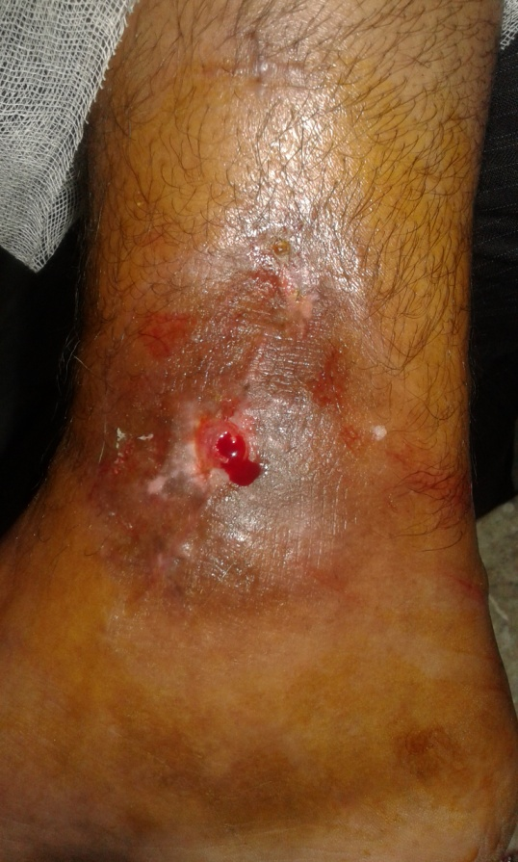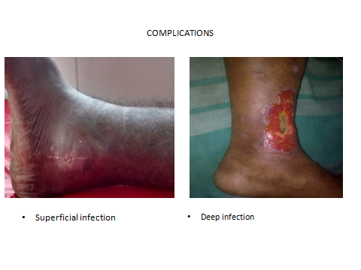

CONCLUSION
Restoration of length, articular reduction, articular congruity, axial and rotational alignment with better soft tissue handling are key to excellent functional results following fractures of tibial pilon. Final outcome depends upon chondral damage, residual articular displacement, soft tissue scarring and early mobilization.
The functional result is directly proportionate to the anatomical reduction and fixation during operation and inversely proportionate to the fracture comminution.
The principles and procedure of primary open reduction and internal fixation of pilon fracture with distal tibial locking compression plate with or without fibula plating contribute towards optimal reduction and good stabilization in pilon fracture.
Complications such as stiffness, can be minimized with early mobilization after relieve of pain post operatively and early physiotherapy. Stiffness is found to be less where wound heals with minimal scar.
Overall union rate in our study is comparable with the other major studies done on pilon fracture.
Primary ORIF in fresh displaced pilon fracture gave satisfactory functional results. The anatomical or radiological outcomes did not always correlate with the functional outcomes. The functional outcome was seen to be even better in some of the patients who had less than adequate anatomical or radiological appearance.
Displaced fibular fractures should always be picked up for fibular plating in an attempt to contribute towards greater stability of the ankle mortice.
A prospective study involving a large number of patients with long term follow-up is clearly needed to bring the long term result evaluation for this procedure undertaken. BIBLIOGRAPHY
1. Ruedi T, Matter P, Allgower M. Intra articular fractures distal tibial end. Helv Chir Acta 1968;3(5):556-582
2. Dillin L, Slabaugh P. Delayed wound healing, infection and nonunion following open reduction and internal fixation of tibial plafond fractures. J Trauma1986;26(12):1116-1119.
3. Teeny SM, Wiss DA; Open reduction and internal fixation of tibial plafond fractures. Variables contributing to poor results and complication, Clin Orthop Relate Res 292:108-117, 1993.
4. Tornetta P III, Weiner L, Bergman M, et al. Pilon fractures: treatment with combined internal and external fixation. J Orthop Trauma 1993;7(6):489-496.

5. Zeng XT, Pang GG, Ma BT, Mei XL, Sun X, Wang J,et al. Surgical treatment of open pilon fractures.Orthop Surg.; 2011 Feb;3(1):45-51.
6. White TO, Guy P, Cooke CJl. The results of early primary open reduction and internal fixation for treatment of OTA 43. C-type tibial pilon fractures: a cohort study. J Orthop Trauma. 2010;24:757–763
7. Tang X,Lei L, Chong- T,Jian L, Qi L,Fu-xing P M. Comparison of early and delayed ORIF for treating Closed Tibial Pilon fractures. Foot and Ankle International online Journals 2014.
8. Ruedi T., Allgower M. The operative treatment of intraocular fractures of f lower end of tibia. Clin orthop relt res 1979;138(2)105-110

9. Cheng W, Li Y, Manyi W. Comparison study of two surgical options for distal tibia fracture-minimally invasive plate osteosynthesis vs. open reduction and internal fixation Int Orthop. 2011 May;35(5):737-42
10. Tornetta P III, Weiner L, Bergman M, et al. Pilon fractures: treatment with combined internal and external fixation. J Orthop Trauma 1993;7(6):489-496.
11. Helfet DL, Koval K, Pappas J. Intraarticular â€œpilonâ€ fracture of the tibia. Clin Orthop 1994;(298):221-228.
12. Grose A, Gardner MJ, Hettrich C, et al. Open reduction and internal fixation of tibial pilon fractures using a lateral approach. J Orthop Trauma. 2007;21:530–537.

13. White TO, Guy P, Cooke CJ, Kennedy SA, Droll KP, Blachut PA, O'Brien PJ. The results of early primary open reduction and internal fixation for treatment of OTA 43.C-type tibial pilonfractures: a cohort study. J Orthop Trauma. 2010 Dec;24(12):757-63
14. Boraiah S, Kemp TJ, Erwteman A, et al. Outcome following open reduction and internal fixation of open pilon fractures. J Bone Joint Surg Am. 2010;92:346–352.
15. Mauffrey C, Vasario G, Battiston B, Charlie L, Beazley J, David Seligson. Tibial pilon fractures : A review of incidence, diagnosis, treatment, and complications. Acta Orthop.;Belg., 2011, 77, 432-440.
16. Xianfeng H, Yong H, Penghan Y, Huang , Zhang F, and Yongping R. The operative treatment of complex pilon fractures: A strategy of soft tissue control. Indian J Ortho;. 2013 Sep-Oct; 47(5): 487–492

17. Chen DY, Bing L, Ashwin A, Yun-feng Y, Zhou J, Guang Y. . Open reduction and internal fixation of posterior pilon fractures with buttress plate.Acta Orthop Bras. 2014; 22(1): 48-53

