A Rare Root Canal Configuration of Maxillary Lateral Incisor: A Case Report
Dr. Epsita Ghosh¹ , Dr. A C Bhuyan¹ , Dr. Chandana Kalita ¹, ,Dr. Santanu Ghosh²,
1. Department of Conservative Dentistry & Endodontics, Regional Dental College,Guwahati, Assam,781032,India
2. Tripura Medical College, Hapania, Agartala,West Tripura, India.

Abstract:
A complete knowledge of root canal morphology is a mandatory for the endodontic therapy to be successful. The maxillary lateral incisor in permanent dentition is frequently found with single canal. Most literature refers to the maxillary lateral incisors as a tooth with one root and one root canal in 100% of cases .¹However many authors have found variation in this data regarding lateral incisor, where they have found maxillary lateral incisor with two roots.²Treatment may be unsuccessful because the dentist may fail to recognize the unusual canal configuration. The present paper describes a case of a left maxillary incisor with a canal configuration rarely reported in the literature. The tooth had one root with three root canals, one individual canal and two canals crossing at the apical third. This case report may intensify the complexity of maxillary lateral incisor variation and is intended to increase clinician’s awareness of the rare morphology of single root canals.
Keywords: Root canal, Maxillary lateral incisor, unusual anatomy
Introduction: Successful endodontic therapy of a tooth demands that the dentist should have a thorough knowledge of the root canal morphology, making it mandatory towards thorough radiographic evaluation and diagnosis of the status of the pulp canals as well as the periapical areas. Improper diagnostic protocol may lead to the failure of endodontic treatment. A wide morphological divergence of the root canal systems is known to exist. Maxillary lateral incisor is located in the location of high embryological risk with several anomalies of developmental origin like dens invaginatus , radicular grooves ,talon cusp and peg shaped.
Varying number of the root canals in different teeth, their anatomy and interconnections have been studied and reported by several authors.³⁻⁵ Vertucci has classified morphological patterns of the root canal systems into eight types.^{6,7} Generally, the maxillary lateral incisors have one root canal with one apical foramen (Vertucci type I). However, the occurrence of three root canals with two separate foramina in the maxillary lateral incisors is very rare.
Funato A has reported a case with two root canals and separate apical foramina in the mandibular central incisor.⁸This case report describes the successful endodontic retreatment of the maxillary left central and lateral incisors having combination of vertucci type I & type VII root canal morphological system. The case was followed up for period of six months. The striking feature of this report however was the presence of three root canals in maxillary lateral incisor teeth which has not been reported earlier to the best of our knowledge.
Case report:
A 42 years old lady reported to the Department of Conservative and Endodontic Dentistry, Regional Dental College, Guwahati, with mild pain in the maxillary left lateral incisor since one year. On clinical examination, grade I mobility with discoloration with missing left central incisor has been seen. Radiograph shows periapical pathology in relation to left maxillary lateral with periodontal widening with missing left central incisor .Medical and family history was non-contributory.
A closer observation of the same radiograph revealed two root canals in 21, a rare morphological variation and in the second radiograph with different angulation revealed additional canal in 21.
The teeth were isolated with rubber dam and access was done by round bur followed by Endo Z bur(Dentsply maillefer). Careful exploration of the root canals revealed three separate canals, two labially and one palatally has been found. Working length was established radio graphically. The canals were prepared using a step back instrumentation technique upto K file number 55 # instruments. A 2% of chlorhexidine and normal saline were alternatively used as irrigants at every change of instruments. The canals were dried with sterile paper points and were dressed with calcium hydroxide paste (pulpdent). The access cavities were then temporarily sealed with cavitemp. At 2 weeks follow up as the teeth were asymptomatic, obturation of the root canals was under taken with laterally condensed gutta-percha using lateral condensation technique. Post obturation radiograph was taken and the access cavities were sealed with IRM. The patient was followed up at regular interval of 1, 3, and 6 months respectively. At 6 months follow up; complete resolution of the periapical pathology was observed [Figure - E].
Discussion:
Overall success of the endodontic treatment is directly dependent on thorough debridement of the root canals and hermetic seal of the obturated materials, thus proper preoperative radiographic evaluation is necessary.
The anatomy of root canal systems dictates the condition under which root canal therapy is carried out and can directly affect its prognosis. Extra root or root canals if not detected are a major reason for failure of this treatment.⁹ Incomplete removal of all the irritants from the pulp space may increase the possibility of treatment failure.^{10, 11} The main reasons for failure in endodontic treatment of incisors is the inability to detect the presence of a extra root canal, which can then not be prepared and obturated during treatment.¹²In present case, three root canals with two separate foramina were distinctly observed in the maxillary left lateral incisor. Numerous antimicrobial agents have been recommended as inter appointment dressings.¹³ Calcium hydroxide paste is a simple and remarkably effective antimicrobial medicament. It has been shown to dissolve necrotic tissue.¹⁴ In the present case, calcium hydroxide (Pulpdent) was used as the intra-canal medicament. At 15 days recall teeth were asymptomatic and thus taken up obturation.
Conclusion: Careful radiographic examination of the root canal system is important prior to the root canal preparation, so as to detect and be aware of variations in root canal anatomy, before and during endodontic treatment procedures. Finally, it is also important that the endodontic treatment be reviewed periodically to ensure continuous healing without complications.

Referances:
1. Ingle J.I, Beveridge E.E. in: Endodontics. 2. Lea & Febiger, Philadelphia; 1976:192–197.
2. Jesus D, Soraia V, Silva S.,Maxillary Lateral Incisor With Two Roots- Case Reports .Braz Dent J(1991) 2:151-153.
3. Pineda F, KutlerY. Mesiodistal and buccolingual roentgenographic investigations of 7,275 root canals.Oral Surgery, Oral Medicine, Oral Pathology 1972;33:101-10.
4. Bellizzi R Hartwell G. Clinical investigation of in vivo endodontically treated mandibular anterior teeth. Journal of Endodontics 1983;9:246-8.
5. Caliskan MK, Pehivan Y, Sepetcioglu F, Tuncer SS. Root canal morphology of human permanent teeth in a Turkish population. Journal of Endodontics 1995;21:200-4.
6. Vertucci FJ. Root canal anatomy of mandibular anterior teeth . Journal of American Dental Association 1974;89:369-71.
7. Vertucci FJ. Root canal anatomy of the human permanent teeth. Oral Surgery, Oral Medicine, Oral Pathology 1984;58:589-99.
8. Nair R, Sjogren U, Kreg G, Khanberg KE, Sandquist G. Intraradicular bacteria and fungi in root filled asymptomatic human teeth with therapy resistant periapical lesion- a long term light and electron microscope follow up study. Journal of Endodontics 1990;16: 580-8.
9. Sjogren U, Hagglund B, Sundquist G, Wing K. Factors affecting the long term results of endodontic treatment. Journal of Endodontics 1990;16:498-504.
10. Kartal N, Yanikoglu F C. Root canal morphology of mandibular incisors. Journal of Endodontics 1992;11:562-564.
11. Holtzman L. Root canal treatment of a mandibular canine with three root canals. Case report.International Endodontic Journal 1997;30:291-3.
12. D'Arcangelo C, Varvara G, De Fazio P. Root canal treatment in mandibular canines with two roots- A report of two cases. International endodontic Journal 2001;34:331-4.
13. Bystrom A, Claesson R, Sundquist G. The antibacterial effect of camphorated paramonochlorophenol, camphorated phenol,and calcium hydroxide in the treatment of infected root canals. Endodontics and Dental Traumatology 1985;1:170-5.
14. Hasselgren G, Olsson B, Cvek M. Effects of calcium hydroxide and sodium hypochlorite on the dissolution of necrotic porcine muscle tissue.Journal of Endodontics 1988;14:125-7.

Figures: Radiographs

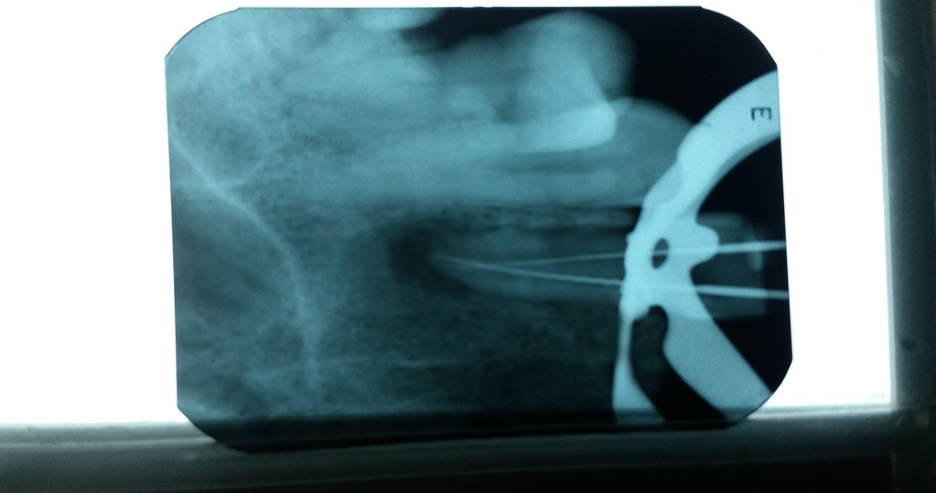
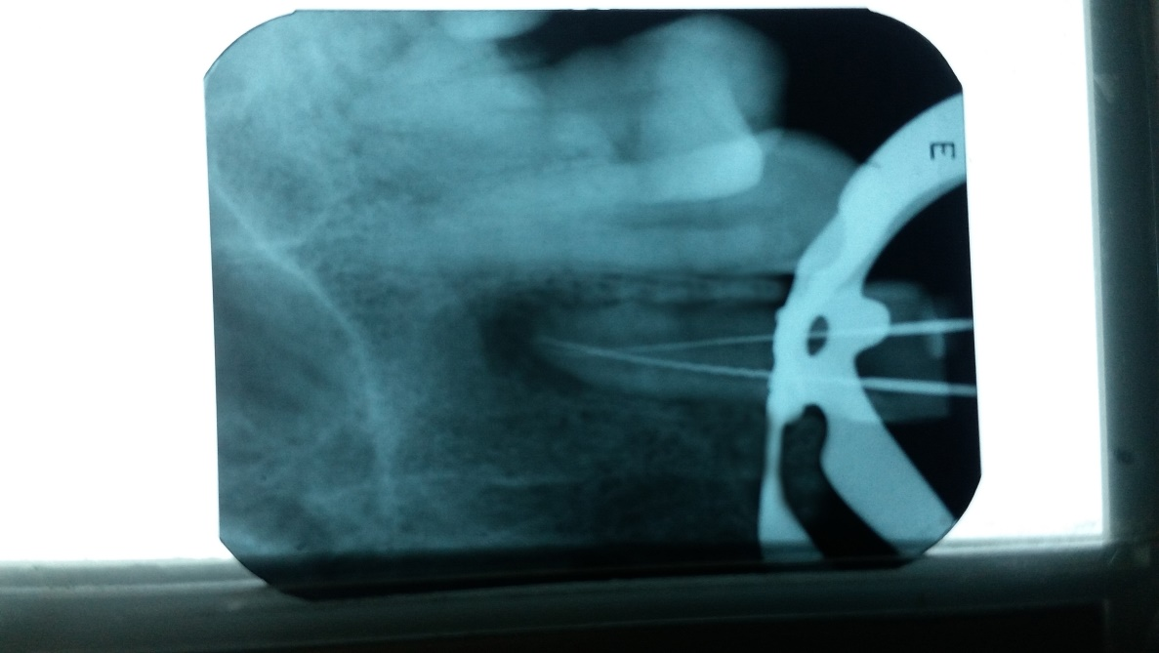
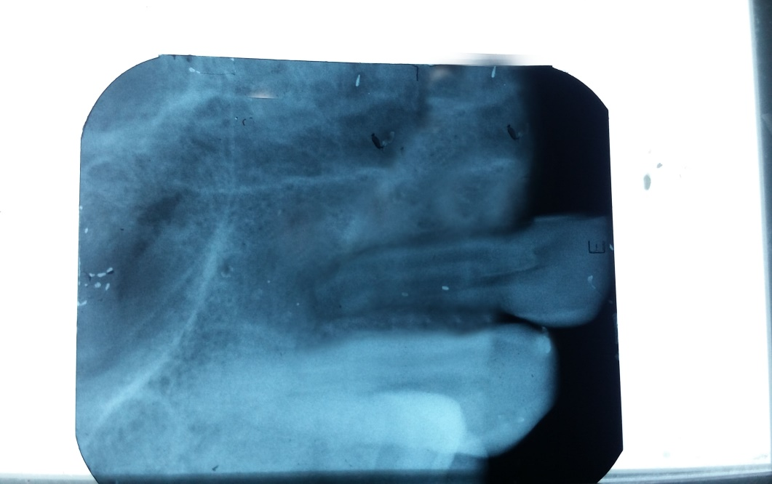
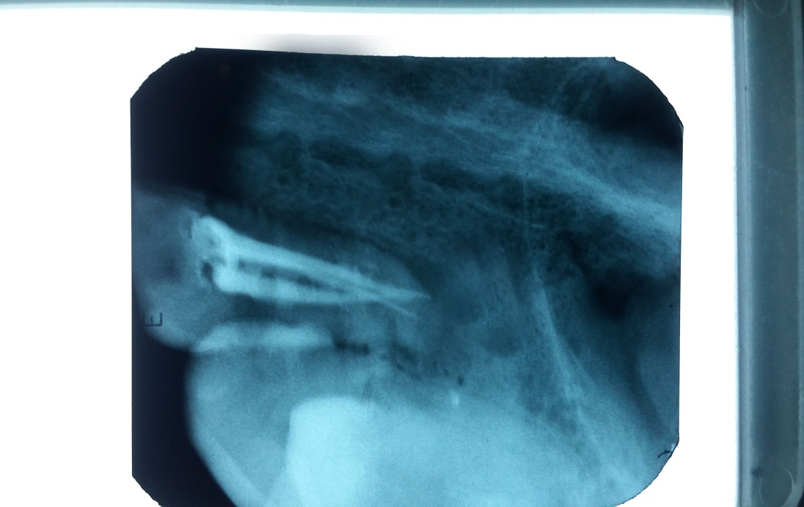
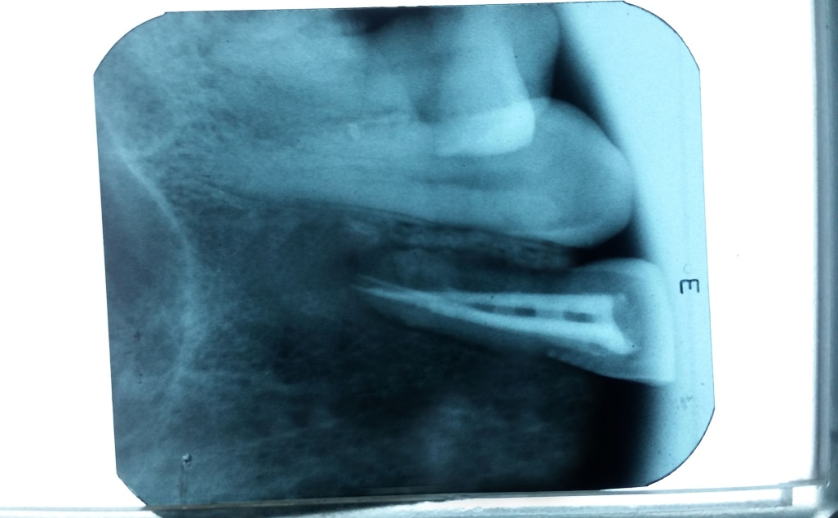
Figure C: Working length radiograph
Figure B: Working length radiograph
Figure A: Pre operative radiograph
Figure E: Post obturation follow up
Figure D: Post obturation

