A SYNONYM TO HEALING FOR PERFORATION REPAIR-MTA
(CASE REPORTS)

ABSTRACT:
INTRODUCTION: Root perforation is an iatrogenic communication between the root canal system to the supporting tissues of teeth . Often, it is an accidental result of misaligned use of rotary burs during access preparation and location of root canal orifices. Other possible etiologic factors for perforation can be strip perforations during cleaning and shaping procedures, root resorption, defect created during post space preparation, perforation of floor of pulp chamber due to extension of carious lesion.
AIM: The present case report throws light on the healing of rarefaction of the furcation area caused due to accidental perforation due to access cavity preparation.
METHOD: Endodontic treatment with placement of MTA as perforation repair material.
RESULT: Many materials have been reported as furcation repair materials but in the present case report MTA is used as a repair material which achieved excellent results.
CONCLUSION: Mineral trioxide aggregate is a suitable material for the treatment of root perforations, with the goal of regenerating periodontal attachment.

KEY WORDS: Iatrogenic furcal perforation, Repair, Radiolucency, periodontal attachment.

INTRODUCTION:
Mineral trioxide aggregate (MTA) has been regarded as an ideal material for perforation repair, retrograde filling, pulp capping, and apexification since its introduction in 1993^{1,2}. With longer duration, new cementum was found on the surface of the material³. Regardless of the cause, a perforation allows bacterial invasion into the supporting structures that initially incites inflammation and loss of attachment, which eventually may compromise the prognosis of the tooth^{4,5}. Furcation perforation is followed by bacterial contamination, periradicular tissue injury, inflammation, bone resorption, periodontal fiber destruction, epithelium proliferation, and periodontal pocket development⁶. A principle goal of endodontic therapy is to remove bacteria and seal the root canal to promote osseous regeneration⁷. Several studies have demonstrated that perforation of the root surface complicates our ability to achieve this goal⁴⁻⁶. The aim of this long-term follow-up case report is to present a successful treatment of iatrogenic furcal perforation by MTA.
CASE REPORT1:
A 22 year old male patient reported to the department of Conservative Dentistry and Endodontics, Regioanl dental college, Guwahati. Patient complained of pain and swelling in right lower region of jaw. On clinical examination: extraorally fluctuant swelling was present in mandibular region. Intraorally temporary dressing was seen with 46 and restoration with 45. On radiographic examination incomplete obturation was found with respect to 45 and radiolucency was seen in bifurcation area 46. Local anaesthesia was applied and rubber dam placed. Temporary dressing was removed with 46 and which was followed with profuse haemorrhage. After copious irrigation with 3% sodium hypochlorite haemorrhage was controlled and furcal perforation was detected. Canals were then located. The perforation was
sealed with mineral trioxide aggregate, ProRoot MTA (Dental Tulsa; Dentsply) mixed in a 3:1 proportion. In this appointment, MTA was applied with MTA carrier, a moist cotton pellet was then placed in the pulp chamber to produce a humid ambient for MTA with the aim of achieving its solidification, and the tooth was temporarily filled with Cavit. In the next appointment the working lengths were determined both electronically and radiographically. The mesial and distal canals were cleaned and shaped using protaper (Dentsply Maillefer, Ballaigues, Switzerland) in a crown-down technique and copious irrigation with 5.25% sodium hypochlorite. Calcium hydroxide was placed as an intra canal medicament for 2 weeks. After which the root canals were obturated with gutta-percha points and AH 26 sealer. Simultaneously retreatment procedure was also performed with respect to 45. Patient was recalled after a week for regular check up. Patient was asymptomatic at 1 week recall. Then a follow up was done at 3,6,9 months which showed complete healing of the large bifurcation radiolucency.

CASE REPORT 2:
A 20 year old girl came to the Department Of Conservative Dentistry And Endodontics, Regional Dental College, Guwahati, Assam with the chief complaint of incomplete root canal treatment with anterior tooth. On examination temporary dressing was found with respect to 11. Local anaesthesia was administered followed by placement of rubber dam. On removal of dressing profuse bleeding was observed with 11. Bleeding was controlled with copious use of sodium hypochlorite and labial perforation was detected both clinically and radiographically. Working length was determined and biomechanical preparation was done and the tooth was obturated till the site of perforation with lateral condensation technique. MTA was placed over the perforation site and remaining pulp chamber was sealed with composite restorative material. During follow up after 1 week patient was found to be asymptomatic and no pathology was seen both radiographically and clinically at 3,6,9 months follow up.

DISCUSSION:
Effective seal of root perforation is essential for prognosis of perforated teeth which would have been rather compromised. The first case report was that of accidental perforation during access cavity preparation where as second case presented with incomplete root canal treatment along with labial perforation defect. Two cases presented here were effectively sealed with MTA , which depicted favourable results as patients were asymptomatic after follow up visits . Radiographs revealed complete osseous healing.
In the past years, amalgam, composite resin and glass ionomer cements have been used for sealing furcal perforation. However, studies have shown that MTA is apparently superior to these materials with respect to marginal adaptation^{8,9,10-12}, bacterial leakage^{8,9,10-13}and cytotoxicity^{8,14}. MTA is a biocompatible material which when used in root-end cavities, stimulates reparation of periradicular tissues, showed no inflammation and deposition of cementum¹⁵ and the ability to induce hard tissue formation¹⁶.

Studies have shown that MTA actively promotes hard-tissue formation rather than being inert or an irritant like other materials^{17,18} The clinical applications also have proved that MTA is suitable for solving the problems derived from perforation. It does not interfere with the presence of moisture, and it inhibits the activity of bacteria ^{19,20,21,22}.

CONCLUSION:
Mineral trioxide aggregate is a suitable material for the treatment of root perforations, with the goal of regenerating periodontal attachment. In the above case reports , root perforation were treated with MTA to seal the perforation site. The repaired teeth were clinically and radiographically healthy and continued to satisfy esthetic and functional demands. Based on the outcome of the cases presented, MTA is a good material for the repair of the perforation and has been proven effective for large perforations and those close to the coronal third of the root.
Though favourable results have been achieved in the above mentioned case reports but long term follow up studies need to be conducted.
REFERENCES

- Lee SJ, Monsef M, Torabinejad M. Sealing ability of a mineral trioxide aggregate for repair of lateral root perforations. J Endod 1993;19:541-544.

- Osorio RM, Hefti A, Vertucci FJ, Shawley AL. Cytotoxicity of endodontic materials. J Endod 1998;24:91-96.

- Qiang Zhu, Robert Haglund, Kamran E. Safavi, Larg S. W. Spanberg : Adhesion
of Human Osteoblasts on Root-End Filling Materials. J Endod 2000; 27: 404-406.

- Ruddle CJ. Nonsurgical Endodontic Retreatment. In Cohen S, Burns RC (eds).
Pathways of the pulp, 8th ed. St Louis: Mosby Inc., 2002:917.

- Sinai IH. Endodontic perforations: their prognosis and treatment. J Am Dent Assoc
1977;95:90 –5.

- Seltzer S, Sinai I, August D. Periodontal effects of root perforations before and during
endodontic procedures. J Dent Res 1970;49:332–9.

- Hirsch JM, Ahlstrom U, Henrikson PA, Heyden G, Peterson LE. Periapical surgery. Int J Oral Surg 1979;8:173– 85.

- Torabinejad M, Hong CU, Lee SJ, Monsef M, Pitt Ford TR. Investigation of mineral
trioxide aggregate for root-filling in dogs. J Endod 1995;21:603-608.

- Torabinejad M, Pitt Ford TR. Root-end filling materials: a review. Endod Dent
Traumatol 1996;12:161-178.

- Torabinejad M, Pitt Ford TR, McKendry DJ, Abedi HR, Miller A, Kariyawasam
SP. Histologic assessment of mineral trioxide aggregate as a root-end filling
in monkeys. J Endod 1997;23:225-228.

- Wu M, Kontakiotis EG, Wesselink PR. Long-term seal provided by some root-
end filling materials. J Endod 1998;24:557-560

- Shabahang S, Torabinejad M, Boyne PP, Abedi H, McMillan P. A comparative
study of root-end induction using osteogenic protein-1, calcium hydroxide and
mineral trioxide aggregate in dogs. J Endod 1999;25:1-5.

- Bates CF, Carners DL, Del Rio CE. Longitunal sealing ability of MTA as a
root-end filling material. J Endod 1996;22:575- 578.

- Keiser K, Johnson C, Tipton DA. Cytotoxicity of MTA using human periodontal
ligament fibroblasts. J Endod 2000;26:288-289.

- Holland R, Filho JA, De Souza V, Nery MJ, Bernabe PF, Junior ED. Mineral trioxide aggregate repair of lateral root perforations. J Endod 2001;1:281–284.

- Yaltirik M, Ozbas H, Bilgic B, Issever H. Reactions of connective tissue to mineral trioxide aggregate and amalgam. J Endod 2004;30:95–99.

- Holland R, Otoboni Filho JA, De Souza V, Nery MJ, Bernabe PF, Dezan E. Mineral trioxide aggregate repair of lateral root perforations. J Endod 2001;27:281-4.

- Torabinejad M, Pitt Ford TR, McKendry DJ, Abedi HR, Miller DA, Kariyawasam SP. Histologic assessment of mineral trioxide aggregate as a root-end filling in monkeys. J Endod 1997;23:225-8.

- Menezes R, da Silva Neto UX, Carneiro E, Letra A, Bramante CM, Bernadinelli N. MTA repair of a supracrestal perforation: a case report. J Endod 2005;31:212-4.

- Arens DE, Torabinejad M. Repair of furcal perforations with mineral trioxide aggregate- two case reports. Oral Surg Oral Med Oral Pathol Oral Radiol Endod 1996;82:84-8.

- Hsien HC, Cheng YA, Lee YL, Lan WH, Lin CP. Repair of perforating internal resorption with mineral trioxide aggregate: a case report. J Endod 2003;29:538-9.

- Main C, Mirzayan N, Shabahang S, Torabinejad M. Repair of root perforations using mineral trioxide aggregate: a long term study. J Endod 2004;30:80-3.

IMAGES
CASE 1:
FIGURE1: MTA PLACED IN FURCATION AREA
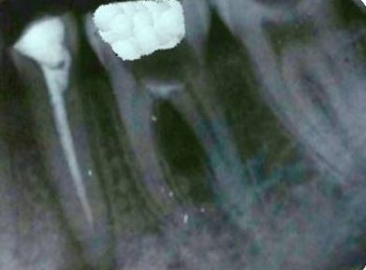

FIGURE 2: WORKING LENGTH DETERMINATION
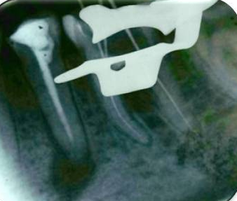

FIGURE 3:POST-OPERATIVE FOLLOW UP AFTER 9 MONTHS

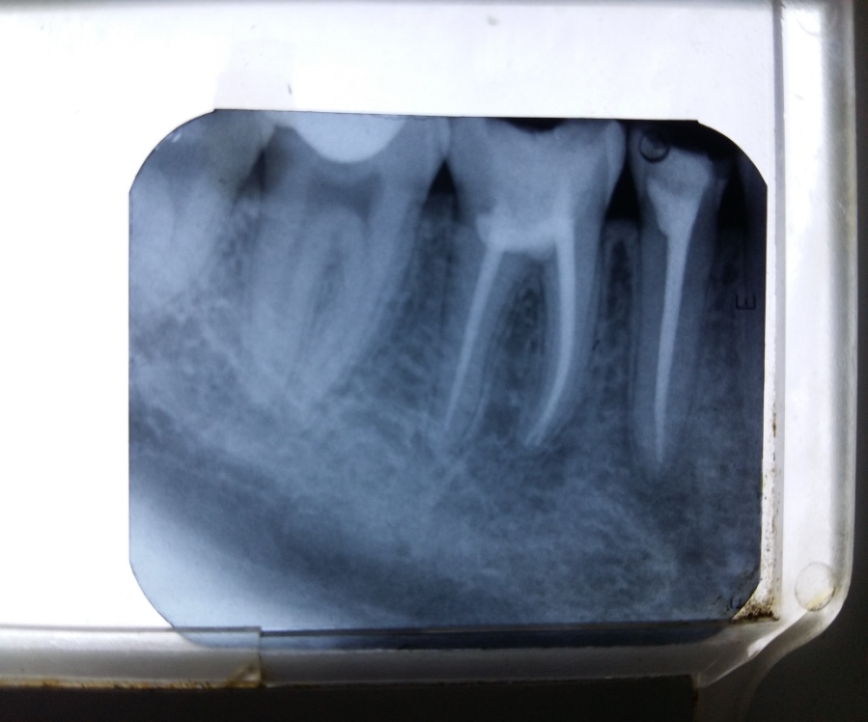

CASE 2:

FIGURE 1: PERFORATION ON LABIAL SURFACE OF CENTRAL INCISOR
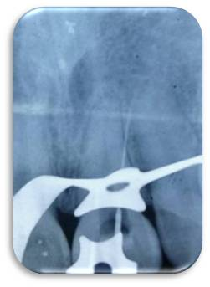

FIGURE 2: POST OPERATIVE FOLLOW UP WITH PLACEMENT OF MTA (9 MONTHS)
