FUSION OF PERMANENT MAXILLARY CENTRAL AND LATERAL
INCISOR: A RARE DENTAL ANOMALY

ABSTRACT:
INTRODUCTION:
Odontogenic anomalies of teeth can be encountered frequently in dental practise. Fusion and gemination are developmental dental anomalies leading to eruption of joined elements as double teeth. These anomalies pose a challenge even to the most experienced clinician in treating this teeth.
AIM:
Aim of this article is to throw light on a case of a fused teeth which was esthetically rehabilitated.
METHOD:
Endodontic treatment followed by esthetic corrections.
RESULT:
Esthetically pleasing result.
CONCLUSION:
Its early interceptive treatment can help in avoiding severe pulpal and periodontal complications along with acceptable esthetic result.

KEYWORDS: Developmental, abnormalities, esthetics, twinning

INTRODUTION:
Developmental dental disorders may be due to abnormalities in the differenciation of dental lamina and tooth germ or abnormalities in the formation of dental hard tissue. Odontogenic anomalies of number and forms may occur in primary and permanent dentition. These include germination, fusion and concrescence. The term double teeth, joined teeth, fused teeth, connoted teeth are often used to describe these anomalies. One of the most unusual anomalies of shape of the tooth is fusion^{1,2}. The etiology of fusion is unknown. It could be hereditary or caused by physical forces acting on developing tooth germs. The purpose of this article is to present a rare case of unilateral fusion of central and lateral incisor.
CASE REPORT:
A medically fit 29 year old male patient reported to the Department of Conservative Dentistry and Endodontics, Regional Dental College, Guwahati for esthetic management of fused teeth. There was no family history of dental anomalies and no consanguinity was reported in the parents. General and extraoral examinations appeared noncontributory. Intraoral examination revealed that maxillary left permanent central and lateral incisors were fused together. There was a deep groove on the labial and lingual surface with incisal notching. The periapical radiograph exhibited that the crowns and the roots were fused with complete union of their pulp chambers and root canals in maxillary left central and lateral incisors. Intentional root canal treatment was completed and CBCT was taken for confirmation. Gingivectomy was performed labially and mesially to remove the fibrous band of tissue between the fused teeth and right central incisor. After gingivectomy distal part of the tooth was sectioned to the level of gingiva and crown preparation was carried out. Provisional restoration was planned for maintaining proper gingival contours. Cantilever bridge was then cemented with retentive arm on canine for retention.

DISCUSSION:
The terms Twinning, Joined tooth or Double tooth, is used to describe both fusion and gemination³. Fused Tooth due to the union of two separated tooth germs may be complete or incomplete tooth fusion depending on the time of union and stages of tooth development. It may be between two normal teeth or sometimes between normal tooth and supernumerary tooth germ¹. In our reported case fusion was seen between permanent maxillary central incisor and lateral incisor which is very rare. Depending on factors such as location of the connecting area, root-development stage, and patient age, treatment of fused teeth may vary⁴.
The etiology of fusion is still unknown; however, the crowding of the tooth germs during their development can be an important factor. Local metabolic disturbances or developmental aberrations of ectoderm and mesoderm during morphodifferentiation of tooth bud can be considered as etiological factors⁵ . Genetic predisposition and racial differences have also been reported as contributing factors⁶ . They do not show any sex predilection but are more frequent among Japanese population and American Indians^{7,8} .
The number of teeth present is usually reduced in fusion, but is normal if the anomaly occur between a regular and supernumerary tooth. In contrast, gemination results in an apparent increase in the number of teeth^{7,8} as they are caused due to the division of a single tooth germ to form two separate teeth. In these situations, differentiation from gemination is clinically difficult or impossible.
Fused and geminated teeth are asymptomatic but necessitate treatment when decayed. Even though there is no variation in the treatment plan, an attempt can be made to differentiate both the anomalies by performing a thorough clinical and radiographic examination. The mesiodistal width of fused teeth is greater than their adjacent normal dentition. Fusion between two teeth usually results in space gain or diastema but may not be the case when the anomaly involves a supernumerary tooth
The buccal and lingual grooves may be deep and extend subgingivally favouring plaque accumulation leading to dental caries and periodontal diseases. The complications that follow a fusion are many. The teeth affected are morphologically abnormal and so unaesthetic⁶. To create a pleasing smile with central and lateral incisor on left side of maxillary arch, the distal part of the fused tooth was sectioned to the gingival level and crown preparation was completed on the remaining mesial part of the fused tooth along with removal of the thick fibrous band of tissue on the labial and thick papilla on the mesial side of the fused teeth. Provisional restoration was luted maintaining the proper contour of gingiva. Followed by placement of a esthetic cantilever bridge comprising of central and lateral incisors.

CONCLUSION:
In conclusion, fusions are rare developmental anomaly and need to be recorded during routine clinical examination. The abnormal morphology demands prophylactic and early interceptive treatment in order to avoid the complicated pulpal and periodontal treatment related to these teeth. The excellent esthetic and functional result obtained is presented here.
REFERENCES
- Peirera AJ, Fidel RA, Fidel SR (2000) Maxillary Lateral Incisor with Two Root Canals: Fusion or Gemination? Braz Dent J 11: 141-146.
- Tewari N, Pandey RK (2011) Bilateral fusion in primary mandibular teeth: A report of two cases. J Indian Soc Pedod Prev Dent 29: 50-52.
- Bharghav M, Chaudhary D, Aggarwal S (2012) Fusion presenting as germination- A Rare Case Report. Oral Maxillofac Pathol J 3: 211-214.
- M. Hülsmann, R. Bahr, and U. Grohmann, “Hemisection and vital treatment of a fused tooth—literature review and case report,” Endodontics and Dental Traumatology, vol. 13, no. 6, pp. 253–258, 1997.
- Tsesis I, Steinbock N, Rosenberg E, Kaufman AY. Endodontic treatment of developmental anomalies in posterior teeth: Treatment of geminated/fused teeth–report of two cases. Int Endod J. 2003;36:372–9.[PubMed]
- Nunes E, de Moraes IG, de Novaes PM, de Sousa SM. Bilateral fusion of mandibular second molars with supernumerary teeth: Case report. Braz Dent J. 2002;13:137–41. [PubMed]
- 3. Lopez C, Leco I, Baca R. Fusion of mandibular third molar with supernumerary fourth molar. Rev Esp Cir Oral y Maxilofac. 2008;30:344–7.
- 4. Wu CW, Lin YT, Lin YT. Double primary teeth in children under 17 years old and their correlation with permanent successors. Chang Gung Med J. 2010;33:188–93. [PubMed]

IMAGES:
FIGURE 1: PRE-OPERATIVE CLINICAL PHOTOGRAPH
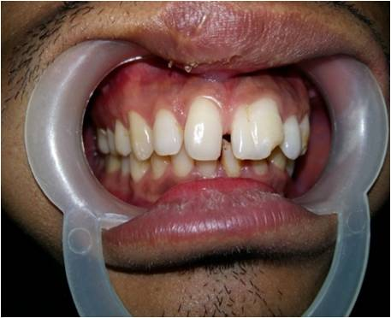

FIGURE 2: CROWN PREPARATION AND PIECE OF GINGIVAL TISSUE RESECTED
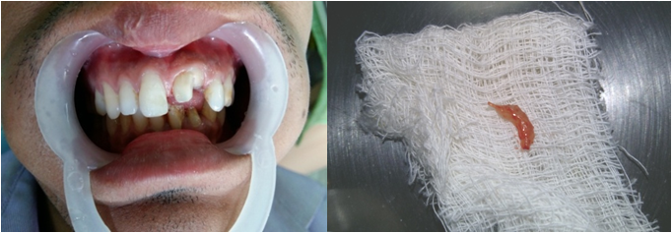

FIGURE 3:POST-OPERATIVE CLINICAL PHOTOGRAPH
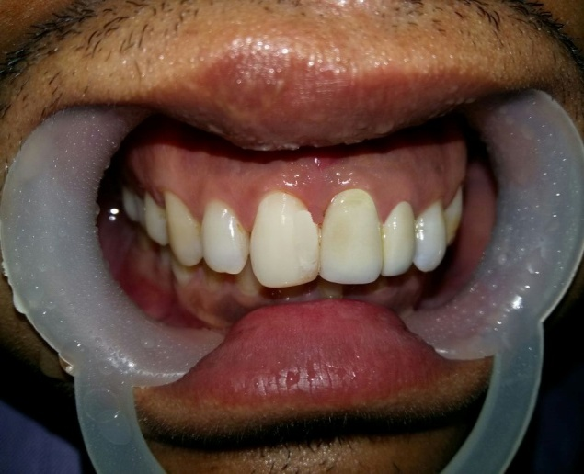

FIGURE 4: PRE AND POST-OPERATIVE RADIOGRAPH

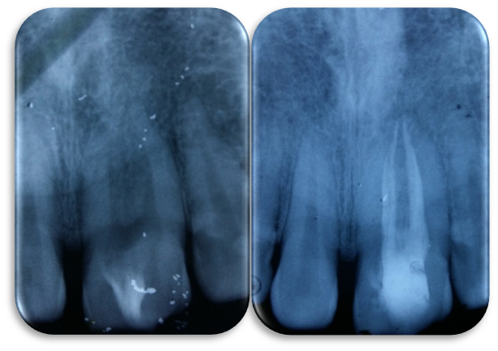

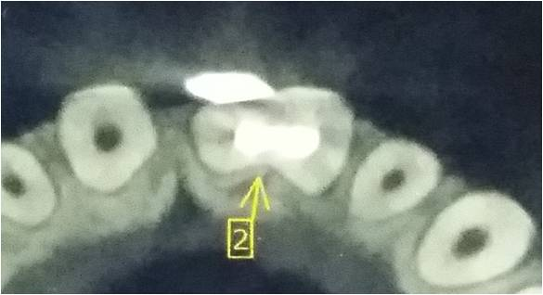
FIGURE 5: CBCT IMAGE

