“SAY NO TO SURGERY”-NONSURGICAL MANAGEMENT OF PERIAPICAL LESIONS – CASE REPORTS

ABSTRACT:
INTRODUCTION:
Periapical lesions develop as sequelae to pulp disease. It is accepted that all inflammatory periapical lesions should be initially treated with conservative nonsurgical procedures . It is a general belief that large periapical lesions will not heal by nonsurgical endodontic treatment and needs surgical intervention. But there is no direct evidence that all large periapical lesions need surgical intervention
AIM: . Non-surgical or conservative management of periapical lesions.
METHOD: Endodontic treatment with the placement of calcium hydroxide as intracanal medicament.
RESULT: Faster healing of the periapical lesions with successful resolution of signs and symptoms both clinically and radiographically.
CONCLUSION: Root canal treatment rendered with the highest standards of care with attention to asepsis, adequate cleaning and shaping, irrigation, canal disinfection and judicious use of intracanal medicament can culminate in non surgical regression of large periapical lesions.
Keywords: Healing, Radiolucency, Calcium hydroxide, Endodontic treatment,

INTRODUCTION:
Bacterial infection of the dental pulp may lead to periapical lesions.⁽¹⁾ Periapical radiolucency is the most pronounced clinical hallmark of these lesions.⁽²⁾ They are generally diagnosed either during routine dental radiographic examination or following acute pain in a tooth.⁽³⁾ When endodontic treatment is performed to accepted clinical standards, a success rate of around 90% can be expected .⁽⁴⁾ The ultimate goal of endodontic treatment should be to return the involved teeth to a state of health and function. ⁽⁵⁾ All inflammatory periapical lesions should be initially treated with conservative nonsurgical procedures.⁽⁶⁾ Surgical intervention is recommended only after nonsurgical techniques have failed. ⁽⁷⁾ Besides, surgery has many drawbacks, which limits its use in the management of periapical lesions. ^{(8,9)} Various nonsurgical methods have been used in the management of periapical lesions including conservative root canal therapy without adjunctive treatment, passive decompression of the lesion, active non surgical decompression technique using the Endo-eze vacuum system, needle aspiration of the cystic fluid using a buccal palatal approach, aspiration through the root canal, methods using intra canal calcium hydroxide, lesion sterilization and repair therapy(LSTR) and apexum procedure .⁽¹⁰⁾ Conventional nonsurgical root canal therapy is the treatment of choice in managing teeth with large periapical lesions.⁽¹¹⁾ This article presents case reports of non surgical management of large periapical lesions .

CASE REPORTS
CASE I:
A male patient 24 years of age, reported to the department of Conservative Dentistry and Endodontics , Regional Dental College, Guwahati with the chief complaint of swelling and intermittent pain in relation to upper front teeth. A history of accident 2 years back involving trauma to tooth was recorded. There was slight bearable pain since one year and swelling since 2-3days which has been increasing progressively. On oral examination, a small swelling was seen on the labial aspect of gingiva with respect to 11 and 12. On radiographic examination, a large radiolucency in the periapical area was seen in relation to 11 and 12 on the lateral aspect(Figure 1). Pulp vitality showed 11 and 12 to be nonvital. Root canal treatment was decided with respect to 11 and 12. Access opening was done and pus drained through the root canal. After thorough irrigation, tooth was sealed with a temporary restoration. In the following visit, the working length estimation and a thorough chemo-mechanical preparation was done using Ni-Ti K files. The root canals were irrigated with 3% sodium hypochlorite and the canals were dried with sterile paper points. Later, calcium hydroxide paste was placed in the root canal as intracanal medicament every 3 weeks for 3 months(Figure 2). Following radiographic examination, obturation was completed with gutta percha using lateral condensation technique after ensuring that the canals were dry . Resolution of periapical radiolucency was observed on radiographs at 3,6,9 months follow up visits(Figure 3).
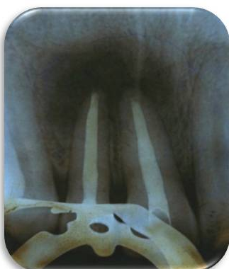
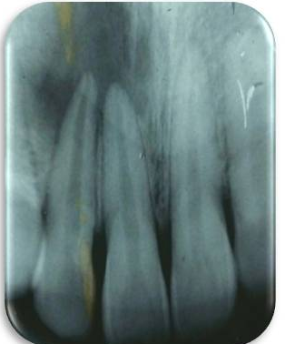
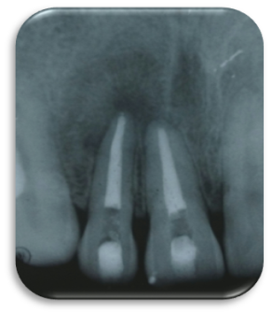

Figure 1: Preoperative radiograph Figure 2:Calciumhydroxide Figure 3: Post operative radiograph
placement (Followup after 9 months)

CASE II:
A 25 year old male patient reported to the department of Conservative Dentistry and Endodontics , Regional Dental College, Guwahati with the chief complaint of pain and swelling in upper front teeth region since 7-8 months. There was a history of trauma while playing football 5 years back. Clinical examination revealed a large labial vestibular swelling in the region of teeth numbered 11 and 21 along with a grade 1 mobility of the teeth. Radiographic analysis showed a moderate periapical radiolucency of approximately 2cmx2cm in dimension and deficient obturation with respect to 11,12 (Figure 4). The root canal system of both the teeth were accessed and the old gutta percha removed (utilizing Gates Glidden drills, hand instrumentation with Hedstrom files and Canalsolv gutta-percha solvent). Cleaning and shaping was performed to the apical file size of 40 using hand K files with copious irrigation with 3% sodium hypochlorite. Thereafter Calcium Hydroxide paste was placed as intracanal medicament which was replaced after every 3 weeks for 3 months(Figure 5). Following radiographic examination, obturation was completed with gutta percha using lateral condensation technique after ensuring that the canals were dry . Resolution of periapical radiolucency was observed on radiographs at 3,6,9 months follow up visits(Figure 6).

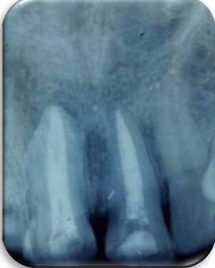
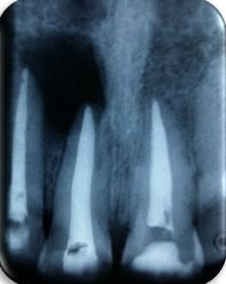
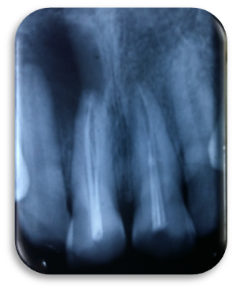

Figure 1: Preoperative radiograph Figure 2:Calciumhydroxide Figure 3: Post operative radiograph
placement (Followup after 9 months)

DISCUSSION:
The management of large periapical lesions is the subject of prolonged debate. The treatment options range from RCT or NSRCT with long-term Ca(OH)2 therapy to various surgical interventions, including marsupialisation, decompression with a tube and surgical removal of the lesion. These treatment options can also be combined.⁽¹²⁾ A thorough instrumentation along with copious irrigation are the foundation stones of a successful root canal treatment. Intracanal medicaments help in disinfecting bacteria contaminated canal . Calcium hydroxide, is a routinely used intracanal medicament and as an inter appointment dressing for management of periapical lesions, non-surgically. It is a strong alkaline substance, with a pH of approximately 12.5. In an aqueous solution, calcium hydroxide dissociates into calcium and hydroxyl ions. It is used in various clinical situations such as to promote apexification, to repair perforation, to enhance healing of periapical lesions, to control root resorption, and to control exudation in teeth with persistent periapical inflammation. A calcium hydroxide-based paste was used as an antibacterial dressing in these cases. The exact mechanism of action of calcium hydroxide is still speculative. It is suggested that the action of calcium hydroxide beyond the apex may be fourfold: (i) antiinflammatory activity; (ii) neutralisation of acid products; (iii) activation of the alkaline phosphatase; and (iv) antibacterial action . It has also been reported that treatment with calcium hydroxide resulted in a high frequency of periapical healing, especially in young patients.⁽¹³⁾ In the above cases radiographic signs such as density change within the lesion, trabecular reformation and lamina dura formation confirmed healing, particularly when associated with the clinical finding that the tooth was asymptomatic and the soft tissue was healthy.

CONCLUSION:
Root canal treatment rendered with the highest standards of care with attention to asepsis, adequate cleaning and shaping, irrigation, canal disinfection and judicious use of intracanal medicament can culminate in non surgical regression of large periapical lesions. However, to ascertain that complete healing has taken place, longer follow up periods are recommended.

REFERENCES:
- Mφller AJ, Fabricius L, Dahlιn G, Ohman AE, Heyden G. Influence on periapical tissues of indigenous oral bacteria and necrotic pulp tissue in monkeys. Scand J Dent Res. 1981; 89:475-84.
- Friedman S. Prognosis of initial endodontic treatment. Endod Topics. 2002; 2:59–88.
- Barbakow FH, Cleaton-Jones PE, Friedman D. Endodontic Treatment of teeth with periapical radiolucent areas in a general dental practice. Oral Surg .1981; 51:552-9.
- Sjogren U, Hagglund B, Sundqvist G, Wing K. Factors affecting the long-term results of endodontic treatment. J Endod. 1990; 16: 498–504.
- Salamat K, Rezai RF. Nonsurgical treatment of extraoral lesions caused by necrotic nonvital tooth. Oral Surg Oral Med Oral Pathol. 1986; 61:618-23.
- Lin LM, Huang GT, Rosenberg PA. Proliferation of epithelial cell rests, formation of apical cysts, and regression of apical cysts after periapical wound healing. J Endod .2007; 33 : 908-16.
- Nicholls E. Endodontics. 3 ^{rd} ed. Bristol: John Wright Sons Ltd., 1984; p. 206 .
- Neaverth EJ, Burg HA. Decompression of large periapical cystic lesions. J Endod. 1982;8:175-82.
- Walker TL, Davis MS. Treatment of large periapical lesions using cannalization through involved teeth. J Endod .1984; 10 :215-20.
- Marina Fernandes, Ida de ataide. Journal of Conservative Dentistry.2010 Oct-Dec ; vol 13 .
- Walton RE, Torabinejad M. Principles and practice of endodontics. 3rd ed. WB Saunders Co.; 2002.
- Campo N. Large periapical lesion management Decompression combined with root-canal treatment. Roots. 2012; 1: 6-9.
- Caliskan MK, Türkün M. Periapical repair and apical closure of a pulpless tooth using calcium hydroxide. Oral Surg Oral Med Oral Pathol. 1997; 84: 683–6.

