Study of incidence of externally visible congenital anomalies in stillbirth human foetuses of Manipuri origin

Abstract.

Introduction: Birth defect, congenital malformation, and congenital anomaly are synonymous term use to describe structural, behavioral, functional, and metabolic disorders present at birth. Causes of congenital anomalies are often divided into genetic and environmental factor. For 50-60% of congenital anomalies the etiology is unknown. In the present study, we only look for visible gross anomalies thereby the exact definition of congenital anomaly may not be fulfilled.

Materials and method:
Study was conducted in the Department of Anatomy, Regional Institute of Medical Sciences, Imphal, for the period of 1 year i.e. from 1st August 2011 to 1st August 2012. 120 numbers of stillbirth human foetuses were collected from the department of Obstetrics and Gynecology, RIMS, Imphal with a due permission from ethical committee. The specimens were preserved in 10% formalin. After 2 weeks specimens were observed carefully for any visible anomalies.
Results and observation:
Out of 120 foetuses; 15 foetuses i.e. 12.5% were found to have congenital anomalies. The commonest anomaly is craniofacial anomaly (6.666%) in the form of anencephaly and cleft lip and palate. Next to craniofacial anomaly is vertebral arch defect in the form of spina bifida (2.5%). Other anomalies are abdominal wall defect and limbs defects, each contributing 1.666% of the total anomalies in the present study.
Conclusion: Conclusion:
The incidence of congenital anomalies in the present study is 12.5%. The commonest anomaly encountered is in the form of craniofacial anomalies. This high of incidence congenital anomalies encountered in this study may be due to the fact that the study was conducted only in stillbirth human foetuses. Further research is recommended in order to pinpoint the causes of these of anomalies with the use of modern sophisticated tools.
Key words: Anomalies, stillbirth, craniofacial, foetuses

Introduction: Birth defect, congenital malformation, and congenital anomaly are synonymous term use to describe structural, behavioral, functional, and metabolic disorders present at birth.¹ Causes of congenital anomalies is often divide into genetic and environmental factor. For 50-60% of congenital anomalies the etiology is unknown.² A major congenital anomaly is a structural or functional defect which is of prenatal in origin and present at the time of live birth or foetal demise or in utero; affecting the health, survival, physical or cognitive functioning of an individual.³ In contrast minor anomalies are those with little or no impact on health or short term or long term function.⁴
In the present study, we only look for externally visible anomalies; thereby the exact definition of congenital anomaly may not be fulfilled.

Materials and method:
Study was conducted in the Department of anatomy, Regional Institute of Medical Sciences, Imphal for the period of 1 year i.e. from 1st August 2011 to 1st August 2012. 120 numbers of stillbirth human foetuses were collected from the department of Obstetrics and Gynecology, RIMS, Imphal with a due permission from ethical committee. The specimens were preserved in 10% formalin. After 2 weeks specimens were observed carefully for any visible anomalies.
Results and observation:
Out of 120 foetuses; 15 foetuses i.e. 12.5% were found to have congenital anomalies. The commonest anomaly is craniofacial anomaly (6.666%) in the form of anencephaly (Fig.1) and cleft lip (Fig.2) and palate. Next to craniofacial anomaly is vertebral arch defect (Fig.3) in the form of spina bifida (2.5%). Other anomalies are abdominal wall defect (Fig.4) and limbs defects (Fig.5), each contributing 1.666% of the total anomalies in the present study.

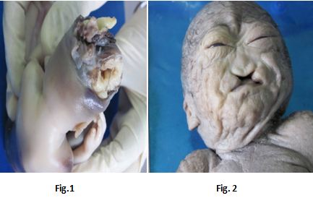
Fig.1 & Fig. 2: Showing craniofacial abnormalities in the form of anencephaly and cleft lip respectively

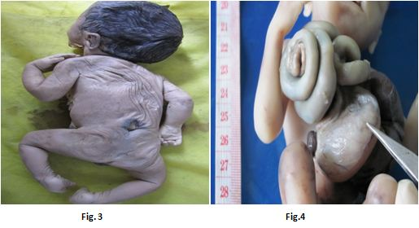
Fig.3 & Fig. 4: Showing vertebral arch defect and abdominal wall defect in the form of lumbar meningomyelocele and gastroschisis respectively

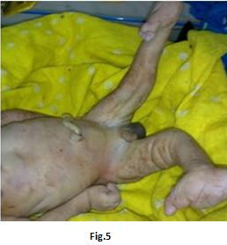
Fig.5: Showing malrotation of lower limbs.

Cases | Nos. | %age
No visible anomaly | 105 | 87.5
Craniofacial anomaly | 8 (6 male & 2 female) | 6.666
Vertebral arch defect | 3 (2 male & 1 female) | 2.5
Abdominal wall defect | 2 (1 male & 1 female) | 1.666
Limbs defect | 2 (both are male) | 1.666

Discussion
Different authors give different opinion regarding the incidence of congenital anomalies. Variations of incidence may vary from race to race and also influenced by environmental factors.
Gadow EC⁵ and Al-Jama F ⁶ reported that the incidence of congenital anomaly is 3-5%. Many authors stated that the incidence of congenital anomalies of central nervous system was highest among all types of congenital anomalies; neural tube defects being the commonest one. Meningocele, meningomyelocele and anencephaly accounts for more numbers of anomalies in CNS and they were more common in stillborn,^{7, 8} whereas Mishra PC & Baveja R,⁹ found higher incidence of multiple congenital anomalies. On the other hand Hatibaruah A, Hussain M ¹⁰ and Gosh et al¹¹ found higher incidence of musculoskeletal system malformation. Shah K, Pensi C.A¹² and Hatibaruah A, Hussain M, ¹⁰ reported the higher incidence of congenital anomalies among male foetuses.
In the present study we found that the incidence of congenital anomalies is 12.5%. Craniofacial anomalies in the form of anencephaly and cleft lip and palate contribute the maximum among all types of congenital anomalies. Central nervous system anomalies in the form of craniofacial anomaly with vertebral arch defects are the commonest cause. This present finding is inconformity with the findings of Gupta S et al ⁷ and Guha DK, Bhatia S⁸ but refutes statement given by the Mishra PC, Baveja R,⁹ Ghose et al¹¹ and Hatibaruah A,Hussain M ¹⁰ as they reported high incidence of multiple congenital anomalies and musculoskeletal malformation respectively. The incidence (i.e. 12.5%) of congenital anomalies in the present study is very high as compared to the incidence reported by Gadow EC ⁵ and Al-Jama F.⁶ The reason for this high incidence may be due to the fact that the present study was conducted only in stillbirth human foetuses. The present finding regarding higher incidence among male foetuses is comparable with the finding reported by Hatibaruah A, Hussain M,¹⁰ and Shah K, Pensi CA.¹²
Conclusion:
The incidence of congenital anomalies in the present study is 12.5%. The commonest anomaly encountered is in the form of craniofacial anomalies. This high of incidence congenital anomalies encountered in this study may be due to the fact that the study was conducted only in stillbirth human foetuses. Further research is recommended in order to pinpoint the causes of these of anomalies with the use of modern sophisticated tools.
Acknowledgement
First and foremost, I bow down and pay my humble homage to the souls of all the unborn human foetuses upon whom I have been privileged to carry out this present study. With pleasure and gratefulness, I take the privilege to acknowledge my heartfelt gratitude to all the contributing authors for their help, guidance, suggestion, inspiration, encouragement and affectionate attitude throughout the entire period of my study.
Conflict of Interest
"No conflict of interest associated with this work".
Ethical clearance
Prior permission was taken from ethical committee RIMS Imphal.
Source of funding
No financial assistant from any source.
Authors Contribution
"We declare that this work was done by the authors named in this article and all liabilities pertaining to claims relating to the content of this article will be borne by the authors".

Referances
- Sadler TW. Langman`s Medical Embryology.Birth Defects and Prenatal Diagnosis. 11thed. New Delhi: Wolters Kluwer Pvt. Ltd; 2011.p. 113.
- Moore KL, Persaud TVN. The Developing Human-Clinically Oriented Embryology. Congenital Anatomic anomalies or Human Birth Defects. 8th ed. New Delhi: Replika Press Pvt. Ltd; 2008.p.457-458.
- Desilva M, Munoz FM, Mcmillan M, Kawai AT, Marshall H, Macartney et al. Congenital anomalies: Case definition and guidelines for data collection, analysis, and presentation of immunization safety data. Vaccine 2016; 34: 6015-6026.
- Rasmussen SA, Olney RS, Holmes LB, Lin AE, Keppler-Noreuil KM, Moore CA. Guidelines for case classification for the National Birth Defects Prevention study. Birth Defects Res A Clinical Mol Teratol 2003; 67:193-201.
- Gadow EC. Primary prevention of birth defects. In: Carrera JM, Carbero L, Baraibar R editors. Perinatal Medicine of the New Mellenium. Bologna: Monduzzi; 2001.P.319-25.
- Al-Jama F. Congenital Malformations in newborns in a teaching hospital in eastern Saudi Arabia. J Obstet Gynaecol 2001; 21: 595-8.
- Gupta S, Gupta P, and Soni JS. A study on incidence of various systemic congenital malformations and their association with maternal factors. National Journal of medical research 2012; 2: 19-21.
- Guha DK Bhatia S. Mother based neonatal care unit. In Guha DK Neonatalogy- principles and Practice. 2nd ed. New Delhi: Laypee brothers: 2008.p.65-66.
- Mishra PC, Baveja R. Congenital anomalies in a newborn- A prospective study. Indian pediatrics 1989; 26: 53-58.
- Hatibaruah A, Hussain M. A study on prevalence of birth defects and its association withrisk factors in Fakhrudhin Ali Ahmed Medical Collage and hospital. Journal of Evidence Based Medicine and Healthcare 2015; 2(30): 4336-4343.
- Ghosh S, Bhargava SK, Bhatia R. Congenital anomalies in longitudinally studied birth cohort in a unban community. Indian J. Med. Res 1985; 82: 427-33.
- Shah K, Pensi C.A. Study of Incidence of congenital anomalies in newborns. Gujarat Medical Journal 2013; 68 (2): 97-99.

