ESTHETIC REHABILITATION OF FLUOROSIS AFFECTED TEETH
ABSTRACT
Introduction: This article describes an esthetic rehabilitation of a case of severe fluorosis. Dental fluorosis is caused by an excessive fluoride intake during tooth formation. Fluoride-related alterations in enamel lead to surface hypermineralization and subsurface hypomineralization which are characterized by white opaque appearance with secondary brown stain. Aim: Esthetic rehabilitation of fluorosis affected teeth. Method: Direct composite technique was applied to improve the color, shape and alignment of the teeth using direct composite veneering. Result: Esthetically pleasing result. Conclusion: Long-term clinical trials are needed to evaluate the appropriateness of the various management options for fluorosis of varying severity.
Keywords: Bonding, management, veneer, discoloration.
INTRODUCTION
Dental fluorosis is a specific disturbance due to chronic ingestion of excessive fluoride during the formative period of the dentition.¹ The increased incidence of dental fluorosis in developing countries over the last few decades is considered to be largely due to the wide spread usage of fluoride. Fluoride-containing drinking water is the main potential sources for this developmental tooth disorder in many parts of the world. Drinking water contains excessive amount of fluorine(3 to 5 mg /L), endemic fluorosis has been observed. Endemic fluorosis has been reported to be an important health issue in certain parts of India, example Andhra Pradesh(Nellore,Nalgonda,and Prakasam district),Punjab, Haryana, Karnataka, Kerala and Tamilnadu.² Fluoride-related alterations in enamel lead to surface hypermineralization and subsurface hypomineralization which are characterized by white opaque appearance with secondary brown stain.^{3,4}
The successful treatment of fluorosed teeth is a subject of interest in the literature. An appropriate treatment plan may be selected depending on the severity of the fluorosis.^{3,4} In the mild cases of dental fluorosis, clinical appearance is characterized by opaque white areas presenting as horizontal lines and cloudy patches on the enamel surface. Bleaching and microabrasion have been recommended for these forms of fluorosis. In the moderate-to-severe level of fluorosis, all tooth surfaces are affected by white opacities.^{3,4} Brown stains also present in the involved teeth. Some pits and wear area may be observed on the surfaces as a result of damage to the poorly mineralized enamel. Treatments include microabrasion, direct composite restorations or combination of both methods. In some instances, esthetic veneers or crowns may be necessary for some patients.^{3,4}
Direct composite veneers allow operator to control and evaluate entire procedure from shade selection to final morphology usually in a single appointment. It is most commonly utilized form of veneering.⁵ These are often been heralded as a more conservative alternative to porcelain. With the advent of microhybrid and nanohybrid composites, finishing and polishing of these restorations can rival that of porcelain.⁶ Frequently, the management of fluorosis involves resin composite restorations. This article presents the stages of esthetic rehabilitation of a patient with severe fluorosis including direct composite veneering. Constant advancement of resin technology and advent of newer materials have resulted in reduced shrinkage, improved color stability, wear resistance, and biocompatibility.⁷⁻⁹
CASE REPORT I
A 23 Year old female patient reported to the Department of Conservative Dentistry and Endodontics, Regional Dental College, Guwahati with the chief complaint of poor esthetic smile due to discolored teeth. The clinical examination and history revealed that the present discoloration was due to fluorosis in cervical and mesial and distal areas of the middle third of the tooth representing as subsurface brown staining and small pits in enamel representing severe fluorosis[fluoride concentration in drinking water; 3ppm] (Figure 1). The diagnosis was made based on the Dean’s fluorosis index. Due to young age, patient was insisting for esthetic correction of anterior teeth only. Radiographic and clinical examination did not reveal any periapical pathological condition. Therefore esthetic correction with more conservative procedure direct composite for maxillary anterior teeth were planned. The color was recorded using the Vita Classical shade guide. The tooth preparation involved a minimal chamfer in the facial surfaces (Figure 2). The enamel surface was acid etched using 35% phosphoric acid gel for 15 sec, rinsed and dried (Figure 3). Bonding agent was applied on the prepared enamel and dentin surface and light-cured (Figure 3). A stratified layering technique was used to fill the tooth with nanohybrid resin composite. The contouring and finishing was accomplished with finishing burs. The polishing was performed with recommended polishing procedures (Figure 4). Patient was recalled in 2 days and encouraged for better dental flossing and also recalled every 6 months for periodical controls.

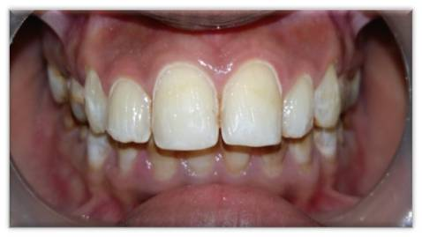
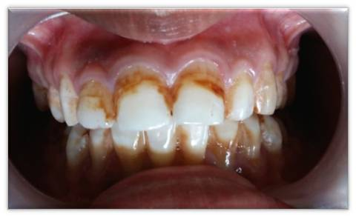

Figure 1 (preoperative clinical photograph) Figure 2 (tooth preparation)

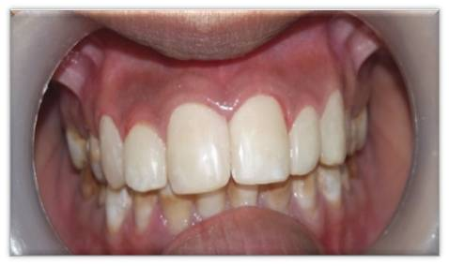
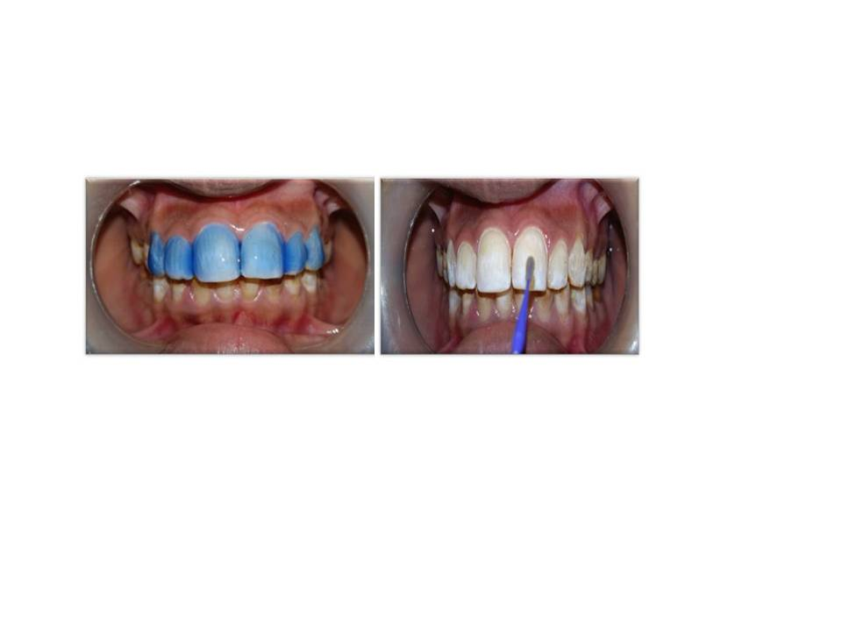
Figure 3 (etching and application of bonding agent) Figure 5 (postoperative clinical photograph)

CASE REPORT II
A 21 year old male patient reported to the Department of Conservative Dentistry and Endodontics, Regional Dental College, Guwahati with the chief complaint of poor esthetic smile due to discolored teeth. The clinical examination and history revealed that the present discoloration was due to severe fluorosis ( fluoride concentration in drinking water; 3·2 ppm ) representing as opaque patches, subsurface brown staining and small pits in enamel representing severe fluorosis (Figure 1). The diagnosis was made based on the Dean’s fluorosis index. Due to young age, patient was insisting for esthetic correction of anterior teeth only. Radiographic and clinical examination did not reveal any periapical pathological condition. Therefore esthetic correction with more conservative procedure direct composite for both maxillary and mandibular anterior teeth were planned. The color was recorded using the Vita Classical shade guide and the shade A₂ and A₃ was considered as the initial colour. Cotton rolls, salivary ejectors and retraction cords were used for field isolation. The whole procedure was carried out in the same manner as described in the previous case(Figure 2,3). Patient was recalled in 2 days and encouraged for better dental flossing and also recalled every 6 months for periodical controls.

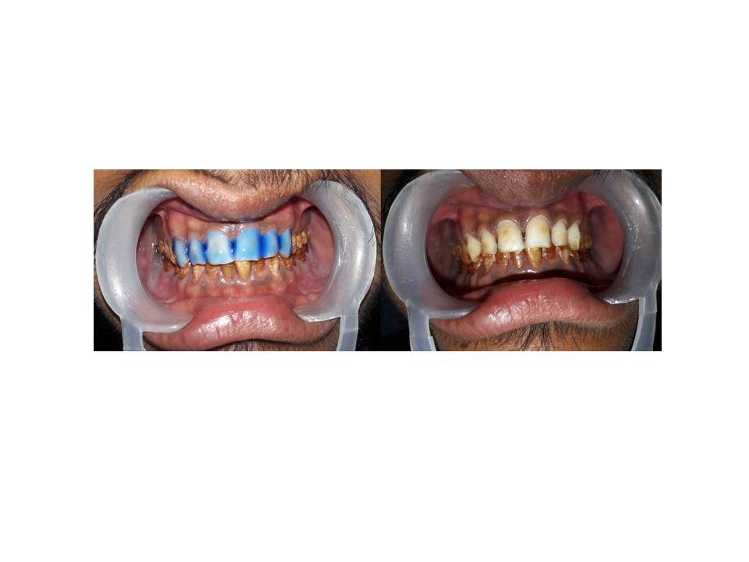
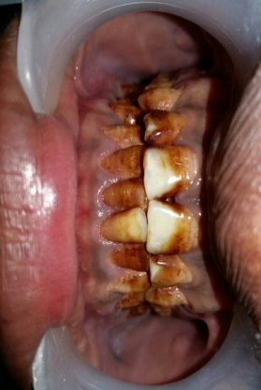

Figure 1 postoperative clinical photograph Figure 2 clinical photograph of tooth preparation and etching
procedure
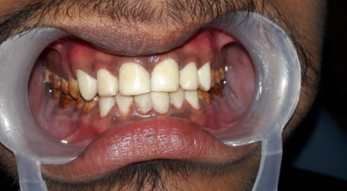

Figure 3: postoperative clinical photograph

DISCUSSION
In both the above presented cases tooth discolouration was due to increased fluoride content in drinking water. The aim of the treatment in these cases was to restore the patient esthetics and self-esteem. Different treatment plans have been proposed for the treatment of discoloration in the fluorosed teeth depending on the severity of the fluorosis. A direct composite restoration was a conservative alternative which offered the ability to correct the shape and the contour of maxillary anterior teeth in addition to the removal of discoloration. Direct composite veneers are becoming more popular in repairing cosmetic defects and to resurface teeth such as to make them appear straight and possess an aesthetically pleasing smile.¹⁰ It is recommended to grind the fluorosed enamel surface to remove the hypermineralized layer. Etching with phosphoric acid for 15 seconds achieved the best results in the normal enamel.¹¹ While the best etching result were obtained at 30 seconds for the moderate fluorosed enamel, increased etching time for severe fluorosis result in less retentive surface.¹¹ Polishing of direct composite veneers is easy and any cracks or fractures on the restoration may be repaired intraorally.¹² Also, marginal adaptation for composite veneer is better than that of indirect veneer restorations.¹³ In these cases, the use of conservative direct composite resins provided both symmetrical and harmonious restoration of the teeth. So in this case we have followed a conservative approach with composite veneering technique to built up esthetics and restore patients self esteem.
CONCLUSION
Discolored and pitted enamel of fluorosed teeth may be esthetically objectionable and a cause of psychological and sociological health problems. Hence, therapeutic intervention, albeit minimally invasive, is often needed to correct cosmetic defects due to dental fluorosis and several management strategies have been proposed for teeth with fluorosis of varying severity.
REFERENCES
- Moller J. Fluorides and dental fluorosis. Int Dent J 1982;32:135-47.
- Park’s text book of preventive and social medicine, 19th edition.
- Akpata ES. Occurrence and management of dental fluorosis. Int Dent J 2001;51:325–333.
- Denbesten P, Li W. Chronic fluoride toxicity: dental fluorosis. Monogr Oral Sci 2011;22:81–96.
- F. Newton. A direct/indirect composite resin veneers: a case report.1996;8(7):627-638.
- N. Fahl Jr. A polychromatic composite layering approach for solving a complex class IV/direct veneer/diastema combination: part II. Practical Procedures & Aesthetic Dentistry 2007;19:17–22.
- J. Vaidyanathan, T. K. Vaidyanathan, Y. Wang, and T. Viswanadhan. Thermoanalytical characterization of visible light cure dental composites. Journal of Oral Rehabilitation 1992;19(1):49–64.
- L. C. Villela, J. R. F. Carvalho, and M. A. J. Araujo. A modified veneering technique using composite resin. Revista Da APCD 1994;48:1535–1537.
- J. F. McCabe and S. Kagi. Mechanical properties of a composite inlay material following post-curing. British Dental Journal 1991;171(8):246–248.
- Pincus CL. Building mouth personality. Aust Dent Cong (9th) Trans 1937;412-418.

- Torres-Gallegos I, Zavala-Alonso V, Patiño-Marín N, Martinez-Castañon GA, Anusavice K, Loyola-Rodríguez JP. Enamel roughness and depth profile after phosphoric acid etching of healthy and fluorotic enamel. Aust Dent J 2012;57:151–156.
- S. Berksun, P. S. Kedici, and S. Saglam. Repair of fractured porcelain restorations with composite bonded porcelain laminate contours. The Journal of Prosthetic Dentistry 1993;69(5):457-458.
- Jordan R E. Esthetic Composite Bonding Techniques and Materials. 2nd ed. USA: Mosby-Year book, St. Louis, Mo; 1993.

