A COMPARATIVE STUDY OF MRI AND ARTHROSCOPIC FINDINGS IN SHOULDER PATHOLOGIES
Author- Dr. Saikia Lelin ¹ Dr. Das Chinmoy² Dr. Daolagupu A.K. ³, Dr. Gogoi P.J. ⁴

ABSTRACT
BACKGROUND- Correct diagnosis of shoulder pathology is essential to start treatment immediately and avoid complications¹. MRI is an important imaging tool, however, arthroscopy remains the reference standard in diagnosing shoulder pathologies against which alternative diagnostic modality should be compared. This study seeks to compare to what extent MRI findings are accurate, with arthroscopic findings, as the “gold standard” in shoulder pathologies.
MATERIALS AND METHODS This was a prospective study of 22 patients with various shoulder pathologies apart from recent fracture, tumor. Both sexes within age group 18-60 years were included in the study. The patients were first examined clinically, followed by 1.5 tesla MRI scan and finally arthroscopically. The findings of MRI were correlated with diagnostic arthroscopy. Sensitivity, specificity, positive predictive value, negative predictive value of MRI findings was calculated to correlate with arthroscopic findings.
RESULTS- MRI had a significant statistic correlation (P <0.05) with various lesions of shoulder.
CONCLUSION- By analysing the results of this study, we conclude that Magnetic Resonance imaging is accurate, practical, efficient, non-invasive, acceptable diagnostic modality in shoulder pathologies especially in condition like full-thickness supraspinatus tear, impingement syndrome, Hill-Sachs lesion and Bankart’s lesion.
However, statistically significant correlation was not found in SLAP lesions and subscapularis tear.
KEY WORDS- SLAP lesions, Subscapularis tear, Bursoscopy, Diagnosis.
Address for corerespondence:
¹Registrar of Orthopaedics,
Tezpur Medical College and Hospital,
Ph. No- 08403894136. E.mail.-lelinsaikia@gmail.com
²Associate Professor of Orthopaedics
Tezpur Medical College and Hospital, Tezpur
Email: drchinmoydas@yahoo.com
Mobile: +919435043908

INTRODUCTION-
Shoulder joint includes three primary articulations, the glenohumeral joint, the acromioclavicular joint and the sternoclavicular joint. The shoulder mobility is at the expense of stability, and the resulting “freedom of movement” of the joint predisposes it to a variety of conditions¹. Third most common common cause of musculoskeletal consultation in primary care². Shoulder problems tend to present mainly as pain. Any disability or pain in the shoulder affect a person’s ability to carry out daily activities and work. Early diagnosis to attain prompt recovery and avoid chronicity and complications.
Shoulder pain is mainly due to 1) Referred pain, 2) systemic illness, 3) musculoskeletal pain arising from shoulder. Clinical history, physical examination, special tests, imaging modalities (plain X- rays, U/S shoulder, CT- scan, MRI) and diagnostic shoulder arthroscopy are usual diagnostic modalities. MRI is the preferred imaging study. However several lesions continue to provide diagnostic challenge. Arthroscopy of the shoulder is a major modality in the diagnosis and treatment of shoulder pathologies. Diagnostic arthroscopy is the most essential step in treating shoulder pathology.
Arthroscopy is the reference standard in diagnosing shoulder pathologies against which alternative diagnostic modality should be compared. This study seeks to compare to what extent MRI findings are accurate, with arthroscopic findings, as the “gold standard”, in shoulder pathologies.
AIMS AND OBJECTIVES- The aim of the present study is to compare MRI and Arthroscopic findings in shoulder pathologies and to find out the accuracy of MRI findings as compared to arthroscopy in the diagnosis of shoulder pathologies.
MATERIALS AND METHODS- This was a prospective study of 22 patients carried out at our institute in a period of 1 year. Patients aged between 18 to 60 years irrespective of sex or with suspected shoulder pathology and with radiologically diagnosed shoulder pathology were included in the study. Patients with musculoskeletal tumours around shoulder joint or with recent fractures around shoulder joint or with psychiatric disease, pregnancy or lactation or with Medical contraindications for surgery/MRI were excluded from the study.
SURGICAL TECHNIQUE-
The basic steps of diagnostic arthroscopy are as Patient positioning in lateral decubitus position, Surface outlining of bony landmarks, Making portals, Insertion of scope, Visualizing the intrarticular and extrarticular structures in a systematic manner and Closure.
PROCEDURE- The pateints were examined under anaesthesia. They were put in lateral decubitus position with 30° posterior tilt of the trunk. The shoulder was abducted to 70° and forward flexed to 20°-30°. Traction was applied with adhesive bandage tied to forearm and fixed with a post (fig 1).
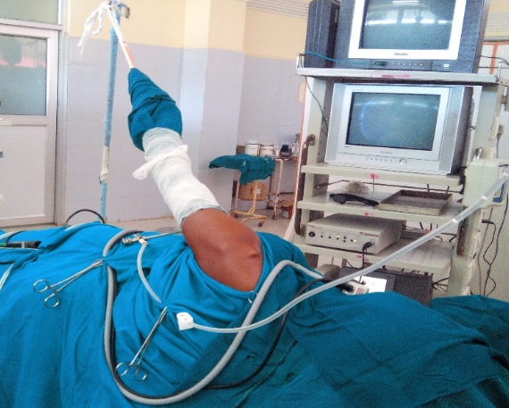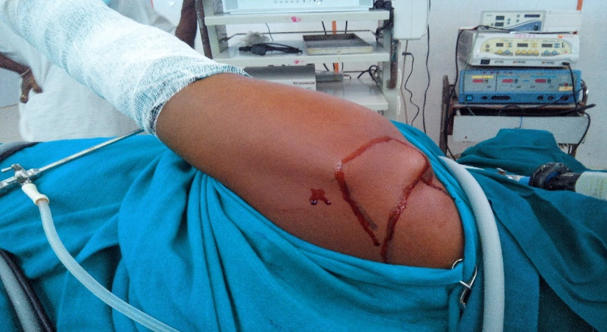
Fig 1 Fig 2
SURFACE OUTLINING- Anteriorly, the coracoid process (CP), the acromioclavicular joint (ACJ) and the anterior border of the acromion are located and marked. Laterally, the lateral border of the acromion is palpated and marked, posteriorly and laterally, the posterolateral corner of the acromion is also marked (fig 2)
MAKING PORTALS- Posterior portal was made at a point located 2cm inferiorly and 1cm medially to the posterolateral acromial edge (fig 3). Arthroscopic cannula with a tapered-tip obturator was inserted through the posterior skin incision and through the muscle until the posterior humeral head was palpated. After the capsule was punctured, the scope was inserted. For anterior portal creation, the tip of the arthroscope is passed into the anterior triangle between the biceps and the subscpularis tendons. The scope is angled a few degrees superiorly and laterally and hold it against the anterior capsule. The scope is removed and a taper-tipped guide rod is inserted into the cannula to puncture the anterior capsule and rent the skin. A small stab wound adjacent to the tip of guide rod and anterior portal is created.
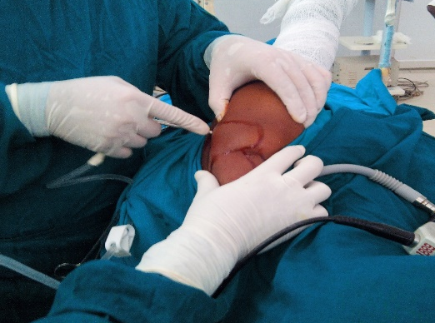
Fig 3
GLENOHUMERAL JOINT EVALUATION- The arthroscopic evaluation was performed with the video image oriented so that the glenoid surface horizontal on the lower half of the television monitor. A 15- Point anatomy review was done systematically as mentioned by Snyder³. The first 10 points of anatomy are visualized in a sequential manner from the posterior portal. The arthroscope was changed to anterior portal and remaining 5 points of anatomy was reviewed.

15 POINTS ANATOMY REVIEW
Posterior Portal
1. Biceps tendon and superior labrum
2. Posterior labrum and capsule recess
3. Inferior axillary recess and inferior capsule insertion
4. Inferior labrum and glenoid articular surface
5. supraspinatus tendon of rotator cuff
6. posterior rotator cuff insertion and bare area
7. Articular surface of the humeral head
8. Anterior superior labrum, SGHL, MGHL and subscapularis tendon
9. Anterior inferior labrum
10.Anterior inferior ligament
Anterior Portal
1. Posterior glenoid labrum
2. posterior rotator cuff
3. Anterior glenoid labrum
4. Subscapularis tendon
5. Anterior surface of the humeral head
SUBACROMIAL BURSOSCOPY- Diagnostic bursoscopy was performed to complete the shoulder arthroscopic evaluations as mentioned by Snyder⁴. The arthroscopic cannula fitted with blunt obturator is inserted into the posterior skin portal, tunnelled through the subcutaneous tissue until the posterior edge of the acromion is encountered. The cannula was advanced under and parallel to the acromion until the anterior boundary of the bursa was encountered and scope was subsequently inserted.
POSTOPERTAVE CARE- Padded cotton dressing was applied from mid-clavicle to mid arm for 24-48 hours to give better compression and haemostasis. Postoperatively, patient was given routine IV analgesics and antibiotics for 48 hours. Passive range of motion exercises from second postoperative day onwards.
FOLLOW-UP PERIOD- Patients were followed up in the out-patient department on 10th day operation and on 3rd, 6th and 10th week. After that every month for 6 months.
REHABILITATION PROTOCOL- Phase 1(1st 3 weeks) Active and passive range of motion of exercises and pendulum exercises. Phase 2 (Weeks 3 to 6) Shoulder muscles strengthening exercises and light work allowed with the involved shoulder. Phase 3 (Weeks 6 onwards) Normal work allowed.
STATISTICAL ANALYSIS- Fisher exact test has been used to find the significance of study parameters on categorical scale between two or more groups. Diagnostic statistics viz. sensitivity, Specificity, PPV and NPV have been calculated.
RESULTS AND OBSERVATION- MRI findings was compared with diagnostic arthroscopic findings. The data was analysed to calculate true positive, true negative, false positive and false negative. Using these specificity and sensitivity, positive and negative predictive values were calculated. Arthroscopic examination was taken as the gold standard for comparison.
The age ranged from 18-54 years with a mean age of 29.5 years in our study. Maximum incidence of shoulder pain and/or instability was found in 21-30 years of age group. Out of 22 patients, 18(81.8%) patients were male and 4 (18.2%) were females in our study. Right shoulder joint was involved in 17 (77.3%) patients and left side was involved in 5(22.7%) patients. Dominant hand was involved in 15(68.2%) cases and non-dominant hand was involved in 7(31.8%) cases. In 13 patients where features of shoulder instability was found in arthroscopy, 12(92.3%) patients had a history of trauma preceding symptoms whereas in 1(7.7%) patient there was no such history. All the patients presenting with features of shoulder instability were of anterior type. The mean duration between MRI and arthroscopy was 3.6 weeks.

Out of twenty two cases, MRI diagnosed impingement syndrome in six patients, partial thickness supraspinatus tear in thirteen patients, full-thickness supraspinatus tear in two patients, partial subscapularis tear in four patients, Bankart’s lesion in ten patients, Hill- Sachs lesion in five cases and SLAP lesion in three patients and adhesive capsulitis in three cases (table 1).

DIAGNOSIS | MRI (No. of cases) | ARTHROSCOPY (No. of cases)
IMPINGEMENT SYNDROME | 6 | 7
PARTIAL-THICKNESS SUPRASPINATUS TEAR | 13 | 13
FULL-THICKNESS SUPRASPINATUS TEAR | 2 | 2
PARTIAL THICKNESS SUBSCAPULARIS TEAR | 4 | 3
BANKARTS LESION | 10 | 8
HILL-SACHS LESION | 5 | 5
SLAP | 3 | 5
ADHESIVE CAPSULITIS | 3 | 4
Table 1: DISTRIBUTION OF MRI AND ARTHROSCOPIC FINDINGS

SHOULDER PATHOLGY | SENSITIVITY | SPECIFICITY | POSITIVE PREDICTIVE VALUE (PPV) | NEGATIVE PREDICTIVE VALUE (NPV) | P VALUE
IMPINGEMENT SYNDROME | 85.7% | 100% | 100% | 93.7% | <0.0001
PARTIAL TEAR OF SUPRASPINATUS | 92.3% | 88.9% | 92.3% | 88.9% | <0.0002
FULL THICKNESS TEAR OF SUPRASPINATUS | 100% | 100% | 100% | 100% | <0.0001
PARTIAL THICKNESS SUBSCAPULARIS TEAR | 66.7% | 89.5% | 50% | 94.4% | <0.0727
BANKART’S LESION | 100% | 85.7% | 80% | 100% | 0.0001
HILL-SACHS LESION | 100% | 100% | 100% | 100% | <0.0001
SLAP LESIONS | 40% | 94.1% | 66.7% | 84.2% | <0.1169
ADHESIVE CAPSULITIS | 75% | 100% | 100% | 94.7% | <0.0026
TABLE 2: STATISTICAL MEASURES OF MRI CORRELATION WITH ARTHROSCOPY OF VARIOUS SHOULDER PATHOLOGY
DISCUSSION Parsons et al⁵ determined the highest prevalence of shoulder pain (17%) in the middle-age group from 45–64 years of age. But in our study we found 21-30 years age group as the most prevalent age group of shoulder pain (50%). This may be due to the fact that this age group is involved more with sports activities and is a sizeable working population. Moreover, most of the patients participating in our study belonged to this age group.
Shoulder pathology was involved in 60% males and 40% females in a study by Halma et al.⁶ In our study, shoulder pathology was present in 81.8% males and 18.2% females. This may be due to the low attendance of female patients having shoulder problems in our institution during the period of study. Rowe⁷ stated that 96% were traumatic in origin and only 4% were atraumatic. In our study, out of 13 patients having features of instability, 12(92.3%) patients had a history of trauma preceding symptoms whereas in 1(7.7%) patient, there was no such history. According to Rowe⁸, majority of the patients present with traumatic anterior instability and 95% of shoulder dislocations are of the anterior type. In our study 100% of patients having features of instability were of anterior instability. In a study by Iannotti et al⁹ and other similar study by A M Malhi, R Khan¹⁰, found sensitivity ranging from 84% to 93% and specificity ranging from 76% to 87% for impingement syndrome, which are comparable to our study. In a systematic study by Smith et al¹¹ and other similar studies^{12.13.14}, the pooled sensitivity values ranged from 44% to 98% and specificity values ranged from were 90% to 95%, which are comparable to our study for partial-thickness supraspinatus tear. In a study by Traugher et al¹⁵ and other similar studies^{16,17,18}, MRI sensitivity ranged from 89% to 100% and specificity ranged from 95% to 100% for full thickness supraspinatus tear, which are comparable to our study. In a retrospective study comparing magnetic resonance imaging and arthroscopic findings by Guido¹⁹ et al, MRI sensitivity and specificity were respectively 25% and 98% for subscapularis tendon tears, which is comparable to our study. Hayes ML, Collins MS et al.²⁰ found that the sensitivity of MRI in detecting Bankart’s lesion was 98.4% and specificity was 95.2%. For Hill-Sachs lesion, sensitivity of MRI was 96.3% and specificity was 90.6%. These are comparable to our study. In 2008, Kautzner et al²¹, found MRI sensitivity of 43 % and specificity of 96 % for SLAP lesions. We found comparable results of 40% sensitivity and 94.1% specificity in our study. Jung et al²²,found sensitivity and specificity of 79% and 100% respectively of MRI for adhesive capsulitis. In our study, we found sensitivity of 75% and specificity of 100% of MRI, which is comparable. Berjano et al²³ reported on 179 shoulder arthroscopic procedures noting an overall complication rate of 9.49%. In our study, out of 22 cases, 2 cases developed complications. One was bleeding during bursoscopy and debridement during intraoperative period for which radiofrequency ablation was done to control bleeding and other developed haemarthrosis which resolved spontaneously. Overall, complication rate in our study was 9.1% which is comparable to previous mentioned literature.
CONCLUSION Magnetic Resonance imaging is accurate, practical, efficient, non-invasive, acceptable diagnostic modality in shoulder pathologies especially in condition like full-thickness supraspinatus tear, impingement syndrome, Hill-Sachs lesion and Bankart’s lesion.

However, for SLAP lesions and partial tear subscapularis tendon we could not find statistically significant correlation between MRI and arthroscopy. Hence, a larger study is recommended for a conclusion to be made.

Continued interaction and collaboration between a Radiologist and Shoulder arthroscopic surgeon may lead to a better understanding of the pathologies and may help in defining required modification and innovation in MRI technique for improved accuracy of MRI in diagnosing shoulder pathologies.
BIBLIOGRAPHY
- Hazleman B. shoulder problems in general practice. Adebajo AO, Dickson J, editor. Collected reports on the rheumatic disease 2005 series4(revised). Arthritis research campaign:2000 May(reviewed 2003).report no.2
- Mitchell C, Adebajo A, Hay E, Carr A. Shoulder pain; diagnosis and management in primary care.BMJ.2005;331;1124-8.
3 Stephen J. Snyder. Shoulder Arthroscopy. 2nd ed. Philadelphia:LIPPINCOTT WILLIAMS & WILKINS; 2003:22-38.
- Stephen J. Snyder. Shoulder Arthroscopy. 2nd ed. Philadelphia: LIPPINCOTT WILLIAMS & WILKINS; 2003:39-45.
- Parsons S, Breen A, Foster NE, Letley L, Pincus T, Vogel S, et al. Prevalence and comparative troublesomeness by age of musculoskeletal pain in different body locations. Fam Pract, 2007. 24(4): p. 308–16.
- J. J. Halma ,,R. Eshuis , Y. M. J. Krebbers , T. Weits , A. de Gast: Interdisciplinary inter-observer agreement and accuracy of MR imaging of the shoulder with arthroscopic correlation. Arch Orthop Trauma Surg (2012) 132:311–320.
- Rowe CR. Prognosis in dislocations of the shoulder. J Bone Joint Surg. 1956;38A:957-77.
- Rowe CR. Anterior dislocations of the shoulder: Prognosis and treatment. Surg Clin North Am. 1963 Dec;43:1609-14.
- Iannotti JP, Zlatkin MB, Esterhai JL, et al. Magnetic resonance imaging of the shoulder. Sensitivity, specifity, and predictive value. J bone Joint Surg Am 1991; 73:17.
- A M Malhi, R Khan: Correlation between clinical diagnosis and arthroscopic findings of the shoulder. Postgrad Med J 2005;81:657–659. doi: 10.1136/pgmj.2004.030254
- Smith TO, Daniell H, Geere JA, et al. The diagnostic accuracy of MRI for the detection of partial- and full-thickness rotator cuff tears in adults. MagnResonImaging 2012;30:336–46.
- Dinnes J, Loveman E, McIntyre L, Waugh N. The effectiveness of diagnostic tests for the assessment of shoulder pain due to soft tissue disorders: a systematic review. Health Technol Assess. 2003;7(29):iii, 1-166.
- Lenza M, Buchbinder R, TakwoingiY, Johnston RV, Hanchard NC, Faloppa F. Magnetic resonance imaging, magnetic resonance arthrography and ultrasonography for assessing rotator cuff tears in people with shoulder pain for whom surgery is being considered. Cochrane Database Syst Rev 2013 Sep 24;9:CD009020. doi: 10.1002/14651858.CD009020.pub2] (PubMed)
- Jean-Sébastien Roy, Caroline Braën, Jean Leblond, François Desmeules, Clermont E Dionne, Joy C MacDermid, Nathalie J Bureau, Pierre Frémont. Diagnostic accuracy of ultrasonography, MRI and MR arthrography in the characterisation of rotator cuff disorders: a meta-analysis. Br J Sports Med 2015;0:1–15.
- Traughter PD, GoodwinTE. Shoulder MRI: arthroscopic correlation with emphasis on partial tears. J computAssisit: 1992 Jan-Feb; 16(1):129-33.(PubMed)
- Marcello Henrique Nogueira-Barbosa; José Batista Volpon; Jorge Elias Jr and GersonMuccillo. Diagnostic imaging of shoulder rotator cuff lesions:Actaortop. bras. vol.10 no.4 São Paulo Oct./Dec. 2002
- Motamedi, A.R, Urrea L.H, Hancock, R.E., Hawkins, R.J. et al: Accuracy of MRI in determining the presence and size of recurrent rotator cuff tears. J Shoulder Elbow Surg. 2002;11 (1):6-10.
- Loeffler, B., Brown, S., D`Alessandro, F., Fleischli, E. and Connor, P. Incidence of false positive Rotator cuff pathology in MRIsOrthopedics. 2011; 34(5):362
- Guido Garavaglia, Henri Ufenast, and EttoreTaverna . The frequency of subscapularis tears in arthroscopic rotator cuff repairs: A retrospective study comparing magnetic resonance imaging and arthroscopic findings: Int J Shoulder Surg. 2011 Oct-Dec; 5(4): 90–94.
- Hayes ML, Collins MS et al. Efficacy of diagnostic magnetic resonance imaging for articular cartilage lesions of the glenohumeral joint in patients with instability. Skeletal Radiol. 2010 Dec;39(12):1199-204.
- Kautzner J, Smetana P, Krótká I, Kos P, Frei R, Trc T.Shoulder joint disorder: correlation of findings by arthroscopy and magnetic resonance imaging:ActaChirOrthopTraumatolCech. 2008 Jun;75(3):190-5] [Article in Czech](PubMed)
- Jung JY, Jee WH, Chun HJ, Kim YS, Chung YG, Kim JM (2006) Adhesive capsulitis of the shoulder: evaluation with MR arthrography. Eur Radiol 16(4):791–796 (PubMed)
- Berjano P, Gonza´ lez BG, Olmedo JF, et al. Complications in arthroscopic shoulder surgery. Arthroscopy. 1998;14:785–788.

