The clinical profile and histological variations of Medulloblastoma in North East India
Introduction:
Medulloblastoma is the most common embryonal central nervous system (CNS) tumor of childhood [1] and is comprised of biologically different subsets of tumors arising from stem and/or progenitor cells of the cerebellum. Although it accounts for 6%–8% of all central nervous system tumours and 12%–25% of such tumors in the pediatric age group, it constitutes only 0.4%–1% of all adult central nervous system tumours [2,3]. Medulloblastoma comprises up to 38% of all pediatric posterior fossa tumours and represents the most common pediatric posterior fossa tumour . The term Medulloblastoma cerebelli was introduced by Bailey and Cushing in 1925 to refer a distinct, highly malignant, small cell tumour of the midline cerebellum[4]. Medulloblastoma is believed to be derived from the granule-cell progenitors which are located in the external granular layer of the cerebellum (12-15).This is a germinal zone harboring actively proliferating progenitor cells originating from the rhombic lip during embryonic development (15). The external granular layer eventually disappears as all cell division ceases and all post mitotic neurons move to the internal granular layer (16). According to most accepted hypothesis medulloblastoma arise from remnants of undifferentiated neuroepithelial cells in the region of cerebellar vermis or inferior medullary vellum [5]. The cerebellum is the most common location for medulloblastomas (94.4% of cases), and most (>75%) of these arise in the midline cerebellar vermis [2,3] . WHO recognizes five histological subtypes: classic, anaplastic, large cell, desmoplastic/nodular, and medulloblastoma with extensive nodularity (MBEN), although majority of studies have combined large cell/anaplastic phenotypes. Classical MBs, which compromise 65% of cases, consist of sheets of undifferentiated small, round cells with characteristic high cytoplasmic-to-nuclear ratio.Anaplastic/large cell tumors are more aggressive tumors, characterized by pleomorphic cells and high mitotic indexes compared to other types of MB. Desmoplastic/nodular MBs contain areas of more differentiated, non-proliferative cells (nodules) that are reticulin negative surrounded by areas of desmoplasia. MBEN tumors display larger and more frequent nodules than desmoplastic/nodular tumors. Prognosis for MBEN and desmoplastic/nodular patients is more favorable than for those with classical MB[5], while large cell/anaplastic tumors are associated with the worst prognosis[6].
Aims and objectives:
In this study we will observe the clinical presentation of medulloblatoma with regards to variables like age,sex etc.,the CT ,MRI features and the various histological types of medulloblastoma, the modes of management and outcome of the patients belonging to the Northeast India
Materials and method:
The present study is a prospective study done in the Department of Neurosurgery,Gauhati Medical College and Hospital from January 2010 to December 2016.A total of 65 patients were included in the study.All patients were thoroughly evaluated and prepared for operative procedure and post operatively confirmed by histopathological reports.Patients thereafter underwent radiotherapy and chemotherapy as per protocol.
Inclusion Criteria: Only biopsy confirmed medulloblastoma cases were included in the study.
Exclusion Criteria: The cases which were not indicative of medulloblastoma, after comprehensive summation of the history, pertinent clinical findings and pathologic characteristics associated with this tumor, were excluded from the study.
Mode of Evaluation:
a. History: A detailed history was taken regarding demography of the patient, chief complaints and associated complaints. Thorough physical and neurological examination was done in all patients.
b. Haematological Examination: Complete haematological examinations were done in all patients.
c. Imaging Studies: All patients underwent CT Head and MRI Brain (plain and contrast) along with screening of whole spine. Post operative gadolinium enhanced MRI of brain and screening of spine was done within 48hrs of surgery (prior to onset of enhancing reactive gliosis, which may be interpreted as tumour
d).Histology: All paraffin blocks used in this study were obtained from surgical specimens. The slides were dissolved in Harri’s Haeaemotoxylin and Eosin solution which results in a colour separation of the different components of the tissue sample.Classification into different types was done according to the microscopic features observed.
Surgical Management:
1. CSF Diversion Procedure before Definitive Procedure:
Indication: Patient presenting with signs and symptoms of raised intra cranial pressure with decreased consciousness level (not improved by pre-operative dexamethasone and Mannitol administration) and CT scan showing hydrocephalous.
2. Definitive Procedure: In the present study all patient underwent sub-occipital craniectomy and excision of the lesion.The extent of resection was determined intraoperatively (by surgeon’s opinion) and by post –operative MRI brain.Depending upon the extent of excision we classified the excision in four categories-
Gross Total:-When no residual tumour tissue left(on the basis of
intraoperative surgeon’s opinion and on post op Gadolinium
enhanced MRI).
Near Total:-When more than 90% of tumour tissue resected.
Subtotal:-When less than 90% of tumour tissue resected.
Biopsy Only:-When less than 10% of tumour mass resected.
c. Radiotherapy:
Post-operatively all patients underwent fractionated external beam radiotherapy. Protocol followed was-36Gy to craniospinal axis and 54-59.6 Gy to posterior fossa as1.50-1.80 Gy/fraction for 5 fractions per week.
d. Chemotherapy:
Chemotherapy was given only to high risk patients. Eight courses of adjuvant chemotherapy consisting of CCNU (lomustine), vincristine and cisplatin were given to those patients.
RESULTS
Age Distribution:
In our study of the total 65 cases,42(64.6%) belong to 5-15 years and constituted the most common age group.11 cases(16.9%) belong to 3-5 years group,9 cases(13.8%) in 0-3 years and 3 cases(4.6%)
Table 1: Age Distribution
Age group | Nos of patient | Percentage
0-3yr | 9 | 13.8%
3-5yr | 11 | 16.9%
5-15yr | 42 | 64.6%
>15 yr | 3 | 4.6%

Sex Distribution:
Of total 65 cases, 40(61.5%) were male and 25(38.4%) were female and male to female ratio was 1.6:1
Table 2: Sex distribution
Sex | Total number | Percentage
Male | 40 | 61.5%
Female | 25 | 38.4%

Signs and Symptoms according to age distribution:
In our study all cases presented with headache,vomiting was seen in 51(78.4%) cases.Anorexia with weight loss was seen in 21(32.3% ) cases and lethargy in 20(30.7%) cases.Imbalance was seen in 43(66.1%) cases,papilledema was seen in 22(33.8%) and decreased vision in 16(24.6%) cases.Truncal ataxia was seen in 29(44.6%) cases and appendicular ataxia in 8(12.3%) cases.
Table 3: Sign and symptoms
Symptoms and sign | Age group in years
Symptoms and sign | 0-3 years | 3-5 years |  | 5-15 years | >15 years
Headache | 9 | 11 | 42 |  | 3
Vomitting | 9 | 6 | 35 |  | 1
Lethergy | 5 | 4 | 10 |  | 1
Aorexia /weight loss | 6 | 5 | 9 |  | 1
Impaired consciousness | 5 | 0 | 3 |  | 1
Truncal Ataxia | 7 | 8 | 13 |  | 1
Appendicular ataxia | 2 | 0 | 4 |  | 2
Head tilt | 4 | 3 | 7 |  | 0
Nystagmus | 3 | 0 | 6 |  | 2
Impaired Vision | 3 | 1 | 11 |  | 1
Papilledema | 5 | 1 | 15 |  | 1
Seizure | 0 | 0 | 0 |  | 0
Imbalance | 7 | 10 | 25 |  | 1
Cranial nerve Palsy | 3 | 1 | 11 |  | 1

Histological Variations depending on age:
In our study classical variant was the most common type with 51(78.4%) cases and most belong to 5-15 years with 32(49.2%)cases.Desmoplastic variant comprised 12(18.4%) cases and Anaplastic variant comprised 2 cases.
Table 4: Histological variant and age group
Histological Types | 0-3 yr | 3-5yr | 5-15yr | >15yr
Classical | 8 | 10 | 32 | 1
Desmoplastic | 0 | 1 | 9 | 2
Anaplastic | 1 | 0 | 1 | 0
Large Cell | 0 | 0 | 0 | 0
MBEN | 0 | 0 | 0 | 0

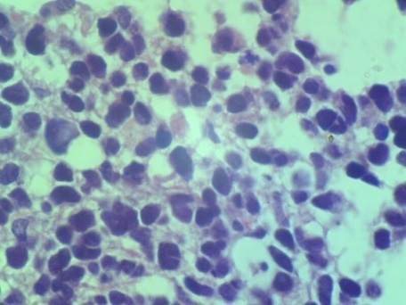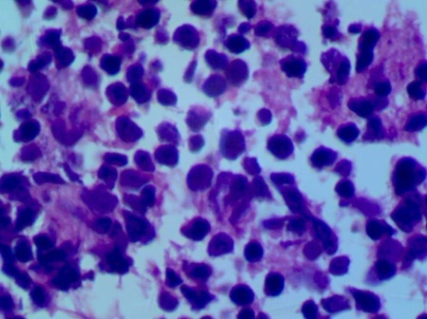
Fig1: Classical type 100x Fig2: Desmoplastic 100x
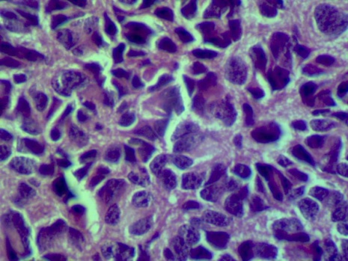 Fig3: Anaplastic 100x

Histological Variations depending on sex:
In our study of 51 classical types, 33(50.7%) cases were male and 18(27.6%) cases were female.Of 12 desmoplastic type 7(10.7%) were male and 5(7.6%) were female.Both the two cases of anaplastic variant were female.
Table 5: Histological variant and sex
Histological Types | Male | Female
Classical | 33(50.7%) | 18(27.6%)
Desmoplastic | 7(10.7%) | 5(7.6%)
Anaplastic | 0 | 2(3.07%)
Large cell | 0 | 0
MBEN | 0 | 0

Histological Variation and Plain CT findings:
Hyperdensity in plain CT was mostly found in classical type with 47(72.3%) cases,mixed density was found in 4(6.1%) cases of classical variant. In desmoplastic variant mixed intensity comprised 9(13.8%) cases and isodensity in 3(4.6%) cases.Two anaplastic variety showed mixed density.
Table 6: Histological variant and Plain CT finding
Histological types | Hyperdensity | Isodensity | Mixed density | Hypodensity
Classical | 47(72.3%) | 0 | 4(6.1%) | 0
Desmoplastic | 0 | 3(4.6%) | 9(13.8%) | 0
Anaplastic | 0 | 0 | 2(3.07%) | 0
Large Cell | 0 | 0 | 0 | 0
MBEN | 0 | 0 | 0 | 0

Histological Variation and Contrast CT findings:
In the classical type 43(66.1%) cases showed homogenous enhancement and 8(12.3%) cases showed heterogenous enhancement in contrast CT.All 12(18.4%) cases of desmoplastic variant showed heterogenous enhancement and 2(3.07%) cases of anaplastic variant showed heterogenous enhancement on contrast CT.
Table 7: Histological variant and Contrast CT findings
Histological variations | Homogenous | Heterogenous
Classical | 43(66.1%) | 8(12.3%)
Desmoplastic | 0 | 12(18.4%)
Anaplastic | 0 | 2(3.07%)
Large cell | 0 | 0
MBEN | 0 | 0

Histological variation and tumour location:
In our study of the classical variants 49(75.3%) were vermian and 2(3.07%) were paravermian in location.In the desmoplastic variety 7(10.7%) were paravermian and 5(7.6%) were lateral in location.Two anaplastic variant were paravermian in location.
Table 8: Histological variant and location of tumour
Histological type | Vermian | Paravermian | Lateral
Classical | 49(75.3%) | 2(3.07%) | 0
Desmoplastic | 0 | 7(10.7%) | 5(7.6%)
Anaplastic | 0 | 2(3.07%) | 0
Large cell
MBEN

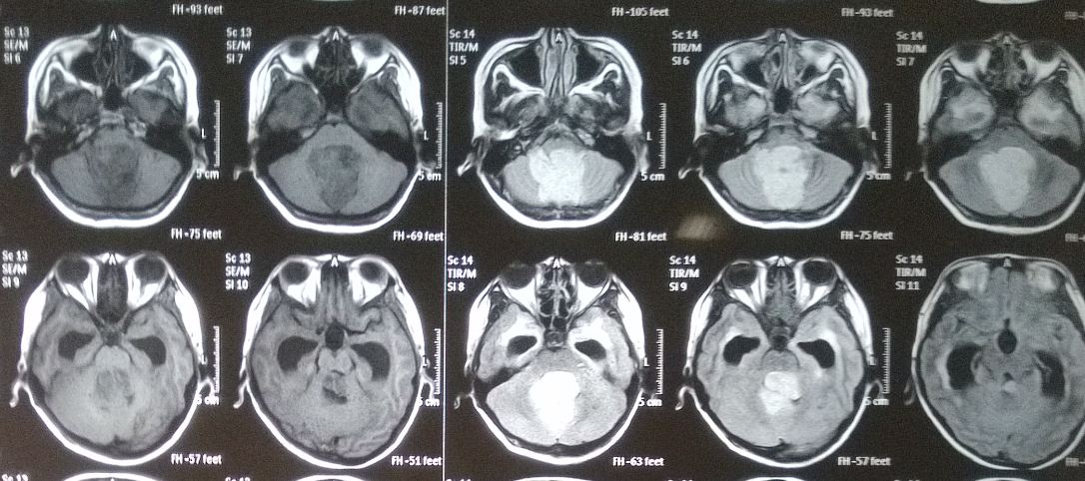
Fig4: T1 and T2 MRI of medulloblastoma case
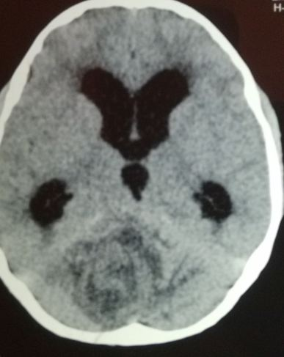
Fig5: Plain CT Scan of medulloblastoma case
Histological variations and MRI Signal intensity:
On T1 weighted images classical variant showed hyointensity in 49(75.3%) cases and 2(3.07%) cases showed isointensity and correspondingly on T2 images 49(75.3%)cases showed hyperintensity and 2(3.07%) cases showed isointensity.In the desmoplastic variant in T1 weighted images 7(10.7%) cases showed hypointensity and 5(7.6%) cases showed isointensity while in T2 images of desmoplastic variant 2(3.07%) cases showed hyperintensity and 10(15.3%) cases showed isointensity.Of the anaplastic variant in T1 weighted images 1 showed hypointensity and 1 showed isointensity while both appeared hyperintense in T2 weighted images.
Table 9: Histological variant and MRI signal intensity
Histological  Type | T1 |  | T2
Histological  Type | Hypo | Iso | Hyper | Iso
Classical | 49(75.3%) | 2(3.07%) | 49(75.3%) |  | 2(3.07%)
Desmoplastic | 7(10.7%) | 5(7.6%) | 2(3.07%) |  | 10(15.3%)
Anaplastic | 1 | 1 | 2(3.07%) |  | 0
Large cell | 0 | 0 | 0 |  | 0
Anaplastic | 0 | 0 | 0 |  | 0

Histological Variations and MRI Features:
Oedema: Oedema was present in 61(93.8%) cases of which 10(15.3%) cases had marked oedema,35(53.8%) cases had moderate oedema and 16(24.6%) cases had mild oedema.Out of the total 51 cases of classical variant 49(75.3%) had oedema and out of 12 cases of desmoplastic variant 10(15.3%)cases had oedema.Both the two cases on anaplastic variant presented with marked oedema.
Margin: Margin was well defined in 57(87.6%) cases and poorly defined in 8(12.3%) cases.In the classical variant 47(72.3%) cases had well defined margin and 4(6.15%%) cases had poorly defined margin.While of 12 desmoplastic variant 10(15.3%) cases had well defined margin and 2(3.07%) had poorly defined margin.Two cases of anaplastic variant had poorly defined margin.
Hydrocephalous:
In our study of the total 65 cases 54(83.07%) cases had hydrocephalous of which 45(69.2%) cases belong to classical variant,7(10.7%) cases belong to desmoplastic and 2(3.07%) belong to anaplastic variant.
Haemorrhage and Necrosis:
Haemorrhage was seen in 4(6.1%) cases of desmoplastic and 2(3.07%) cases of anaplastic variant.Necrosis was seen in 4(6.1%) cases of desmoplastic and 2(3.07%) cases of anaplastic variant.

Table 10: Histological variants and MRI features
Histological type | Oedema | Margin |  | Hydrocephalous | Haemorrhage | Necrosis
Histological type | Oedema | Well defined | Poorly defined | Hydrocephalous | Haemorrhage | Necrosis
Classical | 49(75.3%) | 47(72.3%) | 4(6.15%) | 45(69.2%) | 0 | 0
Desmoplastic | 10(15.3%) | 10(15.3%) | 2(3.07%) | 7(10.7%) | 4(6.15%) | 4(6.15%)
Anaplastic | 2(3.07%) | 0 | 2(3.07%) | 2(3.07%) | 2(3.07%) | 2(3.07%)
Large cell | 0 | 0 | 0 | 0 | 0 | 0
MBEN | 0 | 0 | 0 | 0 | 0 | 0

Histological Variations and CSF diversion and their level of Surgical Excision:
In our study of the total 65 cases 54(83.07%) had hydrocephalous and 51(78.4%) required MPVP shunt.In two cases EVD was given because of poor gcs followed by MPVP shunt placement.
All patients underwent surgical excision followed by radiotherapy. Chemotherapy was given to four cases with high grade tumour.
Gross total excision was done in 51(78.46%) cases and near total was done in 14(21.5%) cases.Out of the 14 near total excision cases 8 had extension to the brain stem. CSF collected by lumbar puncture 2 weeks following surgery had not detected any malignant cells in any patients of our series. Post-operative MRI brain showed residual tumour volume more than 1.5 cm2 in 14 (21.5%) patients.

Table 11: Surgical Treatment
Histological Types | MPVP shunt | Gross Total Excision | Near Total Excision | Subtotal Excision
Classical | 42(64.61%) | 41(63.07%) | 10(15.3%) | 0
Desmoplastic | 7(10.7%) | 10(15.3%) | 2(3.07%) | 0
Anaplastic | 2(3.07%) | 0 | 2(3.07%) | 0
Large cell | 0 | 0 | 0 | 0
MBEN | 0 | 0 | 0 | 0

Post operative complications:
One patient who presented with poor gcs preoperatively expired 36 hours after surgery.Cerebellar ataxia was seen in 10(15.3%) cases and nystagmus in 10(15.3%) cases.Cerebellar mutism was seen in 4(6.15%) cases.Cranial nerve palsy(abducen and facial) was seen in 3(4.6%) cases.Recurrence was noted at 1 year follow up in 6 cases of which two cases did not complete their radiotherapy cycles.

Table 12: Post operative complications.
Complications | Total Number
Cerebellar ataxia | 10(15.3%)
Nystagmus | 10(15.3%)
Cerebellar mutism | 4(6.15%)
Cranial nerve palsy | 3(4.6%)
Mortality | 1(1.5%)
Recurrence | 6(9.2%)

Follow up: Follow was done at 1month,3 month,6 month,9 month and 1 year.Recurrence was seen in 6 cases of which 4 were of classical type and 2 anaplastic type.All 6 cases had near total excision and two of them did not complete their radiotherapy cycles.
Discussion.
In our study majority of the cases belonged to the paediatric age group with only 4.6% cases above the age of 15 years.64.6% cases belonged to the age group 5-15 years,16.9%cases in 3-5 years group and 13.8% cases in 0-3 years group.Majority of cases in our study were male comprising 61.5% and female 38.4% with male to female ratio 1.6:1. Similar findings were reported by Agerlin, N., Gjerris, F., Brincker, H. et al. with 35.5% cases in 0-4 years and 64.4% cases between 5-14 years and a male to female ratio of 2:1 [6].
In our study all cases presented with headache, vomiting was seen in 51(78.4%) cases.Anorexia with weight loss was seen in 21(32.3% ) cases and lethargy in 20(30.7%) cases.Imbalance was seen in 43(66.1%) cases,papilledema was seen in 22(33.8%) and decreased vision in 16(24.6%) cases.Truncal ataxia was seen in 29(44.6%) cases and appendicular ataxia in 8(12.3%) cases. Alston RD et al, 2003 [7] have reported that the older child is more likely to present pressure features of headache, vomiting, and ophthalmic signs. Younger children present with non-specific features such as lethargy, behavioral disturbance, or increasing head size. Ataxia is seen in about 75% of children across the age range.
In our study classical variant was the most common type with 51(78.4%) cases and most belong to 5-15 years with 32(49.2%)cases.Desmoplastic variant comprised 12(18.4%) cases and was seen in older age group. Anaplastic variant comprised 2 cases.Of 51 classical types, 33(50.7%) cases were male and 18(27.6%) cases were female.Of 12 desmoplastic type 7(10.7%) were male and 5(7.6%) were female.Both the two cases of anaplastic variant were female. According to different literatures the age distribution of desmoplastic variety is still disputed.McManamy CS, Pears J, Weston CL, et al [8] found classical variant in 71% cases,desmoplastic in 16% cases and anaplastic in 17% cases.
Most of the classical variants appeared as homogenous mass in CT scan while the desmoplastic and anaplastic variant appeared as heterogenous mass. In our study of the classical variants 49(75.3%) were vermian,in the desmoplastic variety 7(10.7%) were paravermian and 5(7.6%) were lateral in location.Two anaplastic variant were paravermian in location. Bourgouin PM et al, [9] 1992, Hubbard JL et al, 1989, [10] have reported that vermian medulloblastoma are mostly appear as a hyper-dense mass on plain CT, and with intense homogenous enhancements with contrast.Lateral lesion is more common in older age group which appears as mixed density lesion on plain CT, and with heterogenous enhancements with contrast.
Most of the classical variant showed T1 hypointensity and T2 hyperintensity,while the desmoplastic group in T1 showed variable hypo to isointensity and mostly isointensity in T2 MRI signal.Similar findings were reported by Bourgouin PM et al, [9].Heterogeneity is more common in the older age group and it is more prominent in MRI than CT. According to them iso signal intensity on T2 weighted images and more heterogeneity in older age group might be related to desmoplastic histology.
Oedema was present in 61(93.8%) cases of which 10(15.3%) cases had marked oedema,35(53.8%) cases had moderate oedema and 16(24.6%) cases had mild oedema.Out of the total 51 cases of classical variant 49(75.3%%) had oedema and out of 12 cases of desmoplastic variant 10(15.3%)cases had oedema.Both the two cases of anaplastic variant presented with marked oedema.Margin was well defined in 57(87.6%) cases and poorly defined in 8(12.3%) cases.In the classical variant 47(72.3%) cases had well defined margin and 4(6.15%) cases had poorly defined margin.While of 12 desmoplastic variant 10(15.3%) cases had well defined margin and 2(3.07%) had poorly defined margin.Two cases of anaplastic variant had poorly defined margin.Of total 65 cases 54(83.07%) cases had hydrocephalous of which 45(69.2%) cases belong to classical variant,7(10.7%) cases belong to desmoplastic and 2(3.07%) belong to anaplastic variant.Haemorrhage was seen in 4(6.1%) cases of desmoplastic and 2(3.07%) cases of anaplastic variant.Necrosis was seen in 4(6.1%) cases of desmoplastic and 2(3.07%) cases of anaplastic variant.Sandhu A et al, 1987 had reported oedema in 90% cases and marked oedema in 1% cases; they had not reported any specific age/site distribution in their series.Bourgouin PM et al, 1992 had reported that the vermian lesions had well defined margins and in lateral lesions had poorly defined margins.Sandhu A et al[11], 1987 reported haemorrhage in 1% cases only in adults.
In our study of the total 65 cases 54(83.07%) had hydrocephalous and 51(78.4%) required MPVP shunt.Gross total excision was done in 51(78.46%) cases and near total was done in 14(21.5%) cases.Out of the 14 near total excision cases 8 had extension to the brain stem.Post operatively cerebellar ataxia was seen in 10(15.3%) cases and nystagmus in 10(15.3%) cases.Cerebellar mutism was seen in 4(6.15%) cases.Cranial nerve palsy(abducen and facial) was seen in 3(4.6%) cases.Recurrence was noted in 6 cases of which two cases did not complete their radiotherapy cycles.

Conclusion.
Our study indicate that medulloblastoma is commonly seen in paediatric age group and more common in males.Within the paediatric age group certain variants appear in younger group while others in older group.Patients usually presents with features of raised ICP,imbalance and visual disturbance.Classical variant was the most common type with mostly vermian location followed by desmoplastic variant which was paravermian to lateral in location.CT and MRI features varied in different variants of medulloblastoma.In most of the cases gross total excision was possible and surgical outcome is favourable.Post operatively radiotherapy and chemotherapy have proved very useful.Recurrence was seen to be associated with level of surgical excision and post operative radiotherapy and chemotherapy.

Bibliography.
1. Rutka JT: Medulloblastoma. ClinNeurosurg 1997; 44:571.
2.Roberts RO, Lynch CF, Jones MP, Hart MN. Medulloblastoma: a population-based study of 532 cases. J Neuropathol Exp Neurol 1991; 50:134-144.
3. Duffner PK, Cohen ME. Recent developments in pediatric neuro oncology. Cancer 1986; 58:561-568.
4. Bailey P, Cushing H. Medulloblastoma cerebelli: a common type of
midcerebellar glioma of childhood. Arch.Neurol.& Psychiat. XIV,
192-223. 1925.
5. Schoenberg BS, Schoenberg DG, Christine BW, et al: The epidemiology of primary intracranial neoplasms of childhood. A population study. MayoClinProc 1976; 51:51.
6. . Agerlin N, Gjerris F, Brincker H, et al: Childhood medulloblastoma in Denmark 1960-1984. A population-based retrospective study. Childs NervSyst 1999; 15:29.
7. Alston RD, Newton R, Kelsey A, Newbould M J, et al. Developmental Medicine and Child Neurology. London: May 2003; 45 (5): 308.
8. McManamy CS, Pears J, Weston CL, et al: Nodule formation and desmoplasia in medulloblastomas—defining the nodular/desmoplastic variant and its biological behavior. Brain Pathol 2007; 17:151
9.Bourgouin PM, Tampieri D, Grahovac SZ, Leger C, Del Carpio R, Melancon D. CT and MR imaging findings in adults with cerebellar medulloblastoma: comparison with findings in children. AJR Am J Roentgenol 1992; 159:609-612.
10. Hubbard JL, Scheithauer BW, Kispert DB, Carpenter SM, Wick MR, Laws ER, Jr. Adult cerebellar medulloblastomas: the pathologic, radiographic, and clinical disease spectrum. J Neurosurg 1989; 70:536-544.
11.Sandhu A, Kendall B. Computed tomography in management of medulloblastomas. Neuroradiology 1987; 29:444-452.
(12) Kadin ME, Rubinstein LJ, Nelson JS. Neonatal cerebellar
medulloblastoma originating from the fetal external granular layer. J
Neuropathol Exp Neurol 1970 Oct;29(4):583-600.
(13) Reddy AT, Packer RJ. Medulloblastoma. Curr Opin Neurol 1999
Dec;12(6):681-5.132
(14) Marino S, Vooijs M, van Der GH, Jonkers J, Berns A. Induction of
medulloblastomas in p53-null mutant mice by somatic inactivation
of Rb in the external granular layer cells of the cerebellum. Genes
Dev 2000 Apr 15;14(8):994-1004.
(15) Marino S. Medulloblastoma: developmental mechanisms out of
control. Trends Mol Med 2005 Jan;11(1):17-22.
(16) Raffel C. Medulloblastoma: molecular genetics and animal models.
Neoplasia 2004 Jul;6(4):310-22.

