ORIGINAL PARER
Dental Morphological Anomalies in the Adi Tribe of Pasighat in Arunachal Pradesh.

Das Lima¹, Bhuyan A C², Kataki Rubi³, Kalita Chandana⁴

ABSTRACT
Objective: To identify three dental morphological anomalies of permanent teeth namely Peg Laterals, Dens Evaginatus and Rudimentary third molars in the Adi tribe of Pasighat area of Arunachal Pradesh.
Methods: Oral examination for morphological anomalies was done in 156 individuals using a dental mirror and probe for the said anomalies and a questionnaire with details relevant to the study was used during examination.
Results: A total of 156 samples were screened and 35%presented with at least one anomaly out of which 31% had one anomaly, 4% had two anomalies and 0% had more than two anomalies. Total number of positive cases (both single and dual) for each of the anomalies were- Peg Laterals 25%, Dens Evaginatus 20% and Rudimentary third molar 4%. One other anomaly i.e. Cusp of Carabelli not previously considered in this study was found in 22% of the cases.
Conclusion: The data obtained from the present study confirms the prevalence of dental anomalies namely, Peg Laterals, Dens Evaginatus, Rudimentary third molars and Cusp of Carabelli in the tribal population of Pasighat similar to other Mongoloid populations of the world.
Keywords: Anomalies,Adi,Cusp, Peg Laterals, Dens Evaginatus, Rudimentary third molars, Cusp of Carabelli

INTRODUCTION
Dental morphological anomalies in permanent teeth is an important area of study within the subject of Dental Anatomy and Physiology. There are several reasons for studying dental anatomical variants in any population, the most significant being enhanced diagnosis and treatment planning. Early diagnosis of dental anomalies allow for more comprehensive treatment planning, better prognosis and in certain instances, less extensive interception¹.
Another important reason for studying anatomical variation is for forensic value. Anatomical variations related to tooth morphology may show certain traits specific to different racial groups which may be of immense forensic value. Ancestry can be accessed by studying the facial skeleton and comparing the features with the main characteristics of three racial groups: Mongoloid, Negroid, and Caucasoid².
Also, the large variation in morphological features and their form may not be easily altered; thus a trait of the human dentition can be a valuable diagnostic tool for anthropological studies in classifying and characterizing different ethnic groups³. Accumulation of data on the morphological traits of teeth in different populations has let anthropologists to research further on the evolutionary significance of this data and consider its mode of inheritance.

Again the incidence and degree of expression of anomalies in different population groups can provide important information for phylogenic and genetic studies and help the understanding of variations within and between the different world populations⁴.

THE HYPOTHESIS

An initial hypothesis related to the present research is as follows-Three dental anomalies of permanent teeth-Peg Laterals,Dens Evaginatus and Rudimentary third molars are endemic in the Adi population of Pasighat, in Arunachal Pradesh.
AIMS AND OBJECTIVES
The aim of the study is to identify three dental morphological anomalies namely

1.Peg laterals
2.Dens Evaginatus
3.Microdontia of maxillary third molars/Rudimentary third molars(erupted)
in the tribal population in Pasighat area of Arunachal Pradesh,India.

The overall objective of the proposed study was to establish trough data the occurrence of dental morphological anomalies in permanent teeth in the said population.
Specific objectives of the study are:
- To identify particular types of anomalies
- To see if they are specific to any sub tribe
- To see if the anomalies are gender specific.
Geographical area concerned with the study includes the entire Pasighat township within 10 km radius.

DEFINITIONS

- Peg Laterals: A maxillary lateral incisor in which the mesial and distal sides converge or taper together incisally forming a peg shaped or cone shaped crown instead of exhibiting parallel or diverging proximal surfaces⁵.
- Dens Evaginatus: A developmental condition that appears clinically as an accessory cusp or a globule of enamel usually on the occlusal surface between the buccal and lingual cusps of premolars unilaterally or bilaterally⁵.

- Microdontia of third maxillary molars/Rudimentary third molar:
Third molar teeth that are smaller in size than normal i.e. outside the
usual limits of variations⁵.

POPULATION and SAMPLE

Total population of Pasighat according to 2011 census was 36,354, of which 24,656 of the population were in the urban area and approximately only 50% of the urban population was from the Adi tribe. To represent the population in the study a sample was taken using a stratified cluster sampling method for data collection after dividing the said Pasighat area into three main geographical groups and further stratifying them into sub groups. The three main groups are-

- PASIGHAT URBAN subdividion -population contained is 12328
- BALEK GROUP OF VILLAGES -population contained is 2031
- MIRMIR GROUP OF VILLAGES -population contained is 4685

The population ratio of the three main groups are as follows

Pasighat Urban(gr 1) : Balek(gr2) : Mirmir(gr3) = 12328 : 2031 : 4685

i.e. 12:2:5

SAMPLE SIZE FOR THE PRESENT STUDY

A total number of 156 samples were screened in this present study distributed in the three main groups in the ratio 12:2:5 as follows:

- No. of Samples in Pasighat Urban area (gr 1) - 71
- No. of Samples in Balek area (gr 2) - 37
- No. of Samples in Mirmir area (gr 3) - 48

PROCEDURE: Tools and Method

Oral examination for morphological anomalies of permanent teeth was done using dental mirror and probe for the said anomalies and a questionnaire with details relevant to the study was used during examination. The age group selected for examination was above 21 yrs to ensure complete eruption of the permanent teeth.

INCLUSION & EXCLUSION CRITERIA
The inclusion and exclusion criteria for the samples in the study are as follows
Inclusion criteria
- Persons belonging to the Adi tribe
- Age should be above 21 years

Exclusion criteria
- If one or both parents are not from the Adi tribe.
- Restored teeth
- Unerupted third molars

STUDY VARIABLES

- Sub tribes (eg: pasi,padam,panggi,minyong,milang)
- Gender
- Type of anomaly
- Geographical distribution

RESULTS

Oral examination showed the presence of three previously mentioned anomalies-Peg laterals, Dens Evaginatus and microdontia of third molars and also included positives of one other anomaly i.e. Cusp of Carebelli in a number of the cases.
Of the total sample of 156 the number of cases with anomalies was 55 i.e. 35% of the total cases screened.
The number and types of anomalies along with their percentages(including both single and dual) out of the total sample of 156 are as follows:
Number of Cusp of Carabelli found - 34 i.e.22%
Number of Peg laterals(PL) -14 i.e. 9%
Number of Dens Evaginatus (DE) -11 i.e.7%
Number of Microdontia of third(RT) molars were -2 i.e.1%

Of the positive 55 cases the number and percentage of individual anomalies(both single and dual) are as follows:
Cusp of Carabelli - 34 i.e.62%
Peg laterals(PL) - 14 i.e. 25%
Dens Evaginatus (DE) -11 i.e.20%
Microdontia of third(RT) -2 i.e.4%

Again,the prevalence of anomalies were 59% in the females and 41% in the males(Fig 2). The distribution of anomalies in the various sub-tribes are as follows are- Pasi-18%,Padam-16%,Milang-2%,Pangi-4%and Minyong-60%(Fig 3).Geographically,45% of the anomalies were found in the urban area,24% in the Balek area and 31% in the Mirmir area(Fig 4)

DISCUSSION

The occurrence of dental morphological anomalies have been studied by various authors in different world populations at various times. However such studies identifying dental morphological traits in the various tribes and sub-tribes of the north-eastern states of India have not received its due importance^{3,6,7}.
In the present study, of the total number of 156 cases, 35% presented with at least one anomaly(Table 1). 31% of the total cases had one anomaly, 4% had two anomalies and none had more than two anomalies.It was observed that 9% of the total cases were positive for Peg Lateral, 7% for Dens Evaginatus, 1% for rudimentary third molar and 22% for Cusp of Carebelli. Again To statistically analyze the results A ‘Z’ test of proportion was done to test the difference between the hypothesized proportion of anomalies (P=50%) and the observed proportion( p=35%) at 5% significance level. The Z test indicated that the test is significant (p value < 0.05).
Chi square tests were conducted at 5 % significance level to test the difference in the distribution of anomalies according to gender, area and the various subtribes. The tests indicated that there is no significant difference in the distribution of anomalies with respect to gender (p value = 0.85). However, highly significant differences were indicated in the distribution of the anomalies with respect to area (p value <0.001) and to sub tribe (p value < 0.001).

A study similar to our present study was done by Nayak P in
Rajasthan and he found that prevalence of peg lateral was 0.4%
which is very less compared to the 9% prevalence in our study⁸.

Fang Hua and his associates (2013) also did a meta analysis on the prevalence of peg-shaped maxillary permanent lateral incisors and
their associations with race, population type, sex, and sidedness⁹. The
overall prevalence of peg-shaped maxillary permanent lateral incisors
was 1.8%,the occurrence rates being higher in Mongoloid (3.1%) than
in black (1.5%) and white (1.3%) patients. Comparitively the findings
in our study showed a higher % of prevalence of Peg laterals. In his
study women were more likely than men to have peg shaped maxillary
permanent lateral incisors. The prevalence rates of unilateral and bilateral peg-shaped maxillary permanent lateral incisors were approximately the same. However, among the unilateral lateral incisors, the left side (0.4%) was twice as common as the right side (0.2%).

Another similar study on the dental features such as size, shape,cusp number and groove pattern etc. was done on the Tibetian immigrants of india by J Sharma¹⁰. He concluded that overall reduction in size, hypodontia of the third molar and absence of Carebelli’s Cusp were a distinct evolutionary trend in Tibetian dentition. In our study however the prevalence of the Cusp of Carelelli was much higher i.e.22%

In yet another study by Shelly S Stecker et al(2013) the prevalence of dental anomalies in a Southeast Asian Population in the Minneapolis area reported a higher 7.5%prevalence of peg laterals and 1.1% of Dens Evaginatus in Asians¹¹.
In our study since no previous data relating to the prevalence of dental morphological anomalies in the Adi tribe was found, population proportion(P) with anomalies was hypothetically taken as 50%.The observed proportion following data collection and analysis was 35%. The Z test used to compare the two proportions rejected the null hypothesis. However the higher prevalence rates confirmed the presence of specific types of dental anomalies and has given us their prevalence rates for future studies.

CONCLUSION

The data obtained from the present study confirms the prevalence of dental anomalies, namely Peg Lateral, Dens Evaginatus, Rudimentary third molars and Cusp of Carabelli in the Pasighat area of Arunachal Pradesh

Conflict of interest: No conflict of interest associated with this work

Ethical clearance : Done

REFERENCES
- Yonezu T, Hayashi Y, Sasaki J, Machida Y. Prevalence of congenital dental anomalies of the deciduous dentition in Japanese children. Bull Tokyo DentColl1997;38:27-32.
- Leung KK. Forensic odontology. Dent Bull. 2008;13:11.

- King N M, Tsai Jennie S J, Wong H M. Morphological and numerical characteristics of the Southern Chinese dentitions. Part II: Traits in the permanent dentition.The Open Anthropology Journal 2010;3:71-84.

- Patil S, Doni B, Kaswan S, Rahman F .Prevalence of dental anomalies in Indian population J Clin Exp Dent. 2013 Oct; 5(4): e183–e186.

- Shafer,Hine an Levy.Oral Pathology, 5th edition 2006: 52-59
- Jerome CE and Hanlon RJ Jr.Dental Anatomical Anomalies in Asians and Pacific Islanders.C D A J 2007;35(9):631-636.
- Lavelle C L B. A Metrical comparison of Maxillary First Premolar Form. American Journal of Physical Anthropology.1984;63:397-403.
- Nayak P and Nayak S.Prevalence and distribution of dental anomalies in 500 indian school children. Bang J of med Sc vol.10 no 1 Jan
- Fang Hua et al.Prevalence of peg-shaped maxillary permanent lateral incisors: a meta-analysis.Americal journal of orthodontics and dentofacial orthodontics 2013 july;144(1):97-109

- J Sharma.Dental morphology and odontometry of the Tibetan immigrants.American Journal of Physical Anthropology 09/1983; 61(4):495-505

Shelly S Stecker et al. Prevalence of Dental Anomalies in a Southeast Asian Population in the Minneapolis/Saint Paul Metropolitan Area.j of Minnesota dental assoc. nov-dec 2013 vol 92:6
- Hsu JW, Tsai PL et al. Ethnic dental analysis of shovel and Carabellis’s trait in a Chinese population. Aust Dent J 1999; 44:40-5.
- Peiris R, Nanayakkara D and Kageyama I.Crown dimensions of the mandibular molars in two ethnic groups in SriLanka.Anthropological Science.2006;114(1)89-92.
- Rao Yan-gang, Guo Li-Yang, Hu Tao. Multiple Dens Evaginatus of Premolars and molars in Chinese dentition. Int.J Oral SC 2010;2(3):177-180

- Suneelkumar Chinni et al. A facial talon cusp on maxillary permanent central incisors. J Conserv Dent. 2012 Jan-Mar; 15(1): 87–88.
- Pegah Bronoosh et al Prevalence of Taurodontism in Premolars and Molars in the South of Iran.J Dent Res Dent Clin Dent Prospects. 2012 Winter; 6(1): 21–24.

- Hakan Çolak et al.Radiographic Study of the Prevalence of Dens Invaginatus in a Sample Set of Turkish Dental Patients. J Clin Imaging Sci 2012, 2:34

N. B. Nagaveni et al. An Unusual Occurrence of Multiple Dental Anomalies in a Single Nonsyndromic Patient: A Case Report Case Rep Dent. 2012; 2012: 426091

Jeevanandan G et al. Single-rooted primary first molars.Indian J Dent Res 2012:23:104-6

Gündüz K et al.A retrospective study of the prevalence and characteristics of dens invaginatus in a sample of the Turkish population.Med Oral Patol Oral Cir Bucal. 2013 January; 18(1): e27–e32.

ADDRESS OF CORRESPONDANCE:
¹Reader, Deptt. of Conservative Dentistry & Endodontics
Regional Dental College, Guwahati, Assam.
email: limakaling@gmail.com
²Professor and Head, Deptt. of Conservative Dentistry & Endodontics,RDC,Ghy.
³Professor,Deptt. of Conservative Dentistry & Endodontics,RDC,Ghy.
⁴Reader,Deptt. Of Conservative Dentistry and Endodontics,RDC,Ghy.

DESCRIPTIVE STATISTICS
 |  | OBSERVED VALUES | % OF TOTAL SAMPLE (156) | % OF POSITIVE CASES (55)
 | TOTAL NO. OF SCREENINGS (SAMPLE SIZE) | 156
 | NO. OF POSITIVE CASES | 55 | 35%
 | NO. OF CASES WITH ONE ANOMALY | 49 | 31% | 89%
 | NO. OF CASES WITH TWO ANOMALIES | 6 | 4% | 11%
 | NO. OF CASES WITH MORE THAN TWO ANOMALIES | 0 | 0% | 0%
 | NO. OF PL POSITIVE CASES | 14 | 9% | 25%
 | NO. OF DE POSITIVE CASES | 11 | 7% | 20%
 | NO. OF RT POSITIVE CASES | 2 | 1% | 4%
 | NO. OF CC POSITIVE CASES | 34 | 22% | 62%

Table 1. Showing the number and percentage of occurance of anomlies out of the total samples and among the positives.

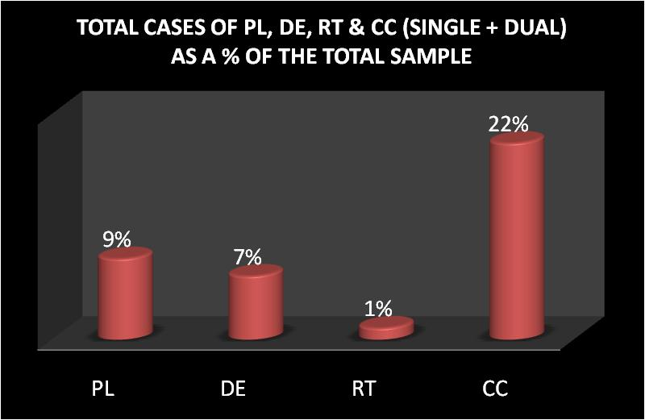
Fig 1. Cylindrical bar diagram showing the distribution of anomalies as a percentage of the total sample.

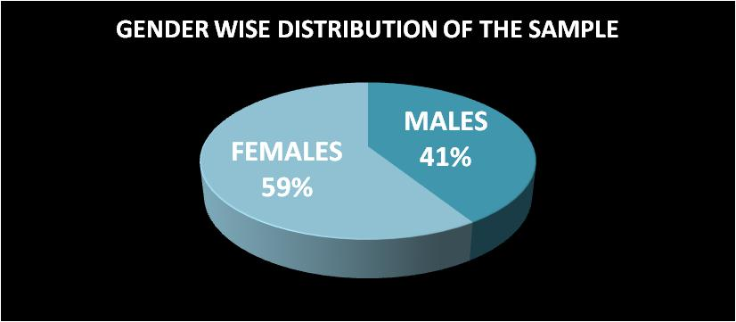
Fig 2. Pie diagram showing the gender-wise distribution of anomalies.

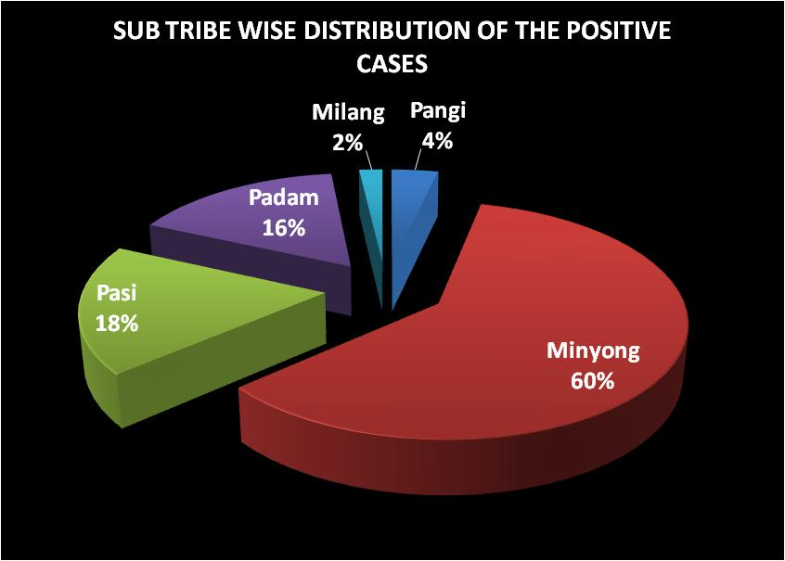
Fig 3. Pie diagram showing the distribution of anomalies according to the sub-tribes
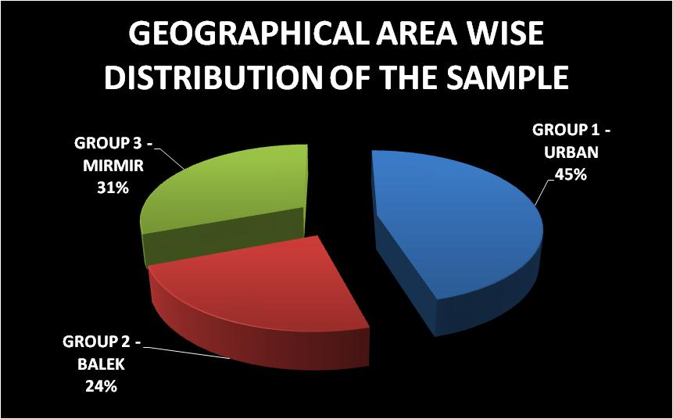
Fig 4. Pie diagram showing the geographical distribution of anomalies.

-----------------------------------------------X---------------------------------------------

