TIMING OF ORTHODONTIC TREATMENT- A REVIEW

ABSTRACT
The ideal time to commence an orthodontic treatment for a given patient has been a controversial issue since the establishment of orthodontia as a specialized art and science. Understanding proper diagnosis criteria, type of cases which should be treated early and customized treatment planning considering the patient goal and desire, with problem oriented approach, will permit the clinician to offer the most efficient treatment for each individual. Early orthodontic treatment is prudent in specific situations for structural balance, functional efficiency, esthetic and psychosocial reasons. However, it does not exclude cases for which later, single-phase treatment is more effective. Therefore, clinicians must decide, on complexity of case, predictability of success and cost benefit basis when to provide orthodontic treatment.

Keywords: Early, Malocclusion, Single phase, Timing, Treatment

INTRODUCTION

Early, or phase I, orthodontic treatment start during either the primary or transitional period to either prevent ,correct or intercept a malocclusion and reduce the need or the time for treatment in the permanent dentition in a manner that will ultimately lead to a better, more stable result than that which would be achieved by starting treatment later¹. The main objectives of early treatment is obtaining a skeletal change (structural), providing the opportunity of a functional change in the environment, utilizing the individual growth, eliminating the detrimental habits and taking advantage of the forces of the occlusal development towards the correction of the problem². The present review thus focus relative merits of early treatment in the management of growth related issues and various malocclusion.

Orthodontists have made remarkable progress in understanding physiology, growth, tissue response, increasingly sophisticated diagnostic techniques, available materials, and information. Nevertheless, with all these advances, many practitioners still find themselves at a dilemma to intervene or not to intervene before the eruption of the complete permanent dentition. To be capable of determining the optimum moment to begin treatment, orthodontists must possess a profound comprehensive knowledge, which discrepancies would benefit from early treatment. It is important that orthodontists perform "triage" so that they will not get caught up in a relentless therapeutic cycle leading only to long, drawn-out treatments, patient and parent fatigue, and professional frustration.^{3, 4}.

EARLY TREATMENT OF CLASS II MALOCCLUSION

Class II malocclusion is a skeletal discrepancy that may be caused by maxillary protrusion, mandibular retraction or a combination of both situations. The treatment can be carried during the pre-puberty stage (early treatment) with Functional appliances by modifying and stimulating growth, restraining it where indicated, or reorienting in order to change neuromuscular behavior and improve the functioning of oral structures, as well as form. The primary indication for early intervention in Class II malocclusions remains psychosocial problems and teasing.^{5,6} .According to recent research, the main advantages of Class II early treatment were: raise patient self-esteem and family satisfaction (78.5%), reduction of risk of anterior teeth fracture (63.6%), and less extensive orthodontic therapy during the second stage (62.6%) ⁷. Incompetent lips, a markedly increased over jet and increased incisal exposure at rest predispose, in particular, to dental trauma may derive some benefit from early intervention⁸. Substantial evidence supports the theory that early growth modification therapy can lead to an improvement, if not complete correction, of the Class II malocclusion.

Other recent studies suggest that as long as the patient is treated while he or she is still growing, the time at which treatment begins may not make a difference in the success of the Class II correction. Either during maximum pubertal growth spurt, the orthodontist could interfere with the problem in order to produce dentoalveolar movements and skeletal changes; or during adulthood, when due to growth absence the extraction of maxillary premolars is practically always considered, and even orthognathic surgery in more severe cases. Therefore, later-stage, single-phase treatment approach is preferable because of the advantages that accompany the reduced treatment time. However, the impact of early treatment on psychological development has yet to be substantiated. As long as the reasons are clear, the choice of timing comes down to the clinical judgment of the orthodontist in consultation with the patients and families .^{9, 10}

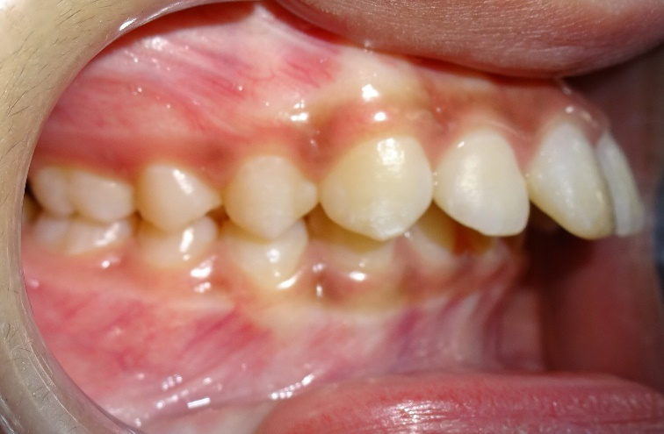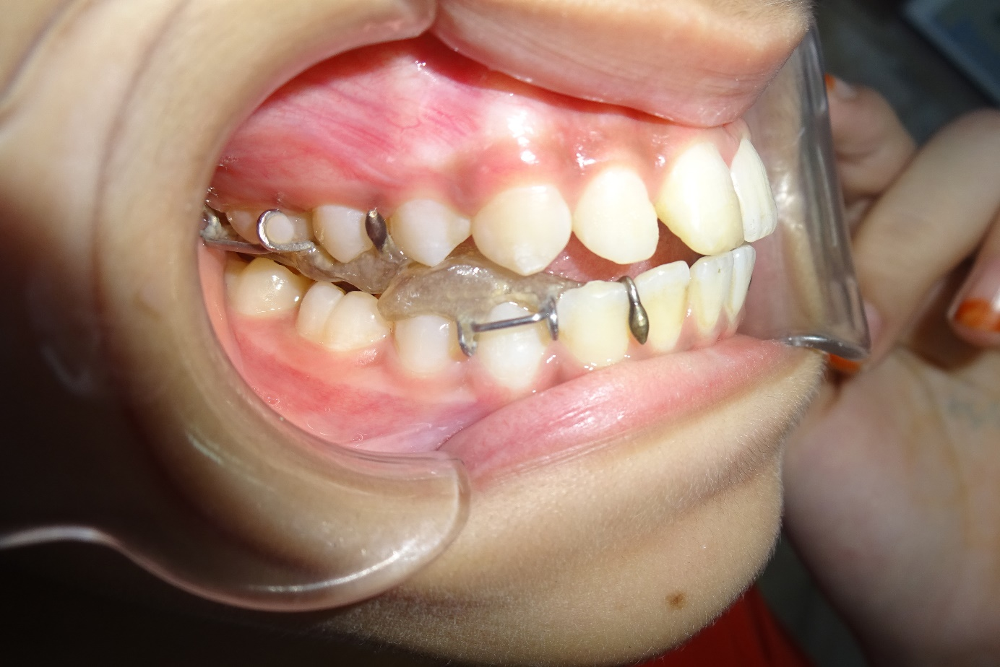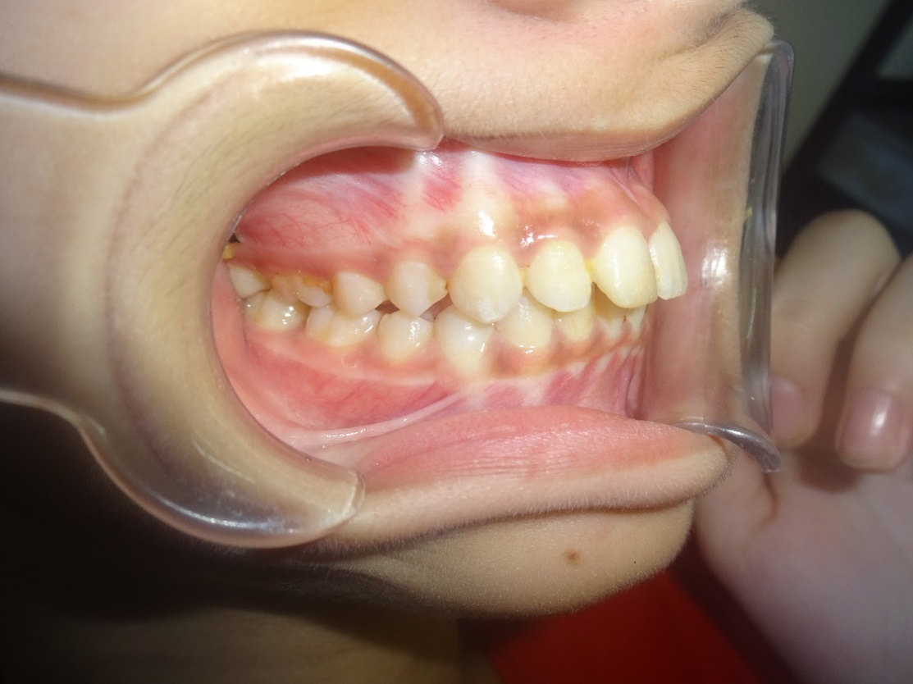

FIG 1: Early Treatment of Class II Malocclusion with Twin block Appliance

EARLY TREATMENT OF CLASS III MALOCCLUSION

Treatment of class III malocclusion in growing subjects is a challenging part of contemporary orthodontic practice. Successful orthopedic correction through growth modification has increased the nonsurgical correction of the growing class III patient. Understanding Optimal timing for the orthopedic approach to class III malocclusion is important. Recent study of Class III treatment supports using facemask therapy during the primary and early-transitional dentition, although it suggests that treatment at later stages is not without merit.

The Class III skeletal pattern is the result of a small and/or posteriorly positioned maxilla, a large and/or prognathic mandible, or a maxilla and mandible that are normal in the sagittal plane of space but underdeveloped in the vertical dimension. Most often, the Class III malocclusion is caused by a combination of two or all three discrepancies. Protraction headgear or Facemask therapy with or without prior palatal expansion is the most common orthopedic treatment protocol for class III malocclusion.¹¹⁻¹³
The typical protocol in facemask therapy is the application of approximately 12 ounces of force on the maxilla for 14 hours a day in a forward and slightly downward direction. Orthodontists most often prescribe facemask therapy for patients in the primary to early transitional dentition, in large part because of the patency of the circummaxillary sutures appropriate to this age. Growth modification of this kind is based on the premise that applying tension to these immature sutures is a stimulus for the formation of new bone. Although a significantly greater correction of the Class III pattern was observed in 4- to 10-year-olds than in 10- to 13-year-olds, the effect of age on treatment response was less than would be commonly expected.¹¹⁻¹³

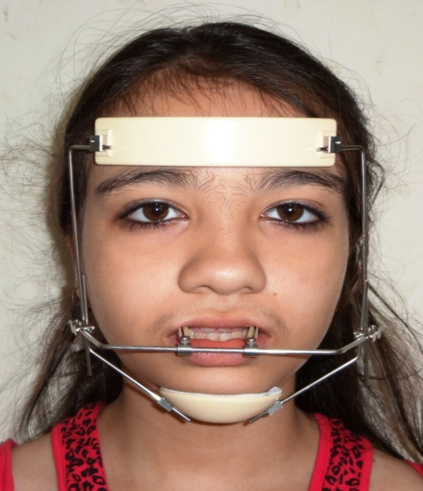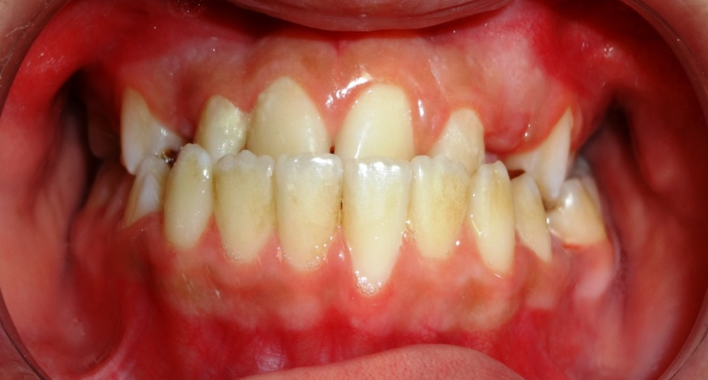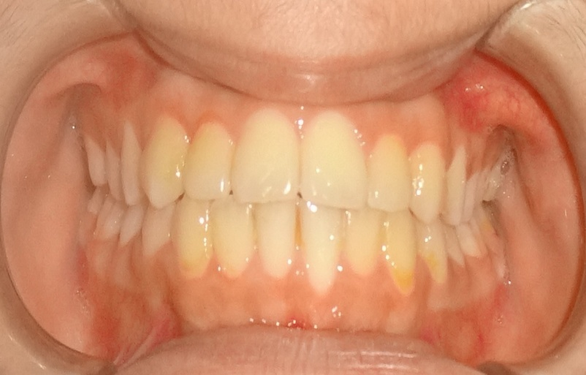

Fig 2: Early Treatment of Class III Malocclusion with Orthopedic Appliance

EARLY TREATMENT OF TRANSVERSE DISCREPANCIES

Skeletal or dental discrepancies in the transverse plane manifest either as crossbites unilaterally or bilaterally. Correction involves either dental or palatal expansion which can be undertaken with fixed or removable appliances. Many authors consider that widening of the midpalatal suture is a suitable method for treating maxillary arch size discrepancies. Rapid maxillary expansion (RME) is a clinical technique largely employed in orthodontic treatment to manage maxillary transverse deficiencies. The correction of a skeletal cross bite via palatal expansion is generally considered more appropriate in young patients because the sutures are not as interdigitated as in adults. In the early stages of skeletal maturation (that is, before the adolescent growth spurt’s peak height velocity), little-to-no midpalatal approximation exists. Therefore, beginning palatal expansion just before the onset of puberty is consistent with the biology of the tissue involved. Once the palatal suture is fused, correction of a skeletal crossbite usually requires surgical intervention. A recent study on modified type of Haas appliance shown increase in the transverse dimension of the maxillary dental arch in the mixed dentition with appropriate timing for treatment to be before the eruption of the permanent lateral incisors. However, for transverse dental discrepencies, dental expansion can be accomplished by simple tooth movement and, preferably done during phase II treatment.¹⁴⁻¹⁶

EARLY TREATMENT OF ARCH-LENGTH DISCREPANCIES
Treatment of arch-length discrepancies depends on the nature of the crowding. Natural arch development has the potential to correct early mild incisor crowding. Management of the leeway space will resolve a majority of cases of crowding. This approach is best accomplished in the transitional to late-transitional dentition. Severe crowding may warrant the extraction of permanent teeth. A serial extraction protocol may be desirable and the extraction sequence for such an approach begins in the early transitional dentition, while the appliance phase occurs in the early-permanent dentition. To determine the need for and appropriate timing of treatment for arch-length discrepancies, clinicians must be equipped with the knowledge about normal arch development.

EARLY INTERCEPTION OF VERTICAL MALOCCLUSION:

OPEN BITE
Early correction of an anterior open bite may be attempted by a range of fixed or removable appliances. The treatment technique, the orthodontist chooses and the etiologic factors involved will affect the prognosis .Conservative methods including education intervention and use of barriers, such as plasters, varnishes or gloves, are considered the first line of treatment for open bites related to aberrant habits, such as digit sucking . The use of fixed adjuncts such as tongue spurs to alter tongue posture has been advocated with some retrospective evidence supporting their effectiveness. The early use of myofunctional treatment in an effort to alleviate aberrant neuromuscular behavior has also received some attention.

Growth-related, skeletal open bites require more complex intervention .The ability to alter vertical facial growth is limited and may require sustained intervention. Depending on later growth, for definitive correction in the permanent dentition may be more amenable. Treatment methods including high-pull orthopedic headgear directed through the centre of the resistance of the maxilla, vertical-pull chincup and high-angle functional appliance can be advocated though with limited evidence of skeletal effectiveness .The advent of temporary anchorage devices has also raised the possibility of posterior intrusion of the dentition to induce open bite closure .The latter, however, more correctly represents a compensation for vertical skeletal excess and while the net effect may well be a decrease in the vertical dimension, the effect is produced through dental intrusion^{17,18}.

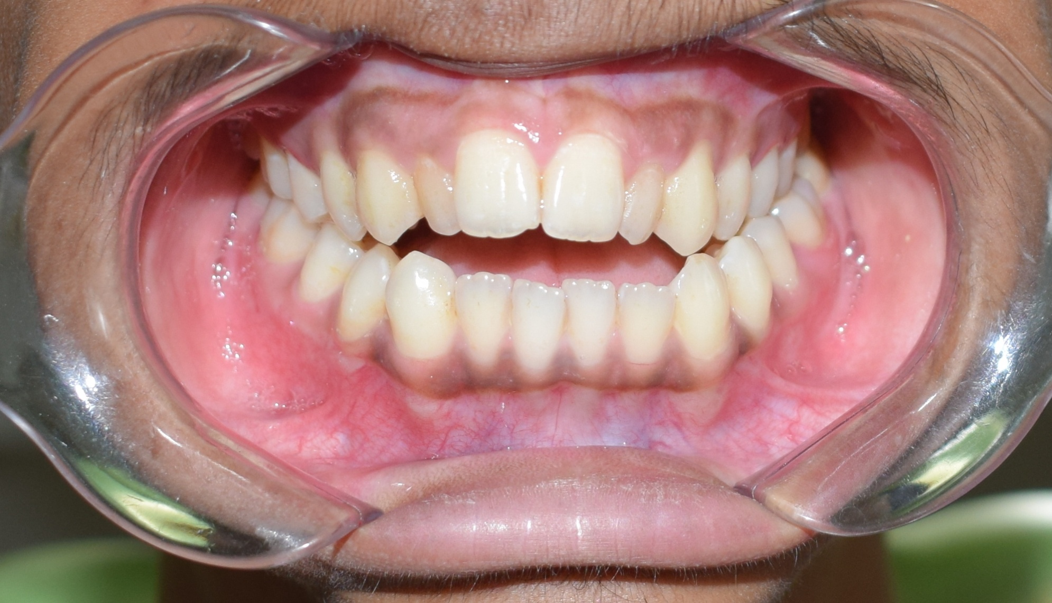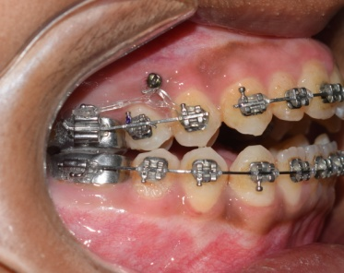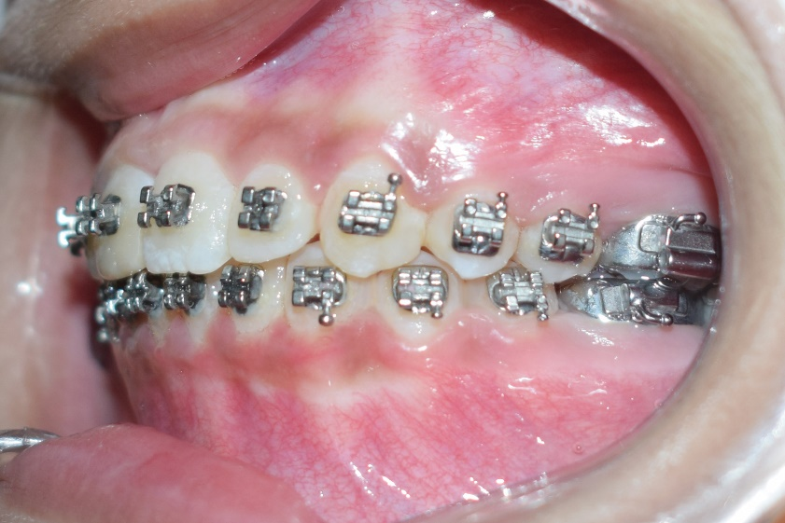

Fig3: Open Bite Treatment with TAD assisted posteriors intrusion.
DEEP BITE

This condition is characterized by either diminished height of the lower face resulting from insufficient vertical skeletal development, or a vertical overgrowth of the maxillary anterior alveolar process which carries the incisal group with it into overbite. By analyzing the separated casts and the cephalometric radiograph, the orthodontist can determine whether a single arch or both arches are implicated in the disorder and whether insufficient posterior vertical growth contributes to or causes the problem. The orthodontist should usually defer treating these patients until the mixed or permanent dentition stages. However, in the rare instances when called on to deal with a Class II division 2 type of developing malocclusion in a young child, the orthodontist can use a bite plate or a preformed plastic positioning device. A fixed appliance with molar bands, bonded attachments and a maxillary or a mandibular utility arch, or both, for intruding teeth where indicated, will provide the best results^{19, 20}.

CONCLUSION

The timing of treatment is influenced by various inevitable dental, skeletal, development and maturation differences in different age groups. Direct comparison of the merits of early or later commencement is complicated .Thus the best timing of orthodontic treatment must be a decision made by the orthodontist, the parent, and the patient based on all the factors that impact success considering the effectiveness and efficiency with cost benefit ratio. All options should be reviewed and considered to offer optimal time to start treatment that provides best treatment and results.

REFERENCES
- Proffit WR. The timing of early treatment: an overview. Am J Orthod Dentofacial Orthod 2006; 129:S47–9.
- Robert M. Ricketts A statement regarding early treatment Am J Orthod May 2000; Volume 117-557
- 3.Clinical success in early orthodontic treatment, Antonio PATTI, MD, Duo,Guy, PERRIER DARC, DDS, PhD, Duo
- G. Thomas Kluemper, Cynthia S. Beeman etal. Early Orthodontic Treatment: What Are The Imperatives? JADA, May 2000; Vol. 131,
- Gianelly AA.A strategy for nonextraction class II treatment. Semin in Orthod. 1998; 4:26-32.
- Jakobsson. Psychology and early orthodontic treatment. Am J Orthod. 1979; 32: 511-29.
- José Augusto Mendes Miguel Rationale for referring class II patients for early orthodontic treatment J. Appl. Oral Sci. vol.13 no.3 Bauru July/Sept. 2005
- PS Fleming Timing orthodontic treatment: early or late? Australian Dental Journal 2017; 62 :( 1 Suppl): 11–19
- O’Brien K, Wright J,Conboy F, et al. Effectiveness of early orthodontic treatment with the Twin-block appliance: A multicenter, randomized, controlled trial. Part 2: psychosocial effects. Am J Orthod Dentofacial Orthop 2003; 124:488–94.
- Nguyen QV, Bezemer PD, Habets LL, Prahl-Andersen B. A systematic review of the relationship between overjet size and traumatic dental injuries. Euro J Orthod 1999; 21:503–15.
- Peter Ngan. Early treatment of Class III malocclusion: Is it worth the burden? Am J Orthod. 2006;129:82-85
- Ngan P. Treatment of Class III malocclusion in the primary and mixed dentitions. In: Bishara SE, editor. Textbook of orthodontics. Philadelphia: W. B. Saunders; 2001. p. 375-414
- Proffit WR. Contemporary orthodontics. 3rd ed. Philadelphia: Mosby; 2000. p. 511-3
- Spillane L M, McNamara J A 1995 Maxillary adaptation to expansion in the mixed dentition. Seminars in Orthodontics 1: 176 – 187
- Haas J A 1965 .The treatment of maxillary deficiency by opening the midpalatal suture. Angle Orthodontist 35: 200 – 217
- Zimring J F, Isaacson R J 1965 Forces produced by rapid maxillary expansion. Angle Orthodontist 35:17 -1
- English JD. Early treatment of skeletal open bite malocclusions. Am J Orthod Dentofacial Orthop.2002; 121:563–5.
- Cozza P, Mucedero M, Baccetti T, Franchi L. Early orthodontic treatmentof skeletal open bite malocclusion: a systematic review. Angle Orthod. 2005; 75:707–13.
- Tulloch JF, Proffit WR, Phillips C. Outcomes in a 2-phase randomized clinical trial of early Class II treatment. Am J Orthod Dentofacial Orthop 2004;125:657-67
- Baccetti et al Early vs. late orthodontic treatment of deepbite: A prospective clinical trial in growing subjects Am J Orthod Dentofacial Orthop 2012; 142:75-82.

