HISTOPATHOLOGICAL STUDY OF CARCINOMA STOMACH IN A TERTIARY CARE HOSPITAL IN ASSAM.

Dr. Baruah Sampriti, Dr. Talukdar Leena, Dr. Bhattacharya Sankar Siddhartha., Dr. Datta Debashis, Dr. Das Mili, Dr. Chaubey Jyoti, Dr. Saharia Jahnabi

ABSTRACT
Gastric cancer accounts for one of the most common cancers worldwide. Adenocarcinoma is the most common type of malignancy of the stomach comprising more than 90% of all gastric cancers. Incidence and pattern of gastric cancer varies amongst various geographical regions and ethnic groups. The present study was conducted at Silchar Medical College and Hospital. 40 cases of gastric adenocarcinoma were collected over one year (from June 2015 to May 2016).The cases included 26 endoscopic biopsies and 14 partial gastrectomy specimens. Diagnosis was made by the histopathologic examination of H & E stained slides. In our study ulcerative growth was the most common growth type macroscopically (65%) and the most common location of tumor being the antrum(67.5%). According to Laurens classification, intestinal types predominated in our study (77.5%). According to WHO classification, tubular adenocarcinoma was the most common (60%). Most of the tumors in this study were found to be poorly differentiated types (57.5%).

KEYWORDS:- Gastric Adenocarcinoma, Histopathology.

INTRODUCTION
Gastric cancer is the fifth most common malignancy in the world with almost one million new cases diagnosed in the year 2012. More than 70% of the cases (677,000 cases) occur in developing countries and half of the cases alone occurs in Eastern Asia, mainly in China.¹ Adenocarcinoma is the most common malignancy of the stomach and accounts for more than 90% of the cases. Certain predisposing factors like H. pylori, intestinal metaplasia and dysplasia are associated with gastric carcinoma. ²
The incidence of gastric cancer has been relatively higher in Southern India, particularly in Chennai. However, recent data indicates that the incidence rates are the highest in the north-eastern region of the country.³ The etiology of gastric cancer is multi-factorial. There are large geographic variations in the incidence of gastric cancer and these may be related to environmental and dietary factors. Apart from dietary factors, such as excessive intake of salt and food containing nitroso-compounds, cigarette smoking and H. pylori infection have been regarded as environmental factors contributing to gastric carcinogenesis.^{4,5}

Various studies on different aspects of gastric cancer are done in India. However in this part of our country studies on gastric cancer are sparse. In our institution, in recent times, no such study on gastric cancer has been done. This study has been carried out in the Department of Pathology in association with Department of Surgery and Medicine, Silchar Medical College and Hospital to study the histopathological pattern of gastric carcinoma from endoscopic biopsy samples of symptomatic patients and from gastrectomy specimens of diagnosed cases of carcinoma of stomach admitted to the hospital.

AIMS
To study the histopathological pattern of carcinoma stomach of patients at Silchar Medical College and Hospital.

MATERIALS AND METHODS

The present study was conducted in the Department of Pathology, Silchar Medical College and Hospital over a period of one year (from June 2015 to May 2016). Ethical clearance of the study was obtained from the institute. Relevant clininal data of the cases were obtained from the case sheets. 40 cases selected for the study which included both endoscopic biopsy cases (28) as well as gastrectomy specimens(12). The gross study included both topography and macroscopic types. Macroscopically tumors were classified as ulcerative, polypoid, fungating and ulcerative types. Microscopical study of the cases were done by examination of Hematoxylin & Eosin (H& E) stained sections. Special stains like PAS and alcian blue and immunohistochemistry were done whenever indicated. Tumors were classified histopathologically both according to Lauren as well as WHO subtypes. Statistical software SPSS Version 18 was used for analysis of the data and Microsoft Office word and Excel. 2007 have been used to generate graphs, tables etc. Resuts were expressed as percentage amd simple frequency.

RESULTS AND OBSERVATIONS
The present study was carried out in the Department of Pathology, Silchar Medical College and Hospital, Silchar from June 2015 to May 2016. We obtained 40 cases of gastric adenocarcinoma during the study period. .The results and observation of the study on these 40 cases are presented below.
Table 1: Table showing age distribution of cases.
AGE GROUP | NO. OF CASES | PERCENTAGE OF CASES
21-30 | 1 | 2.5%
31-40 | 5 | 12.5%
41-50 | 12 | 30%
51-60 | 12 | 30%
61-70 | 6 | 15%
71-80 | 3 | 7.5%
81-90 | 1 | 2.5%
TOTAL | 40 | 100%

The analysis of the above table shows that age of the patients included in the study ranged from 25 to 82 years with a mean age of 53.8±11.7 years. The most common age group was found to be 41 to 50 years as well as 51 to 60 years ( 30% each ), followed by 61to 70 years (15%). In our study, least number of patients were found among 21-30 age group and 81-90 age group (2.5% each).
Table 2: Gender distribution of cases.
SEX | NO. OF CASES | PERCENTAGE OF CASES
MALE | 26 | 65%
FEMALE | 14 | 35%
TOTAL | 40 | 100%

From the above table, it is seen that of the 40 cases, 26 cases (65%) were males and 14 cases (35%) were females; the male to female ratio being 1.86:1.0
Table 3: Table showing distribution of location of gastric carcinoma.
LOCATION OF TUMOR | NO. OF CASES | PERCENTAGE OF CASES
CARDIA | 5 | 12.5%
FUNDUS | 4 | 10%
BODY | 4 | 10%
ANTRUM | 27 | 67.5%
TOTAL | 40 | 100%

From table 3, it is evident that antral tumors were the most common (67.5%), followed by tumors of the cardia (12.5%) and fundus and body tumors each constituted 10% of the total.
Table 4: Distribution of macroscopic appearances of carcinoma stomach.
MACROSCOPIC APPEARANCE | NO. OF CASES | PERCENTAGE OF CASES
ULCERATIVE | 26 | 65%
POLYPOIDAL | 2 | 5%
FUNGATING | 2 | 5%
INFILTRATIVE | 10 | 25%
TOTAL | 40 | 100%

From table 4, it is seen that maximum cases had an ulcerative growth (65%), followed by infiltrative growth (25%) while polypoidal and fungating growths each constituted only 5% of the total cases.
Table 5: Distribution of WHO histological types.
WHO HISTOLOGICAL TYPE | NO.OF CASES | PERCENTAGE OF CASES
TUBULAR | 24 | 60%
PAPILLARY | 2 | 5%
MUCINOUS | 5 | 12.5%
POORLY COHESIVE | 9 | 22.5%
TOTAL | 40 | 100%

From table 5, it is seen that maximum gastric adenocarcinomas were of tubular type (60%), followed in decreasing frequency by poorly cohesive (22.5%), mucinous (12.5%) and papillary adenocarcinoma(5%).

Figure 1: Pie diagram showing distribution of cases as per Laurens classification
It is seen that in our study majority of the gastric adenocarcinomas were of the intestinal type (77.5%). The diffuse type constituted only 22.5% of the total cases.

Figure 2: Diagram showing distribution of cases according to degrees of differentiation
From figure 2, it is seen that in our study maximum cases were poorly differentiated (57.5%) followed by moderately differentiated cases (22.5%) and least number of well differentiated cases (20%).
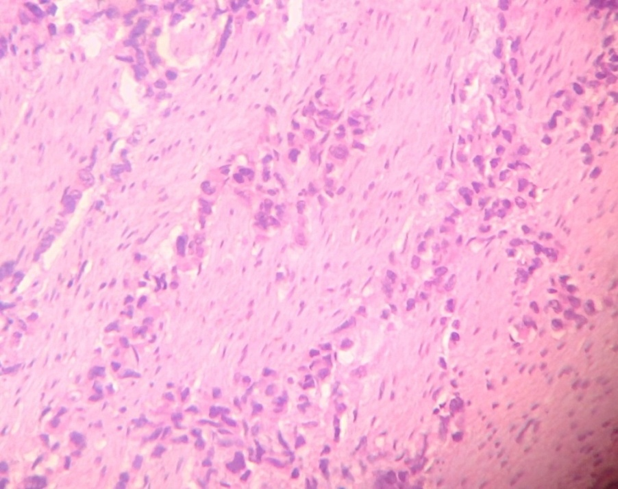
Figure 3: Diffuse carcinoma of stomach
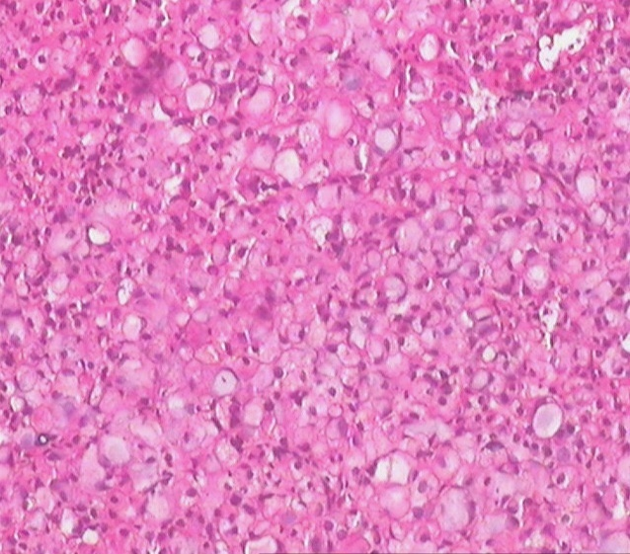
Figure 4: Signet ring cell adenocarcinoma of stomach
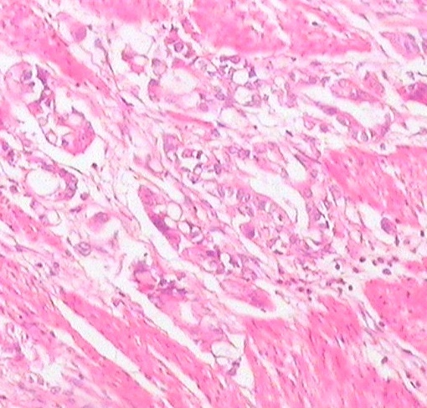
Figure 5: Intestinal type of gastric carcinoma (well differentiated type)

DISCUSSION
Gastric cancer accounts for one of the most common cancers worldwide. Adenocarcinoma is the most common type of malignancy of the stomach and comprises more than 90% of all gastric cancers. Incidence and pattern of gastric cancer varies amongst various geographical regions and ethnic groups.Various studies on gastric cancer were conducted in different parts of the world.
Our study included a total of 40 gastric carcinoma cases. In our study, of the 40 cases of gastric carcinoma, age of the patients ranged from 25-82 years with a mean age of 53.8 ± 11.7 years. Shan et al.⁶ studied a total of 1463 patients of gastric and gastroesophageal junction adenocarcinoma in Beijing, China, between August 2009 and February 2012 and they found that the median age of patients in their study was 58 years. The age of the study population ranged from 20 to 82 years. Tewari et al.⁷ in their study on 70 gastric and gastroesophageal junction adenocarcinoma between 2010 to 2012, in Varanasi, U.P. found a mean age of 52.97 ± 7.08 years of the patients in their study. The age of patients ranged from 30 to 71 years.

In the present study, of the 40 cases, 26 were males and 14 were females, showing a clear male preponderance (65%). The male to female ratio being 1.86:1.0. Our study is in accordance with the studies of Rajagopal et al⁸ and Lee et al.⁹

In our study the most common location of gastric carcinoma was antrum (67.5%), followed by cardia (12.5%) and fundus and body tumors each constituted 10% of the total. This is in concordance with the studies of Rajagopal et al.⁸ and Begnami et al1.¹⁰ where it was found that distal tumors were the maximum (79%) in their study.
In the present study, we found that maximum cases had an ulcerative growth (65%), followed by infiltrative growth (25%) and fungating and polypoidal growths each constituted of 5% of the total. Saha et al.¹¹ (2013) in their study on a total of 462 cases in West Bengal, found that ulcerative lesion (57.8%) was the most common. Dewan et al.¹² (2015) conducted a study on 100 cases of gastric adenocarcinoma, in New Delhi, found that most of the tumors (83%), were of the ulcerating type on gross examination. In our study majority of the cases were of tubular type (60%), followed by poorly cohesive type (22.5%), mucinous (12.5%) and papillary type (5%). Calik et al.¹³ in their study on 84 patients who were diagnosed with gastric cancer at the Hospital of the Faculty of Medicine, Ataturk University, Turkey, between August 2003 and June 2013, found that tubular adenocarcinoma was the most common histological type consisting of 62 cases (73.8%) in their study.

In the present study, we found that majority of the tumors were of intestinal type (77.5%). Diffuse tumors constituted only 22.5% of the cases. We found no mixed type of tumor in our study which may be due to our small study population. Movagharnejad et al.¹⁴ carried out a study on 60 cases of gastric adenocarcinoma, during 2010-2011in Iran. They found that 42 cases were of intestinal subtypes (72%) and 18 cases were of diffuse subtypes (30%) in their study. Rajagopal et al.⁸ in their study on 60 cases of gastric adenocarcinoma in Bengaluru, found that 81.7 % of tumors were of intestinal type and the rest were of diffuse type (18.3%). The present study is in accordance with other studies published.

In the present study, we found that of the 40 cases, most of the cases were poorly differentiated type (57.5%), followed by moderately differentiated type (22.5%) and least number of well differentiated type (20%). Begnami et al¹⁰ in their study on 221 patients of gastric cancer found that poorly differentiated tumors were the most common (59%), followed by moderately differentiated tumors (33%) and well differentiated tumors (8%). Calik et al.¹³ in their study on 84 gastric cancer patients, found that poorly differentiated tumors were most common (53.4%), followed by moderately differentiated ones (39.3%) and well differentiated ones (8.3%).
However Rajagopal et al.⁸ in their study found moderately differentiated tumors were the predominant (66.7%) type followed by poorly differentiated (18.3%) and well differentiated type (15%). The present study is in accordance with the findings of Begnami et al.¹⁰ and Calik et al.¹³

CONCLUSION
Gastric cancer is one of the leading cause of cancer related deaths worldwide. Etiology of gastric cancer is varied and comprises of environmental, social and genetic factors. The pattern of gastric cancer also varies according to different geographical locations.The prognosis of gastric cancer patients remains poor despite advanced chemotherapy regimes. Therefore extensive studies considering large number of cases should be carried out to know the histopathological patterns and also risk factors associated with its causation.

ACKNOWLEDGEMENTS

Grateful acknowledgement to Dr. Leena Talukdar, Associate Professor,Pathology, Silchar Medical College, Dr. Siddhartha Sankar Bhattacharya, Associate Professor, Surgery, Silchar Medical College and Dr. Debashis Datta, Professor, Pathology, Silchar Medical College for their guidance in carrying out the study.

Conflict of Interest:”No conflict of interest associated with this work”.

Ethical Clearance: Ethical clearance was obtained from the Institutional Ethics Committee.

Source of funding: Personal

Contribution of Authors: I (We) declare that this work was done by the author(s) named in this article and all liabilities pertaining to claims relating to the content of this article will be borne by the authors. The study was conceived, designed by Dr. Sampriti Baruah along with data collection. Statistical analysis was carried out by Dr.Sampritii Baruah

REFERENCES
- Ferlay J, Soerjomataram I, Ervik M, Dikshit R, Eser S, Mathers C, Rebelo M, Parkin DM, Forman D, Bray, F.GLOBOCAN 2012 v1.0, Cancer Incidence and Mortality Worldwide: IARC CancerBase No. 11 [Internet]. Lyon, France: International Agency for Research on Cancer; 2013. Available from: http://globocan.iarc.fr, accessed on 10/12/15.
- Dikshit R, Gupta P, Ramasundarahettige C, et al. Cancer mortality in India. A nationally representative survey. Lancet 2012; 379(9828):1807-16.
- NCRP (2009) Two-year report of the population based cancer registries-2006-2008. National cancer registry programme, Indian council of medical research (ICMR), Bangalore, India, 2009.
- Tredaniel J, Boffetta P, Buiatti E, Saracci R, Hirsch A. Tobacco smoking and gastric cancer: review and metaanalysis. Int J Cancer. 1997; 72: 565 – 573.
- Correa P. Human gastric carcinogenesis: a multistep and multifactorial progression. Cancer Res. 1992; 52: 6735 – 6740.
- Shan L, Ying J, Lu N. HER2 expression and relevant clinicopathological features in gastric and gastroesophageal junction adenocarcinoma in a Chinese population. Diagnostic Pathology; 2013, 8: 76.
- Tewari M, Kumar A, Mishra RR, Kumar M, Shukla HS. HER2 Expression in Gastric and Gastroesophageal Cancer: Report from a Tertiary Care Hospital in North India. Indian J Surg. 2013.
- Rajagopal I, Niveditha SR, Sahadev R, Nagappa PK, Rajendra SG. HER 2 expression in gastric and gastro-esophageal junction (GEJ) adenocarcinomas. J Clin Diagn Res. 2015 Mar 1;9:EC06-10.
- Lee KE, Lee HJ, Kim YH, Yu HJ, Yang HK, Kim WH, et al. Prognostic Significance of p53, nm23, PCNA and c-erbB-2 in Gastric Cancer. Jpn J Clin Oncol. 2003; 33(4): 173–179.
- Begnami MD, Fukuda E, Fregnani JHTG, Nonogaki S, Montagnini AL, da-Costa JWL. Prognostic Implications of Altered Human Epidermal Growth Factor Receptors (HERs) in Gastric Carcinomas: HER2 and HER3 Are Predictors of Poor Outcome. Journal of Clinical Oncology. 2011; 29(22): 3030-3036.
- Saha AK, Maitra S, Hazra SC. Epidemiology of Gastric Cancer in the Gangetic Areas of West Bengal. ISRN Gastroenterology. 2013.
- Dewan K, Madan R,Sengupta P. Correlation of Lauren’s histological type and expression of E-cadherin and HER-2/ neu in gastric adenocarcinoma. Internet Journal of Pathology and Laboratory Medicine. 2015; 1(1): OA2.
- Çalik M, Dermirci E, Altun E, Çalik I, Gundogdu OB, Gursan N. Clinicopathological importance of Ki-67, p27, and p53 expression in gastric cancer. Turkish Journal of Medical Science. 2015; 45: 118-128.
- Movagharnejad K, Sharbatdaran M, Sheffaee S, Kashifard M, Sedaghat S. HER-2/neu Marker Examination using Immunohistochemical Method in Patients Suffering from Gastric Adenocarcinoma. Int J Mol Cell Med Autumn. 2013; 2(4).

