PATTERN OF DEATH IN UNKNOWN/ UNCLAIMED BODIES AT A TERTIARY HEALTHCARE CENTRE

ABSTRACT

Introduction: Identity of an individual plays an important role in life as well as death. It becomes a difficult task for even a seasoned forensic expert to determine to establish the identity of the unknown/unclaimed body.
Aims: The current study was undertaken in order to establish the parameters to study the cause/ manner of death in unknown/ unidentified individuals.
Methods: Documents like the ADR report, Inquest, Panchnama provided by the police were scrutinized thoroughly. Data was analyzed using MS Excel 2013 software. The reasons which lead to a lapse of judgment on the part of the forensic expert or the investigating officer such as foetuses, mutilated or decomposed bodies, body parts are also were also analyzed in this study. Results: It was observed that out of the 7.6% unknown cases, most cases were in the 31-40 years age bracket, with male predominance seen especially in the month of August. Respiratory illness was the cause of most of the natural deaths, while Head Injury was the leading cause of unnatural deaths.
Conclusions: We feel a web based interactive tracking application is unequivocally essential to bridge the time gap between the Investigating Officer and the Forensic Expert. In addition, the inter-sectoral co-ordination of medicine and law enforcement agencies may play a crucial role in a smooth functioning of finding the identity of the individual.

KEYWORDS
Forensic Science, Identity, Cause of death, Unidentified bodies, Manner of death

INTRODUCTION

Identification is the determination of the individuality of a person based on certain physical characteristics, i.e. exact fixation of personality.¹ It establishes the individuality of a person. Identification data includes the sex, age, external peculiarities such as malformations, scars, tattoo marks, wounds; anthropometric measurements, fingerprints, teeth. In depth data can be identified by DNA profiling, bone analysis and such other methods.^{2,3} Identity should be established in both alive and the dead.⁴ This isn’t a complicated process though it is heavily taxing for the meticulous data preservation. But after death, the Investigating Officer or the Forensic Expert may be unable to identify the unknown/unclaimed body because of improper/inadequate history, destruction, decomposition, mutilation of the body.⁵⁻⁷ This warrants forensic experts to consider the scrutiny of such various parameters to confirm the pattern of death.⁸ The aspects of geographical surroundings should be taken in consideration while trying to establish the cause of death of such unknown/ unclaimed bodies. In the urban areas, such bodies are not hidden from the human eye and thus brought promptly to the Forensic Expert. However, in rural areas, this may not be the case. The bodies may be left to decompose or may be mutilated by animals.⁹ Such bodies when brought for the forensic evaluation of the cause of death pose a
challenge for the experts.

MATERIAL AND METHODS

A descriptive study was conducted at Grant Government Medical College and Sir J.J. Group of Hospitals, Mumbai for a study period of 6 months (15th April 2016-15th November 2016).
Sample Size: 55
Inclusion Criteria
1. Cases of unknown/unclaimed bodies brought for post mortem to the Forensic Medicine and Toxicology Department of this hospital during the study period.
2. Unknown/unclaimed persons admitted in the hospital during the study period.
Exclusion Criteria
1. Bodies which were identified later during the autopsy.
2. Deaths certified by the physician in case of known admitted cases.
Before beginning the study, the Institutional Ethics Committee’s approval was obtained.
Method:
In cases brought for post mortem, ADR report, Inquest, Panchnama and other documents provided by the police were scrutinized thoroughly. In case of the admitted patients, hospital records, investigations and autopsy findings were noted.
Cause of the death was studied. Confidentiality was strictly maintained. Bodies brought for autopsy were treated with utmost dignity, findings carefully documented.
Statistical Analysis:
The data was calculated using MS Excel 2013 software for the parameters mentioned below. The percentages were calculated and translated into a graphical format.

OBSERVATION AND RESULTS

Out of the 721 bodies brought to the hospital as well as the mortuary in the study period, the number of unidentified cases were 55. Out of the unidentified cases, males comprised of 46 in number, 7 were females and 2 were unknown, owing to the fact that one was a decomposed body and the other was an incomplete skeleton. (Figure 1)







Total Bodies brought to the
Mortuary in the Study Period
55
666
Identified Bodies
Unidentified Bodies

Figure 1 No. of unidentified bodies

The age-wise distribution of the cases was peculiar. The maximum number of cases (13) were from the age group 31-40 years, followed by equal number of cases (11 each) in the age groups of 31-40 years, 41-50 years, 51-60 years; 3 cases in the age group of 61-70 years, 1 case in the age group of 1-10 years and 1 case in the age group of less than one year, while no cases were registered in the age groups of 11-20 and >70 years of age. (Figure 2)

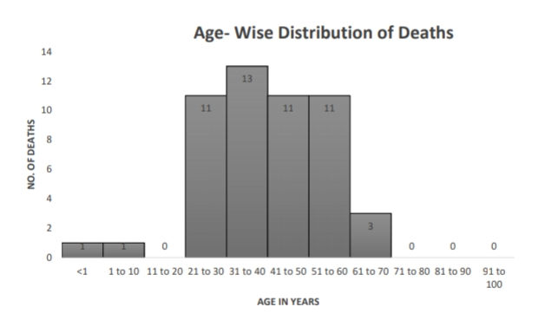

Figure 2 Age-wise Distribution

The highest number of cases were brought in the month of August (25%) followed by the month of May (20%), 16% in June, 13% in the first 15 days of October, 11% in September, 9% in July and 5% in the last fortnight of April. (Table 1)
Table 1 Temporal Distribution

Month | % of Cases
April | 5
May | 20
June | 16
July | 9
August | 25
September | 11
October | 13

Autopsy was performed in 54 cases while 1 case didn’t undergo autopsy, owing to the fact that it was a skeleton. The cause of death was formulated after autopsy. Due to the unavailability of the analysis of the investigations sent to the concerned department at that time, the opinion was reserved in 9 cases. 25 cases died of natural causes. Among them, Pulmonary Tuberculosis was the cause of 20 cases, followed by deaths due to damage to the Hepatobiliary system, which were 9 in number. Central Nervous System causes contributed to 7 cases, Cardiovascular system damage contributed as the cause of death in 4 cases; Kidney related causes in 2 cases. It has to be noted here that multisystem failure is witnessed and the causes may overlap. (Figure 3)
Unnatural deaths formed 36% of all the cases out of which Head Injury alone was a cause of 11 deaths while the head injury was coupled with Bone Fracture, Polytrauma, Burns can be seen.10 One death was caused by a road-traffic accident while cut-throat injury and drowning contributed to one death. (Figure 4)

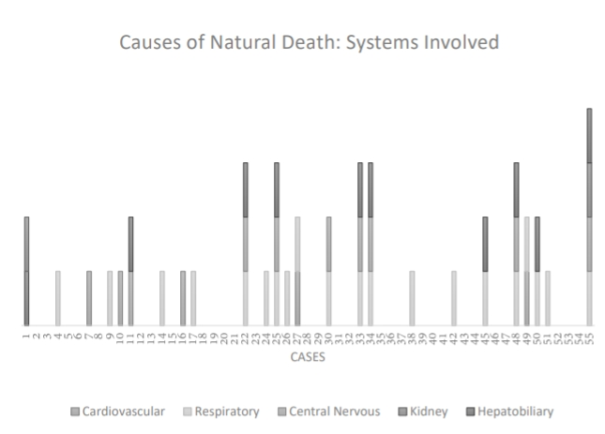

Figure 3 Systems Involved in Natural Deaths
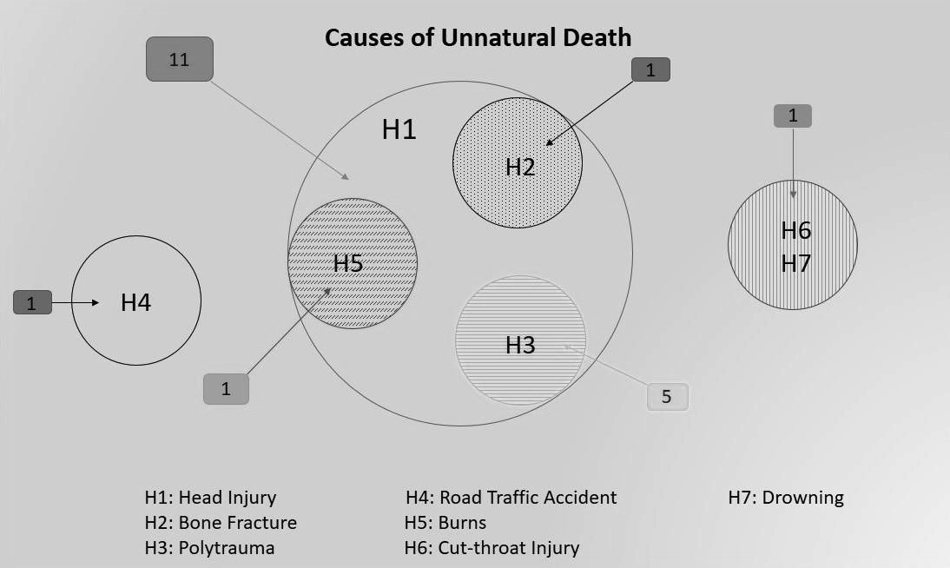
Figure 4 Causes of Unnatural Death

The bodies were analysed after the autopsy and a thorough examination of the system suspected in the cause of the death was carried out. Efforts were made by the forensic experts to establish the identity of the individual. In order to do that, Fingerprints of all the ten fingers of the hand were taken for 53 cases as of the remaining 2, one was decomposed and one was a skeleton. Blood samples were collected from 53 cases as well. DNA11 was collected from 50% of the cases, as an aide for establishment of the unique identity of the individual. The viscera were collected and preserved in 22% of the cases as were sent for histopathological and chemical analysis. Bone and tooth samples12 were also acquired for additional investigation in certain cases. (Figure 5)

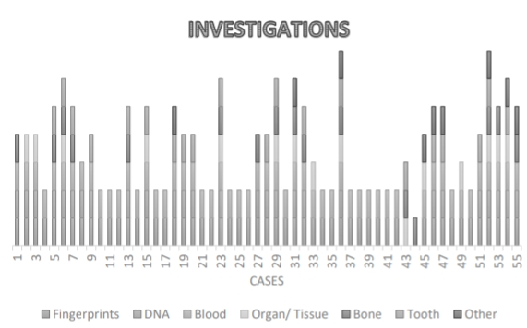

Figure 5 Investigations done to establish the identity

It was found out that 32% bodies were brought from the rural areas while 51% bodies were brought from urban areas, giving a faint idea about the predisposing socio-economic factors of the individuals.
However, no data was found regarding 17% of the cases.
None of the unknown/ unclaimed bodies which were brought had their deaths certified. 60% of cases were admitted to the hospital while 40% of the cases were brought dead.

Out of the 33 cases previously admitted autopsy was performed in less than one day in 96% cases while in 4% cases, autopsy was carried out after 24 hours.
Out of the 22 cases brought dead, Inquest was carried out for 5 cases in 24-36 hrs, 8 cases in 36-48 hrs. 7 cases were subjected to Inquest after the 2nd day and 2 cases after the 3rd day. (Table 2)

Table 2 Analysis of the time taken for carrying out the Inquest in brought dead bodies.

Percentage of the Cases which were  brought cases | Time taken for carrying out the Inquest (Panchnama) after the  acquisition of the body
20 % | 24-36 hrs
38 % | 36-48 hrs
32 % | 48-72 hrs
10 % | >72 hrs

DISCUSSION

The aim of this study was to study the pattern of unknown/ unclaimed bodies with accuracy and reliability. The present study shows the various parameters required for assessing the pattern.
It is with great difficulty and a sense of responsibility that an autopsy surgeon has to deal with the unidentified bodies’ autopsies. However, it has to be noted that the unidentified bodies formed just 7.6% of the total deaths registered during the study period at the study centre. This may look like a small figure, but the amount of professional experience that the forensic expert has to put in it is taxing. When extrapolated on a large scale, it puts a great stress on the resources of the nation. It is mentioned that almost all the cases that were brought dead had their Inquest (Panchanama) done after 24 hours. The reason is the delay between the written communication between the police station/ authority in the area where the body was found and the tertiary health care centre where the body was brought for autopsy. However, communication via telephone was carried out in such cases, to ease the burden of the process. These formalities are the cause of the delay which can be mitigated by a national level web-based interactive tracking application of the unknown/ unclaimed bodies by various agencies as well as an intersectoral co-ordination between the law enforcement agencies and the Forensic Medicine department.
Maximum number of deaths (24%) occurred in the age group of 31-40, the very pillars of the development of the society. Similar results were recorded in a study conducted at Kolkata.13 Also, 51% of the cases brought were from the urban areas, portraying the socio-economic imbalance even in the urban setting.
The gender distribution of the unknown bodies is skewed. 84% of the bodies consisted of the male cohort. This pattern is similar to the pattern observed in a study made in Chandigarh.14 25% cases were registered in the month of August, giving an estimate of the unsymmetrical autopsy load on the department. Tuberculous Meningitis was the cause of death in almost 36% of the cases followed by Head Injury in 32.7% of the recorded cases. Similar results were recorded in a study conducted at Chandigarh.14 The cause of death was registered as natural and unnatural. Analayis of the morbidities associated with the natural deaths from a community medicine perspective give us a rough idea of the low socio-economic strata of the cases. Unnatural deaths may have several factors involved, like vehicular or rail accidents, drowning, burns, poisoning, violent fights, body run over by cars or trains, etc.10,15-22 These cases often involve the beggars or the destitute of the streets. The personal belongings of the bodies play an essential role in establishing the identity of the individual. It can be of help even in cases where long-distance relatives establish the identity of the individual after a long time. Thus, the data collected by the forensic expert was a cumulative effort of the autopsy and the belongings as well as the visible identification data.
Investigations are the pillars of the identification process. 96.3% of the cases had their fingerprints of all the ten fingers of the hand as well as the blood samples taken. Viscera was acquired from 22% of the cases. The samples were sent for histopathological and chemical analysis.
The autopsy fulfils the demands to answer the questions which form the aims and objectives of the study. The cause of death, age-distribution, gender distribution, temporal distribution should be studied by examination and assessment of the individual during the autopsy and the reports of the samples sent for histopathological and chemical analysis should be assessed. Thus, this duty lies in the hands of the forensic expert, Investigating Officers, Biochemistry as well as Pathology Faculty of the institution. The Autopsy Protocol was followed.23
Shortfalls of the study include possible observer bias, arising from the inter-observer variation between different autopsy experts analyzing bodies over the period of the study.24 Methods such as uniform proforma for data collection were undertaken so as to ensure uniformity. Further, sample size could be expanded by undertaking the study over longer periods of time. Ultimately, the study undertaken provides a useful baseline for enthusiastic researchers to conduct further surveys into the pattern of death in unknown/ unclaimed bodies including inferential studies designed to predict the number of unknown/ unclaimed bodies arising out of a particular social strata.
CONCLUSION
The present study has established the pattern of death in unknown/ unclaimed bodies brought at the tertiary health centre in Mumbai region in the 6 month study period. Most of the cases were in the month of August. Male predominance is seen in the cases. Respiratory disorders were the cause of most of the natural deaths while Head Injury contributed to most of the unnatural deaths. The technical formalities are the cause of the delay which can be mitigated by a web-based interactive tracking application of the unknown/ unclaimed bodies by various agencies as well as an intersectoral co-ordination between the law enforcement agencies and the Forensic Medicine Department.
Newer techniques for the autopsy, preservation of the viscera, bone dating to find the time since death, a dedicated section in the Microbiology department for the bacteriological analysis of the specimens should be set up and DNA of each and every specimen should be collected so that the identification is confirmed even after the destruction of the body. A visual record of the autopsy should be documented for future reference. This can be done by a photography of the autopsy.25
Acknowledgements: We owe our sincere gratitude to the staff of the Department of the Forensic Medicine and Toxicology for their support. The authors express their sincere thanks to Mr. Kuber Bhinde and Mr. Amogh Nadkarni for their support and assistance in conducting this study.
Conflict of Interest: None declared.
Ethical Clearance: Institutional Ethical Committee clearance was obtained before beginning the study.
Source of Funding: Self- funded.
Contribution of Authors: We declare that this work was done by the authors named in the article and all liabilities pertaining to the claims relating to the content of this article will be borne by the authors.
Conception of Idea, Aims and Objectives of the Study and Discussion of the Results, Collection of Data and attending the autopsies, Graphical Representation of the Data, Statistical Analysis of the Data – Nitish Nadkarni. Supervision of Data Collection – Dr. B. G. Chikhalkar, Dr. G. S. Chavan.

REFERENCES
- Reddy KSN. The Essentials of Forensic Medicine and Toxicology. 33rd Ed. New Delhi: Jaypee Brothers Medical Publishers (P) Ltd; 2014. P 57.

- Jayaprakash PT, Singh B, Yusop RAAM, Asmuni HS. Skull-photo Superimposition: A remedy to the Problem of Unidentified in Malaysia. Malaysian J Forensic Sci 2010;1(1):34-41

- Riepert T, Ulmcke D, Schweden F, Nafe B. Identification of unknown dead bodies by the skull using the X-ray simulation program FoXSIS. Forensic Sci Int 2001;117(1-2):89-98.

- Vij K. Textbook of forensic medicine and toxicology Principles and practice. 5th Ed. Elsevier; 2011. P 35-7.

- Smith EL. Scientific identification of deceased prevents misidentification. Forensic Science @ suite 101http://erikalynsmith.suite101.com/scientific-identification-of-deceased-prevents- misidentification-a360528. Published May 20, 2011.

- Ludes B, Tracqui A, Pfitziner H, Kintz P, Levy P, Disteldrof M, et al. Medico-legal investigations of the Airbus A 320 crash upon Mount Ste-Odile, France. JFS 1994;39(5):1147-1152

- Job C. Determination of cause of death in decomposed bodies – a regional study. JIAFM 2009;31(1):11-17

- Balloch J. Identifying the unknown dead: new system cross-checks missing person cases with unidentified bodies. http://m.knoxnews.com/news/2012/jan/15/identifying-the-unknown-dead-new- system-that-to/ published Jan 15 2012.

- Kumar A, Tyagi A, Aggarwal NK. Sex determination by morphology of talus bone. J Forensic Med Toxicol 2008;25(1):50-3

- Harish D, Kumar A, Sharma BR. Burns Septicemia: The Leading Cause of Burn Mortality. Jr. of Punjab Academy of Forensic Medicine & Toxicology. 2008;8(2) :10-16

- Budowle B, Bieber FR, Eisenberg AJ. Forensic aspects of mass disasters: strategic considerations for DNA-based human identification. Legal Medicine 2005; 7: 230–243.

- Valenzuela A, Martin-de las Heras ST, Marques NE, Bohoyo JM. The application of dental methods of identification to human burn victims in a mass disaster. Int. J Legal Med (2000) 113:236–239.

- Chattopadhyay S, Shee B, Sukul B. Unidentified bodies in autopsy – A disaster in disguise. Egyptian Journal of Forensic Sciences. 2013;3(4):112-5.

- Kumar A, Chavali KH, Harish D, Singh A. Pattern of cause of death in unknown dead bodies: a one year prospective study. J Punjab Acad Forensic Med Toxicol 2012;12(2):92-5.

- Job C. Determination of cause of death in decomposed bodies – a regional study. Journal of
Indian Academy of Forensic Med. 2009;31(1):11-7.

- Kanchan T, Krishan K, Sharma A, Menezes RG . A study of correlation of hand and foot dimensions for personal identification in mass disasters. Forensic Sci Int 2010 Jun 15;199(1- 3):112.e1-6.

- Ludes B, Tracqui A, P fitziner H, Kintz P, Levy P, Disteldrof M, et al. Medicolegal investigations of the Airbus A 320 crash upon Mount Ste-Odile, France. JFS. 1994;39(5):1147-52.

- Hanzlick R, Smith GP. Identification of the unidentified deceased. Am J For Med Pathol. 2006;27(1):79-84.

- Sharma BR, Harish D, Sharma V, Vij K. Poisoning in Northern India: Changing Trends, Causes and Prevention Thereof. Med. Sci. Law 2002; 42(3): 251-257

- Sharma BR, Harish D, Sharma V, Vij K. Road Traffic Accidents – A Demographic and Topographic Analysis. Med. Sci. Law. 2001; 41 (3): 266-274

- Chavali KH, Sharma BR, Harish D, Sharma A, Sharma S, Singh H. Head injury, the principal killer in road traffic accidents. Jr Indian Academy of Forensic Medicine 2006; 28(4): 121-124.

- Singh A, Gorea RK. Safe designing of Vehicles from pattern of fatal Road Traffic Accident. Proceedings: International Conference on Advances in Mechanical Engineering-2006, Fatehgarh Sahib, Punjab, India, 2006:P 258.

- Reddy KSN. The Essentials of Forensic Medicine and Toxicology. 33rd Ed. New Delhi: Jaypee Brothers Medical Publishers (P) Ltd; 2014. P 103.

- Park K. Textbook of Preventive and Social Medicine. 22rd Ed. Jabalpur: Banarsidas Bhanot Publishers; 2013. P 130.

- Reddy KSN. The Essentials of Forensic Medicine and Toxicology. 33rd Ed. New Delhi: Jaypee Brothers Medical Publishers (P) Ltd; 2014. P 104

