Immunohistochemical expression of Ki 67 and p53 in colorectal carcinoma
Das Mili, Baruah Sampriti, Chaubey RN, Chaubey Jyoti, Saharia Jahanabi
ABSTRACT
Aim: To investigate the expression of Ki-67 and p53 antibodies in colorectal carcinomas and to correlate expression patterns of these markers with histopathological grades of colorectal carcinoma. Material and methods: We determined immunohistochemically the expression of Ki-67 and p53 antibodies in 62 cases of colorectal adenocarcinomas. Results: Mean Ki67 index in our study was 33.9%. Mean Ki67 increased with dedifferentiation of tumor (Grade I-18.8%, Grade II-33.2%, Grade III-49.1%). The difference in mean Ki67 index is statistically significant with histopathological grade.p <o.ooo1. p53 overexpression was seen in 69.3% cases .Percentage of diffuse p53 positivity increased with dedifferentiation of tumor. p53 positivity rate was observed in 22.2% cases of well differentiated carcinoma and increased from 76.2% to 81.8% in moderately to poorly differentiated carcinoma. The difference was statistically insignificant with histopathological grade. Conclusion: As the result of this study it is concluded that in colorectal carcinoma Ki 67 LI correlated with grade and increases with the dedifferentiation of tumor and also p53 overexpression occurs increases with dedifferentiation of tumour. Thus the evaluations of markers expression p53 and Ki67 can be used as a poor prognostic marker allowing the identification of aggressive forms.

KEYWORDS: Histopathology, Immunohistochemistry.

INTRODUCTION
Colorectal cancer (CRC) is the fourth most common malignant disease with over one million new cases and over 500000 deaths each year worldwide.¹ Incidence of colorectal cancer varies widely with higher incidence rates in North America, Australia and Europe. Developing countries have lower rates; particularly Africa and Asia.² However, with westernization of lifestyle, the incidence of colorectal cancer is nowadays increasing in many developing countries also. Surgery still remains the primary treatment modality and pathological examination of resected specimen is a powerful tool for assessing the prognosis.³
The p53 gene mutation is related to carcinogenesis in most malignant diseases and has been widely studied. The distribution of Ki 67 and p53 as markers of cell proliferation is also studied in colorectal carcinoma. More articles reveal that their immunostain could predict the colorectal carcinoma prognosis. The p53 protein is encoded by a gene p53, located on the short arm of chromosome 17, a frequent site of allelic loss in many tumors. The wild p53 maintains the integrity of genes by detecting mutations and preventing the division of cells with damaged DNA. It blocks the cells in G1 phase of cellular cycle. In colorectal carcinoma, the gene p53 may be rearranged and p53 protein may be altered. Therefore, the replication errors and deregulation of cell growth could appear. The p53 protein is evidentiated by immunohistochemistry. The monoclonal antibody DO-7 reacts with both wild and mutant type of the p53 protein, being expressed intranuclear. According to the literature, the deletion of p53 with the overexpression of p53 protein is correlated with a lower rate of survival, thus being an independent prognostic factor.⁴

Ki 67 is a nuclear antigen, which is expressed in proliferating cells from G1 to M-phase of the cell cycle. Many studies have shown a predictive role of Ki 67 in a wide range of human malignancies, including gastrointestinal stromal tumours, gastrointestinal neuroendocrine tumours, and prostate and breast cancer.⁵ Quantification of cell proliferation activity in neoplasms has been targeted with the help of Ki67 antibody.

This present study was conducted to investigate combined immunoexpression of Ki67 and p53 protein in colorectal carcinomas and to correlate expression patterns of these markers with histopathological variables of colorectal carcinoma. The present study evaluated their role in colorectal carcinoma in our set up.
MATERIALS AND METHODS
This is a hospital based study, done in Department of Pathology, Silchar Medical College and Hospital. We studied 68 consecutive cases of colorectal carcinomas over a period of 2 years (2015 to 2017). But, we considered only adenocarcinomas for further study, excluding the mucinous carcinomas and carcinoid. 62 cases were of colorectal adenocrcinomas were studied. Blocks were retrieved and H&E staining done. The tumor was then graded as well, moderately and poorly differentiated according to WHO grading criteria. In Grade I cancers, mainly simple tubular structures are seen, in which the nuclear polarity is easily discerned. Grade II cancers are composed of tubules that are simple, complex, or slightly irregular, in which the nuclear polarity is barely discernible or is lost. Grade III tumors are characterized by a predominance of solid growth pattern without glandular differentiation and lost nuclear polarity. Diagnosis of a colorectal carcinoma as a grade III tumor is done when the poorly differentiated component comprises >50% of the tumor.⁶
Immunohistochemistry for p53and Ki-67 were done. Sections (4 μ) from formalin fixed paraffin embedded tissue blocks were stained by standard immunohistochemical methods using horseradish peroxidase-linked antibody.

The following primary antibodies were used: antibody to p53(DO7) (mouse monoclonal antibody, prediluted, CELL MARQUE), antibody to Ki67(SP6) (Rabbit monoclonal antibody, prediluted , CELL MARQUE).
The positive controls used were sections of infiltrating duct carcinoma of the breast for both p53 and ki67 antigen. The negative controls used were sections of the study tissues with no primary antibody incubation.

INTERPRETATION OF RESULTS
The MIB-1 immunostained sections were light-microscopically evaluated. 6-9 sites within the tumour were examined, excepting the areas with tissue enfolding, necrosis and haemorrhagic infiltrate. Nuclear staining was regarded as positive whereas cytoplasmic staining was considered as artefact. MIB-1 labelling index (LI) was determined by counting about 500 tumor cells.
Ki-67 immunostaining index was interpreted as Labeling index (Ki-67 LI) = Number of nuclei showing positive staining (brown color)/total number of nuclei × 100 in 40 x magnification. A tumor was considered positive with significant proliferating activity only if nuclear Ki-67 accumulation was identified in at least 10% of all malignant cells in a tissue section.
In p53 immunostaining 10% or more stained malignant nuclei were scored as positive, regardless of the staining intensity. If fewer than 10% of the nuclei were stained, the slide was scored as negative. The staining distribution was either focal or diffuse.
STATISTICAL ANALYSIS
Statistical analysis was done using Chi square test and ANOVA.

RESULTS
Out of the 68 total cases of colorectal cancers, 62 (91.1%) cases were adenocarcinoma, 4 (5.9%) cases were mucinous carcinoma, and 2 (2.9%) case were signet ring carcinomas. Only cases of colorectal adenocarcinoma were studied. Age of the patients ranged from 30 years to 75 years, (mean 57.8±1.2 years). Males (66.1%) were more commonly affected than females (33.9%).
.
The rectum was the most common affected site contributing to 38 cases (61.2%) followed by ascending colon with 14 cases (22.6%), caecum 6 cases (9.7%) and descending colon 4 cases (6.5%). Most common histopathological type were moderetaly differentiated adenocarcinoma accounting for 67.7% cases. Well differentiated and poorly differentiated cases were 14.5% and 17.8% cases respectively.

Positive nuclear immunohistochemical staining for Ki 67 antibody was seen in all 62 colorectal carcinomas. Ki-67 LI ranged from 7% to 53%. The mean Ki 67 LI was 33.9%. Mean Ki 67 index was 18.8% in grade I, 33.2% in grade II, 49.1% in grade III. The difference in mean Ki67 index is statistically significant with histopathological grade. p <0.0001, highly significant Anova.

Table 1 : Expression of Ki 67 in different grades of colorectal adenocarcinoma

GRADE | Ki 67 LI values
GRADE | Minimum | Maximum | Range | Mean | SD
Well Differentiated | 7 | 34 | 27 | 18.8 | ±9.03
Moderately Differentiaetd | 23 | 41 | 18 | 33.2 | ±4.08
Poorly Differentiated | 42 | 53 | 11 | 49.1 | ±4.08

p53 overexpression was seen in 69.3% of cases. The positivity percentage increased with increase in the histolopathological grade in adenocarcinomas. p53 positivity rate was observed in 22.2% cases of well differentiated carcinoma and increased from 76.2% to 81.8% in moderately and poorly differentiated carcinoma. The difference was statistically significant with histopathological grade.

Table 2: Expression of p53 in different grades of colorectal adenocarcinoma

HISTOPATHOLOGIC GRADE | P 53 + | P 53 -
WELL DIFFERENTIATED | 2(22.2%) | 7 (77.8%)
MODERATELY  DIFFERENTIATED | 32(76.2%) | 10 (23.8%)
POORLY DIFFERENTIATED | 9 (81.8%) | 2(18.2%)

p value 0.003 (chisquare test)

The p53 immunostaining was diffuse (ie,more than 50% of the cells stained) in 42.8% cases and focal (ie. 5-50% cells stained) in 57.2% cases. Diffuse p53 distribution was seen in 31.4% cases of well differentiated cases, 40.5% of moderately differentiated cases and 59.6% of the poorly differentiated cases.

Table 3: Percentage of cases with diffuse p53 distribution in different grades of colorectal adenocarcinoma

Grades | Percentage of cases with diffuse distribution of p53
Well Differentiated | 31.4%
Moderately Differentiated | 40.5%
Poorly Differentiated | 59.6%

DISCUSSION
In our study, the mean age of colorectal cancer was found to be 57.8±1.8 years, which is in accordance with the study done by Nayak et al.⁷ where mean age was 55.6±1.2 and Peedikayil et al.⁸ where mean age was 58.4 years. In this study, it was found that rectum was the most common site affected contributing to 61.2% cases, followed by ascending colon 22.6%, caecum 9.7% and descending colon 6.5% cases. Peedikayil et al.⁸ found 74% of the tumors were located distal to the splenic flexure., Nayak et al.⁷ reported sigmoid colon to be the commonest site followed by cecum and rectum.
Table 4: Comparison of Mean Ki67 index in different studies
Study | No. of cases | Mean ki 67 Index
Ihmann et al.⁹ | 43 | 32.8%
Komal Mahendra et al.¹⁰ | 47 | 34.7%
Saleh et al.¹¹ | 52 | 38.12%
Claudia et al.¹² | 41 | 48%
Porschen R et al¹³ | 61 | 38.7%
Palmquist R et al.¹⁴ | 56 | 43.7%
Present study | 62 | 33.9%

In the above studies, CRCs showed a wide range of Ki-67 LI, ranging from 32-50% indicating a variation in proliferative activity. The mean Ki67 index in our study was 33.9%. This is in accordance with the study done by Ihmann et al⁹ in which Ki 67 LI was 32.8%, Komal Mahendra et al¹⁰ LI 34.7%, Saleh et al¹¹ LI 38.1% and Porschen et al¹³ LI 38.7%. However Claudia et al¹² and Palmquist et al¹⁴ found a bit higher levels of LI of 48% and 43.7% respectably. Ki 67 has a prognostic and/or predictive value in different tumor types. Some newer studies¹⁵ established the fact that an increased expression of Ki 67 indicates a better survival in rectal and recto sigmoid cancer as these tumors have better response to radiotherapy.
In this study, Ki-67 immunostain was positive in all the cases of adenocarcinomas. The mean values for Ki-67 LI for well, moderate and poorly differentiated lesions were 18.8%, 33.2% and 49.1% respectively, and the difference was statistically significant p < 0.0001. A strong positive significant correlation between Ki-67 LI and histopathological grade was found. In our study, mean values for Ki-67 LI increased with increase in grades of colorectal carcinoma. This in accordance with studies done by Amway Sen et al.¹⁶ who found that the Ki-67 LI increased with the histological grade of adenocarcinomas. There was a strong positive significant correlation between Ki-67 LI and histopathological grade in their study. Georgescu et al.¹⁷ found that the Ki-67 LI increased with the histological grade of adenocarcinomas. The difference between grade 1 and grade 2 adenocarcinomas was not significant while the difference between grade 2 and 3 adenocarcinomas was significant. Also in studies done by Claudia et al.¹², Saleh et al.¹¹, Simona et al.¹⁸, Azza et al.¹⁵ the mean Ki67 index increased with grade of tumor or dedifferentiation of the tumor. In contrast to these studies, other studies by Uzma et al.¹⁹ and Ishida et al.²⁰ found that Ki 67 inndex was lower in cancers with poor differentiation.
Table 5: Comparison of Mean Ki67 index with histological grade of tumor
Mean Ki67 Index/  Grade | Amway et al.¹⁶ | Claudia et al.¹² | Saleh et al.¹¹ | Ishida et al.²⁰ | Present study
Well Differentiated | 14.25% | 20% | 35.7% | 57.7% | 18.8%
Moderately Differentiated | 31.64% | 34% | 35.7% | 60.9% | 33.2%
Poorly Differentiated | 43.08% | 57% | 48.3% | 46.6% | 49.1%

Detection of p53 overexpression by immunohistochemistry is based on the accumulation of p53 protein in cells. However the wild p53 type can also accumulate in the nucleus in cases of cellular hypoxia or DNA alterations. But, not all aberrant mutations of p53 cause p53 accumulations and therefore this can cause false negative results. Several studies done previously have shown that p53 expression is positively correlated with p53 gene mutation and p53 overexpression is associated with poorer prognosis in patients with colorectal cancer. In this study p53 overexpression was seen in 69.3% of cases. The positive cases increased with the increase in the histolopathological grade and results were statistically significant.

Comparison of p53 positivity rate in different studies`
The frequency of p53 over expression ranged from 58% to 70% in different studies. However this wide range of p53 positivity is due to inter-study variations, including different antibodies, scoring systems, cut-off values, and study populations. The p53 overexpression in our study was found in 42 cases (69.3%). This is in accordance with study done by Saleh et al.¹¹ where p 53 overexpression was seen in 67.3% cases. p53 overexpression was also seen in some previous reported studies such as Yamagiwa H et al.²¹ 60.6%, Claudia et al.¹² (58.5%),Yong Shin et al.²² ( 60.9%), Komal et al.¹⁰ (72.3%)

Comparison of p53 positivity rate with histological grade
In respect to cell differentiation we found that the p53 positivity increased with the dedifferentiation of tumours. The results were statistically significant. This was in accordance to study by Claudia et al.¹². But Saleh et al.¹¹ found that p53 positivity rate decreased with dedifferentiation though it was not statistically significant.

Comparison of cases with focal and diffuse p53 positivity
In this study 57.2% cases showed focal p 53 positivity and 42.% cases with diffuse p 53 positivity. This is in accordance with study done by Claudia et al.¹² where 58.3% cases had focal p 53 positivity and 41.6% cases had diffuse p53 positivity. However, Komal et al.¹⁰ found that 17.65% cases had focal p 53 positivity and 82.35% cases had diffuse p53 positivity.
Comparison of percentage of cases with diffuse p53 positivity with histological grade of tumor
In this study diffuse p 53 positivity was found in 31.4% cases of well differentiated, 40.5% and 59.6% in moderate and poorly differentiated colorectal adenocarcinoma respectively. The high p53 positive rate in high grade adenocarcinomas suggest that p53 is involved in cell dedifferentiation in colorectal adenocarcinomas. This is in accordance with study by Claudia et al.¹² and Komal et al.¹⁰

CONCLUSION
As the result of this study it is concluded that in colorectal carcinoma Ki 67 LI correlated with grade and increases with the dedifferentiation of tumor and also p53 positivity rate increases with dedifferentiation of tumour.Thus the evaluations of markers expression p53 and Ki67 can be used as a poor prognostic markers allowing the identification of aggressive forms. This can also help in selecting patients for targeted therapies in near future.

ACKNOWLEDGEMENTS

Grateful acknowledgement to Dr.R.N.Chaubey, Professor, Pathology, Silchar Medical College for his guidance in carrying out the study.

Conflict of Interest:”No conflict of interest associated with this work”.

Ethical Clearance: Ethical clearance was obtained from the Institutional Ethics Committee.

Contribution of Authors: I (We) declare that this work was done by the author(s) named in this article and all liabilities pertaining to claims relating to the content of this article will be borne by the authors. The study was conceived, designed by Dr. Mili Das and coauthors along with data collection. Statistical analysis was carried out by Dr.Mili Das.
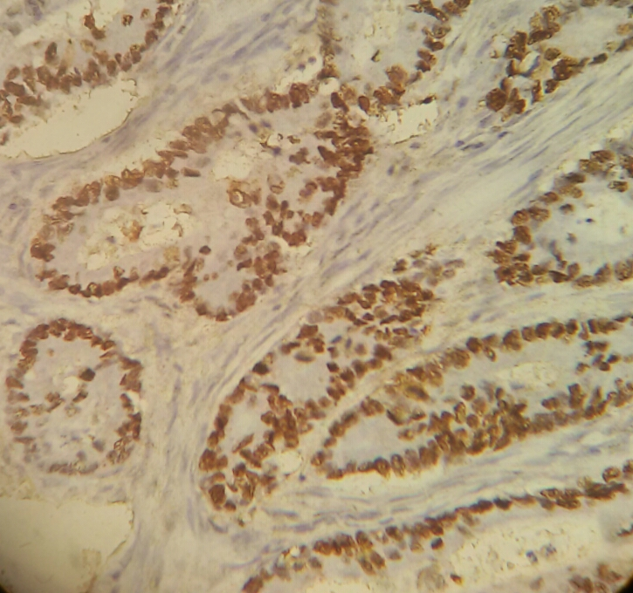

Fig 1: Ki 67 staining in well differentiated adenocarcinoma colon

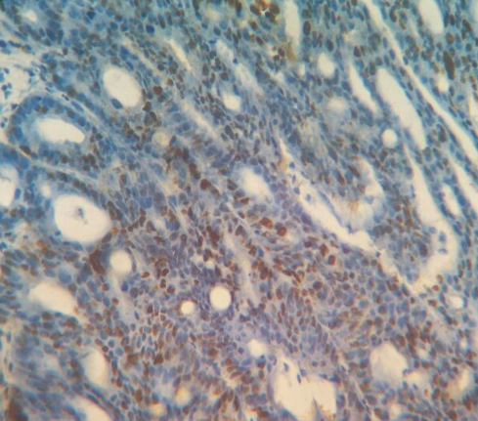
Fig 2: Ki 67 staining in moderately differentiated adenocarcinoma colon

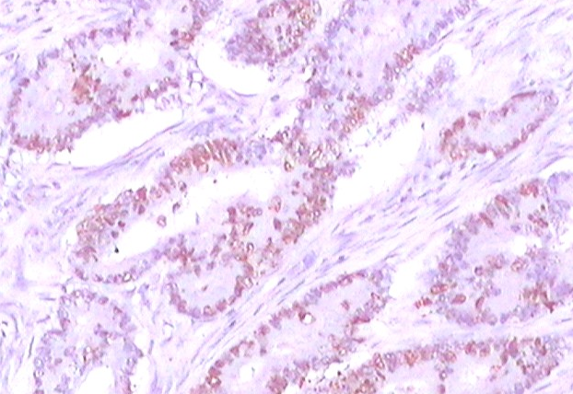
Fig 3: p53 staining of well differentiated adenocarcinoma colon

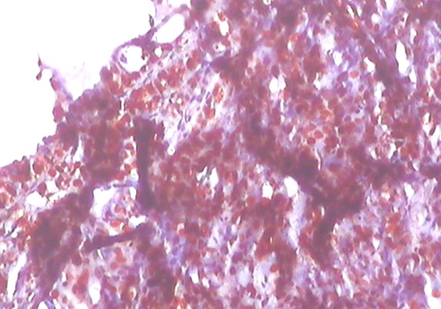
Fig 4: p53 staining in poorly differentiated carcinoma colon

REFERENCES
1. Jemal A, Bray F, Center MM, et al. Global cancer statistics. CA Cancer J Clin 2011;61:69–90.
2. Parkin DM, Pisani P, Ferlay J. Global Cancer Statistics.CA Cancer J Clin 1999; 49:33‐64, (1).
3.Vassilopoulos PP, Kelessis N, Plataniotis G, Gondikabis E, Galanos A. Colorectal cancer trends by anatomic sites, age and staging. A 20 year study of 1412 Greek cases. Anticancer Res 2000, 20: 4773‐6.
4. Darmon E., Cleary K. R., Wargovich M. J., Immunohistochemical analysis of p53 overexpression in human colonic tumors, Cancer Detect Prev, 1994, 18(3):187–195.
5. Melling N, Kowitz CM, Simon R, et al. J.High Ki67 expression is an independent good prognostic marker in colorectal cancer.Clin Pathol 2016;69:209–214.
6. Cooper HS. Intestinal neoplasms. In: Mills SE. Sternberg’s Diagnostic Surgical Pathology. 5th ed. Vol. 1. Philadelphia: Lippincott Williams & Wilkins; 2010. p. 1395-401.
7. Nayak SP, Sasi MP, Sreejayan MP, Mandal S. A case-control study of roles of diet in colorectal carcinoma in a South Indian Population. Asian Pac J Cancer Prev 2009;10:565-8.
8 . Peedikayil MC, Nair P, Seena SM, Radhakrishnan L, Sadasivan S, Naryanan VA, et al. Colorectal cancer distribution in 220 Indian patients undergoing colonoscopy. Indian J Gastroenterol 2009;28:212-5
9.Ihmann T, Liu J, Schwabe W et al. High-level mRNA quantification of proliferation marker pKi-67 is correlated with favorable prognosis in colorectal carcinoma J Cancer Res Clin Oncol 2004; 130: 749-756
10. Komal Mahendra Ashar and Smita Chetan Patel.Correlation of proliferative marker (Ki67), p53 expression and histomorphology in colorectal carcinoma. International Journal of Biomedical and Advance Research 2016; 7(12): 597-603.
11. Saleh AH, Jackson H, Banerjee M. Immunohistochemical expression of bcl-2 and p53 oncoproteins: correlation with Ki67 proliferation index and prognostic histopatologic parameters in colorectal neoplasia. Appl Immunohistochem Mol Morphol 2000; 8: 175-182
12. Claudia Valentina Georgescu1, Adrian Sãftoiu2, Corneliu Cristian Georgescu3, Raluca Ciurea4, Tudorel Ciurea. Correlations of Proliferation Markers, p53 Expression and Histological Findings in Colorectal Carcinoma. J Gastrointestin Liver Dis June 2007 Vol.16 No 2, 133-139.
13. . Porschen R, Lohe B, Hengels KJ, Borchard F. Assessment of cell proliferation in colorectal carcinomas using the monoclonal antibody Ki-67. Correlation with pathohistologic criteria and influence of irradiation. Cancer 1989; 64: 2501-2505.
14. Palmqvist R, Sellberg P, Oberg A Travelin B, Rutegard JN, Stenling R. Low tumour cell proliferation at the invasive margin is associated with the poor prognosis in Dukes‘ stage B colorectal cancers. Br J Cancer 1999; 79: 577-581.
15. Azza Hegazy, Sahar A. Daoud, Wael Shawky Ibrahim, Kamal El-Atrebi, Mona Sakerand Nagwa Abdel-Wahab. Role of Ki-67, P53 and Bcl-2 in Advanced Colorectal Carcinoma (Histopathological and Immunohistochemical Study) Academic Journal of Cancer Research 2014; 7 (3): 168-172.
16. Anway Sen, Sumit Mitra1, Ram Narayan Das et al. Expression of CDX-2 and Ki-67 in different grades of colorectal adenocarcinoma;Indian journal of pathology and microbiology 8( 2 ) april – june 2016.
17. Georgescu CV, Saftoiu A, Georgescu CC, Ciurea R, Ciurea T. Correlations of proliferation markers, p53 expression and histological findings in colorectal carcinoma. J Gastrointestin Liver Dis 2007;16:133-9.
18. Simona Gurzu, J. Jung, T. Mezei, Z. Pávai. The correlation between the immunostains for p53 and Ki67 with bcl-2 expression and classical prognostic factors in colorectal carcinomas. Romanian Journal of Morphology and Embryology 2007; 48(2):95–99.
19. Uzma Nabi, N.A.H., Waqas Sami and L.P. Department of Pathology. University of Health Sciences, ki67 proliferating index and histological grade, type and stage of colorectal carcinoma. J Ayub Med Coll Abbottabad, 2008; 20(4): 44-48.
20. Ishida H, Sadahiro S, Suzuki T et al. Proliferative, infiltrative, and metastatic activities in colorectal tumors assessed by MIB-1 antibody. Oncol Rep 2003; 10: 1741-1745
21. Yamagiwa H, Onishi N, Onishi T et al. Immunohistochemical study of PCNA, EGFR, c-erbB-2 and p53 in carcinomas of large intestine. Rinsho Byori 1995; 43: 703-707..
22. Yong Shin, Na Young Sung, Youn Soo Lee, Taek Soo Kwon, Yoon Si, Yoon Suk Lee, Seong Taek Oh, and In Kyu Lee. The Expression of Multiple Proteins as Prognostic Factors in Colorectal Cancer: Cathepsin D, p53, COX- 2, Epidermal Growth Factor Receptor, C-erbB-2, and Ki-67.Gut and Liver, 2014; 8 (1): 13-23.

