ORIGINAL PAPER
Silicone finger prosthesis: Bracing Back the Life
Trivedi Hina¹, Barman Jogeswar²
Received on April 30, 2018; editorial approval on
ABSTRACT
Introduction: Rehabilitation of amputed finger is of utmost importance and the first choice is microvascular reconstruction. But whenever surgical reconstruction in patients is not possible contraindicated, unavailable, unsuccessful or unaffordable, the prosthetic rehabilitation is considered. It relieves the individual from the social stigma, while simultaneously improving their physical capability. Aim: This clinical report describes a method to fabricate silicone prosthesis for a patient who has a partial finger loss caused due to trauma. Methods: Prosthetic rehabilitation was done using room temperature vulcanizing silicone prosthesis to restore a non-functional esthetic finger Results: Partial finger amputations can be successfully rehabilitated using silicone materials Conclusion: Silicone prosthesis is truly capable of restoring the life like appearance of the lost body part although the function cannot be restored.
Keywords: Amputation, silicones, finger loss
Address for correspondence:
¹ PGT, Deptt of Prosthodontics
Regional Dental College
Bhangagarh, Guwahati, Assam
Mob: 8472824090
Email: trivedihina91@gmail.co
² Reader, Deptt of Prosthodontics
Regional Dental College
Bhangagarh, Guwahati, Assam
Mob: 7035706076
Email: barmandentust@gmail.com

INTRODUCTION
Amputation”, derived from the Latin word “amputare” (to excise, to cut out) has been defined as the “removal of part or all of a body part enclosed by skin” (Dorland Medical Dictionary). There are various types of amputations such as self-amputation, congenital amputation or traumatic amputation. Finger and partial finger amputations are some of the most frequently encountered forms of partial hand losses.¹ The complete or partial loss of a finger results in significant functional deficiencies. In addition to immediate loss of grasp, strength and security, the absence of a finger may cause marked psychological trauma.² Hence rehabilitation of amputed finger is of utmost importance and the first choice for which is microvascular reconstruction. But when surgical reconstruction in patients is not possible contraindicated, unavailable, unsuccessful or unaffordable, the prosthetic rehabilitation becomes an alternative in order to improve the psychological status of an individual.³
Replacement of a missing finger by fabricating a prosthetic finger is a challenging task that requires great skill in terms of artistic and technical expertise.⁴ Various treatment modalities like implants, silicone elastomers, myoelectric replacements, 3-D printed prosthesis are currently in use for replacing missing finger. Over the years different materials have been tried and tested but acceptance rate for custom sculpted silicone elastomer has been exceptionally high due to its life like appearance.⁵
This case report describes rehabilitation of patient with partially missing finger using silicone elastomer.
Case report: A 27 year old male patient reported to the Department of Prosthodontics, Crown and Bridge, Regional Dental College, Guwahati with the complaint of a partially missing finger. The patient revealed history of a lost digit in a traumatic injury caused by a mechanical lathe ten years back. A complete examination of the hand revealed a residual stump approximately 3cm size terminating in the middle phalangeal region. The area around the residual stump was keratinized without any sign of inflammation.
METHODS
Impressions and pattern fabrication: The fabrication of the silicone finger prosthesis consisted of making an impression of the stump, followed by fabrication of wax pattern and laboratory procedures to obtain the silicone prosthesis.
PVS putty light body impression (3M ESPE Soft Putty Vinyl Poly Siloxane, 3M ESPE, Seefeld, Germany) is made of the amputated stump of the right index finger and the left normal hand. Stone replicas are made of the amputated finger.
Wax pattern (DPI Modeling Wax (Tropical Standard, DPI, Mumbai, India) is obtained by analogous finger technique, where moulding and sculpture on another persons’ finger is performed and adapted on the stone replica of the residual stump. Additional surface anatomy peculiar to the patients’ adjacent fingers is reproduced on the wax pattern.
This wax pattern was then seated in a flask with dental stone material covering it up to the sides. Markings were made on the cast to ensure the correct location of the stump. The undercut formed was to lock the stump to counter balance before flasking procedure. After applying separating medium (DPI) it was counter flasked and dewaxed Figure 6
Processing finger prosthesis
The finger stump was carefully separated without breaking mold. The finger stump was placed back in the mold, and complete closure of flask was again checked. The maxillofacial silicone (Copsil T 30 silicone resin and hardener) was mixed following manufacturer's instructions, avoiding incorporation of air bubbles. The mix was divided into two parts one for dorsal, and other for ventral portion of the finger. Shade matching was carried out by adding an appropriate ratio of intrinsic colors (Mp Sai biomed silicone prosthesis - set of five pigments) available with silicone material preferably under natural light. The obtained shade of mix was sequentially checked with patient's ventral and dorsal aspect of finger. Once satisfactory shade was obtained, packing of maxillofacial silicone material was done with respect to dorsal and ventral portions. The flask was closed under pressure and was left undisturbed for 4 hour for complete polymerization (room Temperature vulcanization of maxillofacial silicone. Deflasking was done, and finger prosthesis was carefully retrieved from stump and excess silicone were trimmed using sharp curved scissors. The fit and shade of the finger prosthesis were evaluated on the patient. The customized metal ring was used as an auxiliary aid of retention and also to mask prosthesis and skin junction. On completion of curing, the mould is removed. Prefabricated acrylic nails were attached with cyanoacrylate resin on the silicone nail bed.
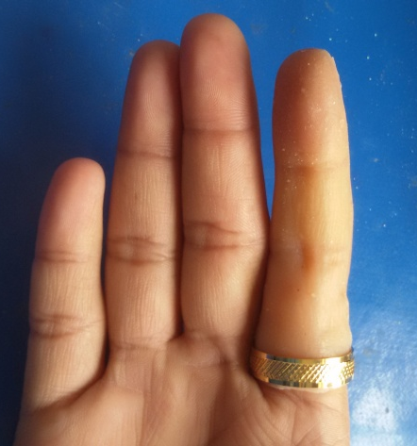
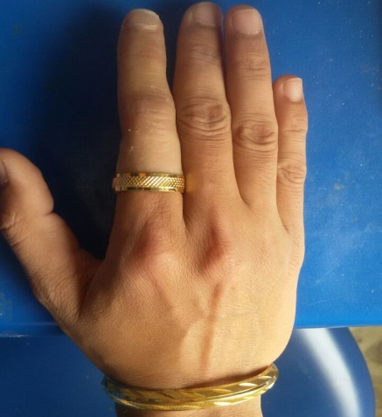
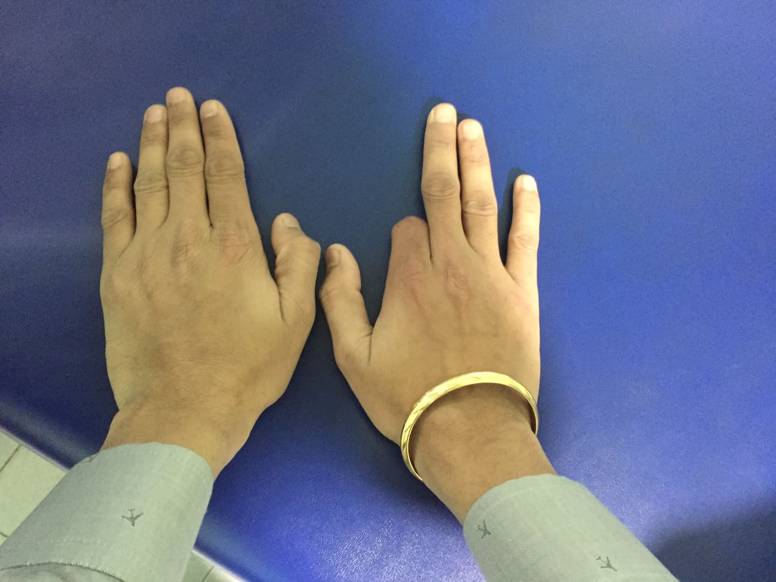
Fig 1. Defect

Fig 2. Silicone Finger Prosthesis : Palmer Surface
Fig 3. Silicone Finger Prosthesis : Dorsal Surface

DISCUSSION
Loss of finger affects esthetics and functionality, greatly impacting dexterity of an individual. Despite the advances in the microsurgical techniques, the reconstruction of the amputated digits for a number of patients may not be successful and they can better be restored with a passive prostheses.⁵ Over a period of time different materials like polyurethane, PVC, acrylic resins have been tried but none can be compared to silicones in simulating the lost structures. A significant advantage of using this technique is the exact duplication of the anatomical and the fine surface details of the digits. This allows the surface characteristics of the prosthesis to be closely matched to that of the remaining digits of the hand.⁶
Multiple layers of clear silicone over each layer of color improves translucency and protects the coloration from environmental damage. The overall durability and stain resistance of silicone is far superior to any other material currently available for finger restorations. Almost all stains, including ballpoint ink, newsprint, clothing dyes, and food colorings can be removed easily with water and soap.⁷ Silicone finger restorations may have additional functional benefits. Many traumatic amputees experience painful hypersensitivity at the termination of finger remnants. The gentle, constant pressure of elastomer prosthesis can help desensitize and protect the injured tip.⁸ With the property of elasticity of silicone elastomer, it is possible to enhance retention further by scraping grooves into the positive model, creating separate vacuum chambers.⁹
CONCLUSION
For most patients, the aesthetic appearance of an amputated finger plays a more important role than function. With the advancement in skill, technology and materials available today, the rehabilitation of an amputated finger is no more aesthetically challenging. When fabricated with immense care, they can be made life- like. A well fabricated aesthetic prosthesis can help in providing the patients with psychological support.

Conflict Of Interest: No conflict of interest associated with this work
Contribution Of Authors: "I (We) declare that this work was done by Dr Hina Trivedi in this article and all liabilities pertaining to claims relating to the content of this article will be borne by the authors".
Ethical clearance: None required
Source of funding: None

REFERENCES
1. Pillet J. The aesthetic hand prosthesis. Orthop Clin N Am 1981;12:961–970.
2. Beasley RW. Hand and finger prosthesis. J Hand Surg Am 1987;12:144–147.
3. Pilley MJ, Quinton DN. Digital prosthesis for single finger amputation. J Hand Surg Br 1999;24(5):539–541.
4. Pillet J. Partial-hand amputation-aesthetic restoration. In: Bowker JH, Michael JW, editors. Atlas of limb prosthetics: surgical, prosthetic and rehabilitation principles. St. Louis: CV Mosby; 1992. p. 227–235.
5. Buckner H. Cosmetic hand prosthesis—a case report. Orthot Prosthet 1980;34(3):41–45.
6. Venkataswamy R. Aesthetic prosthesis in hand injuries surgery of the injured hand. New York: McGraw-Hill; 2010.
7. Michael JW, Buckner H. Options for finger prosthesis. J Prosthet Orthot 1994;6(1):10–19.
8. Livingstone DP. The D-Z stump protector. Am J Occup Ther 1988;42:185–187.
9. Herring HW, Romerdale EH. Prosthetic finger retention: a new approach. Orthot Prosthet 1983;37(2):28–30.

