CASE REPORT

APPENDICITIS AS A CAUSE OF SMALL BOWEL OBSTRUCTION IN PEDIATRIC AGE GROUP: A CASE REPORT AND REVIEW.

INTRODUCTION:
Intestinal obstruction is one of the common causes of acute abdomen in children encountered on daily basis in emergency setup. Although appendicitis causing intestinal obstruction is a rare cause with only a few reported cases in literature, among the cases there has been only one report of this occurrence in pediatric age group(1). Mechanical obstruction, with or without strangulation, can result from loops of the small bowel becoming entangled and pinched by the inflamed appendix, or adhesion of the distal end of the appendix to loops of the small bowel, caecum, or retroperitoneum. This creates conditions wherein the small bowel can herniate through the ring-like structure formed by the inflamed appendix; herniation can occur with or without strangulation(2).

CASE STUDY:
A 6 year old male child presented to emergency with abdominal pain for 4 days with obstipation for 3 days. It was associated with multiple episodes of bilious vomiting. He was apparently normal a week ago with no complain of pain abdomen or fever. On examination vitals were stable. Abdomen was distended with tenderness elicited on the palpation of lower abdomen. Bowel sounds were sluggish. Per rectal examination was done to rule out fecal impaction or mass and was found to be normal. Rectum was found to be collapsed with no digital staining with blood, mucus or stool.

Routine blood investigations revealed mild increase in liver enzymes and an increase in leucocytes count. X-ray plain picture erect abdomen showed dilated bowel loops. An ultrasound revealed fluid filled dilated distal small bowel loops with the possibility of bowel obstruction along with ascites and mild hepatomegaly. Meanwhile patient was kept nil per oral with nasogastric aspiration, with bilious aspirate. He was started on prophylactic intravenous antibiotics and analgesics. On reassessment, patient's condition remained unaltered. A diagnosis of mechanical intestinal obstruction of unknown etiology was made and was scheduled for emergency laparotomy.

The abdomen was then opened by an upper right transverse incision just above the umbilicus. Dilated bowel loops were identified and traced up to ileum where the distal part of ileum was seen obstructed by the inflamed appendix. Inflamed appendix was seen lying over the distal ileum and tip was attached to the ileocecal mesentry resulting in a band like structure causing obstruction. Careful blunt dissection of the inflamed appendix done and the band removed with release of the obstruction. Following the release, appendicectomy was done and the bowel loops inspected for any color or gangrenous changes. Bowel was found viable and hence no resection was needed. About 50 ml of clear reactionary fluid drained. Post operative period was uneventful and patient was discharged on the seventh post operative day. The patient is on follow-up.

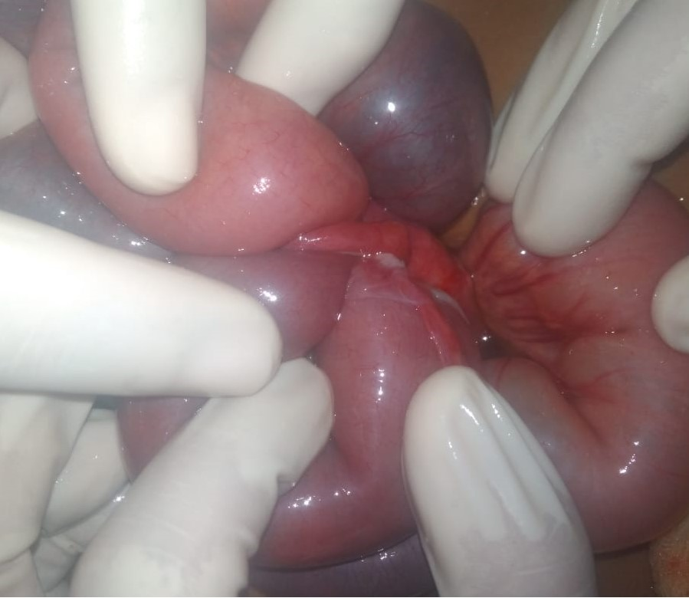

Fig.1: On table picture showing the appendix acting as an obstruction band over distal ileum.

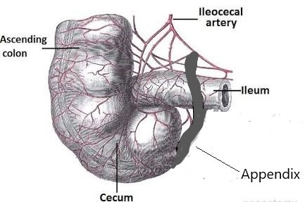

Fig 2: The inflamed appendix is seen lying over the terminal ileum and the tip attached to the ileocecal mesentry resulting in a band like structure causing obstruction.

DISCUSSION:

Appendicitis causing intestinal obstruction was described as early as 1901, when Lucius Hotchkiss read at the meeting of New York surgical society, three successful surgeries for intestinal obstruction due to appendicitis(3). In 1908, Forbes Hawks divided them into mechanical, septic and a combination of the two(4).
1. Adynamic
2. Mechanical (without strangulation)
3. Strangulation of intestine
4. Intestinal obstruction due to mesenteric ischemia

Adynamic type of intestinal obstruction is due to the local paralytic ileus occurring as a result of appendicular inflammation spreading to the adjacent bowel wall. Mechanical intestinal obstruction without strangulation occurs as a result of kinking, compression or traction of the small bowel trapped in an appendicular mass or abscess. The first case of small bowel strangulation caused by appendix was described by Naumov in 1963(4). Intestinal obstruction occurring as a result of mesenteric ischemia produced by appendix is the rarest type with a sole case described by Gupta S. in 1969(5).
Clinically these patients can be classified into two types:
1) Predominant features of appendicitis with some evidence of intestinal obstruction. In this group of patients, intestinal obstruction occurs during the phase of active appendicitis.
2) Patients with Acute intestinal obstruction, on laparotomy found to have appendicitis as the cause. In this group, there may or may not be a history of appendicitis. Intestinal obstruction dominates the clinical picture and may completely obscure the underlying appendicular disease.

CONCLUSION:

Intestinal obstruction due to appendicitis may be of four types. Clinically and radiologically it may not be possible to differentiate these types. It may be predominantly appendicitis or predominantly intestinal obstruction. In the second group it is important to rule out appendicitis by careful re-evaluation. We found that mechanical bowel obstruction in direct connection with appendiceal inflammation is an extremely rare, but potentially life-threatening complication. Clinical signs of the disease are variable and inconsistent, although symptoms during its progression are consistent with symptoms of small-bowel obstruction. A conclusive diagnosis typically has to wait until visualization during the surgical intervention. As such a case presenting with acute intestinal obstruction of unknown etiology, we need to consider appendicitis as a probable cause.

CONSENT:
Written informed consent was obtained from the patient for publication of this case report and any accompanying images.

FUNDING:
No funding to disclose.

ETHICAL APPROVAL:
Not required.

REFERENCES:

1. Yang AD, Lee C-H. Appendico-ileal knotting resulting in closed-loop obstruction in a child. Pediatr Radiol. 2002;32(12):879–881.
2. Bhandari L, Mohandas P. Appendicitis as a cause of intestinal strangulation: a case report and review. World J Emerg Surg WJES. 2009 Oct 10;4:34.
3. Hotchkiss LW. V. Acute intestinal obstruction following appendicitis. A report of three cases successfully operated upon. Ann Surg. 1901;34(5):660.
4. Hawkes F. III. The Prevention of Intestinal Obstruction Following Operation for Appendicitis. Ann Surg. 1909;49(2):192.
5. ALI K, GUPTA MK, AGARWAL BB, SARANGI R, GUPTA S. Inf lamed appendicular tourniquet causing mechanical ileal obstruction.

