CASE REPORT
CRANIOCEREBRAL GUNSHOT INJURY WITH NO NEUROLOGICAL DEFICIT: A CASE STUDY AND DISCUSSION ON THE TRENDING NEUROSURGICAL CHALLENGE.
Mitrajit Sharma¹; Indrajith K Sudhy²
1;2: Department of General Surgery, Gauhati Medical College and Hospital.

ABSTRACT
Penetrating brain injury is a traumatic brain injury caused by high-velocity projectiles or low-velocity sharp objects. A wound in which the projectile breaches the cranium but does not exit is referred as a penetrating wound. A large number of these patients who survive their initial wounding will nevertheless expire shortly after admission to the hospital.¹ Here we discuss a case of penetrating bullet injury in a civilian, who presented with no neurological deficit and the management of the case along with a short discussion on the various presentation of the case and their respective neurosurgical management.

Key Words: Penetrating Brain Injury; Civilian; Neurological Deficit; Neurosurgery.

INTRODUCTION
Penetrating brain injury (PBI) is a type of traumatic brain injury (TBI) defined as brain trauma in which a low-velocity sharp object, such as a knife, or a high-velocity projectile, such as a bullet, penetrates the skull but does not exit it.² Craniocerebral gunshot injuries (CGI) are currently increasingly encountered by neurosurgeons in civilian and urban settings, which is on the rise especially in developing countries. Although less prevalent than closed head trauma, penetrating brain injury carries a worse prognosis.³ CGI are the most lethal of all firearm injuries, with reported survival rates of only 7% to15%.⁴ This study reports an interesting case of CGI, with an inlet 4 cm above the right eyebrow and bullet was removed from right parietal region with insignificant residual neurological defect.
CASE STUDY
A 14 year old male presented to emergency department on 14th of October, 2018 from Meghalaya with a history of homicidal penetrating bullet injury to brain with facial soft tissue injury. An entry wound is seen 4 cm above right eye brow. No exit wound was seen. The GCS (Glasgow Coma Scale) on presentation was E₃V₅M₆. CT (computed tomography) showed a foreign body in the right parietal region. He was started on triple intravenous antibiotics, anti epileptics and antiemetic. He had no neurological or motor deficit.
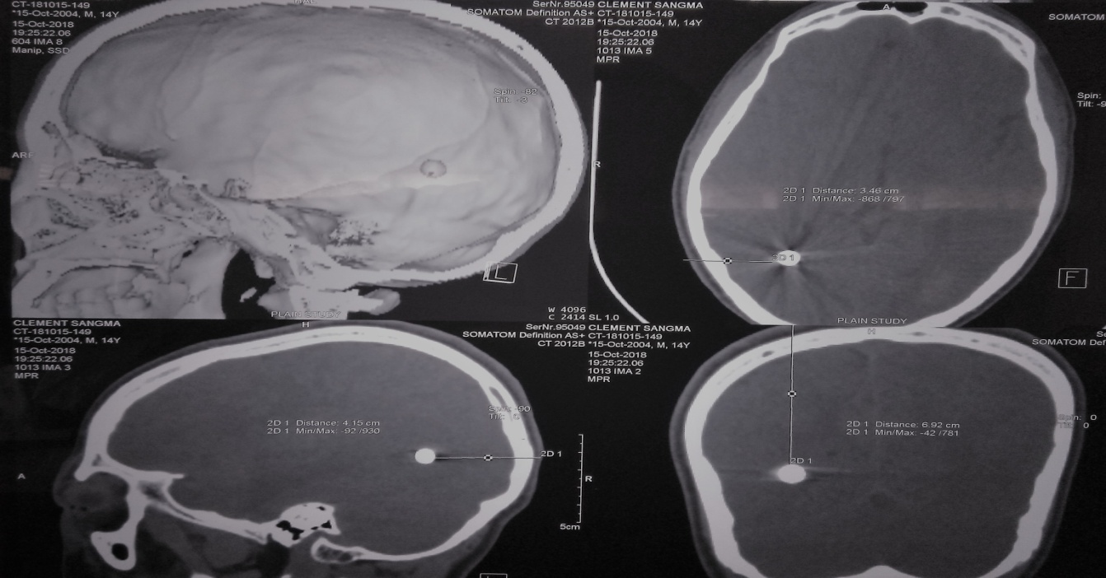
Fig 1: CT scan showing the bullet position and bullet track.
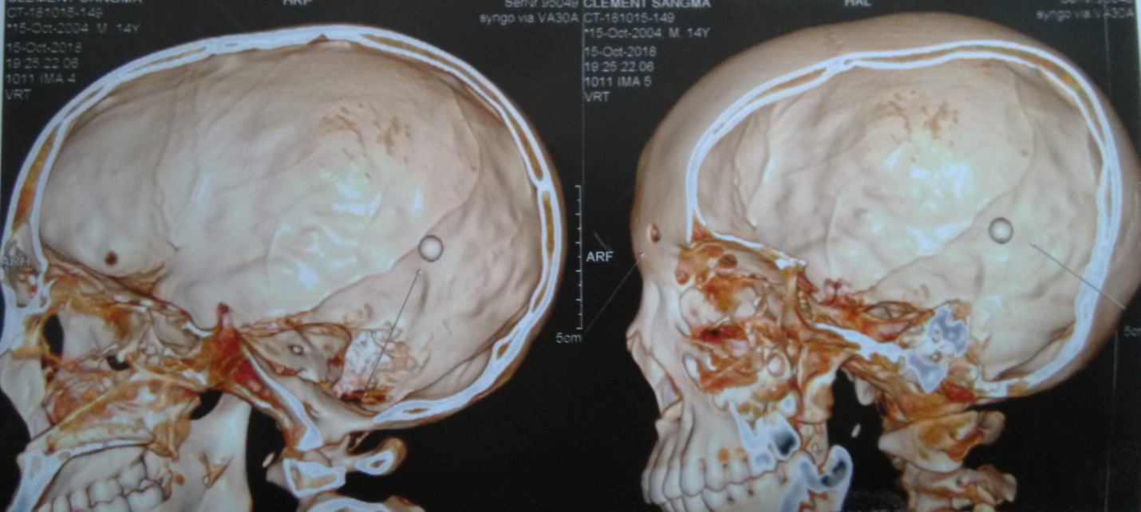
Fig 2: Scan showing the entry wound the bullet lodged in parietal lobe.
Right parietal curvilinear incision given. Incision deepened and temporalis muscle retracted. Periosteum elevated and craniotomy done in curvilinear manner using pneumatic drill. Bullet position determined using intra operative C arm. Bullet was around 2.5 cm from the inner table of the bone. It was extracted using rubber forceps. A metallic pellet about 4 mm diameter with minute erosion of surface was extracted and sent for forensic diagnostics. Homeostasis achieved, duramater was not closed and bone flap repositioned. Patient was then shifted to intensive care unit.
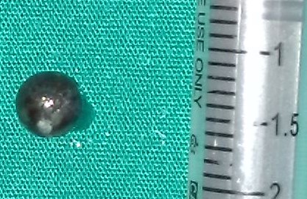
Fig 3: The pellet in comparison to scale.
The patient recovered well and was put on oral feeds after 24 hours. Post operative period was uneventful and the case is now on follow-up.

DISCUSSION
The introduction of Guidelines for the Management of Penetrating Brain Injury has revolutionized the medical and surgical management of PBI during the last decade. There has been a paradigm shift toward a less aggressive debridement of deep seated fragments and a more aggressive antibiotic prophylaxis in an effort to improve outcomes.⁵ Computed tomography scanning is the neuroradiologic modality of choice. Cerebral angiography is recommended in patients with PBI, where there is a high suspicion of vascular injury.⁶ Guidelines for the Management of Penetrating Brain Injury recommends the treatment of small entrance bullet wounds to the head with no significant intracranial pathology, with local wound care and closure. More extensive wounds with nonviable scalp, bone, or dura should be debrided more extensively before primary closure or grafting to secure a watertight wound is to be done if possible within 12 hours of the injury. Routine surgical removal of bone or missile fragments lodged distant from the entry site especially in the eloquent areas of the brain is not recommended. When the trajectory of the missile violates an open air sinus, a water tight closure of the dura should be done as the literature suggests that it may decrease the risk of abscess formation and CSF fistulas.⁷ Advanced age, suicide attempts, associated coagulopathy, Glasgow coma scale score of 3 with bilaterally fixed and dilated pupils, and high initial intracranial pressure have been correlated with worse outcomes in PBI patients.⁸

CONCLUSION

PBI though less prevalent than closed head trauma, carries a shoddier prognosis. The publication of Guidelines for the Management of Penetrating Brain Injury in 2001, attempted to standardize the management of PBI.⁷ This paper provides an insight to the prognostic factors and management protocols for such cases. A precise medical and surgical management of these inimitable injuries present a significant challenge. A better and standardized study has to be undertaken to bring in lime light the best modality of treatment of such cases in our infrastructure.

CONSENT
Written informed consent was obtained from the patient for publication of this case report and any accompanying images.

FUNDING
No funding to disclose.

ETHICAL APPROVAL
Not required.

BIBLIOGRAPHY

- Penetrating brain injury | Journal of Lumbini Medical College [Internet]. [cited 2018 Oct 24]. Available from: https://jlmc.edu.np/index.php/JLMC/article/view/37
- Modi M, Arivazhagan A, Bharath RD, Rao MB. Penetrating brain injury with machete, stuck to calvarium: Hurdles in imaging and solutions. J Neurosci Rural Pract. 2014;5:S63-65.
- Part 1: Guidelines for the management of penetrating brain injury. Introduction and methodology. J Trauma. 2001;51(2 Suppl):S3–6. [PubMed]
- Selden BS, Goodman JM, Cordell W, Rodman GH Jr, Schnitzer PG. Outcome of self-inflicted gunshot wounds of the brain. Ann Emerg Med. 1988;17(3):247–53. [PubMed]
- Nagib MG, Rockswold GL, Sherman RS, Lagaard MW. Civilian gunshot wounds to the brain: prognosis and management. Neurosurgery. 1986;18(5):533–537
- Neuroimaging in the management of penetrating brain injury. J Trauma. 2001;51:S7–11. [PubMed]
- Management of penetrating brain injury [Internet]. [cited 2018 Oct 24]. Available from: https://www.ncbi.nlm.nih.gov/pmc/articles/PMC3162712/
- Part 2. Prognosis in penetrating brain injury. J Trauma. 2001;51:S44–86. [PubMed]

