Case report on:
EMERGING INFECTIONS: Shewanella in lactational breast abscess.
Concise Title: Shewenella putreficans in temperate region

Mitrajit Sharma¹, Pulak Kumar Das², Partha Pratim Das³, Jaydeep Malakar⁴

Address of correspondence
1: PgT, Department of General Surgery
Gauhati Medical College and Hospital
Email: mitrajitsurgery@gmail.com
Ph number: 9706582392
2: Assistant Professor
Department of General Surgery
Gauhati Medical College and Hospital
Email: pulak_kr_das@yahoo.co.in
3: HOD and Professor
Department of General Surgery
Gauhati Medical College and Hospital
Email: ppdasdr@gmail.com
4: PgT, Department of General Surgery
Gauhati Medical College and Hospital
Email: jmala4@gmail.com
ABSTRACT
Shewanella spp. is saprophyte bacteria that are part of the marine microflora in warm climates and they are rarely pathogenic. In recent times, the incidence of Shewanella infections is in the rising trend. In humans, it is mostly isolated from cellulitis, abscesses, bacteremia and wound infections and with no literature suggesting its isolation from lactational breast abscess. The case was managed by incision and drainage with proper antibiotic coverage. This case study suggests that Shewanella infection is more widespread and not just limited to coastal areas, with exposure to sea water and marine product ingestion. In addition, the unexpectedly multi –drug resistant isolate raises concern.
KEY WORDS: Rare pathogen, emerging bacteria, Vibrionaceae, Shewanella putrifecans, imipenem resistant, breast infection.

INTRODUCTION:
Lactational breast abscess is defined as a localized collection of pus within the breast during the period of lactation. It is most often a complication of lactational mastitis which is an inflammation of breast tissue secondary to stasis of milk and bacterial colonization, mostly staphylococcus[1]. Shewanella spp. is unusual cause of abscess in humans with no report of its isolation from breast abscess. It is a saprophytic, gram negative rod, belonging to the family Vibrionacea. It is oxidase and catalase positive, non fermenter that produces hydrogen sulphide[2]. This ubiquitous organism has been isolated from many foods, sewage and both fresh and salt water. There are several reports describing this organism causing human infections, such as cellulitis, abscesses, bacteremia and wound infections[3].
Here, we report a rare case of isolation of Shewanella putrefaciens from a sample of lactational breast abscess in a patient without recent contact with aquatic environment and/or consumption of products of marine origin, suggesting a more widespread distribution of pathogenic Shewanella spp. in warm tropical areas.

CASE STUDY:
A 20 year lactating mother reported to the emergency with left sided engorgement of breast, with redness and swelling, with associated fever and chills. Ultrasound showed multiloculated collections in right upper inner quadrant with abscess measuring 6 X 7 cms in dimension. It was managed with incision and drainage and pus was sent for culture (Fig 1).The culture report came positive fro (91%) Shewanella putrefaciens (done in VITEK 2 automated identification and antibiotic testing system). It was imipenem resistant with sensitivity shown to Aztreonam, Minocycline, Tigecycline, Colistin (Fig 2). She was started on Colistin, supported by breast emptying and regular dressing with a placental extract gel. She recovered well, defect was closed using Ethilon 2-0 c and the patient is on followup.
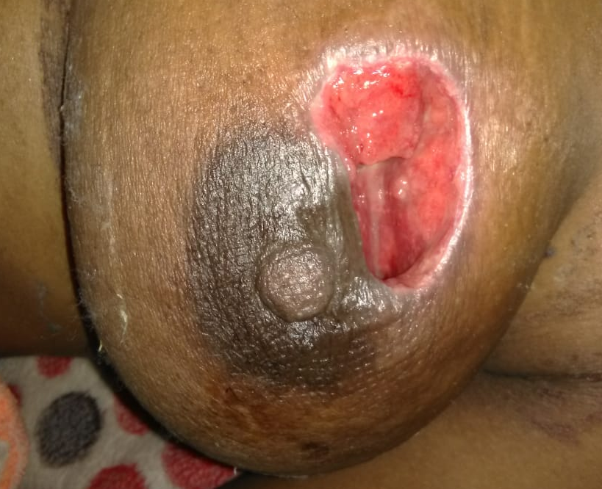
FIG 1: The abscess after incision and drainage & debridement

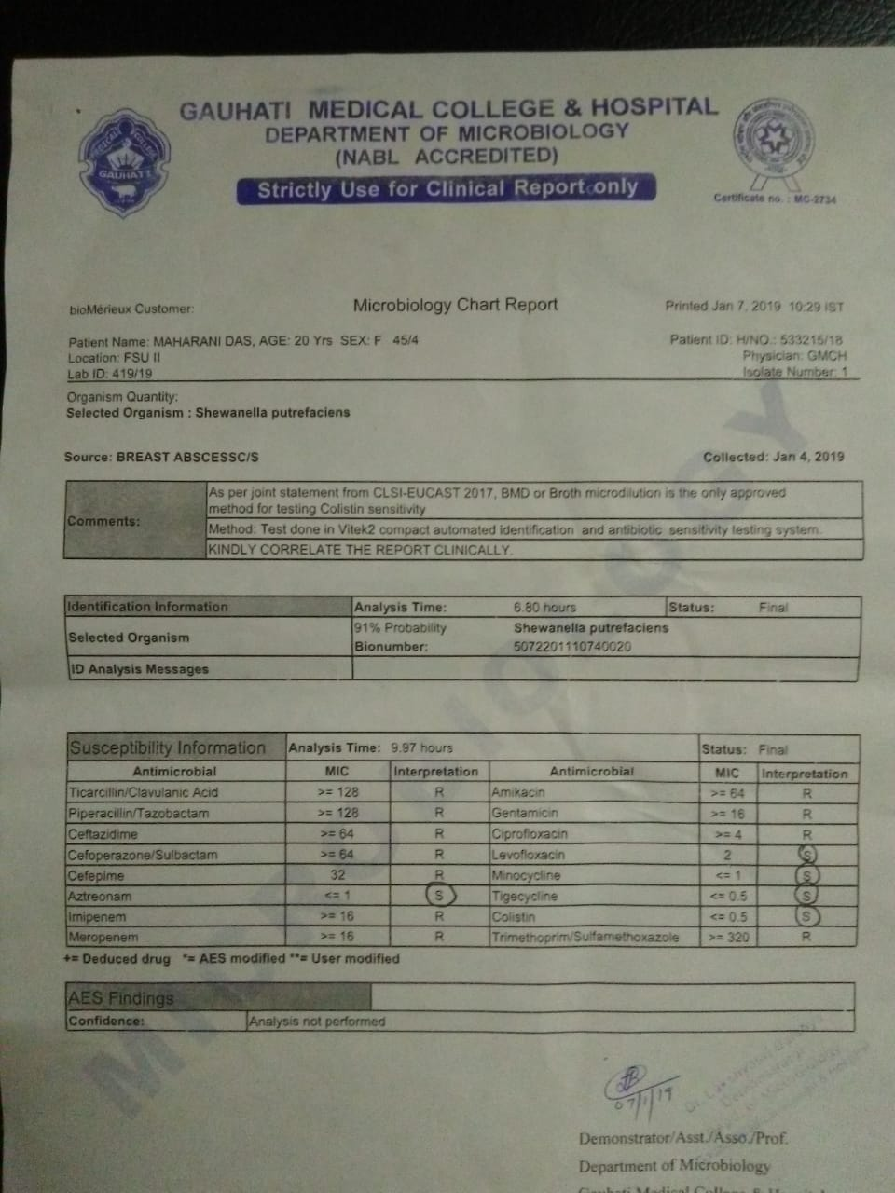
FIG 2: The culture sensitivity report of the case

DISCUSSION
Shewanella spp. have been associated with several kinds of infections like biliary tract infections, empyema, skin and STIs such as fulminant periorbital facial cellulitis, dacrocystitis, perianal abscess, finger abscess, traumatic lesions or burns of lower limbs, bacteremia and rheumatic heart diseases. It has also been reported in premature babies with pneumonia[4]. This, according to us, is the first case of Shewanella isolation from lactational breast abscess. It is mostly reported from ear infections, followed by cellulitis, diabetic foot ulcers, necrotizing fasciitis, myonecrosis. This case adds to an emerging infection from Indian Subcontinent which has relatively less reported cases in comparison to the European Countries. The isolate came sensitive to Aztreonam (≤1), Minocycline (<1), Tigecycline (≤0.5) and Colistin (≤0.5). Shewanella can show resistance to imipenem by secreting oxacillinase[5]. At presentation, as the abscess was >5cms in dimensions, with necrosis of overlying skin, we did incision and drainage in accordance with the recommendations for surgical management, Christian Medical College and Hospital, Vellore[6], along with antibiotic coverage with colistin and breast emptying and regular dressing with Placentrex Gel.

CONCLUSION
Even though Shewanella infection in humans is scarce, the number of reports has significantly increased over the last decade, suggesting that it indeed has a pathogenic potential. Though literature review suggests organism to be susceptible to beta lactamase antibiotics, the emergence of imipenem and beta lactamase resistant isolates is a concerning factor[3]. As such, there is a need to look for such rare organisms and not to dispose all oxidase positive organisms as pseudomonas. It may not affect the overall outcome of the patient but will definitely help in better understanding of the epidemiology, pathogenesis and preventive aspects of such organisms.
Conflict of interest: None Declared.
Source of funding: None Declared.
Author Disclosure: The authors do not have any disclosable interest.

BIBLIOGRAPHY:
- Brunicardi F, Andersen D, Billiar T, Dunn D, Hunter J, Matthews J, Pollock R. Schwartz's principles of surgery, 10e. McGraw-hill; 2014.
- Janda JM, Abbott SL. The genus Shewanella: from the briny depths below to human pathogen. Critical reviews in microbiology. 2014 Nov 1;40(4):293-312.
- Vignier N, Barreau M, Olive C, Baubion E, Théodose R, Hochedez P, Cabié A. Human infection with Shewanella putrefaciens and S. algae: report of 16 cases in Martinique and review of the literature. The American journal of tropical medicine and hygiene. 2013 Jul 10;89(1):151-6.
- Ivanova EP, Flavier S, Christen R. Phylogenetic relationships among marine Alteromonas-like proteobacteria: emended description of the family Alteromonadaceae and proposal of Pseudoalteromonadaceae fam. nov., Colwelliaceae fam. nov., Shewanellaceae fam. nov., Moritellaceae fam. nov., Ferrimonadaceae fam. nov., Idiomarinaceae fam. nov. and Psychromonadaceae fam. nov. International journal of systematic and evolutionary microbiology. 2004 Sep 1;54(5):1773-88.
- Héritier C, Poirel L, Nordmann P. Genetic and biochemical characterization of a chromosome-encoded carbapenem-hydrolyzing Ambler class D β-lactamase from Shewanella algae. Antimicrobial agents and chemotherapy. 2004 May 1;48(5):1670-5.
- Irusen H, Rohwer AC, Steyn DW, Young T. Treatments for breast abscesses in breastfeeding women. Cochrane Database of Systematic Reviews. 2015(8).

