Inter-canine width as a tool for sexual dimorphism and stature estimation

Abstract
Introduction: Identification by means of dental tissue is an easy and very helpful tool in forensic Odontology. Dental architecture grows in proportion to the human body and shows some positive correlation. Also, being so hard and resistant to adverse conditions makes this tissue very valuable in scientific studies. Considering that canine has a longer root as compared to other teeth in the jaw, it makes it a notifiable structure that can be used in research. Hence, among the dental tissues, canine tooth is chosen most often in studies.
Materials and method: This study was conducted in Department of Forensic Medicine & Toxicology, Himalayan Institute of Medical Sciences, Dehradun, Uttarakhand, involving 200 healthy populations (100 males & 100 females) of age ranging from 19 to 24 years. Intercanine width of maxilla and mandible were measured by manual vernier caliper in order to determine sex and height of these subjects. All the data was compiled in excel sheet and analyzed by SPSS computer software.
Observations and result: Mean Maxillary Intercanine width and Mean Mandibular Intercanine width of males was found to be more as compared to females and were found to be statistically highly significant. Sexual dimorphism was more by using Mandibular Intercanine width as compared to Maxillary Intercanine width. Percentage accuracy of sex determination was found to be more in Maxillary Intercanine width as compared to Mandibular Intercanine width. Simple linear regression equations were obtained for predicting height from Intercanine width (independent parameter). Correlation between Height and Intercanine width of Maxilla and Mandible was found statistically significant in males as compared to females.
Conclusion: Sexual dimorphism and stature estimation could be possible measuring Intercanine width in the jaw. However, better prediction with more accurate height and sex determination requires a combined study of dental tissue along with bones in contrast to dental tissues alone.

Keywords: Forensic Odontology, Intercanine width, Sexual dimorphism, Stature

Introduction:
Human beings have important characteristics that differ from each other due to uniqueness, and one such feature is the morphology of dentition. It is one of the most durable parts like bone in the body that resist damage under time factors and weather conditions. This unique and strong characteristics of dentition is used for the purpose of research in medico-legal field. An excellent proof ofits indestructible property is the presence of teeth in the lower jaw of Tabun man which is approximately about 35,000 years old.¹ In Human jaw, canine’s morphology and structure is such that it is less affected by disease, plaque, abrasion from brushing and is also the least extracted tooth.^{2,3,4}Canine can survive even in a hurricane disaster^{.5}In situations, such asflood, earthquakes, cyclones tsunami etcwhere body is decomposed and identification becomes difficult then,the odontometricparameters helps in identification of the individual. Themost reliable, easy, and less time consuming method in investigation is the measurement of teeth.It was reported that sexual dimorphism^{6,7} and stature estimation from permanent canines and their arch width could be possible.However, using dentition for estimation of stature needs moreexplorationand with this background, the current study was conducted to establish a relationship between stature, sexual dimorphism and Intercanine width.

Aim & objectives:
- To find out sexual dimorphism based on Intercanine width
- To find out relationship between Intercanine width and stature
Materials and Methods:
A descriptive cross sectional study was conducted in the Department of Forensic Medicine and Toxicology, Himalayan Institute of Medical Sciences, Swami Rama Himalayan University, Uttarakhand, involving 200 subjects (100 males and 100 females) of age ranging from 19 to 24 years. A written informed consent was duly obtained from all of them, informing about the study, purpose and techniques to be used for the measurements. Only those subjects having normal dental alignment with complete eruption of permanent teeth were included. Subjects having missing teeth, fractured teeth, dental caries, endocrine or any other abnormalities were excluded from the study.
Inter-canine width is defined as the horizontal distance between the two canines. It was measured using a manual Verniercaliper; the subject was asked to open his/her mouth and then the two tips of external jaw of manual verniercaliper were placed at the distal borders of right and left canine respectively for measuring the maximum Intercanine width (max. Id) and for measuring the minimum Intercanine width (min. Id), the tips of the external jaw of manual Verniercaliper were placed at the medial borders of right and left canine of both the jaw, then an average value was noted. In order to maintain proper hygiene,aftertaking these measurements, the tips of Verniercaliper were cleaned before using it on another subject.
For measuring the stature, a stadiometer was used; the subject was asked to stand barefoot in an upright posture with his/her head positioned in Frankfurt plane and with his/her heel, buttocks, scapulae and occiput touching the measuring rod, then by using a movable rod, the reading was taken. To reduce the errors while observing, all the readings were taken twice. The collected data was then analysed using Computer Software SPSS.

Observations:
Table no. 1. Independent t test: for sex differentiation from Inter-canine width
Parameter | sex | Mean ± SD | T value | P value | Significance level | % of sexual dimorphism
Maxillary Inter-canine width | M | 3.4512 ± .23568 | 5.027 | 0.000 | Statistically Highly significance | 5.43 %
Maxillary Inter-canine width | F | 3.2980 ± .19336
Mandibular Inter-canine width | M | 2.7042 ± .22900 | 4.466 | 0.000 | Statistically Highly significance | 6.16 %
Mandibular Inter-canine width | F | 2.5712 ± .19036

The mean Intercanine width of males was more than females in both Mandible as well as Maxilla; they were found to be statistically highly significant. Since, T value between males and females was more in Maxillary Intercanine width than Mandibular Intercanine width, hencesexual dimorphism is more in Mandibular Intercanine width. Also, sex can be differentiated on the basis of Inter-canine width of thesubjects as P value is less than 0.05, which is statistically highly significant. [Table no. 1]
Percentageaccuracy to predict the sex on the basis of Inter-canine width is 62 % in males and 70% in females if using maxilla, 68 % in malessand 55 % in females if using mandible.
Correlation between the stature and Maxillary Intercanine width is more positive and strong as compared to Mandibular Intercanine width in total subjects as well as male and female subjects individually. They were found to be statistically highly significant in total subjects and male subjects as p value is less than 0.05 but not statistically significant in female subjects as p value is more than 0.05.[Table no. 2& Fig 1]

Table no. 2. Regression analysis for predicting stature (Y) of subjects (dependable variable) considering Inter-canine width as an independent variable
S.No | Parameter | Mean | Std. Deviation | Correlation value | P value | R Square | Regression equation
1. | Mean Height of Total Subjects (n= 200 ) | 167.06 | 9.48231 | .368 | .00 | .135 | Y = 115.525 + 15.270  (maxillary Intercanine width in Total Subjects)
1. | Mean Maxillary Inter-canine width of Total Subjects (n =200) | 3.37 | .22833
2. | Mean Height of Total Subjects (n= 200 ) | 167.06 | 9.48231 | .332 | .00 | .110 | Y = 129.355 + 14.293  (mandibular Intercanine width in Total Subjects)
2. | Mean Mandibular Inter-canine width of Total Subjects (n =200) | 2.64 | .22037
3. | Mean Height of Male Subjects (n=100) | 174.42 | 5.90969 | .239 | .008 | .057 | Y = 153.706 + 6.003  (maxillary Intercanine width Of male Subjects)
3. | Mean Maxillary Inter-canine width of Male Subjects (n =100) | 3.45 | .23568
4. | Mean Height of Male Subjects (n=100) | 174.42 | 5.90969 | .217 | .015 | .047 | Y = 159.258 + 5.609  (mandibular Intercanine width in male Subjects )
4. | Mean Mandibular Inter-canine width of male Subjects (n = 100) | 2.70 | .22900
5. | Mean Height of Female Subjects (n=100) | 159.69 | 6.00936 | .109 | .141 | .012 | Y = 148.563 + 3.373  (maxillary Intercanine width in Female Subjects )
5. | Mean Maxillary Inter-canine width of Female Subjects (n =100) | 3.30 | .19336
6. | Mean Height of Female Subjects (n=100) | 159.69 | 6.00936 | .097 | .168 | .009 | Y = 115.525 + 15.270  (mandibular Intercanine width in Female Subjects )
6. | Mean Mandibular Inter-canine width of Female Subjects (n =100) | 2.57 | .19036

Fig 1: Scatter diagram showing correlation between Intercanine width and stature (a to f)

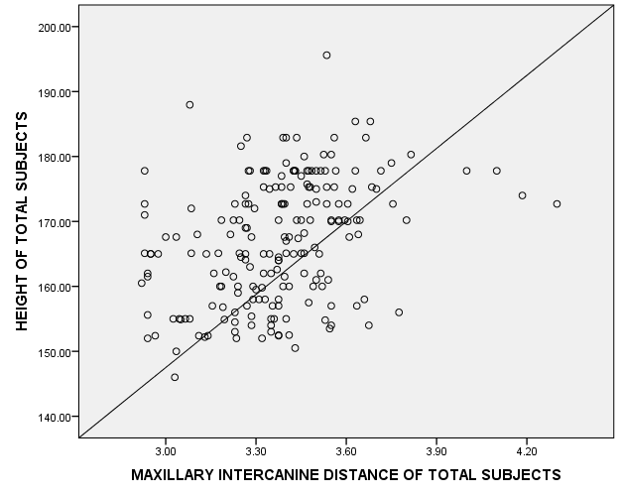
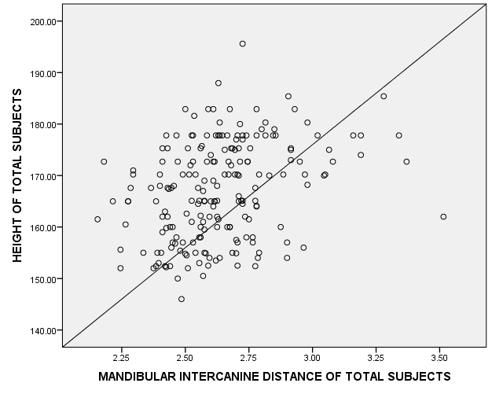
- (b)
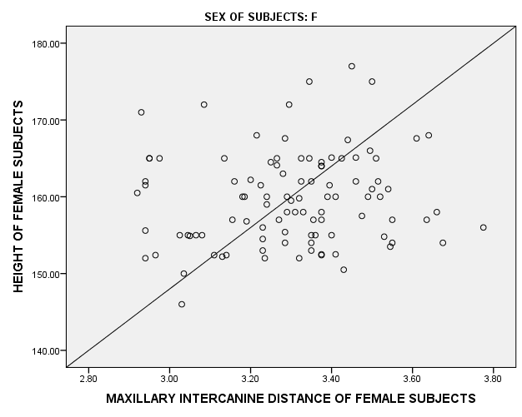
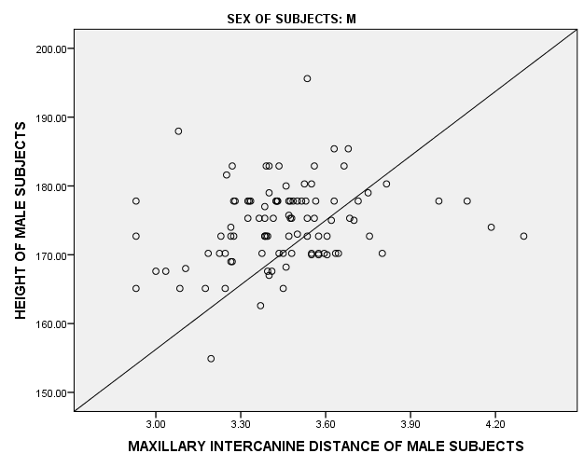
(c) (d)

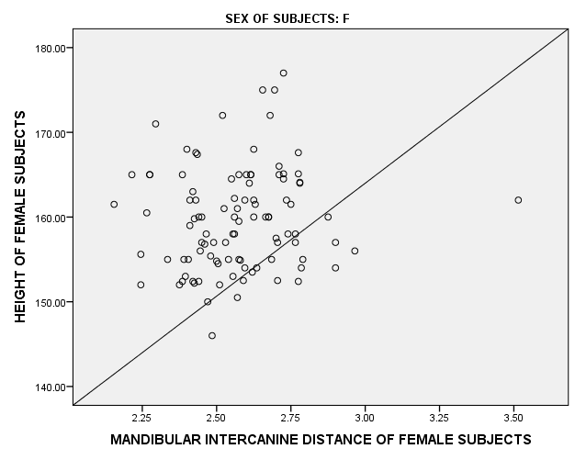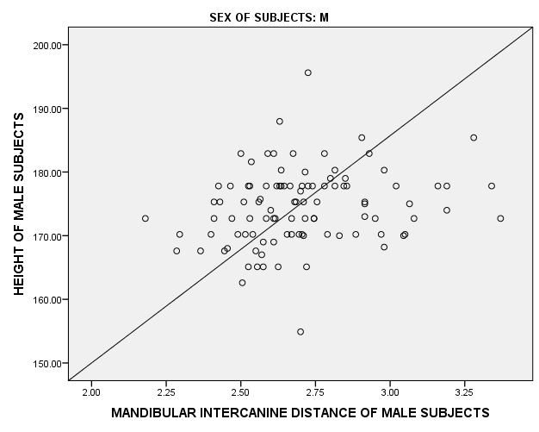
(e) (f)
Discussion
The present study was conducted for sexual dimorphism using Mandibular and MaxillaryIntercanine width, thereafter prediction of stature was done by considering Intercaninewidth as an independent variable. The mean Mandibular Intercanine width was more in males as compared to females; statistically significant differencewas found as p value was less than 0.05. These findingsare consistent with most of the studies^{8,9,10, 12,13,14, 15, 16,17}but inconsistent with study conducted by Dayananda¹⁸ where mean value was more in males but statistically insignificant difference was observed. In the present study, mean Maxillary Intercanine width was more in males as compared to females and statistically significant difference was found between males and females which is consistent with Prakash Chandra jhaetal¹⁸ and Rao G V¹⁹but inconsistent with Hamid and Mastooreh²⁰where statistically insignificant difference was found.Sexual dimorphism using Mandibular Intercanine width in the present study was found to be 6.61 % whereas a slightly higher higher percentage was found byFulwariaMukesh²¹(13.74 %).The correlation coefficient between Stature and Maxillary intercanine width of the present study was found to be weakly positive (0.368) and a statistically significant relationship was obtained which is consistent with Harshala S Patil’s²² (r = 0.493 and p value < 0.05).
Conclusion
Sexual dimorphism is successfully possible ifIntercanine width of Maxilla and Mandible are measured in the jaw. Also, percentage of sexual dimorphism using Mandibular Intercanine width is more than Maxillary Intercanine width. The percentage accuracy to predict the sex, considering Intercanine width is more in females(62 % in males, 70% in females) if using Maxilla and more in males( 68 % in males, 55 % in females) if using Mandible. Since, we obtained a positive, weakly strong correlation and not a very high percentage of sex prediction. Hence, there is a need formore research relating to Intercanine width involving a larger population of different age groups.In order to obtain a more reliable, better and more accurate prediction of stature and sexual dimorphism it suggested to conduct a combined study of dental tissues and bones in contrast to dental issues alone.
Acknowledgment: we owe our sincere gratitude to the subjects and staff of forensic medicine department who were involved directly or indirectly in this study.

Conflicts of interest: none

Contribution of Authors: All authors declare that: (1) The article is original with author(s) and does not infringe any copyright or violate any other right of any third party. (2) The article has not been published (whole or part) elsewhere, and is not being considered for publication elsewhere in any form, except as provided herein. (3) All author(s) have contributed sufficiently in the article to take public responsibility for it and (4) All author(s) have reviewed the final version of the above manuscript and approved it for publication. The contributions were made as: Dr. Rattan Singh: Concept, study design, data collection, data arrangement, statistical analysis, manuscript writing; Neha Bhasin: Collect the data, review the manuscript; Dr. Jyoti Barwa: Interpret the table and graphs, Draft writing, review the manuscript; Dr. Sanjoy Das: Concept, Study Design, Draft writing, Review Manuscript.

Ethical clearance: obtained by Institutional Ethical Committee

Source of funding: self

References:
- Whittaker DK. Introduction to forensic odontology. Quintessence Int. 1994; 25:723–30.
- Williams P.L., BannisterL.H., BerryM.M., CollinsP., DysonM., DussekJ.E., and FergussonM.W.J.. The Teeth. In Gray’s Anatomy. 38th ed. London; 2000. p. 1699-1700.
- Bosset WA, Marks HH. Prevalence and characteristics of periodontal disease in 12,800 persons under periodic dental observation. J Am Dent Assoc. 1956; 52: p. 442-49.
- Krogh HW. Permanent tooth mortality: A clinical study of causes of loss. J Am Dent Assoc. 1968; 57: p. 570-675.
- Patterson KB, Kogan SL. Dental identification in woodbridge disaster. J Canad Dent Assoc. 1985; 37: p. 301-06.
- Omar A, Azab S. Applicability of determination of gender from odontometric measurements of canine teeth in a sample of adult Egyptian population. Cairo Dent J 2009; 25:p. 167-80.
- Sekhon H, Singh R, Barwa J. Determination of Sex from Mandibular Canine Index in Delhi Population; Medicolegal Update July- December 2017; p. 156-159.
- Muller M, Lupi- Pegurier L, Quatrehomme G, Bolla M. Odontometric method useful in determining gender and dental alignment. Forensic Science International 2001; 121: 194 – 7.
- Kaushal S, PatnaikVVG ,Sood V , Agnihotri G . Sex determination in North Indians using mandibular canine index. J I A F M 2004;26(2): 45 – 9.
- Abdullah M.A, MohammedA.Q., Ashraf I, Khan N. Saudi Dental Journal- 1997; 9(1): 1-5.
- Yogitha R, Aruna N, BalasubramanyamR. Journal of the Anatomical Society of India. Abstract 217. Vol. 54, No 1. 2005.
- BondevikO. Changes in occlusion between 23 and 34 years of age. Angle Orthod1998;68(1) : 75-80.
- Anderson DL, Thompson GW. Interrelationships and sex differences of dental and skeletal measurements. J Dent Res 1973; 52(3): 431 – 8.
- Sherfudhin H, Abdullah MA, Khan N. A cross – sectional study of canine dimorphism in establishing sex identity: comparison of two statistical methods. Journal of Oral Rehabilitation 1996; 23: 627 – 31.
- Aggarwal B, Vasudeva K, Kaushal S, Chhabra U, Singla S .Gender Based Comparison of Intercanine Distance Of Mandibular Permanent Canine In Different Populations.JPAFMAT 2008; 8(2).
- Ayoub F, Shamseddine L, Rifai M, Cassia A, Diab R, Zaarour I, Saadeh Metal. Mandibular Canine Dimorphism in Establishing Sex Identity in the Lebanese Population. International Journal of Dentistry Volume 2014,pg 1-4.
- RaoG V,KiranG. Sex Determination by means of Inter-Canine and Inter-Molar Width- A Study in Telangana population. Asian Pac. J. Health Sci., 2016; 3 (4):171-175
- Jha PC, Sanghamesh NC, Alok A, Singh S, Bharti BB, Raj R. Dimorphism of Canine: A Diagnostic Value in Gender Identification - A Clinical Study. Int J Sci Stud 2015;3(8):81-84.
- Dayananda R, Kumar MP, GovindaRaju HC, Anand P Rayamane, Ashish Saraf. Sexual Dimorphism in Permanent Mandibular Canines. JKAMLS Vol 23(1) Jan - Jun 2014:1-8.
- Asli H M,MastoorehK G.Evaluation of the relationship between upper intercanine and inner canthal distances in selected patients. Biosci. Biotech. Res. Comm 2017). 10(2): 143-147.
- Fulwaria M, Bijaraniya K. Determination of Sexual Dimorphism in Bikaner city population in Rajasthan by Odontometric Study of Permanent Mandibular Canine Sch. J. App. Med. Sci., Oct 2017; 5(10E):4187-4190.
- PatilHS, AlaneU Y. Estimation of Stature in Local Beed (Maharashtra) Population: An Odontometric Approach. Journal of Dental and Medical Sciences.Volume 16, Issue 9 Ver. X (September. 2017), PP 80-84.

