MANUSCRIPT OF ORIGINAL ARTICLE
To be published in International Journal of Health Research & Medico Legal Practice
HISTOLOGY OF SEEDS – SPROUTING THE NEURONS FOR DIAGNOSIS OF POISONING

Abstract:
Nature has provided a lot of blessings for its creations in this world. Food is one of its blessings for the survival of the living. Different parts of certain plants are very frequently consumed by human beings for nutrition purpose. The regulated and recommended consumption of such eatables is for nutrition but, irrational use of them either by accident, suicide or homicide can lead to illness, disease or even death in certain cases and is considered as poisoning. It is extremely difficult to detect the biological poisons at the laboratories in the samples collected from the patient. Its physical characteristics and histological features are useful in diagnosis of poisoning when the fragmented remains of the poisons are found in the gastric lavage or when these poisons are brought by the relatives of the patient. As per best of our knowledge, no database is available regarding the physical and histological characteristics of routinely used seeds in biomedical literature. Here we have tried to prepare a pictorial database of physical & microscopic characteristics of frequently consumed seeds of toxicological significance in Gujarat region.

Introduction:
The plants have served as a good source of nutrition to not only the human beings but also the other creatures on this planet. Different parts of certain plants are very frequently consumed by human beings for nutrition purpose. The recommended and regulated consumption of such eatables is for nutrition, but irrational use of them by accident, suicide or homicide can lead to illness, disease or even death and is considered as poisoning. It is extremely difficult to detect the biological poisons at the laboratories in the samples collected from the patient. Its physical characteristics and histological features may play a key role in diagnosis of poisoning when these poisons are brought by the relatives of the patient or the remains of the poisons are found in the gastric lavage. As per best of our knowledge, no database is available regarding the physical and histological characteristics of routinely used/abused toxic seeds in biomedical literature. This kind of information which can serve as a single point ready reference is not available in a single compiled piece of literature or book, even in botany! The authors have tried to prepare a pictorial database of histology of toxic seeds in the constrained set up of a medical college as compared to the sophisticated infrastructure for processing of the seeds available in the departments of botany elsewhere. But in spite of the limitations, the results obtained and recorded by the authors surprisingly approach the standard results in a standard set up.
Aims & Objectives:
1. To create a pictorial database of histology of toxic seeds commonly causing poisoning, for their identification to aid in diagnosis.
2. To establish a histological confirmation of commonly encountered toxic seeds as a helpful adjunct to their identification based on their physical and clinical features.
3. To check the utility of conventional method of tissue processing for histology of toxic seeds.

Materials & Methods:
Various toxic seeds were procured from the local shop. They were identified by gross features. Those included are seeds of 1) Poppy, 2) Datura, 3) Moringa oleifera, 4) Argemone mexicana, 5) Semecarpus anacardium, 6) Abrus precatorious, 7) Strychnos nux vomica, 8) Croton tiglium, 9) Capsicum annum and 10) Jatropha curcas.
The seeds were subjected to conventional method of tissue processing^{[1]} at Histopathology laboratory in our hospital, were stained with Haematoxylin & Eosin (H&E) and slides were prepared. The slides were examined under light microscope in various magnifications (10X, 40X) and photographs were captured. The photographs were processed in Microsoft office picture manager software and were reproduced with better resolution.

Observations: Following are the images of the gross appearance and sections prepared out of the ten toxic seeds. (Fig. 1 to Fig. 10)
Figures:

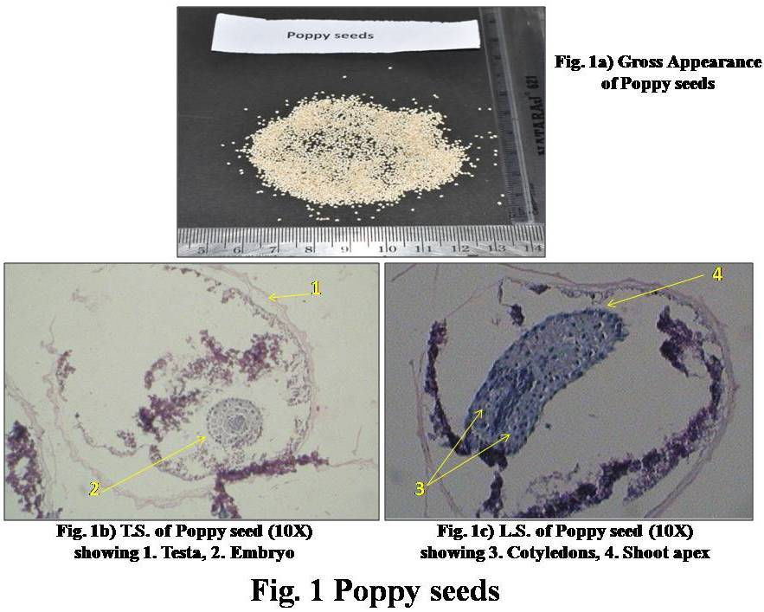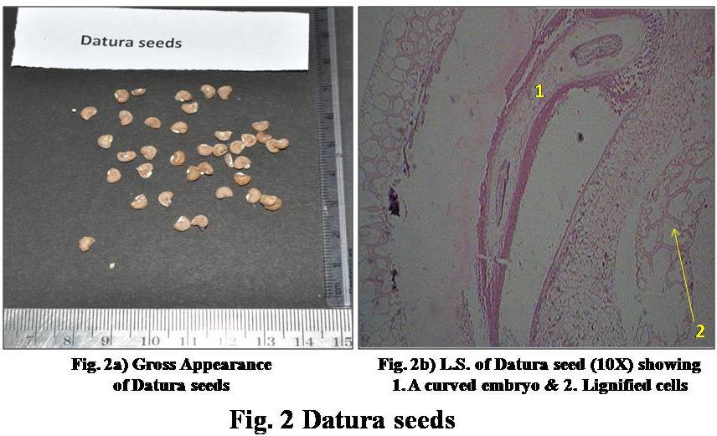

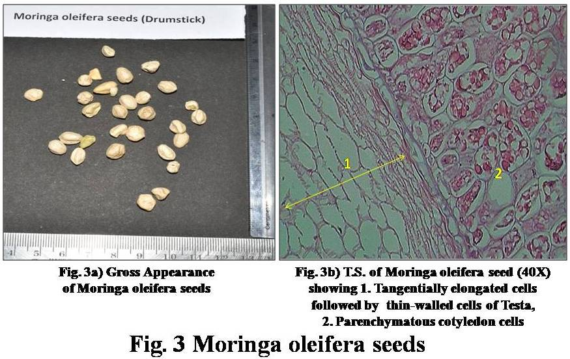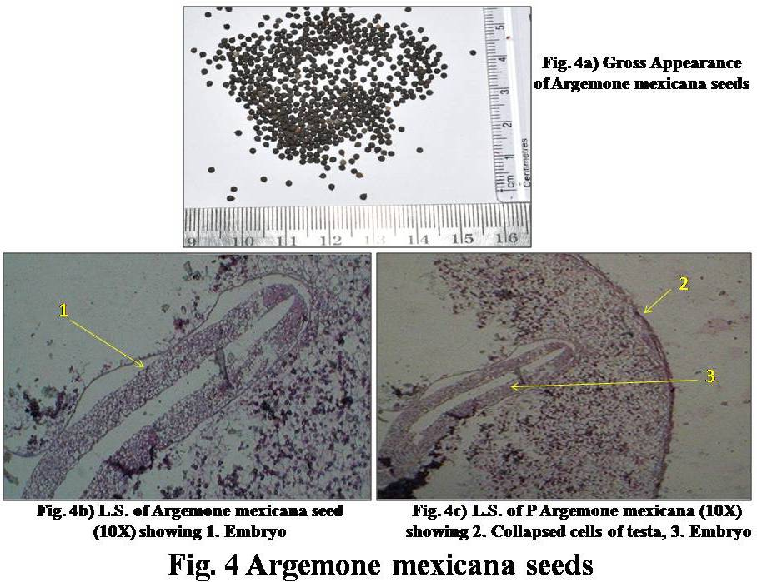
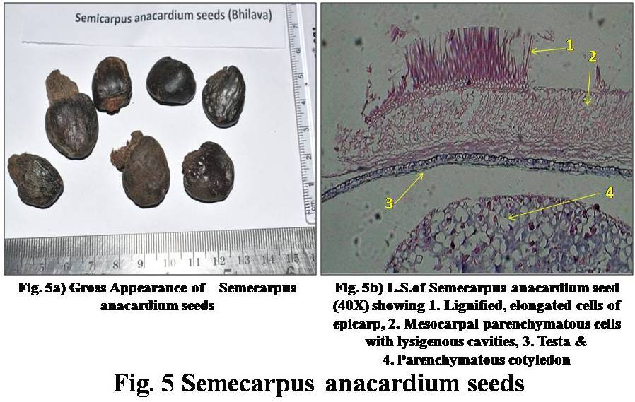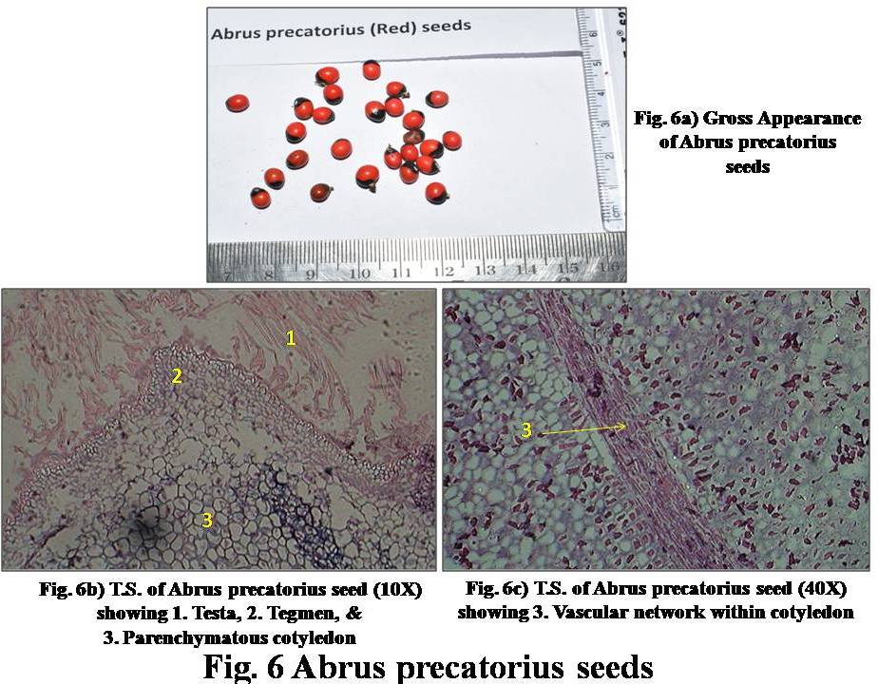
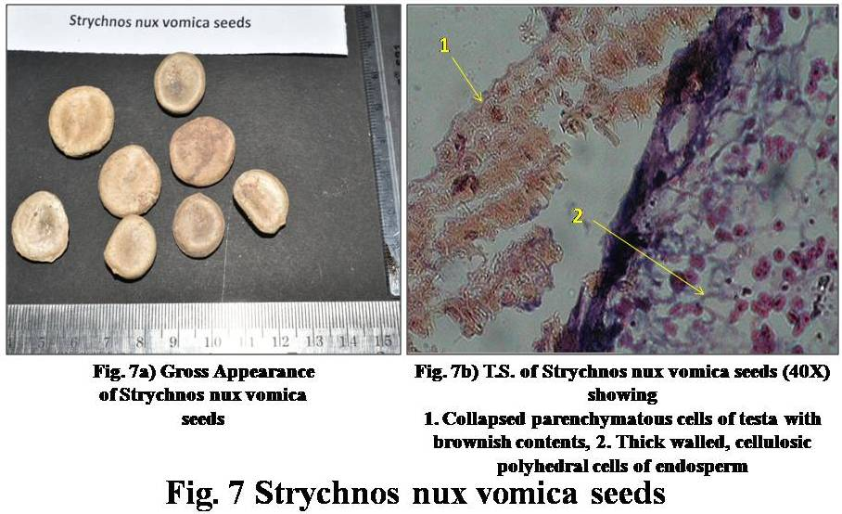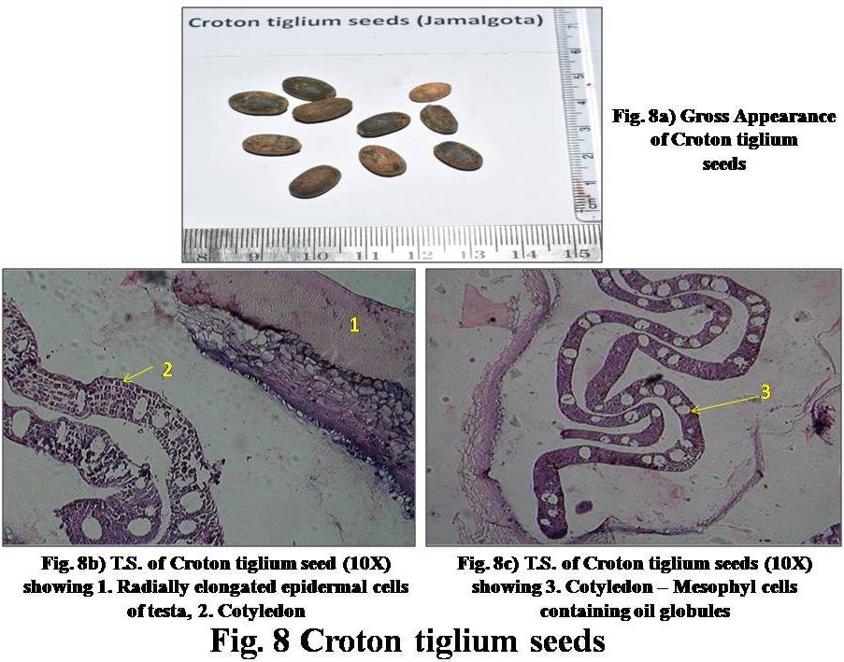
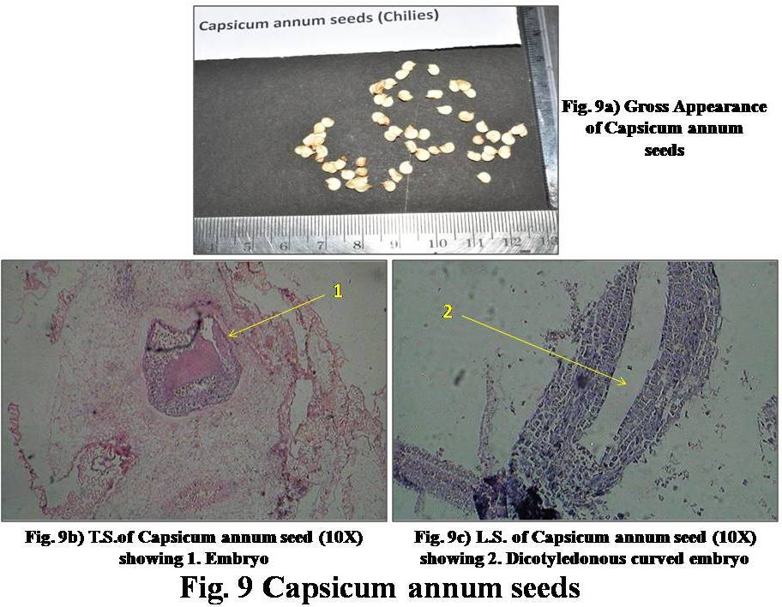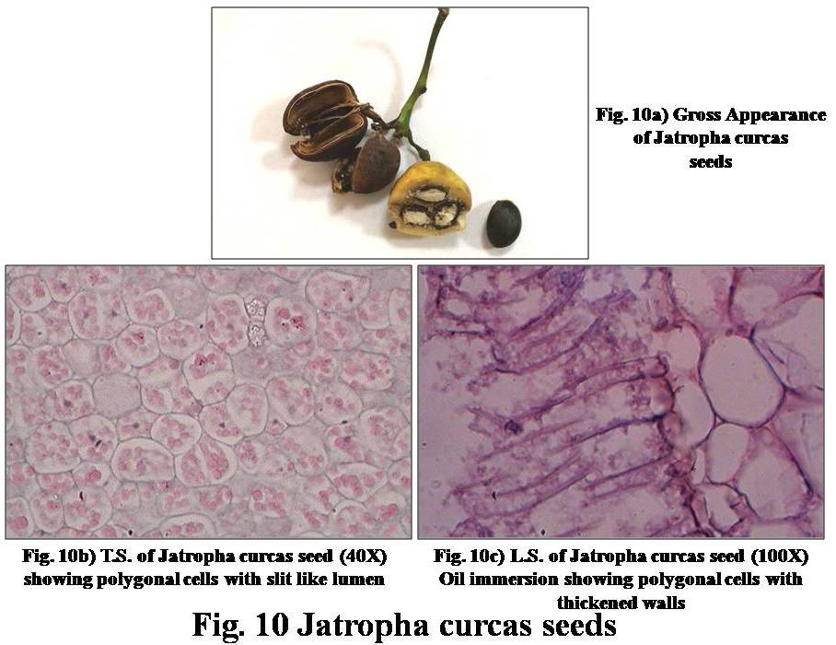
Discussion:
The authors encountered a case where a pediatric patient consumed unknown seeds and presented with severe vomiting and diarrhoea, where the pediatrician was confused with the diagnosis, but the diagnosis of poisoning with Jatropha curcas seeds was confirmed by the exercise of gross as well as histological examination of the seeds brought by relatives of the patient.^{[2]} This exercise was collaboratively carried out by Pediatrics & Forensic Medicine departments. The authors were encouraged to create a histological database for other toxic seeds commonly causing poisoning in the region by success of the case mentioned in reference 2.
The authors found compatible literature of histology of some seeds from The Ayurvedic Pharmacopoeia of India^{[3]} with which the slides were compared and confirmed, but no references for the images of histological features of these toxic seeds were found. The seeds were subjected to the conventional method of tissue processing at Histopathology laboratory of the hospital which yielded confirmatory results in some, but not all. This might be because the sectioning could not be done properly; which is attributable to the hardness of the seeds, as opposed to the human tissues which have softer consistency. However, the seeds if soaked in alcohol before sectioning can yield better sections. Stains like Safranin & Methylene blue can be better substitutes to H&E stain; & parallel staining with Sudan can help easier identification of lipid filled cells. The standard procedure for sectioning of seeds mentioned by Willard W. Rowlee^{[4]} can yield better results when carried out in a sophisticated Forensic Botany laboratory with compatible instruments and stains for the seeds.
Conclusions:
1. A pictorial database of histology of toxic seeds commonly causing poisoning in the Gujarat region was created.
2. The seeds brought by the patient or relatives, recovered from the crime scene or by filtering the gastric lavage contents can be collected and their histology can be compared with the database as an adjunct to their physical features for its identification in cases of poisoning with biological poisons where, these poisons are not being able to be detected routinely in Forensic science laboratories.
3. Forensic Medicine departments in different medical colleges are suggested to carry out such an exercise to create their own regional database.
4. Better images of histological features can be produced by using standard method of processing of toxic seeds in sophisticated Botanical laboratories and this area of Forensic Botany can be explored further.

Ethical Clearance: Not required as this study does not involve human participants.
Acknowledgements:
The authors are thankful to the Department of Pathology, GCSMCH & RC, Ahmedabad for their support in processing of the seeds. The authors are also grateful to Dr Afroz Bloch, Assistant Professor, Microbiology, GCSMCH & RC, Ahmedabad and Mr. Yasin Bloch, Retired Botanist for their valuable support.

Conflict of interest: None declared.
Authors’ Contribution: We declare that this work was done by the authors named in this article and all liabilities pertaining to claims relating to content of this article shall be borne by the authors. Concept, Design, Manuscript writing by: Dr Mohammed Ziyauddin G Saiyed, Dr Chetan B Jani. Processing of the seeds & identification of the features on sections were done by the authors with the help of personnel mentioned in acknowledgements.

References:
1. Ramnik Sood. Histopathology. In: Medical Laboratory Technology – Methods and Interpretations. 4th Ed. New Delhi: Jaypee Brothers; 1994. pp.586-93.
2. Saiyed MZ, Prajapati S, Jani CB, Prajapati BS. Paediatric poisoning panic and Forensic Toxicologist. JIAFM 2015;37(4):pp.435-7.
3. The Ayurvedic Pharmacopoeia of India. – Official publication of Department of Ayush, Ministry of Health & Family Welfare, Government of India. Part I, Vol. I-V.
4. Proceedings of the American Society of Microscopists, Vol. 12, Thirteenth Annual Meeting (1890): pp.113-5.

