VIRTOPSY: A RECENT ADVANCEMENT IN TRADITIONAL NECROPSY
Manoj Kumar Pathak¹, Shashank Shekhar Jha²
¹ Professor and Head, Forensic Medicine, Department of Forensic Medicine, Institute of Medical Sciences, Banaras Hindu University, Varanasi, India
² Junior Resident-II, Forensic Medicine, Department of Forensic Medicine, Institute of Medical Sciences, Banaras Hindu University, Varanasi, India
Corresponding Author: Dr. Manoj Kumar Pathak, Professor and Head, Forensic Medicine Department of Forensic Medicine, Institute of Medical Sciences, Banaras Hindu University, Varanasi-221005, India: Mobile No.9450179177: Email- drmanojpathak@gmail.com

ABSTRACT
Virtopsy is “Virtual Autopsy.” Virtopsy is a virtual alternative to a traditional autopsy, conducted with scanning and imaging technology. Radiographic methods were used to forensically analyse the victim's remains which aided the legal judgment. This instance is commonly heralded as the birth of virtopsy. Virtopsy has four cornerstones. . It uses an all-in-one machine called “Virtobot” which integrates the four imaging modalities mentioned above to practice virtopsy. The dissection of body is minimal, thus providing a more humanitarian approach. Infections and health hazards for forensic experts can be reduced.
KEYWORDS: Virtopsy, MSCT, Virtobot, Virtomobile, Artefacts.

INTRODUCTION
Virtopsy is “Virtual Autopsy.” Its etymology is derived from ancient Latin and Greek languages. The word “virtual” is derived from the Latin word virtues, meaning “useful, efficient, and good.” “Autopsy” is a marriage of the classical Greek terms “autos” (“self”) and “opsomei” (“I will see”), meaning “to see with one's own eyes.” Thus, the terms “virtual” and “autopsy” merge to form “virtopsy”.^{[1]}
An autopsy is a procedure which surveys the mortal remains of a person to identify the cause of death.^{[2]} Forensic medicine deals with the examination and identification of relevant medical data in both the living and deceased and presentation of the same with exhaustive scientific matter for judicial proceedings.^{[3]} Autopsy is also referred to as necropsy or postmortem examination and is revered as the cardinal expertise in forensic science. It is thus fondly called “the expertise of expertise.”^{[4]}
The conventional procedure in postmortem examination is dissection, interpretation, and cataloguing.^{[5]} The data obtained from this examination is then compiled, and the forensic experts arrive at a conclusion. The dead body is then handed over for the last rites to be performed. However, if the forensic expert wants to reconsider his/her decision over the previously gathered data, it may be difficult and not feasible.^{[3]} The possible mutilation involved in the conventional autopsy often leaves the grieving family disturbed. Thus, the family of the deceased declares a negative consent for autopsy procedure on a sentimental basis.^{[6]} Certain religious groups such as the Jews, Muslims, Jehovah's witnesses do not completely accept conventional autopsy procedures.^{[7]} These pitfalls of a conventional autopsy led to the genesis of virtopsy.
Virtopsy is a virtual alternative to a traditional autopsy, conducted with scanning and imaging technology.

HISTORY
In the late 1990s, a high-profile homicide case in Switzerland demanded an accurate forensic opinion. The impressions of the skull of the victim had to be matched with a most likely murder tool. The extensive work followed in this arena focusing on an objective method of forensic analysis which would minimally disturb the skull of the victim. Radiographic methods were used to forensically analyse the victim's remains which aided the legal judgment. This instance is commonly heralded as the birth of virtopsy.[3]
Examination of dead by virtopsy: In 2003, a 3000 year old mummy was subjected to virtopsy methods to find out manner of death, cause of death and identification of the deceased. Virtopsy methods were ground breaking in that they have established a new high-tech toolbox into morphological investigation aspects of modern forensic pathology [6]. Since virtopsy is non-invasive, it is less traumatic for surviving family members and may not violate religious taboos against violating bodily integrity.[7]
Examination of the living: Non-invasive imaging is also conducted in living or surviving subjects, but as that has been the main clinical application of CT and MR imaging to begin with, their use in medicolegal investigation of the living is not as ground breaking as using them for investigation of death. Nevertheless, a number of applications that may be regarded as specific for medicolegal imaging applications in the living have found attraction for Virtopsy-derived methods:
Matching weapon or injury-causing agent and injury. The application of 3D surface documentation of injuries for the benefit of medicolegal reconstruction must be accredited to Brueschweiler et al. (2003).[8]
Strangulation and estimation of risk of death. The first paper documenting systematic application of MRI to survivors of strangulation for the benefit of forensic medicine was published by Yen et al. in 2005.[9]
Body packing. According to a paper of the Virtopsy group, CT scanning may be more suitable to body packer identification than conventional or plain abdominal X-rays.[10]

TOOLS
Virtopsy has four cornerstones, namely,
(a) Three-dimensional surface scanning 3D/computer-aided design photogrammetry,
(b) multi-slice computed tomography (MSCT),
(c) magnetic resonance imaging (MRI)
(d) MRI spectroscopy.[11]
Three-dimensional surface scanning three-dimensional/computer-aided design photogrammetry
it is the science of making measurements using photographs. A number of different photographs are taken from different angles and are analysed by TRITOP/ATOS II system (GOM, Braunschweig, Germany) software.[12] This software uses high-speed imaging and remote sensing to construct a 3D comprehensive image of the surface features of the deceased.
Multislice Computed Tomography (MSCT)
It features the hard tissue architecture in multiple sections. It aids in the identification of any changes in the same.
Magnetic resonance imaging
It features the condition of the soft tissue. It aids in the identification of any changes in the same. MSCT and MRI together help in the differentiation of the adjacent structures.
Magnetic resonance imaging spectroscopy
It provides the biochemical picture of the deceased. It uses metabolites in the brain emerging from post-mortem decomposition to give an accurate time of death.
Micro-computed tomography
Special cases require modifications of the above-mentioned techniques. The Institute of Medical Physics in Erlangen, Germany, developed a scanner to image a 3D volume with an isotropic resolution ranging from 10 to 100 μm.[13] This scanner is sensitive to examine samples of diameters ranging from 4 to 40 mm.
Magnetic Resonance Microscopy
In vitro studies on eyeballs were anatomically imaged. After this, eyeballs were paraffin embedded, and sections of 6 μm were cut and stained with hematoxylin and eosin.[14]
TECHNOLOGY
The technology currently used for conducting a “virtual autopsy” comprises:
Robot-guided surface scanning for three-dimensional documentation of the surface of the body, to scale and in color.[15] This supplements the external post-mortem examination of the body" that is done in a conventional autopsy;
Multislice spiral CT and MRI for visualising the body in 3D. This supplements the internal post-mortem examination of the body in an autopsy;[16]
Post mortem angiography, which visualises the cardiovascular system of the deceased with the aid of a peristaltic pump and contrast medium;[16]
Image- and robot-guided, contamination-free sampling for a wide range of supplementary forensic analyses, such as histology, bacteriology, virology, toxicology and diatomology.[17] This procedure replaces the usual collection and storage of sample material from the body.

PRACTICE OF VIRTOPSY
Virtobots
In this era of robotics, virtopsy is not to be left behind. It uses an all-in-one machine called “Virtobot” which integrates the four imaging modalities mentioned above to practice virtopsy. This machine will allow combined surface and body volume data acquisition within a single 3D space, making present-day data fusion techniques dispensable.
Virtomobile
Virtobot is a gigantic machine making its utility in the sites of mass disaster futile. This leads to the requirement of a more compact device for the practice of virtopsy. Thus, virtomobile was conceived. It is a version of Virtobot mounted on a trailer which can be easily transported to the site of disaster.[18]
PROCEDURE OF VIRTOPSY
In virtopsy, there is fusion of the technologies of medical 3D imaging techniques as well as a 3D surface scan used in the automobile designing used to map the external surface of the body. It records and documents the 3D image of the body surface area in detail. [19]

BENEFITS OF VIRTOPSY: ^{[20]}
- It can be done in highly infected dead bodies or those with radioactive exposure.
- The dissection of body is minimal, thus providing a more humanitarian approach.
- It is preferred by family members due to its non-invasive nature.
- It saves time and data can be stored indefinitely.
- Opinions are more observer-independent and less subjective.
- It can be used to complement standard autopsies and increase the quality of autopsies.
- It permits additional analysis on the same body by other forensic pathologists, i.e., should allegations creep up in the future, second or third opinions can be sought even years later.
- Visualisation tools increase the quality and efficiency of forensic methods.
- Infections and health hazards for forensic experts can be reduced.
- In cases involving the compression of the neck, haemorrhages that are not visible to naked eye can be detected. Similarly, internal bleeding, bullet paths, hidden fractures bone and missile fragmentation, brain contusions and gas embolisms that are hard to find in a traditional autopsy can be detected.
- Unlike a traditional autopsy, a virtopsy does not destroy the human tissues.
- This can be an important tool in medical teaching.
DEMERITS OF VIRTOPSY
- Colour changes of contusions in deep muscles are not visible.
- Smaller haemorrhages may be missed.
- Hairline fractures may not be seen.
- Expansive investment.
- Artefacts are difficult to identify.
- Odour and colour changes on the skin at the time of arrival of corpse may not be recorded.
- Very fine surface features cannot be studied.

CONCLUSION
Virtual autopsy should replace the conventional method of post-mortem examination. The mental anguish suffered by relatives of the deceased due to mutilation of the corpse can be prevented by virtual autopsy. It should be provided to at least district headquarters of every state or should be at least done in all 29 states of the country.
The conventional post-mortem method is not the proper dignified way and is violation of human rights so human right activists should raise their voice on this pertinent issue to the government. Virtual autopsy provides a ready to compare and reference data whenever the need arises as post-mortem report is in a digital form, there are less chances of manipulation of data.

ACKNOWLEDGEMENT:
Authors would like to thank print and electronic media for providing us with immense resource materials in preparation of this article.
CONFLICT OF INTEREST: Nil
SOURCE OF FUNDING:
This research was not funded by any agency.
ETHICAL CLEARANCE:
The present study was approved by “Institutional Ethical Committee” of Institute of Medical Sciences, Banaras Hindu University, Varanasi. All the information has been taken under consideration of medical ethical committee.
STATEMENT OF INFORMED CONSENT:
This is a review study done by going through various online as well as offline contents from the recent textbooks of forensic medicine and toxicology. No consent was required.

PHOTOGRAPHS
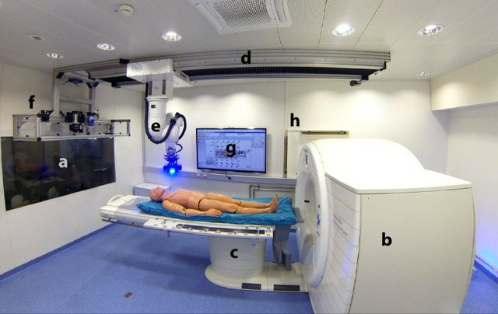
Figure 1: Virtobot room. A: X-Ray shielded working area; b: CT-gantry; c: CT table; d: external rail of the Virtobot; e: Virtobot mounted on external axis with lifting mechanism; f: tool stand with surface scanner, digital photo camera and biopsy module; g: monitor which is connected to the computer running the Virtobot software, h: safety light fence for device protection.
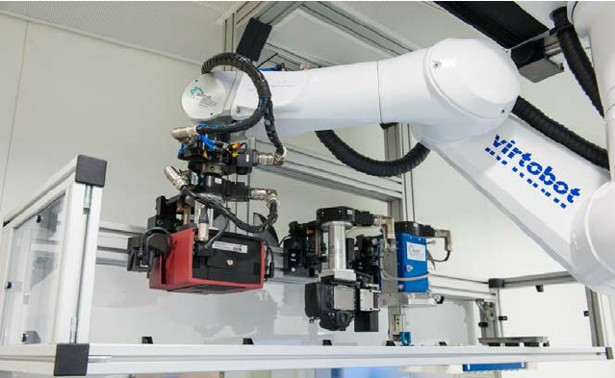
Figure 2: Tool stand during automatic tool change. Left to right: Surface scanner, digital photo camera for photogrammetry and biopsy module.

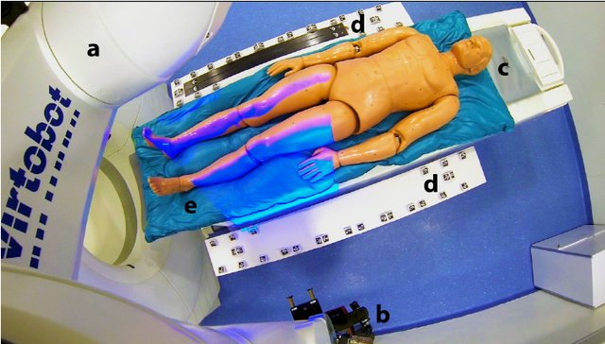
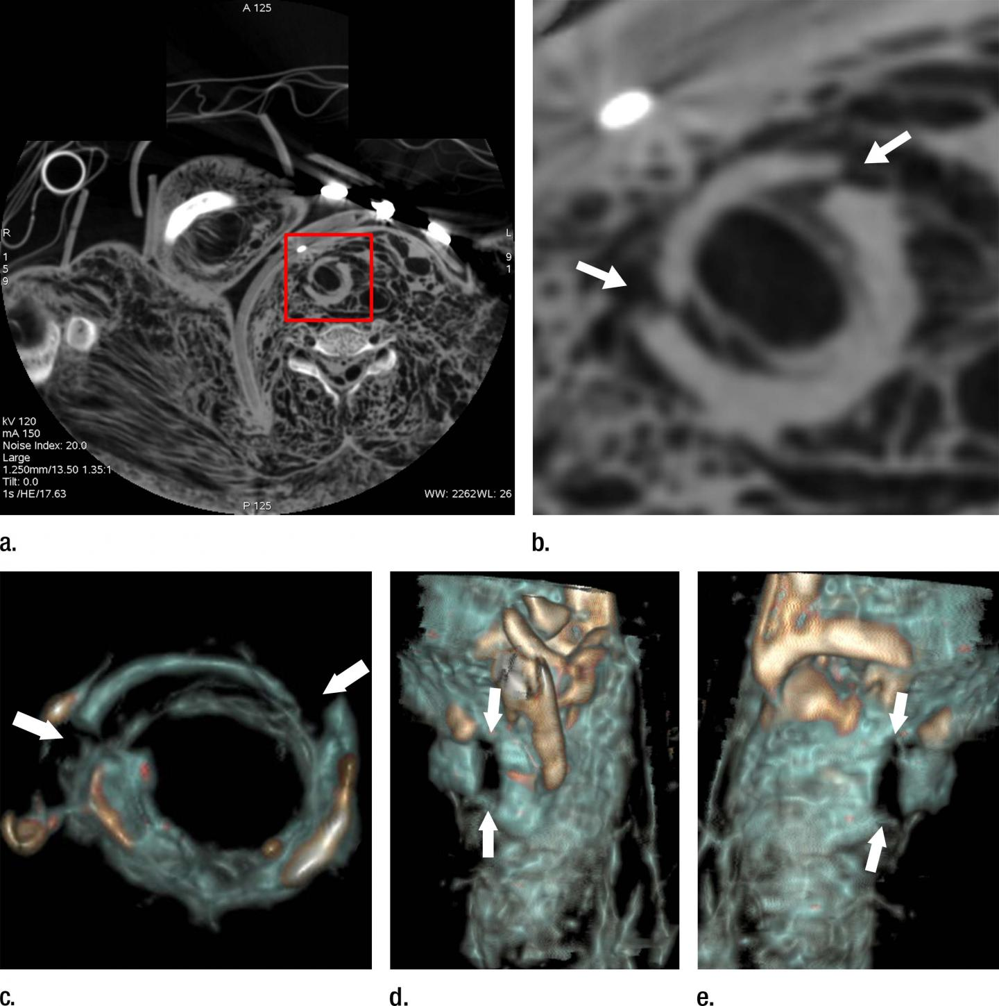
Figure 3: Setting for surface documentation. A: Virtobot; b: mounted optical 3D surface scanner; c: CT-table; d: attached side boards with integrated markers and scale bars; e: deceased placed on a vacuum mattress.
Figure 4: (a) Axial cervical post-mortem CT scan and (b) zoomed section of the cricoid cartilage (box in a) of a 27-year-old woman who died of strangulation. Three-dimensional volume rendered reconstructions from cranial (c), left lateral oblique (d), and right lateral oblique (e) views.

REFERENCES
- Jeelani S, Baliah J. Virtopsy – A moral boon in forensics. J Sci Dent 2013;3:54-8.
- Rajendran R, Sivapathasundharam B. Forensic Odontology. Shafer's Textbook of Oral Pathology. 7th ed. Elsevier India; 2012. p 879-907.
- Dirnhofer R, Jackowski C, Vock P, Potter K, Thali MJ. VIRTOPSY: Minimally invasive, imaging-guided virtual autopsy. Radiographics 2006;26:1305-33.
- Zacharias M, Zacharias E. Dictionary of legal medicine. 2nd ed. Curitiba: University Publishing House Champagnat; 1991
- Lundberg GD. Low-tech autopsies in the era of high-tech medicine: Continued value for quality assurance and patient safety. JAMA 1998;280:1273-4
- Ignatius P C. Forensic Medicine and Toxicology. 4th ed. Elsevier India; 2019. p 398-9.
- "Digital autopsy: Replacing scalpels with scanners". Gizmag.com. Retrieved 2019-10-11
- W. Brueschweiler and M. Braun and R. Dirnhofer and M.J. Thali (2003). "Analysis of patterned injuries and injury-causing instruments with forensic 3D/CAD supported photogrammetry (FPHG): an instruction manual for the documentation process". Forensic Science International. 132 (2): 130–138.
- Yen, Kathrin Thali, Michael J and Aghayev, Emin and Jackowski, Christian and Schweitzer, Wolf and Boesch, Chris and Vock, Peter and Dirnhofer, Richard and Sonnenschein, Martin (2012). "Strangulation signs: Initial correlation of MRI, MSCT, and forensic neck findings". Journal of Magnetic Resonance Imaging. 22 (4): 501–10.
- Flach PM, Ross SG, Ampanozi G, Ebert L, Germerott T, Hatch GM, Thali MJ, Patak MA (2005). ""Drug mules" as a radiological challenge: sensitivity and specificity in identifying internal cocaine in body packers, body pushers and body stuffers by computed tomography, plain radiography and Lodox". Eur J Radiol. 81 (4): 501–510.
- Bolliger SA, Thali MJ, Ross S, Buck U, Naether S, Vock P. Virtual autopsy using imaging: Bridging radiologic and forensic sciences. A review of the Virtopsy and similar projects. Eur Radiol 2008;18:273-82.
- Dirnhofer R, Jackowski C, Vock P, Potter K, Thali MJ. VIRTOPSY: Minimally invasive, imaging-guided virtual autopsy. Radiographics 2006;26:1305-33.
- Engelke K, Karolczak M, Lutz A, Seibert U, Schaller S, Kalender W. Micro-CT. Technology and application for assessing bone structure. Radiologe 1999;39:203-12
- Vogel H. Violence Ro¨ntgenbild: Findings in war, torture and crimes. Echomed. 1997; 41:13-42

- Ebert LC, Ptacek W, Naether S, Fürst M, Ross S, Buck U, Weber S, Thali M (2010). "Virtobot--a multi-functional robotic system for 3D surface scanning and automatic post mortem biopsy". Int J Med Robot. 6 (1): 18–27.
- Thali MJ, Yen K, Schweitzer W, Vock P, Boesch C, Ozdoba C, Schroth G, Ith M, Sonnenschein M, Doernhoefer T, Scheurer E, Plattner T, Dirnhofer R (2003). "Virtopsy, a new imaging horizon in forensic pathology: virtual autopsy by postmortem multislice computed tomography (MSCT) and magnetic resonance imaging (MRI)--a feasibility study". J Forensic Sci. 48 (2): 386–403. PMID 12665000.
- Ebert LC, Ptacek W, Naether S, Fürst M, Ross S, Buck U, Weber S, Thali M (2010). "Virtobot--a multi-functional robotic system for 3D surface scanning and automatic post mortem biopsy". Int J Med Robot. 6 (1): 18–27.
- Rajendran R, Sivapathasundharam B. Forensic Odontology. Shafer's Textbook of Oral Pathology. 7th ed. Elsevier India; 2012. p 879-907
- Thali MJ, Jackowski C, Oesterhelweg L, Ross SG, Dirnhofer R. VIRTOPSY – The swiss virtual autopsy approach. Leg Med (Tokyo) 2007;9:100–4.
- Guharaj P V, Gupta S K. Forensic Medicine and Toxicology. 3rd ed. Universities Press, India; 2019. p 147-8.
- Figure 1-4. Google images.

