CHILD ABDUCTION HOMICIDE BY ADOLESCENT PERPETRATORS – A RARE CASE REPORT.
Abstract:
Cases of child abduction and homicide though are rare but are often over whelming due to the public and media attention. While numerous studies on child abuse and neglect has been conducted throughout the country and worldwide, research on child abduction and homicide remains scant. We report such a case of a child who was abducted and eventually smothered to death by a couple of adolescent perpetrators. We also intend to better understand these types of child abduction homicides and to analyse strategies that will help to revamp the expertise into such criminal investigations.
Keywords: Child abduction, homicide, smothering, juvenile hate crimes, adolescents.
Conflict of interest: No conflict of interest associated with this work.
Contribution of authors: We declare that this work was done by the author(s) named in this article and all liabilities pertaining to claims relating to the content of this article will be borne by the authors”. In addition, a declaration of the role of each author mentioned in the manuscript should be provided. The author who conceived and designed the study as well as the person (s) who collected and analyzed the data must be specified.

Introduction:
Often children are found missing for a very short period of time and reappear on their own without any testament of foul play. Nevertheless, children do get missing against their own prerogative. A vast majority of them do undergo traumatic and stressful experiences, but are returned home alive without any serious physical anguish. A very small group of this abducted children are gravely victimized, either they are sexually molested or killed.
The list of children who are abducted and killed each year by someone who is a stranger is relatively small, compared to the number of missing children or to other types of child murder. Worldwide there is approximately one child abduction murder for every 10,000 reported missing children. ¹ In India, child abduction murder has a very low frequency of all murders committed. And even fewer children are killed by asphyxia, i.e. either by strangulation or smothering.
As the victims of child abduction murders are unique among murder victims, so too are their killers. About 1/10th of them are juvenile. Though cases of juvenile hate crime have become more prevalent over the past 25 years due to a drastic cultural and societal change which has been marked by a lack of a parent in the home providing guidance and/or poor peer selection.² Regardless, child abduction murders where the perpetrators are adolescents themselves are extremely few. And this makes our case very unique and unexampled.
Case History:
A 4 year old male child (Figure 1.) was found lying dead near a bamboo forest at around 7 AM in the morning. The local people of the village informed the police personals who identified the body of the subject. Incidentally, a missing report was lodged with the above police on the previous evening with the child being missing from 4 PM. The police arranged the body to be send for post mortem examination and after consultation with the autopsy surgeons started interrogating the local people of the area. On further investigation, two adolescent boys of 12 and 13 years respectively were nabbed by the police and they admitted to having killed the child. As per the confession of the boys the child was playing with a costly mobile phone in the late hours of evening near his own house. The two adolescent boys lured him to a secluded place and took his phone from him. When the child started crying and shouting, the boys smothered him to death and disposed of the body in a gunny bag and kept it in the bamboo forest in the dark of the night.
Autopsy findings:
Post mortem examination revealed the subject was of medium built and was moderately nourished. Rigor mortis was present all over the body. On external examination, evidence of bluish discoloration was found over the nail beds, tips of fingers and lower lip. The tip of the nose was found to be flattened. Post mortem gnawing was found over both right and left lobules of the ear with absence of both sided lower one third of the ear lobules. Post mortem gnawing over the left eye with partial evisceration with extrusion of intra ocular contents was noted. Linear abrasions were found on the right and left check each. Abrasions were found placed over the left side of the chin adjoining the left labial commissure. One sub cutaneous tissue deep bruise was found measuring 0.8” x 0.5” over the left side of the chin just below the left labial commissure. Bruises were also found diffused over the tip of the nose and inner aspects of the upper and lower lips with evidence of fracture of the nasal septum with extravasations of blood in and around. The abrasions were fresh and non-scabbed and the bruises were reddish in colour. On dissection, all the internal organs were seen to be congested. Multiple petechial haemorrhagic spots were found on serous membranes in the thorax, lungs (figure 2 ) and the pericardium particularly on the posterior aspect. Forensic science laboratory gave a negative report for poisoning. Opinion given as to the cause of death was due to effects of asphyxia resulting from smothering – ante mortem in nature and homicidal in manner which were further corroborated with the circumstantial evidences.
Discussion:
Child abduction homicides are rare incidents and coupled with their complexity and emotion laden nature and with the massive media attention, they are extremely difficult to investigate. Investigating officers should always earnestly deal with all reports of missing child. They need to understand that children are vulnerable in a psychological sense. They are immature and innocent and hence are easily deceived by the offenders. A quick assessment of the nature of the case is to be made with all details surrounding the age of the child, history and circumstances in which the child was missing and then a thorough search to find the body as early as possible. And then to come to a conclusion requires a complete and meticulous autopsy and correlating the critical findings at autopsy with the exhaustive crime scene analysis and police interrogations and evidences. The pivotal aspect in the investigation of child unexpectedly found dead coupled with suspicious findings, is to establish the accurate manner and cause of death and for a matter of fact all such cases should be considered a potential homicide until proven otherwise.
Smothering refers to a form of asphyxial death from mechanical occlusion of the mouth and the nose (external respiratory orifices), either by hands or by some foreign substances. ³ Homicidal smothering is possible when the victim is incapacitated from drink or drugs, debilitated, suffering from ill health, aged or a child as in our case.⁴ But homicidal smothering of a child by adolescent perpetrators are sporadic and unique.
Prevention of juvenile hate crime requires an understanding of the hate crime perpetrator. Adolescence is a time of exploration and experimentation of the surrounding world as the individual strives to develop a sense of self. Hence the goal should be to address the risk factors and to select the most appropriate form of treatment to minimize them. And as a society, it’s upon us to look for the risk factors and warning signs in these adolescents who instigate hate crimes or commits murders. Most often than not, they have a history of conflict with parents and lack of parental affection and support, poor school performance, conduct or aggression problems, impulse-control problems, exposure to television violence or feeling of betrayal and underlying hurt. ^{5,6,7} It is recommended that increasing self-esteem, establishing a close bond with the primary caregiver, and enhancing an individual’s social and emotional skills along with psychological counselling will go a long way in reducing these rare events of adolescent homicides.⁸
Conclusion:
Cases of child abduction homicide are a rare entity and more so when the perpetrators are themselves adolescents. Researches on child abduction and homicide are scant and when done suffer from geographical limitations. Further well designed and large scales studies needs to be carried out throughout the country to have a better understanding and have a statistical correlation of the socio-demographic characters and risk factors of children who are abducted and then killed. It would also provide an insight into the psychopathology of the offenders focusing on their psychiatric states and family backgrounds and help in formulating a plan for investigation of child abduction homicides and their prevention by rapid action and proper investigation.
References:
1. Hanfland KA, Keppel RD, Weis JG. Case Management for missing children homicide investigation. Seattle: Washington State Office of the Attorney General; 1997.
2. Steinberg A, Brooks J, Remtulla T. Youth hate crimes: identification, prevention, and intervention. Am J Psychiatry. 2003; 160(5):979–89.
3. Reddy KSN, Murty OP. The essentials of forensic medicine and toxicology. 33rd Ed. Jaypee; 2014. p. 360-61.
4. Knight B, Saukko P. Knight’s forensic pathology. 3rd ed. London: Edward Arnold; 2004.p. 359-60
5. Beck AT. Prisoners of hate: the cognitive basis of anger, hostility, and violence. New York: HarperCollins; 1999.
6. Cheng TL, Wright JL, Fields CB, et al. Violent injuries among adolescents: declining morbidity and mortality in an urban population. Ann Emerg Med. 2001; 37(3):292–300.
7. Shumaker DM, Prinz RJ. Children who murder: a review. Clin Child Fam Psychol Rev. 2000; 3(2):97–115.
8. Douglas K, Bell CC. Youth homicide prevention. Psychiatr Clin North Am. 2011; 34(1):205–16.

Figures:
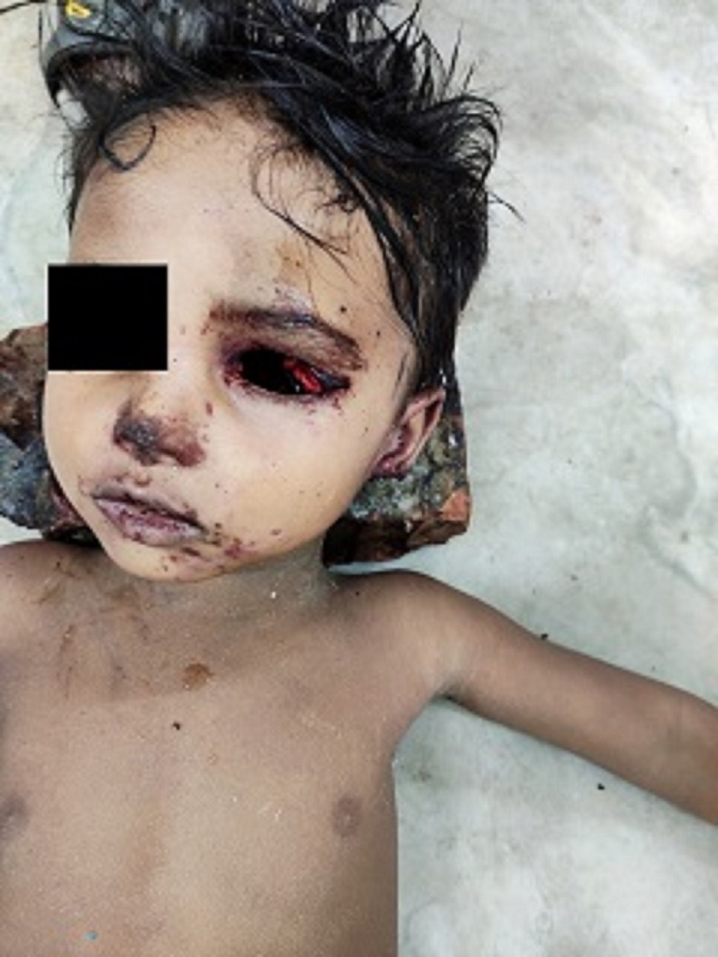
Figure 1: The deceased child.

Figure 2: Petechiae on Lungs.

