PREVENTION OF SURGICAL SITE INFECTION IN CLEAN-CONTAMINATED AND CONTAMINATED WOUNDS BY INFILTRATION OF AN ANTIBIOTIC INTO THE SUBCUTANEOUS SPACE AT THE TIME OF WOUND CLOSURE.
Partha Pratim Das¹, Ranjit Kumar Deka² , Mitrajit Sharma^{3*}, Jaydeep Malakar^{4,} Devajit Choudhury⁵
1,2,3,4,5,6: Department of General Surgery, Gauhati Medical College & Hospital.
* Corresponding author: Department of General Surgery, Gauhati Medical College & Hospital.
Email id: mitrajitsurgery@gmail.com

Background: Surgical Site Infection (SSI) is the most common nosocomial infections and a major cause of postoperative morbidity and resource utilization. Infection is generally used to mean the invasion and multiplication of pathogenic micro-organisms in a bodily part or tissue, which may produce subsequent tissue injury and progress to overt disease through a variety of cellular or toxic mechanisms.
Methods: This study was performed to assess the potential for reduction of wound infection in patients undergong midline exploratory laparotomy by infiltration of amikacin into the wound after closure of rectus sheath. Followup was for a minimum of 4 weeks.
Results: Of 50 patients of the group receiving amikacin, excluding 4 who died of other cause except SSI 15.21% developed SSIs, whereas of 50 patients not receiving amikacin excluding 7 cases that expired, 51.16% developed SSIs.
Conclusion: Using amikacin to infiltrate the wound along with other standard preventive measures can drastically decrease the incidence of SSIs in patients undergoing exploratory laparotomy in the emergency setup of GMCH

INTRODUCTION
Surgical Site infections (SSIs) pose a rather significant challenge to the surgeon as well as the surgical patient, whose primary morbidity, now already taken care of, now has an added morbidity preventing his return to normalcy. Several discourses have highlighted a staggering increase of SSIs of up to 2-5 % in patients with clean extra abdominal procedures and up to 20 % in patients with contaminated intra abdominal procedures¹. They also highlight a strong association between SSIs and increased hospital stay and overall increment in hospital costs posing a burden to the healthcare system. SSIs doubles the mortality of patients and make them 60% more prone to have an ICU stay with readmission rates up to 5 times more than patients without SSIs². This study was aimed at determining whether or not infiltration of the incisional wound with Amikacin in patients undergoing emergency midline laparotomy decreases the incidence of SSIs in the Department of General Surgery, GMCH.

AIM OF THE STUDY
- To determine the efficacy, appropriateness and convenience of prophylactic preoperative antibiotic dose of Pipercillin + Tazobactum 4.5g and infiltration of the wound with Inj. Amikacin 1000mg diluted to 20 ml after rectus sheath closure in decreasing the incidence of SSIs in the patients undergoing midline exploratory laparotomy in emergency setup in GMCH.

PATIENTS AND METHODS
A total of 100 patients operated upon at GMCH from March 2018 to September 2018 using the same technique were analyzed. Only those patients who presented to Casualty, GMCH with Hollow Viscus Perforation, Acute or Subacute Intestinal Obstruction, Appendicular Perforations within 72 hours of the presenting symptoms were only included. Patients who presented with a history of trauma were excluded along with patients with any known co morbid conditions. The mean age was 39 years. Each patient had his wound infiltrated with 1000mg of Amikacin, diluted to a 20 mL concentration, after rectus sheath closure.
All patients received identical measures for prevention of wound infection which includes:
- All patients received a pre operative dose of antibiotic (Inj. Piperacillin + Tazobactam 4.5 grams), 30 minutes before skin incision.
- Shaving of the abdomen from nipple to mid thigh was done 30 minutes before the surgery.
- Skin preparation was done with Cetrimide and Chlorhexidine digluconate (Savlon) + 10 % Povidone Iodine (Betadine) and allowed to dry before skin incision.
- In all cases, the abdomen was accessed with a midline laparotomy incision with abdominal drains places as and when required.
- Absorbable running sutures (Polydiaxone) was used for fascial and muscle closure at a gap of 1cm.
- Fat was approximated with Polygalctin 910 to obliterate any dead spaces.
- Skin closure was done wither with Nylon or skin staplers.
- Post operatively patients were treated with Piperacillin + Tazobactam and Metronidazole.

The first post operative dressing was done on the 4th Post Operative day and was checked for any evidence of collection or infection. If any evidence of infection was found, as dictated by pus or redness of the skin margins, along with rise in temperature or an increase in the Total Leukocyte Count and other systemic signs, dressing was done twice a day with Povidone Iodine and Mupirocin Ointment. Secondary Suturing was given if wound gaping was substantial. Patients who expired due to reasons other than SSIs were excluded.

RESULTS
The cases where we infiltrate inj. Amikacin 1000mg diluted to 20ml are hereby denoted as Group A. The cases that are treated as usual without any local infiltration of antibiotic are hereby denoted as Group B.
Table 1: Gender Specific Age Distribution
Age Group (Years) | MALE | FEMALE | TOTAL
≤20 | 14 | 2 | 16%
21-40 | 60 | 4 | 64%
41-60 | 18 | 2 | 20%
TOTAL | 92 | 8 | 100 (100%)

Table 2: Diagnosis Specific Gender Distribution
 | GROUP A |  | GROUP B
DIAGNOSIS | MALE | FEMALE | MALE | FEMALE
Antro – Pyloric Perforation | 13 | 1 | 16 | 0
GB Perforation | 0 | 2 | 0 | 0
Caecal Perforation | 0 | 0 | 1 | 0
Ileal Perforation | 4 | 0 | 5 | 0
Psoas Abscess | 2 | 0 | 0 | 1
Appendicular Perforation. | 6 | 0 | 6 | 1
Acute Intestinal Obstruction. | 19 | 3 | 20 | 0
TOTAL | 44 | 6 | 48 | 2

Organisms Isolated.
ORGANISM | GROUP A | INCIDENCE | GROUP B | INCIDENCE
E coli | 5 | 71.42% | 10 | 45.45%
S aureus | 1 | 14.28% | 8 | 36.36%
K pneumoniae | 1 | 14.28% | 2 | 9.09%
Pseudomonas | 0 | 0 | 2 | 9.09%

Table 5: Antibiotic Sensitivity results of the infected cases.
ANTIBIOTIC | SENSITIVE | RESISTANT
Amikacin | 11 | 18
Penicillin | 7 | 22
Ciprofloxacin | 4 | 25
Azithromycin | 1 | 28
Cephalosporins | 10 | 19
Ofloxacin | 1 | 28
Vancomycin | 29 | 0
Linezolid | 22 | 7
Piperacillin + Tazobactam | 28 | 1
Imipenem | 29 | 0

Table 6: Final Results of incidence of SSIs in both the groups
Group | TOTAL CASES | EFFECTIVE CASES AFTER EXCLUSION | POST OPERATIVE SSI CASES | PERCENTAGE OF INFECTED CASE
GROUP A | 50 | 46 | 7 | 15.21
GROUP B | 50 | 43 | 22 | 51.16
P value= 0.0175

DISCUSSION
Following laparotomy, a surgical site infection is one of the most common complications, with infection rates ranging from 10-20% when a combination of good surgical techniques and perioperative antibiotics are used in tandem. This analysis was aimed to determine the potential influence of antibiotics which were instilled into the wound after closure and the subsequent development of wound infections. Amikacin was chosen as the injectable antibiotic of choice in this study considering previous studies which included other antibiotics of the Aminoglycoside group. Moreover, Amikacin is readily available in hospital supply, hence causing no financial burden to the patients and it can effortlessly reconstituted, and is easily delivered into the wound with minimal dilution.
In GROUP A, 5 were found to have SSI on the 10th day and 2 on the 14th day. On the other hand, we found 11 cases of group B to be infected on day 4th, 8 on 10th day 3 on 14th day and 6 were found to be infected while they came for follow up after 4 weeks.
Of all the infected cases we have 17.18% cases to be in the age group between 21 to 40 years, and 82.82% above 21 years.
The most common pathologies in our study, presenting with acute abdomen were, Antro Pyloric Perforation (28% in Group A and 32% in Group B) and Acute Intestinal Obstruction (44% in Group A and 40 % in Group B).
The most common organism isolated amongst both the groups was E coli. In Group A the incidence of infection with E coli was 71.42% and in Group B, 45.45%. S aureus was found in 14.28% of patients in Group A and in 36.36% of patients in Group B.
The sensitivity of E coli and S aureus to Imipenem was 100%, Vancomycin was 100% and Piperacillin + Tazobactam was 96.5%. The organisms were 96.5% resistant to Azithromycin and Ofloxacin.
This study counters the findings of the study done by Wayi et al who concluded that the most common organism isolated from their study was S aureus³.
Morbidity in this study was mainly due to surgical wound infection and wound dehisence, which together accounted for 32.58 % of which Group A had a morbidity of 15.21% and Group B 51.26% (p value: 0.0175).
There was no death associated with surgical wound infection. In a study done by DiPiro et al on 12,384 patients found higher rates of post operative wound infection, 22% following colorectal procedures and 25% following upper gastrointestinal procedures⁴. Mc Ardle et al did colorectal surgery on 169 patients with an overall wound infection rate of 17%⁵.
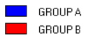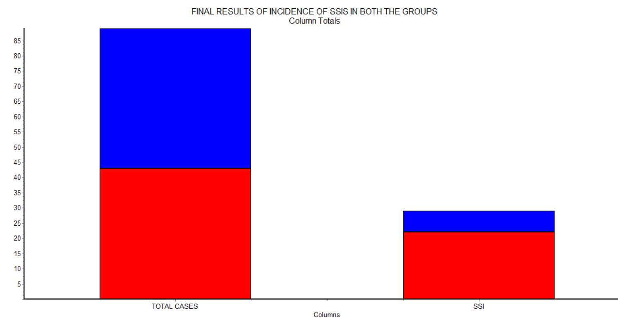 The highlight of this study is that strict adherence to principles for prevention of wound infection along with infiltration of the wound with amikacin into the subcutaneous space will result in ablation of serious wound infections, with reference to clean, contaminated abdominal incisions.
Critical components include:
- Reduction in contamination from skin organisms.
- Use of prophylactic systemic and local antibiotics.
- Meticulous wound care including, minimizing tissue damage and the use of sutures hindering microbial growth.
- Reduction in load of enteric contaminants and support of oxygen delivery to the wound also play pivotal roles.

CONCLUSION
Our study concludes that the incidence of Surgical Site Infections in clean contaminated and contaminated wounds decreases drastically with the introduction of Amikacin being infiltrated into the wound. Although both Gram Negative and Gram Postitive organisms were isolated from the wound, the incidence of E coli isolates were the highest, followed by S aureus. The isolates were all sensitive to Imipenem and Vancomycin and were resistant to Ofloxacin and Azithromycin. The age group of patients above 40 years was most susceptible to SSIs.
From the present study we can safely infer that a good surgical technique and judicious use of pre operative antibiotic along with wound infiltration with Amikacin in clean contaminated and contaminated abdominal operations have shown to decrease the incidence of SSIs in the emergency setup of General Surgery in GMCH. In this new era, in spite of modern standards of preoperative preparations , prophylactic drugs and excellent anesthetic and operative techniques, post-operative surgical site infection still remains a major problem, indeed, there is a long way to go till we can write the last word in absolute control and elimination of post-operative wound infection.

CONFLICTS OF INTEREST
The authors state that they have no conflicts of interest.
CONSENT:
Written informed consent was obtained from the patient for publication of this case report and any accompanying images.

FUNDING:
No funding to disclose.

REFERENCES
- Auerbach AD. . Prevention of Surgical Site Infections. Making Health Care Safer: A Critical Analysis of Patient Safety Practices.:221.
- Kirkland KB, Briggs JP, Trivette SL, Wilkinson WE, Sexton DJ. The impact of surgical-site infections in the 1990s: attributable mortality, excess length of hospitalization, and extra costs. Infection Control & Hospital Epidemiology. 1999 Nov;20(11):725-30.
- Richards DM, Heel RC, Brogden RN, Speight TM, Avery GS. Ceftriaxone. Drugs. 1984 Jun 1;27(6):469-527.
- Dipiro JT. Short-term prophylaxis in clean-contaminated surgery. Journal of chemotherapy. 1999 Dec 1;11(6):551-5.
- McArdle CS, Morran CG, Pettit L, Gemmell CG, Sleigh JD, Tillotson GS. Value of oral antibiotic prophylaxis in colorectal surgery. British journal of surgery. 1995 Aug;82(8):1046-8.

