A case report on
ANGIOMYOFIBROBLASTOMA-LIKE TUMOR OF THE SCROTUM: A CASE REPORT AND REVIEW OF LITERATURE

Mitrajit Sharma¹, Ranjit Kumar Deka², Partha Pratim Das^{3,} Jaydeep Malakar ⁴

Address of correspondence
1: SR, Department of General Surgery
Gauhati Medical College and Hospital
Email: mitrajitsurgery@gmail.com
Ph number: 9706582392
2,3,4: Department of General Surgery
Gauhati Medical College and Hospital
Email: ranjitkdeka@gmail.com
Email: ppdasdr@gmail.com
Email: jmala4@gmail.com

ABSTRACT
Within the spectrum of extratesticular mesenchymal tumour, in the scrotum and perineum, lies cellular angiomyofibroma or cellular angiofibroma, also known as Angiomyofibroblastoma like tumour, a rare lesion which until a decade ago, was thought to be exclusively occurring in the vulva, perineum and pelvis of women. Angiomyofibroblastoma-like (AMF-like) tumor commonly occurs during the fifth to eighth decades of life and mainly involves the inguinoscrotal region. It is derived from perivascular stem cells and has capacity of lipoid and myofibroblastic differentiation. We report a case of this tumour in a 62 year old male who presented to us as an out patient with a firm scrotal mass which was excised. Recommended treatment is surgical excision with long term follow-up as local recurrence may occur years after the lesion has been resected.

KEYWORDS: Extratesticular Mesenchymal Tumour; Angiomyofibroblastoma-Like (AMF-Like) Tumor; Myofibroblastic Differentiation; Perivascular Stem Cells; Surgical Excision.

INTRODUCTION
There is a broad variety of benign and malignant solid neoplasms arising in the perineum of both genders, such as neurofibrioma, schwannoma, haemangiopericytoma, leiomyoma and angiomyxoid neoplasms. In 1992, Fletcher et al, separated angiomyofibroblastoma (AMFB) as a benign entity distinct from angiomyxoma.¹ In 1997, Nucci et al described angiofibroma to occur exclusively in the female vulva.² Laskin et al, later described 11 examples of this pathology occurring in the male genital tract.³
The angiofibroblastoma like tumour is a rare tumour with only 34 observations described in literature. It is a benign neoplasm of the scrotal and inguinal area and is rich in fibroblasts. A safe initial diagnosis is difficult because of its location, nature, and correlation with other structures of the area. It can easily be confused with a hernia. Moreover, it is crucial to differentiate it from aggressive angiomyxomas (AAM) and other spindle-cell neoplasms, since they exhibit malignant behavior with recurrences and metastases. The tumour is generally well circumscribed, whose size may vary from 2.5 cm to 14 cm with an average of 6.7cm. Its tag is based on the similarities with cellular angiofibroma of female genital tract. We hereby report an exceptional case of the tumor in a 62 year male and discuss the available literature on the pathology.

CASE REPORT
A 62 year old male presented to us as an out patient with a firm, palpable scrotal mass. The patient had a medical history significant for left ventricular hypertrophy, type 2 diabetes mellitus on insulin and essential hypertension. He had previously undergone a craniotomy for extradural hematoma, 5 years ago. The patient complained of mild itching over the scrotum for 1 ½ years with gradual increase in size of the scrotum. It was painless and he did not complain of any difficulty in micturation. As the patient belonged from a filariasis belt, it was suspected to be scrotal filariasis although, preliminary investigations for the patient came out to be negative. Ultrasonography was also not specific about any diagnosis. At this time as no conclusive decision was made about the nature of the lesion and it was unclear whether the solid enhancing mass was due to filariasis or some other pathology, it was decided to be operated upon.
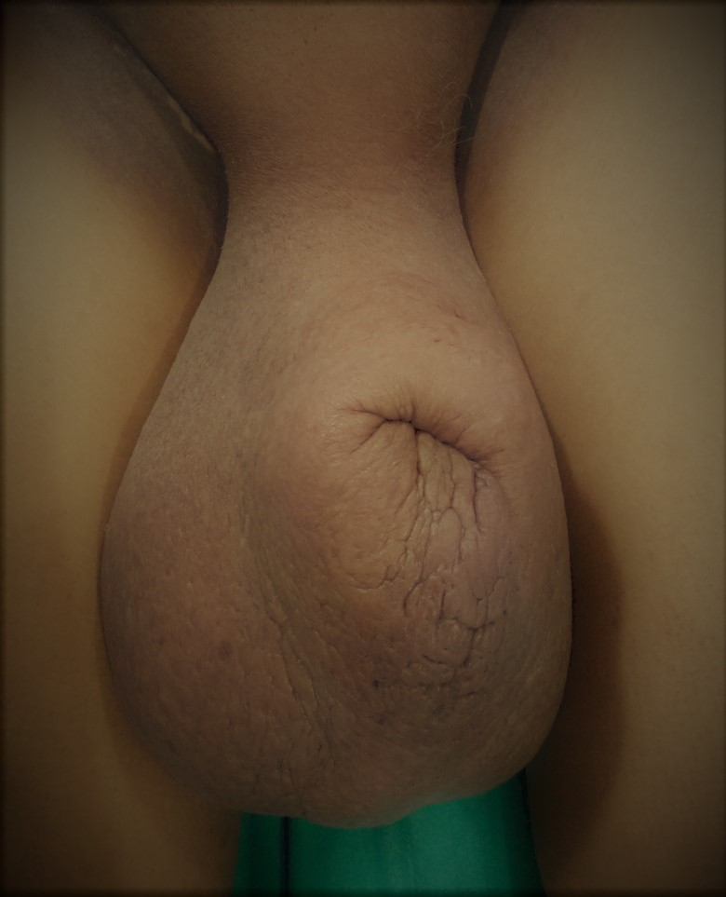
Figure 1: Clinical picture of the scrotum at presentation
A debulking surgery was planned and executed, sparing the testes. A scrotal mass (measuring 20x18x10 cm³) was sent for histopathological examination (HPE).
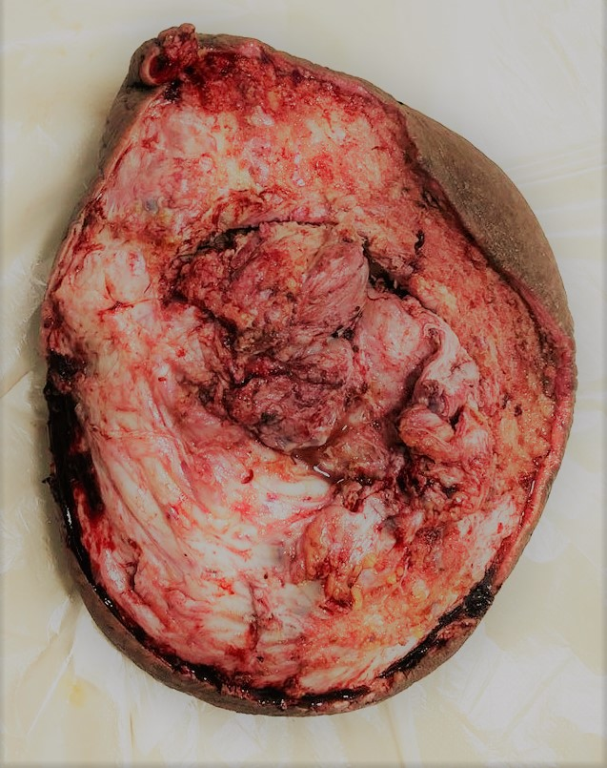
Figure 2: Well limited tumour mass after excision.
The HPE report showed a tumour composed of hypocellular matrix, showing haphazardly arranged oval to elongated or stellate cells in the fibrohyalinized stroma. The stromal blood vessels are dilated and there is mild perivascular lymphocytic infiltration. There was no nuclear atypia or increased or atypical mitosis. The patient is on follow-up with no evidence of local recurrence.
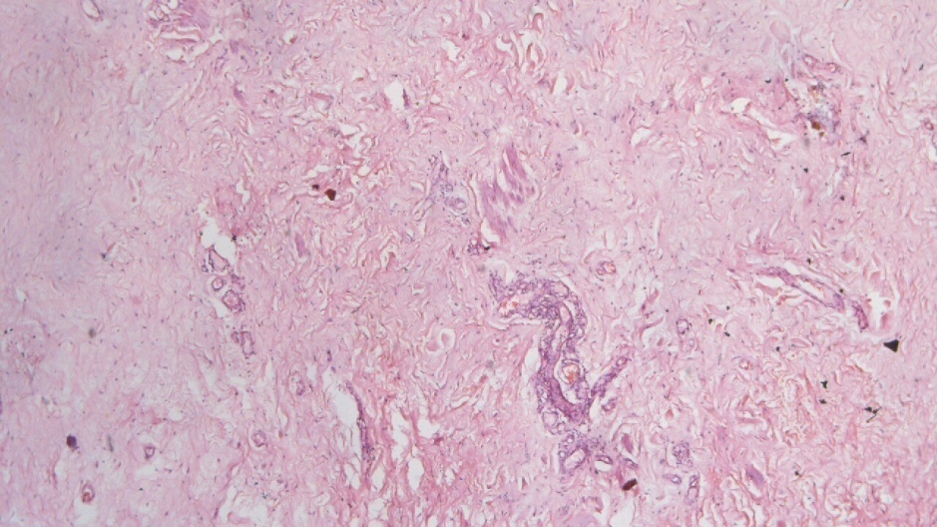
Figure 3: Proliferation of small caliber blood vessels surrounded by clusters of epitheloid cells and associated spindle cell proliferation.

DISCUSSION
We believe that it is one of the few reported cases of angiomyofibroblastoma like tumour of the scrotum. These are mesenchymal, extratesticular tumours having two integral components, the blood vessels and stromal cells; the vascular component is always associated with stromal cells. Fibroblastic differentiation of stromal cells is shown by the well developed golgi apparatus and the rough endoplasmic reticulum in a collagenous background.
Angiomyofibroblastoma like tumours are rare, distinctive, slow growing, potentially recurrent mesenchymal neoplasms of the female vulva, perineum and pelvis and male scrotum of inguinal canal. The male neoplasms are superficial, well-marginated masses that are only occasionally associated with pain. Female AMFs are typically composed principally of spindled rather than epithelioid-appearing mesenchymal cells, which proliferate haphazardly or in loose fascicles between vessels without exhibiting a tendency for perivascular growth or forming thin, cordlike configurations or nested aggregates.⁴ A condensed collagenous stroma containing a higher focus of acid mucin is seen in majority of male tumors. In females in contrast to males we can see the edematous, loosely textured collagenous stroma. Furthermore, elongated, thick-walled vessels and irregularly contoured hemangiopericytomatous vessels commonly accompanied rounded vessels in male tumors. Ectatic or hemangiopericytomatous vessels were only a focal finding in studies of female AMF. Perivascular fibrosis is a common feature, and small amounts of intralesional fat are also a frequent finding in both neoplasms.⁵
The diagnostic imaging workup includes a CT scan without specific findings for this entity, while on MRI scans it may be hyperintense on the T2-weighted phase, depending on its origin and tissue composition (fat tissue, collagen, and spindle cells), or may show intense enhancement due to its rich vascularity.⁶
It may be difficult to distinguish it from other tumors of the scrotum on the basis of radiological data only. The differential diagnosis includes tumors of Schwann cells, perineuromas, spindle cell lipomas, aggressive angiomyxomas (AAMs), solitary fibrous tumors (SFTs), spindle-cell liposarcomas, and leiomyomas. Based on imaging, the differential diagnosis can be narrowed down to AAM, AMF, and SFT as follows: (1) AAM has a highly infiltrative pattern of growth, lower cellularity, and lower vascular growth and displays high signal intensity on T2-weighted MRI scans; (2) AMF exhibits high signal intensity on T2-weighted MRI scans but may appear slightly inhomogeneous and (3) SFT exhibits low signal intensity to isointensity for muscle tissue on T1-weighted MRI scans, intermediate to high signal intensity on T2-weighted MRI scans, and intense enhancement on gadolinium injection scans. ^{7,8}

Concise efforts should be made to differentiate these tumours from AAM and other spindle neoplasms which have the potential to metastasize. Surgical resection of the tumor is the therapeutic method of choice. Unfortunately, follow-up clinical data for cellular AF is limited, although recurrences have been reported. A complementary resection must follow initial local excision if the tumor relapses.

CONCLUSION

Angiomyofibroblastoma like tumour is a benign neoplasm of the scrotal and inguinal area. It is of vascular origin and is composed chiefly of fibroblasts. A safe initial diagnosis is difficult because of its location, nature, and correlation with other structures of the area. It can easily be confused with a hernia, especially when the lesion slides toward the scrotum. Moreover, it is crucial to differentiate it from AAM and other spindle-cell neoplasm.

CONSENT:
Written informed consent was obtained from the patient for publication of this case report and any accompanying images.

FUNDING:
No funding to disclose.

ETHICAL APPROVAL:
Not required.

REFERENCES

- Fletcher CD, Tsang WY, Fisher C, Lee KC, Chan JK: Angiomyofibroblastoma of the vulva: a benign neoplasm distinct from aggressive angiomyxoma. Am J Surg Pathol. 1992, 16: 373-382. 10.1097/00000478-199204000-00006.View ArticlePubMedGoogle Scholar
- Nucci MR, Granter SR, Fletcher CD: Cellular angiofibroma: a benign neoplasm distinct from angiomyofibroblastoma and spindle cell lipoma. Am J Surg Pathol. 1997, 21: 636-644. 10.1097/00000478-199706000-00002.View ArticlePubMedGoogle Scholar
- Laskin WB, Fetsch JF, Mostofi FK: Angiomyofibroblastomalike tumor of the male genital tract: analysis of 11 cases with comparison to female angiomyofibroblastoma and spindle cell lipoma. Am J Surg Pathol. 1998, 22: 6-16. 10.1097/00000478-199801000-00002.View ArticlePubMedGoogle Scholar
- Miyajima K, Hasegawa S, Oda Y, Toyoshima S, Tsuneyoshi M, Motooka M, Matsuura Y, Ishioka H, Ono M: Angiomyofibroblastoma-like tumor (cellular angiofibroma) in the male inguinal region. Radiat Med 2007, 25:173-7. [ PubMed ]
- Lee SH, Yang JW, Do JM, Seo DH, Jung JH, Chung KH, Lee JS, Hyun JS : Angiomyofibroblastoma-like tumor of the scrotum. Korean J Urol 2010, 51: 365-7. [ PubMed ]
- Koo PJ, Goykhman I, Lembert L, Nunes LW: MRI features of cellular angiomyofibroma with pathologic correlation. J Magn Reson Imaging. 2009, 29: 1195-1198. 10.1002/jmri.21747.View ArticlePubMedGoogle Scholar

- (Suster S, Nascimento AG, Miettinen M, Sickel JZ, Moran CA: Solitary fibrous tumors of soft tissue: a clinicopathologic and immunohistochemical study of 12 cases. Am J Surg Pathol. 1995, 19: 1257-1266. 10.1097/00000478-199511000-00005.View ArticlePubMedGoogle Scholar

- Dei Tos AP, Mentzel T, Newman PL, Fletcher CD: Spindle cell liposarcoma, a hitherto unrecognized variant of liposarcoma: analysis of six cases. Am J Surg Pathol. 1994, 18: 913-921. 10.1097/00000478-199409000-00006.View ArticlePubMedGoogle Scholar

