TOPICAL GRANULATED SUGAR FOR PROLAPSED UNCOMPLICATED STOMA.
Running title: Granulated sugar as a dessicant to reduce prolapsed stoma
Mitrajit Sharma¹, Devajit Choudhury²
1,2: Department of Surgery, Gauhati Medical College & Hospital
1: Dr Mitrajit Sharma, Senior Resident,
Department of Surgery, Gauhati Medical College & Hospital
email: mitrajitsurgery@gmail.com
Ph No: 09706582392
2: Dr Devajit Choudhury, Assistant Professor,
Department of Surgery, Gauhati Medical College & Hospital
Ph number: 09864093053

ABSTRACT
Prolapse is a well-described complication after ileostomy or colostomy, and is typically asymptomatic and easily reducible. Manual reduction is generally successful, but in a number of cases with edematous prolapsed bowel it may be unsuccessful. Unsuccessful reduction in elderly patients and in hemodynamically unstable or patients with co morbidities may advocate the need for emergent laparotomy which carries high risk of morbidity. As such we advocate the use of osmotic agent, specially granulated sugar as an alternative method for conservative management of prolapsed stoma in targeted population.
Keywords: Ileostomy; Colostomy; Complications; Bowel; Laparotomy; Osmotic agent; Dessicant.

INTRODUCTION
A prolapsed stoma is the telescoping out of the inner lining of the bowel from within the stoma. It is one of the most distressing complications of stoma creation. The long-term complication rate with stomas is variable. The incidence of stomal prolapse has been reported in up to 22% in adults, and 38% in children [1, 2]. Prolonged exposure of the prolapsed stoma can lead to mucosal ulcerations, bleeding and incarceration. Manual reduction of the stoma must be tried in any case, but due to edema and incarceration in many occasions it is unsuccessful owing to difficulty in manipulation. An irreducible prolapse might necessitate surgical correction which is not without risks and associated morbidities especially in the elderly population and people with co morbidities. A successful reduction can eliminate the need for emergency surgery and can allow planning for elective surgery at a later stage. Here we suggest a simple method which can be applied to alleviate the need for emergency surgery.

CASE REPORT
A 55 year old gentleman presented to emergency with a prolapsed ileostomy. He had undergone ileostomy for multiple perforations following typhoid two weeks back. He underwent resection and anastomosis of the perforated segment followed by a proximal ileostomy. He was a known case of uncontrolled diabetes mellitus and dyselectrolytemia. Although the management of prolapsed ileostomy is emergency surgery but his co morbidities hampered the process.
Gentle manual reduction of the prolapse was attempted but failed because of gross oedema (Figure 1). 500 gram of granulated table sugar was then applied to the stoma for 15 min and the gentle reduction was attempted again successfully (Figure 2). The stoma was successfully reduced; the patient was kept in hospital for further observation of any potential complications. The patient was safely discharged after management of dyselectrolytemia and diabetes mellitus. At the time of writing, 6 weeks has passed following the successful reduction, he has not had a recurrence.
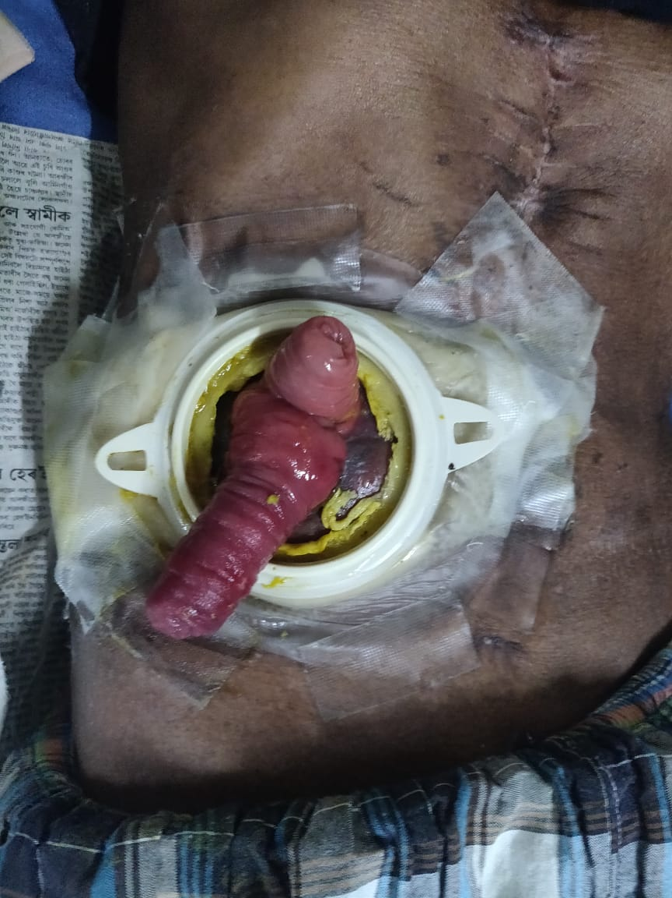
Figure 1: Prolapsed ileostomy

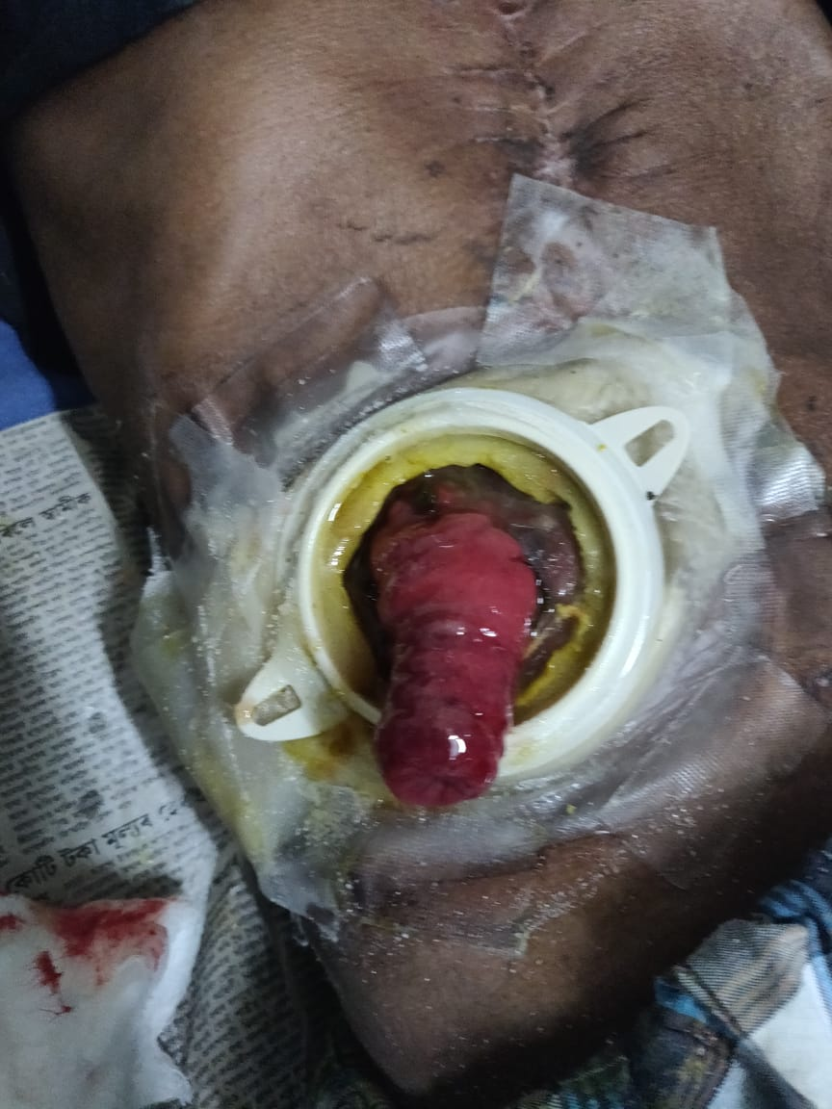
Figure 2: Reduction in prolapsed ileostomy seen following application of sugar

DISCUSSION:
Fascial fixation at initial operation has been proposed by some surgeons; whereas some surgeons prefer to create a small fascial defect to prevent prolapse of stoma. [3] Once stoma prolapsed occurs in temporary ileostomies, conservative approach is generally successful and the case can be taken up for elective operation at a later date for re-establishment of intestinal continuity. To treat prolapse of permanent stomas, surgical options include simple fixation with or without resection of redundant bowel, and stoma relocation.
In our case we tried to reduce the prolapsed stoma using granulated sugar. There have been reports of the use of icing sugar for the same purpose. [4] Icing sugar has smaller granule size and as such has a high surface area to volume ratio. One obvious disadvantage of the method is that it is not readily available, whereas granulated sugar is readily available in cafeterias in hospital and readily available at a low cost. Manual reduction of an incarcerated stoma can be assisted with conscious sedation and desiccants such as witch hazel and sugar. These techniques were initially described by veterinarians in conditions such as bovine uterine prolapse. In the few reports found in the surgical literature, after failure of manual reduction using continuous pressure, reduction was quickly and easily accomplished using sugar as a mean to reduce tissue edema. [5] Few case reports are available in pediatric age group also on the using of granulated sugar. [6]
The technique we followed uses simple granulated sugar which is applied generously on top of the prolapsed bowel. The sugar acts as a desiccant and a topical osmotic agent, draws water out of the swollen bowel, and thus enables its easy or spontaneous reduction. The benefits of successful reduction can be significant, especially in poor surgical candidates who is spared from an emergent laparotomy.

CONCLUSION
We conclude from the report that even though the procedure is not very technical and skill oriented, nevertheless the use of sugar as the osmotic agent in the patient has proved to be effective, since it avoided performing an emergency laparotomy and the use of sedation and anesthesia. Moreover, the technique is simple and cost effective. The procedure can be undertaken easily in the peripheries and can be administered by nurses to reduce the edema before referring the case to the tertiary health care facility. Considering the exposed, in patients that meet the criteria with the absence of necrosis in the stoma and unsuccessfulness on attempts of manual reduction this procedure should be considered as an alternative before open surgery.

BIBLIOGRAPHY

- Duchesne JC, Wang YZ, Weintraub SL, Boyle M, Hunt JP (2002) Stoma complications: a multivariate analysis. Am Surg 68:961–966
- Millar AJ, Lakhoo K, Rode H, Ferreira MW, Brown RA, Cywes S (1993) Bowel stomas in infants and children. A 5-year audit of 203 patients. S Afr Surg 37:110–113
- Shapiro R, Chin EH, Steinhagen RM. Reduction of an incarcerated, prolapsed ileostomy with the assistance of sugar as a desiccant. Techniques in coloproctology. 2010 Sep 1;14(3):269-71.
- Theofanis G, Saedon M, Kho SH, Mulita F, Germanos S, Leung E. Avoiding emergency stoma surgery with the use of sugar. British Journal of Nursing. 2017 Dec 14;26(22):S24-6.
- Mohammed O, West M, Chandrasekar R. Granulated sugar to reduce an incarcerated prolapsed defunctioning ileostomy. BMJ Case Reports. 2013;2013.
- Júnior JA, Júnior JV, Forte HB, de Vasconcelos LM, Bezerra MM. Topical osmotic therapy for a prolapsed incarcerated ostomy. Journal of Pediatric Surgery Case Reports. 2020 Apr 15:101454.

