Forensic Case Study of Firearm Fatalities Substantiated by GSR Analysis through SEM-EDXA.
Abstract
Firearms are frequently involved in crimes like murder, robberies, happy marriage shootings, police encounters, and terrorist activities. With the advancement of technology it is now becoming easier to evaluate ballistic evidences which provide a greater incite in the investigation. The gunshot residues are present in almost all the cases and their proper collection and evaluation helps in identifying the shooter, in determination of range, understanding the wound appearance and sometimes in ascertaining the common source of ammunition which in turn helps to identify the source of ammunition.
Keywords: SEM-EDXA, Wounding power, Section 324, Forensic Ballistic.

Introduction
A firearm can be defined as an instrument that is used to fire a missile through initiation of combustion of explosive substances, which leads to the expansion of gases under pressure and discharge of the missile from the instrument. The missile possesses high velocity and great kinetic energy. Calvin Goddard is considered the father of Firearm Identification.
According to the condition of barrel a firearm is divided into a rifled firearm and a smooth bore firearm. If we consider the manufacturing process they are divided into factory made, country made and unorthodox guns. They can also be classified based on the muzzle velocity into low velocity firearm (<340m/s), medium velocity firearm (340-850m/s) and high velocity firearm (>850m/s).^{[1]}
Today firearms is not a very unusual term, nor is its use uncommon .Section 324(326) IPC deals with voluntarily causing hurt by dangerous weapon or means. It defines dangerous weapon as any instrument for shooting, stabbing or cutting or any instrument which, used as weapon of offence, is likely to cause death.^{[2]} . These weapons claim thousands of lives per year in India. Possession of illegal firearm weapons is easy and so is its use. They provide an easy and quick mode of crime conduction. Crimes involving firearms are considered serious crimes and should be tried accordingly in court of law.
It is very important that the justice is done and is served at full tilt. For a fair trial to be conducted and for the culprit to be convicted the judiciary system has to seek the help of medico- legal experts as well as ballistic experts.
The knowledge of forensic ballistic comes to the aid of law enforcement department. Forensic ballistics deals with investigation of firearms and ammunition, the injuries caused by it and the medico-legal problems associated with it.^{[3]}
Firearm wounds are considered one of the most notorious mechanical injuries and hence it is very important that a methodical investigation of the wound, associated injuries, post-mortem examination is conducted as well as reliable history is obtained before coming to any conclusion.
With the advancement in technology and availability of trailblazing instruments like SEM- EDX it has now become comparatively easy to scrutinize even trace amount of Gunshot Residue or Post-blast Residues which is highly useful in differentiating fake encounters, suicide from homicide, entry and exit wounds as well as distance of the fire.
Method:
The present study was conducted in Varanasi region of Uttar Pradesh. A total of 70 cases were studied during the span of over two years i.e., from April 2018 to June 2020. Out of these cases 5 cases were analysed for GSR.
Post-mortem findings including gross analysis was diligently explored as well as samples of GSR were collected in Department of Forensic Medicine, Institute of Medical Sciences, Banaras Hindu University. The gunshot residues were
collected from the site of entrance of bullet as well as from the hands and cloths. A small cotton wool ball is moistened with dilute hydrochloric acid and different entry sites are swabbed separately, dried in air and stored in separate sterile containers. In two cases tape lifting method was also adopted. Prior to SEM-EDX test calorimetric screening tests are performed. The swab is treated with triphenylmethylarsonium iodide. This is called Harrison and Gilroy test. Thin layer chromatography was performed using silica plate with the solvent being used was acetone to decide
the line of exclusion for Gunshot residue. These GSR samples were then taken to Department of Chemical Engineering of Indian Institute of Technology, B.H.U., Varanasi for analysis of gunshot residue using SEM-EDX. This analysis is of both qualitative and semi-quantitative type.
The history of the case was also acquired from relatives and family members who had accompanied the body to the Mortuary of Institute of Medical Sciences, Banaras Hindu University.

Observation and Result:
Table 1: Age and sex distribution of victims of fatal firearm injury
Age group (years) | Male | Female | Percentage
20-30 | 2 | 0 | 40%
31-40 | 2 | 0 | 40%
41-50 | 1 | 0 | 20%

Table 2: Manner of death
Manner | Number | Percentage
Homicidal | 4 | 80%
Suicidal | 1 | 20%
Accidental | 0 | 0
Unknown | 0 | 0

Table 3: Targeted Area

Injury Received | Number | Percentage
Head | 3 | 60%
Chest | 1 | 20%
Abdomen | 0 | 0
Limbs | 1 | 20%

Table 4: Reason behind the Fatal Gunshot Cases
Motive | Number | Percentage
Unknown | 0 | 0
Robbery | O | 0
Property Dispute | 2 | 40%
Loan | 0 | 0
Enmity | 2 | 40%
Encounter | 0 | 0
Depression | 1 | 20%
Damage to Prestige | 0 | 0
Road Rage | 0 | 0
Deceit in marriage or love affair | 0 | 0
Under influence of liquor | 0 | 0
Mental or Physical Disorder | 0 | 0
Psychopathic Personality Disorder | 0 | 0

Table 5: Estimated Range of Shots for Rifled Firearm.
Range | Number | Percentage
Contact Shot | 2 | 40%
Close Shot | 1 | 20%
Near Shot | 2 | 40%
Distant Shot | 0 | 0

Calculated Muzzle Velocity: All the 5 bullet injuries were inflicted by Pistols. The muzzle velocity of the pistol is considered to be approximately 380 m/s
Calculated kinetic Energy:
Kinetic Energy= ½ m×v²
- Weight of the first bullet= 5gms
K.E =1/2×5/1ooo×380×380
= 361 joule
- Weight of the second bullet=4gms
K.E =1/2×4/1000×380×380
=288.8 joule

- Weight of the third bullet=6gms
K.E= 1/2×6/1000×380×380
=433.2 joule

- Weight of the fourth bullet= 6gms
K.E= 1/2×6/1000×380×380
=433.2 joule
- Bullet had exit the body in the fifth case studied.

SEM-EDXA Findings:
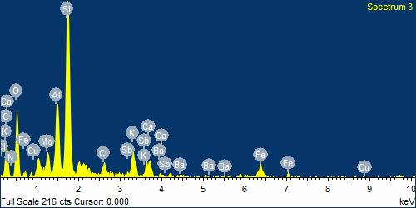
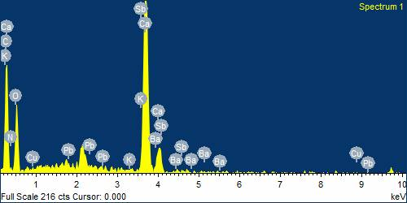

Figures 1: GSR samples of various shapes and sizes were detected by tape lifting method from the firearm injury present over the body of deceased.

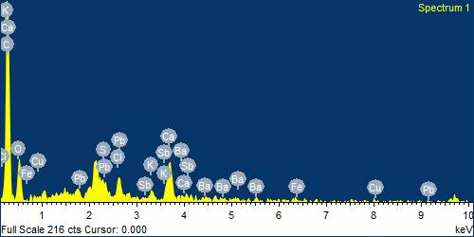

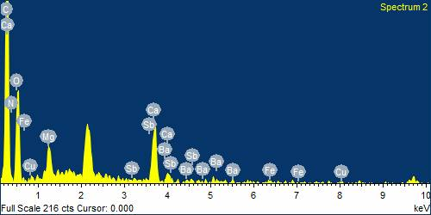

Figure 2: Spheroidal shaped GSR samples detected along with fibres of the cloth sample taken from the deceased.

Discussion:
The victims were young men in the age group of 20-40. This can be attributed to the fact that young men are often impulsive and they being the main financial support to the family are more exposed to stress and strain of daily life for earning livelihood of the family. They often are exposed to situations that generate anger in them and they decide to end it for once and for ever.
Manner of death was homicidal in 80% of cases. Use of firearm ensures fatal outcomes. Its popularity as a weapon of choice in homicides is increasing at an alarming rate. There is no need to overpower the victim through physical strength. A single bullet is enough to cause fatality if it hits a vital organ or blood vessel. It also eliminates the complexities of being in close proximity of the victim. The surety of death and the least physical effort involved makes firearms an excellent weapon of choice for homicides. Suicide by firearm also ensures a sure and quick death. The most common site for the infliction of suicidal injury is head as it contains one of the component of the tripods of life and trauma to it leads to quick and sure death.
The cause of death in 3 of the cases was coma as the injury was inflicted on the head region. The injuries lead to the fracture of skull and damage of brain tissues. Intracerebral Haemorrhage caused coma leading to death. In the other 2 cases several internal organs were ruptured due to which severe bleeding occurred and the victim died due to haemorrhagic shock.
The targeted area was head in majority of cases as trauma of head ensures the sure shot death of the individual. Shots to the head region were close contact or near contact shots. Most of the assailants are not sharp shooters and to target such small surface area of the body they need to be in proximity of the victim.
Wounding capacity of a firearm depends upon the kinetic energy its projectile possesses on being discharged. The more is the mass the more kinetic energy it will possess as K.E is directly proportional to mass of the bullet. If the velocity of the projectile increases it will also increase the Kinetic Energy. When the bullet transfers this K.E to tissues it creates lethal effect.
There are several techniques for the examination of GSR. However, Scanning Electron Microscope (SEM), coupled with an EDX analyser is considered the best for elemental analysis of unique GSR trio elements i.e., Pb-Sb-Ba.^{[4]}
Gunshot wounds are considered notorious wounds. No two gunshot cases are alike and each case presents its own challenges and peculiarities. Homicides portrayal as suicides are common. Appearance of wound and the associated artefacts are not always enough to determine the range of fire. Presence of gunpowder on the hands of suicide victims or its absence changes the course of investigation. The range of fire helps in cross checking the accuse account of the incident. All the four spectrums are positive for Pb-Sb-Ba are the trio elements of GSR. Particles of Pb-Sb-Ba are considered characteristic of GSR.^{[5]}
Conclusion
Postmortem forensic nano-chemical analysis and ballistic findings were included to conclude this study. Firearm injury is the commonest method used to cause homicide as it causes maximum lethality and surety of death is very high. Head is the commonly targeted region as maximum incident is of close shot or contact shot. Assailants were known to the victim in most of the cases. Pistol was the commonly used weapon to cause firearm fatality. The bullets used were of non-standard calibres. In this case GSR was detected in all of the cases from the body of deceased and it was further confirmed by the most sophisticated tool for detection of GSR in the present era i.e., SEM-EDXA. Hence this case study is useful in providing a brief glimpse of present trend of firearm violence.

Acknowledgement
Authors would like to thank Faculty and Staff of Department of forensic medicine, IMS, BHU for their valuable support in preparation of this case report..
Conflict of Interest
No conflict of interest associated with this work
Source of Funding
This study was funded by UGC
Contribution of Authors
We declare that this work was done by the authors named in this article and all liabilities pertaining to claims relating to the content of this article will be borne by the authors. Dr. Manoj Pathak conceived and designed the study, Srishti Rai collected the data and analysed it.
References
- Aggrawal A. Textbook of Forensic Medicine and Toxicology. Avichal Publishing Company, 2016.
- IPC 324.[Internet]. Available from: https://devgan.in/ipc/section/324/ [Accessed on 2020 Sep 21].
- Ignatius PC. Forensic Medicine and Toxicology. 4th ed. Elsevier India; 2019.
- Sharma BR. Firearms in Criminal Investigation and Trials. 5th Edition. Universal Law Publications, 2017.
- DiMaio JMV. Practical Aspects of Firearms, Ballistics and Forensic Techniques. 3rd edition. CRC Press, 2016.

