ULTRASOUND GUIDED SERRATUS ANTERIOR PLANE BLOCK FOR POST THORACOTOMY PAIN
Rumi Baruah*, Ananya Bhorali*
*Department of Anaesthesiology and Critical Care ,Gauhai Medical College and Hospital,Guwahati, Assam,India

ABSTRACT
Background and Aims: Thoracotomy is widely recognized as one of the most painful surgical procedures. This form of intensified pain is a matter of high concern, and pain relief becomes important not only for the comfort of the patient, but also to prevent pulmonary complications. Opiates and other weaker analgesics are not sufficiently effective on controlling post-thoracotomy pain. Now, presently there has been an increased interest in the use of regional nerve block. Serratus Anterior Plane Block (USG SAPB) is an interfascial block providing paresthesia of T2 to T9 dermatomes of the anterolateral thorax Methods: In this single hospital-based, patient and observer blinded study, 60 patients scheduled for elective thoracotomy were randomized to receive” USG SAPB” (n=30) with 0.2% Ropivacaine after induction and 20 minutes before incision or “Standard control group” (n=30) that received standard post-operative pain control with intravenous opioids, NSAIDS and acetaminophen (paracetamol). We compared the post-operative pain assessment, hemodynamic parameters and complications,if any, of both the groups at 2nd ,4th ,6th ,8th ,12th ,24th hours. The statistical analyses were done by using the PSW software version 21.0. Data were compared using the Chi-square test, Unpaired t- test and Mann-Whitney U test. Result: The Visual Analogue Scale score was significantly lower in USG SAPB group than the Standard pain control group group both at rest and coughing (p< 0.001) at 8,12 and 24th post-operative hours and 6,8,12 and 24th hours respectively. The need for rescue analgesia was significantly lower in USG SAPB (p=0.046). The hemodynamic parameters were comparable in both the groups. Conclusion: The USG SAPB provided prolonged and effective analgesia and thus can be used as an adjuvant treatment option for post-thoracotomy.
Key words: Thoracotomy, Serratus Anterior Plane Block, Post-thoracotomy pain, Visual Analogue Score

INTRODUCTION
Thoracotomy is widely recognized as one of the most painful surgical procedures.^{1,2} Pain following surgery is a universal phenomenon. Its intensity varies according to the nature of surgery and the residual wound with which the patient is left with. Postoperative pain is initiated by tissue injury which determines the natural process of healing. With the birth of anaesthesia, “post-operative pain” was recognized as a discipline, worthy of attention in its own right.³ Post thoracotomy pain (PTP) is mediated through multiple nociceptive and neuropathic mechanisms, which originate from somatic and visceral afferents. The main source of pain are intercostal nerves, the vagus nerve and phrenic nerve in the pleura, the superficial cervical plexus, the brachial plexus in the ipsilateral side. The thoracotomy incision involves cutting through several muscle layers of the chest wall along with resection of the ribs. ⁴ This form of intensified pain is a matter of high concern, and pain relief becomes important not only for the comfort of the patient, but also to prevent pulmonary complications.⁵ In addition to this, poor analgesia may result in delayed mobilization of the patient with increased chances of deep vein thrombosis and pulmonary embolism.⁶ Furthermore, acute post thoracotomy pain, if untreated, may lead to chronic post thoracotomy pain which has a serious negative impact on the quality of life⁷.
Most acceptable methods for treating post-thoracotomy pain are opioid administration and thoracic epidural anaesthesia (TEA) which are associated with serious side effects. Opiates can cause respiratory depression frequently requiring reintubation and reventilation while TEA is not only technically difficult to perform but also has risk such as inadvertent intra-vascular injection, pneumothorax. Weaker analgesics, such as NSAIDS are not effective in controlling severe pain and are also complicated by gastrointestinal bleeding. With the introduction of ultrasound guidance, it has facilitated various plane block to achieve effective regional anaesthesia. In our present study, we used Ultrasound-guided Serratus Anterior Plane Block( SAPB). SAPB was 1st described by Blanco at al.⁸
METHODS
Ethical approval of this study was provided by the Institutional Ethical Committee at Gauhati Medical College and Hospital under the under the Department of Anaesthesiology and Critical Care, Gauhati Medical College and Hospital, Guwahati with reference number MC/190/2007/Pt-11/MAR-2019/PG/29.This randomized, patient and observer blinded, single hospital study was conducted in the Cardio Thoracic and Vascular Surgery operation theatre of our hospital from 1st June 2019 to 31st January 2020 on the patients aged 18-65 years undergoing elective thoracotomy with American Society of Anaesthesiologists (ASA I) Physical Status class I and II under general anaesthesia. Exclusion criteria were Allergy to the study drugs, contraindications to Serratus anterior plane block and Intercostal nerve block ,systemic infections or patients having local sepsis at the site of injection, Cardiovascular diseases hypertension (blood pressure more than 140/90), tachycardia, congestive heart failure, and coronary artery disease),chronic obstructive pulmonary disease, renal insufficiency , liver dysfunction, disorder of homeostasis, patients having chronic pain, redo – thoracotomy. Written and informed consent was obtained from all the patients.
Based on a previous study ⁹, considering the mean (standard deviation) VAS of 2.6 (1.93), to detect a difference of 1.5 in VAS, 26 samples were required in each group with a power of 80% at the significance level of alpha value 0.05 and confidence interval of 95%. Considering an attrition rate of 15%, 30 patients in each group were required in this study. Thus, a sample size of 60 patients was obtained for the study.
Thereafter, random allocation of patients via a computer-generated random selection were done into two equal groups- Group A (SAPB=30) who received Ultrasound guided Serratus Plane Block with 0.2% Ropivacaine after induction and 20 mins prior to skin incision and Group B (Standard control=30) who received post-operative analgesic regime comprising of opioids, NSAIDS and acetaminophene.
As per perioperative anaesthesia management, patients were nil per oral for 6 hrs before the surgery. In the operating room,an intravenous cannula of 18-gauge was secured in non-dominant hand. General anaesthesia was administered as per departmental protocol comprising of Inj Fentanyl (1-2 mcg/kg), inj Propofol (2-3 mg/kg), inj Vecuronium bromide(0.08-0.1mg/kg) and maintenance with Sevoflurane at titrated dose. Unilateral postero-lateral thoracotomy was carried out at the space between 4th – 5th ribs.
A designated resident, who was not involved in the preoperative, intra operative and postoperative assessment of patient parameters, performed the SAPB and injected the drugs to patients as handed over by the designated technician . Decoding of data was done only after the analysis phase was over.
For SAPB, the patient was turned laterally with the operative side upwards. Under all aseptic and antiseptic precautions, the area around the proposed puncture site was prepared with povidone iodine and alcohol. A high frequency linear probe covered with a sterile gloves was placed in a sagittal plane over the patient’s midaxillary line at the level between 4th and 5th rib. With the rib, pleura and the overlying serratus anterior and latissimus dorsi muscle visualized (Figure 1), a 22-gauge 50-mm insulated stimulation short bevel needle (Stimuplex® @ B-Braun Medical, Germany) was advanced in in-plane technique at 45 degrees. After reaching the appropriate plane, i.e the plane in between latissimus dorsi above and serratus anterior below, 1-2ml of normal saline was injected after negative aspiration and hydro-dissection of fascia was seen for confirmation (Figure 2). Twenty ml of 0.2% Ropivacaine 3ml/kg was injected in the plane between the serratus anterior and Latissimus dorsi. The needle was then removed and site sealed with antiseptic gauze.

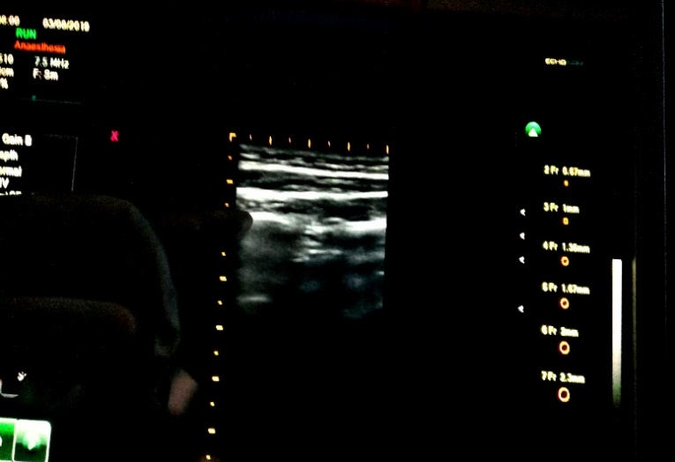
d
c
b
a

Figure 1: a) latissimus dorsi muscle,b) the plane for drug deposit c) serratus anterior muscle d) pleura

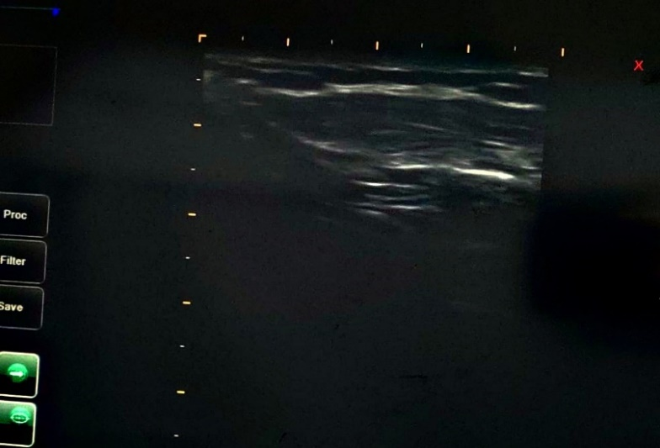
HYDRODISSECTION OF PLANE

Figure 2: Ultrasonoghraphic image of drug spread

After the completion of surgery, patients were managed in the cardio thoracic intensive care unit for atleast 24 hours . Analgesia was assessed at an interval of 2, 4 , 6 , 8 , 12 and 24 postoperative hours respectively using a pre-validated non-invasive pain scoring system ( i.e. Visual Analogue Scale; VAS : 0cm = no pain and 10 cm = worst pain imaginable ) ¹⁰, both at rest and during coughing . The data were collected as per a pre-defined proforma by the attending nurse blinded to the allotment. Duration of analgesia, side effects and complications ,if any, were also recorded. Intravenous tramadol 50 mg stat was used as rescue analgesic, when VAS score was more than 4 or at patient’s request, up to maximum of 3 doses in the first 24 hours postoperatively. Beyond that intramuscular injection of diclofenac 75 mg was used. The time of administration of the rescue analgesics was noted. Hemodynamic parameters including blood pressure, heart rate and respiratory rate were monitored. Adverse events comprised of hypotension, bradycardia, hypoxemia (SpO₂<90%) or nausea and vomiting.
The statistical analyses were done by using the PSW software version 21.0.
For analysis, descriptive and inferential statistics were used. Chi square test was used to evaluate difference between categorical variables. Data was checked for normality using Kolmogorov-Smirnova test. Unpaired t test and alternative non parametric Mann-Whitney U test was used depending on fulfilment of normality assumption. Probability if less than 0.05 was considered to be significant.

RESULT
Our study group comprised of 60 patients with 30 patients randomly allocated to each group. The flow of patients in the trial is shown in the Consort flow diagram
(Figure 3). Patient’s demographics (Table 1) were similar with no significant differences among both groups in terms of age, weight, gender, height, operative time.
As per the primary outcome, The VAS score was significantly lower in USG SAPB group than the Standard control group both at rest and coughing (p< 0.001) at 8,12 and 24th post-operative hours and 6,8,12 and 24th hours respectively ( Figure 4a and 4b).
The need for rescue analgesia was significantly lower in USG SAPB (p=0.03).
The duration of analgesia was longer in SAPB group (847.5 ± 55.067 mins) than standard control group (480.83 ± 50.26 min). At the same time, there were no statistically significant difference in heart rate, mean arterial pressure, respiratory rate.
Table 1: Demographic and other data
 |  | N | Mean | Std. Deviation | Minimum | Maximum | p value
AGE(years) | Group A | 30 | 38.93 | 15.193 | 18 | 64 | 0.412
AGE(years) | Group B | 30 | 40.73 | 11.687 | 24 | 60 | 0.412
 |  | N | Mean | Std. Deviation | Minimum | Maximum | p value
HEIGHT(cm) | Group A | 30 | 162.1 | 6.91 | 150 | 170 | 0.200
HEIGHT(cm) | Group B | 30 | 159.6 | 7.76 | 145 | 170 | 0.200
 |  | N | Mean | Std. Deviation | Minimum | Maximum | p value
WEIGHT(kg) | Group A | 30 | 55.73 | 8.598 | 42 | 70 | 0.530
WEIGHT(kg) | Group B | 30 | 54.32 | 8.918 | 40 | 70 | 0.530
 |  | N | Mean | Std. Deviation | Minimum | Maximum | p value
DURATION OF SURGERY(min) | Group A | 30 | 97.00 | 17.30 | 70 | 135 | 0.725
DURATION OF SURGERY(min) | Group B | 30 | 98.67 | 19.21 | 60 | 130 | 0.725

Allocation
Allocated to intervention in GROUP A (n=30 )
- Received allocated intervention (n=30)
- Did not receive allocated intervention (n=0)
Allocated to intervention in GROUP B(n=30)
- Allocated to intervention in GROUP B (n=30 )
Received allocated intervention(n=30)
- Did not receive allocated intervention (n=0)

- Did not receive allocated intervention(n=0)
Lost to follow-up (n=0)
Lost to follow-up (n=0)
Discontinued intervention ((n= 0)
Discontinued intervention (n= 0)
Analysed(n=30)
- Excluded from analysis (n=0)
Analysed (n= 30 )
- Excluded from analysis (n=0)

- Excluded from analysis (n=0)
Analysis
Follow-Up
Randomized (n= 60)
Excluded(n=19)
- Not meeting inclusion criteria (n=12)
- Declined to participate (n=7)

Enrollment (n =79)

Figure:3 Consort flow diagram
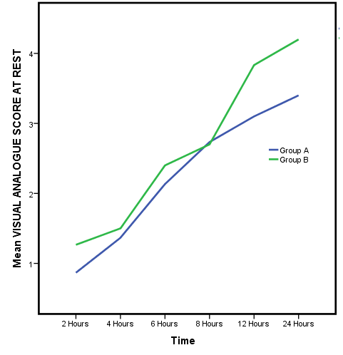

Figure 4a: Postoperative VAS score at rest

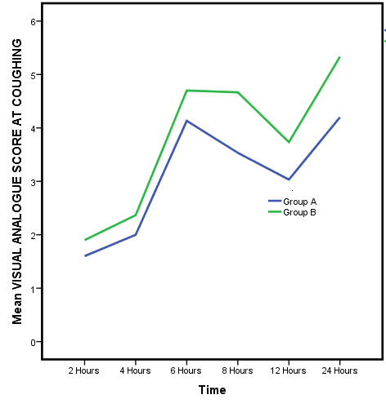
Figure 4b: Postoperative VAS score while coughing

DISCUSSION
The main findings of the study were 1) patients receiving SAPB reported significantly lower levels of pain after thoracic surgery as assessed by the VAS score as compared to the patients in the standard pain control group;2) the amount of rescue analgesia was lower in SAPB group; 3) the incidence of vomiting was lower in SAPB:4) SAPB was not associated with any complication. Of note, there was no statistically significant differences in the hemodynamic and respiratory parameters between two groups.
The etiology of pain in thoracotomy is due to various factors including local tissue unjury, inflammation of chest wall injury and damage to intercostal nerves.
Various modalities to control post-operative pain after thoracotomy each with attecedant problems, have been tried with varied success, for example: 1) intrapleural analgesia, 2) cryo-analgesia, 3) thoracic epidural, 4) paravertebral block, 5) intravenous narcotics, 6) intrathecal or epidural narcotics, NSAIDS and 7) Transcutaneous nerve stimulation.^{11,12}
None of these techniques used in the past could be considered ideal either due to systemic side effects or due to lack of technical feasibility associated with them. Hence, in order to search for a near ideal option of post-thoracotomy pain relief in terms of simplicity, safety, efficacy and feasibility, regional techniques come into consideration.
One such regional anaesthesia technique is SAPB which provides paresthesia of T2 to T9 dermatomes of the anterolateral thorax. ¹³
In our study, pain score was assessed by the Visual Analogue Scale (VAS score) at 2nd, 4th, 6th, 8th, 12th and 24th hour post operatively, both at rest (VASr) and at coughing (VASc). While comparing the VAS scores at rest, we saw that VASr in the patients receiving SAPB (group A) were lower and significant (p value < 0.05) as compared to group B at the 8th, 12th and 24th post-operative hour. Till 8th post-operative hour, there was no difference in the pain scores between the two groups. Analyzing the dynamic VAS scores,we saw that , pain scores were also lower in the SAPB group (group A) and this difference was significant (p<0.001) at the 6th ,8th,12th and 24th post-operative hour . Till 6th post-operative hour, there was no difference in the pain scores between the two groups.
The iv route is one of the most commonly used multimodal analegia technique and is used primarily for administration of opioids. However, opioids in large doses have significant side effects like nausea, vomiting, respiratory depression, sedation.¹⁴ The result of our study showed that the total amount of tramadol used was lower in SAPB group. Most likely, the decrease in incidence of vomiting in SAPB resulted from lower doses of iv opioids administered. These findings suggest that the addition of SAPB to an opioid administration can lead to significant decrease in total opioid administration post-operatively with consequent decrease in incidence of postsurgical complications.
Thoracic epidural block (TEB) is considered to be gold standard for PTP. However, this technique requires highly trained medical staff, not only for the insertion and removal of the epidural catheter, but also for the management of the continuous infusion of the pain medication. The risks associated with TEB include accidental dural puncture, inadvertent high block, local anaesthetic toxicity and total spinal anaesthesia (inadvertent spinal injection of an epidural dose of local anaesthetic). Additional side effects such as hypotension, neuraxial hematoma, vomiting and urinary retention have also been reported following TEB.¹⁵ Furthermore, an epidural puncture is contraindicated in patients who have local infection or a history of previous spinal surgery, or in patients who have coagulation disorders or who are on concurrent anticoagulant or antiplatelet therapy. ¹⁶
Paravertebral block (PVB) is a technique which involves injection of local anesthetic into the paravertebral space to block nerves after they exit the spinal cord. The major potential complications associated with PVB are total spinal block, pneumothorax and neuronal injury.¹⁶
Due to the side effects and complications of these techniques, alternative methods for palliation of thoracotomy pain are the subject of much current research.
In 2011, Blanco ¹³ described a conceptually new type of regional anesthesia, the PECs and PECs II (modified pectoralis muscle blocks, for pain control after breast surgery). Immediately thereafter, numerous studies appeared which not only dealt with the use of pectoralis block in breast surgery, but also described a number of other thoracic blocks for providing regional anesthesia to specific areas of the surface of the thorax. Prominent among these studies were descriptions of SAP block for pain relief of the anteromedial region of the thorax.^{17,18}
In the present study, we used ultrasound-guided SAP block in the management of post-thoracic surgery acute pain. This block is easy to perform, has a high success rate, and carries minimal complications. In our study, we performed the block when the patients were already anesthetized, and hence, they did not experience any discomfort or pain. Furthermore, SAP block usually requires only a single injection compared to most other regional blocks that often require multiple injections. Patients were benefited by experiencing significantly less pain during the early postoperative hours and by requiring lower opioid dosage during that period.
The reason for extensive analgesia of upto mean 847.5 mins as seen with our study can possibly due to spread of drug along the fascial plane and into the paravertebral space which is filled with adipose tissue and since local tissue perfusion is low in adipose tissue, it results in low absorption speed of local anaesthetic agent into the blood.¹⁸
The incidence of nausea and vomiting was lower in SAPB group than the standard control group. Hemodynamic parameters were comparable in both the groups.
The present study has several limitations. The two technical aspects of SAP block also limit the efficacy of this technique as follows: 1) the zone of anesthesia induced by SAP block sometimes requires the concomitant use of another anesthetic technique and 2) the superficial nature of SAP block does not provide a solution for reduction of pain due to damage to the visceral pleura caused by intercostal drains.¹⁶ There are also some other controversial issues that remain unresolved: SAP block may interfere with the integrity of the serratus muscle, and the fascial plane may be disturbed at the surgical incision site and consequently alter the drug distribution.^{19,20} Moreover, pain after thoracotomy for lobectomy does not match (does not look like) pain after decortication. Pain after decortication has significant skin and muscle components. We should take into account that an SAP block might be inadequate for the muscle component after decortication. Another important issue is the determination of the effective dose of local anesthetic. It appears that SAP block has a lower risk of local anesthetic toxicity than most other regional anesthetic techniques because the total dose of local anesthetic injected during ultrasound-guided SAP is smaller than that used in the other techniques, and also, the local anesthetic agent is injected into an area which is relatively less vascularized. ¹⁶
In the present study, the postoperative VAS scores during the first 8 hours at rest and 6 hours while coughing after the surgical procedure were similar in both study groups, signifying that the analgesic effect of the block persisted for up to 8 hours after the patients regained consciousness post-surgery. We suggest future studies to investigate the feasibility of prolonging the effective period of postoperative analgesia induced by SAP block for up to 24 hours by injecting additional doses of local anesthetic as needed or by administering the local anesthetic by the continuous SAP block technique during the postoperative period.
CONCLUSION
The results of the present study suggest that SAP block is an effective adjuvant treatment option for post-thoracotomy pain. Compared to the current methods used for post-thoracic surgery pain relief, SAP block has some significant advantages, particularly its ease of use and its low potential for side effects.

DECLARATION OF PATIENT CONSENT
The authors certify that they have obtained all appropriate patient consent forms. In the form, the patient(s) has/have given her/their consent for her/their images and other clinical information to be reported in the journal. The patients understand that their names and initials will not be published and due efforts will be made to conceal their identity, but anonymity cannot be guaranteed.
FINANCIAL SUPPORT AND SPONSORSHIP
Nil
CONFLICTS OF INTEREST
There are no conflicts of interest
REFERENCES
- Hughes R, Gao F. Pain control for thoracotomy. Contin Educ Anaesthesia, Crit Care Pain. 2005;5(2):56-60.
- Bong CL, Samuel M, Ng JM, Ip-Yam C. Effects of Preemptive Epidural Analgesia on Post-thoracotomy Pain. J A Cardiothorac Vasc Anesth. 2005 Dec;19(6):786-93.
- Craig D.B. et al. Postoperative Recovery of Pulmunory Fuction. : Anesthesia &amp; Analgesia. Anaesth Analg. 1981Jan;60(1):46-52.
- Yegin A, Erdogan A, Kayacan N, Karsli B. Early postoperative pain management after thoracic surgery; pre- and postoperative versus postoperative epidural analgesia: a randomised study. Eur J Cardiothorac Surg. 2003 Sep;24(3):420-4
- Macias A, Monedero P, Adame M, Torre W, Fidalgo I, Hidalgo F. A randomized, double-blinded comparison of thoracic epidural ropivacaine, ropivacaine/fentanyl, or bupivacaine/fentanyl for postthoracotomy analgesia. Anesth Analg. 2002 Nov;95(5):1344-50
- Gottschalk A, Cohen SP, Yang S, Ochroch EA. Preventing and treating pain after thoracic surgery. Anesthesiology. 2006 Mar;104(3):594-600
- Ng A, Swanevelder J. Pain relief after thoracotomy: is epidural analgesia the optimal technique? Br J Anaesth. 2007 Feb;98(2):159-62.
- Blanco R, Parras T, McDonnell JG, Prats-Galino A. Serratus plane block: a novel ultrasound-guided thoracic wall nerve block. Anaesthesia 2013Nov;68(11):1107-13.
- Erturk E, Aydogdu Kaya F, Kutanis D, et al. The effectiveness of preemptive thoracic epidural analgesia in thoracic surgery. Biomed Res Int. 2014;2014:673682.
- Huskisson EC. Measurement of pain. Lancet. 1974 Nov 9;2(7889):1127-31.
- Wall PD. The prevention of postoperative pain. Pain. 1988 Jun;33(3):289-90.
- Kehlet H, Dahl JB. The value of "multimodal" or "balanced analgesia" in postoperative pain treatment. Anesth Analg. 1993 Nov;77(5):1048-56.
- Southgate SJ, Herbst MK. Ultrasound Guided Serratus Anterior Blocks. 2020 Jul. In: StatPearls [Internet]. Treasure Island (FL): StatPearls Publishing; 2020 Jan–
- Wang J, Olak J, Ultmann RE, Ferguson MK. Assessment of pulmonary complications after lung resection. Ann Thorac Surg. 1999 May;67(5):1444-7.
- Takimoto K, Nishijima K, Ono M. Serratus Plane Block for Persistent Pain after Partial Mastectomy and Axillary Node Dissection. Pain Physician. 2016 Mar;19(3):481-6.
- Semyonov M, Fedorina E, Grinshpun J et al. Ultrasound-guided serratus anterior plane block for analgesia after thoracic surgery. J Pain Res. 2019 Mar 11;12:953-60.
- Shanti CM, Carlin AM, Tyburski JG. Incidence of pneumothorax from intercostal nerve block for analgesia in rib fractures. J Trauma. 2001 Sep;51(3):536-9.
- De Cosmo G, Aceto P, Gualtieri E, Congedo E. Analgesia in thoracic surgery: review. Minerva Anestesiol. 2009 Jun;75(6):393-400.
- Blanco R, Fajardo M, Parras Maldonado T. Ultrasound description of Pecs II (modified Pecs I): a novel approach to breast surgery. Rev Esp Anestesiol Reanim. 2012 Nov;59(9):470-5.
- Okmen K, Okmen BM, Uysal S. Serratus Anterior Plane (SAP) Block Used for Thoracotomy Analgesia: A Case Report. Korean J Pain. 2016 Jul;29(3):189-92.

