TOPIC: Early laparoscopic intervention in acute cholecystitis- A Hospital based study.
ABSTRACT :
The early timing of surgery in acute cholecystitis remains undefined .^{1,2}Laparoscopic cholecystectomy has become the standard treatment for gall stones,but is associated with an increased conversion rate in acute cholecystitis .Patients attending surgical emergency of our hospital between January 2018 –September 2019 for acute pain abdomen and diagnosed as acute cholecystitis both by Ultrasonography and haematological examination and who underwent laparoscopic cholecystectomy were recruited-Diagnosis, duration of symptoms,timing of surgery,outcome,post operation stay and complications and conversion rates were recorded.Results obtained showed that 60 patients who attended the surgical emergency underwent laparoscopic cholecystectomy .The surgical procedures were performed within 72 hours in 30 cases and after 72 hours in another 30 cases..Relating to interval from onset of symptoms to surgery, conversion rates for lapchole were 6/30(20%) in < 72 hours and 9\30(30%) in > 72 hours. Complications ranged from bleeding to bile duct injuries in 1 case. Operative intervention for acute cholecystitis is best achieved if done within 72 hours and can also be done after that period .Conversion rate increases as the timing of intervention increases.
Keywords :Laparoscopic cholecystectomy, ,acute cholecystitis, .
INTRODUCTION:
The role of laparoscopic cholecystectomy in acute cholecystitis is controversial.It has been associated with considerable morbidity and the reported conversion rate is higher than that for non acute cholecystitis^{3,4}.The ideal timing of surgery in acute cholecystitis remains undefined.
Acute cholecystitis as a major complication of gall stones is diagnosed in 10 to 30% cases admitted for cholecystectomy^{5,6..}.The anatomy at callot’s triangle in acute cholecystitis is distorted due to adhesions.As such ,cholecystectomy for this condition is time consuming,technically demanding and results in higher morbidity.In the prelaparoscopicera,patients of acute cholecystitis were initially treated conservatively so that the inflamed gall bladder “cools down”.This was followed by cholecystectomy,six weeks later.This radically changed after D.M.Essenhigh in 1966 ,where he stated that early open cholecystectomy for acute cholecystitis is as safe as delayed cholecystectomy with reduced morbidity and Hospital stay⁷.The treatment of acute cholecystitis by laparoscopy is followed by the same pattern.Initially laparoscopic cholecystectomy was contraindicated in patients with acute cholecystiis because of fear of higher morbidity and high(60%) conversion rate to open cholecystectomy
There is a failure rate of 20-22% of patients of conservative treatment leading to development of early complications requiring an urgent and technically demanding cholecystectomy ^{8,9.} .Moreover another 10-20% of cases are readmitted with recurrent symptoms and undergo an unplanned emergency cholecystectomy. A small proportion of cases(10%) develop other complications like slippage of stones into the common bile duct(CBD) making the patient to undergo a more extensive operation and also possible pancreatitis.
As a result of this and increasing expertise and equipment available ,the indications of laparoscopic cholecystectomy were extended to include patients with acute cholecystitis.Several randomized and non randomized have documented the feasibility and safety to early laparoscopic cholecystectomy ^{8,9,10.}.
The aim of this study was to determine the optimal timing of surgery in acute symptomatic cholecystitis with cholelithiasis. Hospital ethical committee permission was taken.
METHODS:
This study includes all consequtive patients who underwent early cholecystectomy for acute cholecystitis at the Gauhati Medical College Hospital between January 2018 and September 2019. All patients were admitted on an emergency basis. The diagnosis of acute cholecystitis was based on the presence of a fixed criteria , as described in Table 1.
Table 1.
CRITERIA FOR DIAGNOSIS OF ACUTE CHOLECYSTITIS :

1.Acute upper abdominal pain and positive murphy’s sign.
2.White blood count of > 12x10⁹\ L.
3. USG findings of thick walled gallbladder with pericholecystic fluid and gallstones.
4.Fever> 38⁰ C.
5. Histological evidence of acute cholecystitis.

Exclusion from the study included 1.) Patients who had no gallstones. 2.) those who were not operated. 3.) those who had incomplete data. 4.) those who had obstructive jaundice , ascending cholangitis, biliary pancreatitis.
Patients were divided , depending on the duration of symptoms prior to surgery into two groups : symptoms < 72 hours ; symptoms > 72 hours. These groups were analysed to specifically determine the optimum timing for cholecystectomy in acute cholecystitis.

RESULTS AND OBSERVATIONS :
A total of 60 lap cholecystectomies for acute cholecystitis were performed during the period of the study . The Male: Female ratio was 1:2.9 and the mean female age group was younger than that of male patients ( 42.3 – 47.7 vs 52.7—58.9 yrs. ) The procedures undertaken are summarised in Table 2.
TABLE 2.
PROCEDURES PERFORMED IN PATIENTS WITH SYMPTOMATIC CHOLELITHIASIS AND TIMING OF SURGERY :
Timing of surgery.  < 72 hours.  >72hours | Lap chole attempted.  30  30 | Lap chole converted  6(20%)  9(30%) |  |  | Mean hosp. Stay(days.)  2 --3.  4—5.

Laparoscopic cholecystectomy was successful in 80% cases if done within 72 hours and in 70% if done after 72 hours. Conversion rates were 20% and 30 % progressively indicating that it was dependent on the timing of surgery .The reasons for conversion from laparoscopic to open cholecystectomy were
[A] Unclear anatomy(45%)
[B]Difficult dissection(27.5%)
[C]Bleeding(25%)
[D] CBD injury (1.5%) and
[E]Unspecified(1%)
There was one case of CBD injury following laparoscopic cholecystestomy after 72 hours which required Hepatico-jejunostomy at a later date.
DISCUSSION:
Laparoscopic cholecystectomy has become the gold standard for the management of symptomatic gall bladder disease but considerable debate surrounds the role of minimally invasive surgery in the management of acute cholecystitis. This condition was historically considered as contraindication to laparoscopic cholecystectomy. Increasing experience in laparoscopic cholecystectomy in recent years has led to its application in acute cholecystitis with a fair degree of success. This paper represents a limited time period audit of the management of cholelithiasis in our institution and addresses the role of early intervention in a diagnosed case of acute symptomatic cholecystitis.
The results of this study are consistent with recently published data which shows that early laparoscopic cholecystectomy in Acute cholecystitis is safe,with similar conversion rates^{11.} .Early cholecystectomy results in significantly shorter hospital stay and avoids the risk of of failed conservative treatment¹⁰. Despite this acceptable level of outcome ,acute cholecystitis ,remains the most significant risk factor for conversion and complication of laparoscopic cholecystectomy¹². Somasekhar and colleagues in the UK found that waiting for surgery led to repeated investigations and cost escalations due to hospital stay.¹³ In another study by Lawrenschuk et al in Australia, found that cost per patient and complications after 72 hours was much more than that before 72 hours¹⁴ . Uchiyama and colleagues in Japan highlighted the role of clinical pathways in reducing hospital stay and cost of laparoscopic surgery.¹⁵
Although our rate of complication is generally acceptable ,most complications including the single CBD injury were limited to the latter time of intervention(>72 hours).These findings clearly point to the importance of early intervention in acute cholecystitis.
Based on international experience and also in our own study,we support early intervention within 72 hours of admission for acute cholecystitis.Surgical intervention during that period is technically less demanding because the oedema planes magnifies the structures and facilitates dissection.A comprehensive argument in favour of early intervention in acute cholecystitis is the morbidity and the escalating cost of prolonged waiting time for surgery following conservative treatment of initial admission.
CONCLUSION:
Early intervention by laparoscopic cholecystectomy in acute cholecystitis,performed within 72 hours of admission is safe and associated with less mortality and morbidity and lesser hospital stay .However, intervention can be done after 72 hours of initial symptoms but the golden period of 72 hours after admission gives the best possible results.

REFERENCES:
- Geoghegan. JG, Krane FBV, Laparoscopic management of complicated gallstone disease .B.J of Surg.1999;86:145-6.
- Koo KP ,Thirlby RC, Laparoscopic cholecystectomy in acute cholecystitis. Arch. Surg.1996;131:540-5.
- AJ Shapiro, Costello C, Horkabus M, North JH Jr. Predicting conversion of laparoscopic cholecystectomy for acute cholecystitis. JSLS 1999;3(2):127-30.
- Chahin F, Elias N, ParameshA ,Saba A, Godziachvili V, Silva YJ .The efficacy of laparoscopy in acute cholecystitis. JSLS 1999;3(2):21-5.
- Garker SM, Korman J, Cosgrove JM, Cohen JR. Early laparoscopic cholecystectomy for acute cholecystitis. Surg Endosc.1997;11:347-350.[Pubmed]
- Stevens KA, Chi A, Lucas LC, Porter JM, Williams MD. Immediate laparoscopic cholecystectomy for acute cholecystitis : no need to wait. Am J of Surg.2006;192:756-761. [Pubmed ]
- D H Essenhigh. Management of acute cholecystitis. Br. J of Surg.1966;53:1032-1038. [Pubmed ].
- Lo CM, Liu CL, Fan ST, Lai ECS, Wong J. Prospective randomized study of early vs delayed laparoscopic cholecystectomy for acute cholecystitis. Ann Surg. 1998; 227:461-467.[Pubmed].
- Papi C, Catarci M, D’Ambrosio L. Timing of cholecystectomy for acute cholecystitis:a meta analysis. Am J of Gastroenterology.2004;99:147-155. [Pubmed].
- Lau H, Lo CY, Patil NG, Yuan WK. Early versus delayed interval laparoscopic chole for acute cholecystitis : A meta analysis. Surg. Endosc.2006 ; 20:82-87. [Pubmed]
- Lai PBS, Kwong K H, Leung KI, Kwok S P Y, Chan A C W, Chung S C S , Lau WY. Randomised trial of early vs delayed laparoscopic cholecystectomy for acute cholecystitis. Br. J of Surg. 1998; 85:764-7.
- Pessaux P, TurchJJ, Rouge C, Duplessis R, Cervi C, Arnaud JP. Laparoscopic cholecystectomy in acute cholecystitis : A prospective comparative study in patients with acute vs chronic cholecystitis. SurgEndosc. 2000; 14:358-361. [Pubmed].
- Somasekhar K,Shankar PJ, Foster ME, Lewis MH.Costs of waiting for gallbladder surgery. PostgradMed J.2002;78:668-70[Pubmed].
- Lawrentschuk N, Hewitt PN, Pritchard MG. Elective laparoscopic cholecystectomy: implications for prolonged waiting times for surgery.Aust NZ J Surgery.2003 ;73:890-893[Pubmed].
- Uchiyama K, Tokifuji K, Tani M, Onishi H, Yamaue H. Effectiveness of the clinical pathway to decrease the length of hospital stay and cost for laparoscopic surgery. Surg Endosc 2002;16:1594—1597.[Pubmed].

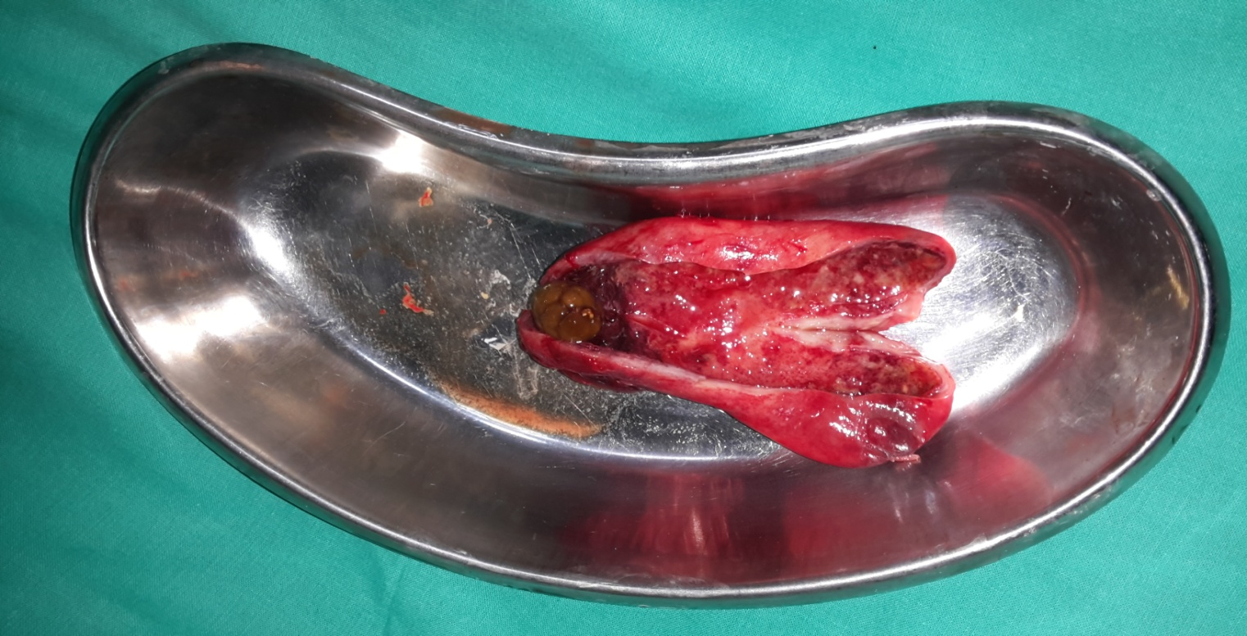

CUT SPECIMEN OF ACUTE CHOLECYSTITIS .

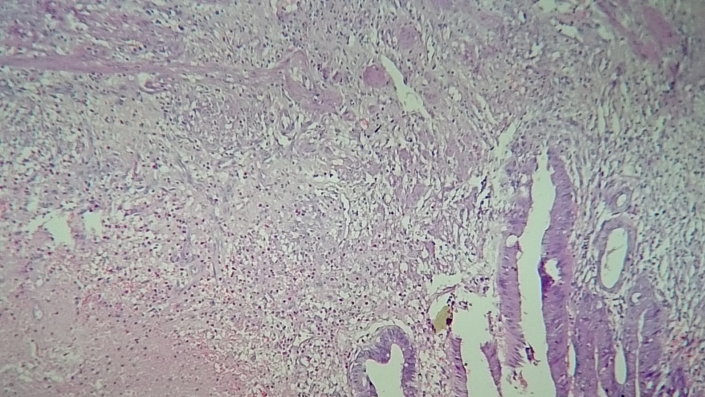
MICROSCOPIC PICTURE OF ACUTE CHOLECYSTITIS. ( LOW POWER VIEW) 100X
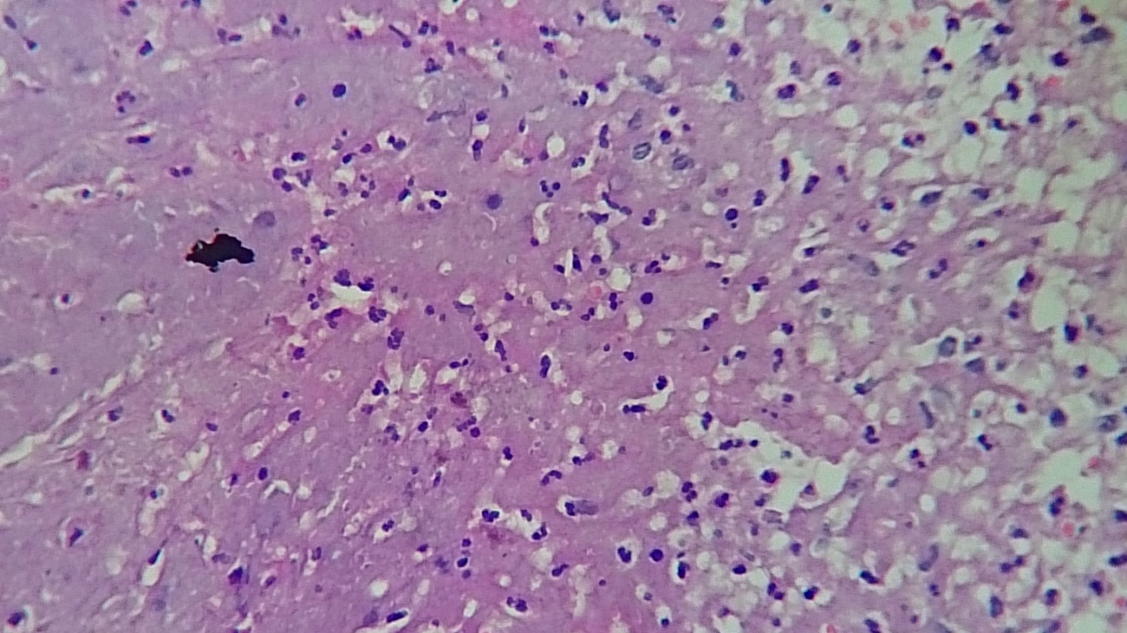
MICROSCOPIC PICTURE OF ACUTE CHOLECYSTITIS ( HIGH POWER VIEW )400X

