REVIEW PAPER
Unethical Practice - An Expanding Epidemic
Mahanta Putul*
Received on May 24, 2015; accepted on July 30, 2015
ABSTRACT
Once upon a time, doctors were considered to be above human next to God. But now, corruption and unethical practices in the medical profession have become the shocking reality and a first hand account of the present day society in the current health-care system. It is a crisis so distinguished by its galactic costs and limited quality care that it affects nearly every person in the country. Gathering anecdotes from different newspapers published in our country, this article has tried to explore in-depth, to look at the crisis and to evaluate what has led to it, which contributes to it, and what it will take to resolve it. Issues of unnecessary operations, consultation abuses, insurance fraud, sexual harassment, drug-impaired physicians, privileges of medical staff membership, high cost of sub-standard services has increased the proportion of unethical practice. These facts not only reveal the rapacity, egotism, malpractice, sex, power, and suffering, but also include remarkable portraits of hope, happenings, and a deep desire for change. Hence, a major reform in the health-care system is suggested that would drastically reduce costs and dramatically combat waste, fraud, and practitioner’s abuse while improving the quality of primary health care.
Keywords: Unethical practice, medical negligence, consultation abuse, quality health
Address for correspondence and reprint:
*Associate Professor, Forensic Medicine and Toxicology
Tezpur Medical College, Tezpur, Assam, India
Email: drpmahanta@gmail.com
Mobile: 09435017802
INTRODUCTION
Once upon a time a doctor was thought to be someone supernatural (Figure 1), but unethical practices in the medical profession have become the shocking reality in present day scenario. The ethical measures of the medical community have required, for nearly 200 years now that docs reported to appropriate authorities about the potentially injurious conduct by colleagues. In 1803, an English physician and philosopher, Thomas Percival, published a treatise entitled "Medical Ethics; or a Code of Institutes and Precepts, adapted to the Professional Conduct of Physicians and Surgeons." This historical record, which served as the basis for the American Medical Association’s (AMA’s) first code of ethics in 1847, was perhaps the most significant document since the Oath of Hippocrates in the fifth century B.C. to establish standards of professional conduct for physicians and surgeons.
Some physicians in India have condemned what they say are attempts by the IMA (Indian Medical Association) to deny the prevalence of unethical practices in our medical profession. The forum for Medical Ethics Society and the Medico Friend Circle, two health groups established by doctors, has jointly called on the association’s officers to “do some genuine introspection” and tackle the problems rather than deny them. Their appeal comes after the association earlier this month criticized a television talk show hosted by a popular “Bollywood” actor, Amir Khan. The show had highlighted how some doctors themselves have described unethical practices: sharing fees for referring patients to specialists, accepting gifts from medicine companies, and irrational prescribing of drugs and diagnostic procedures.¹
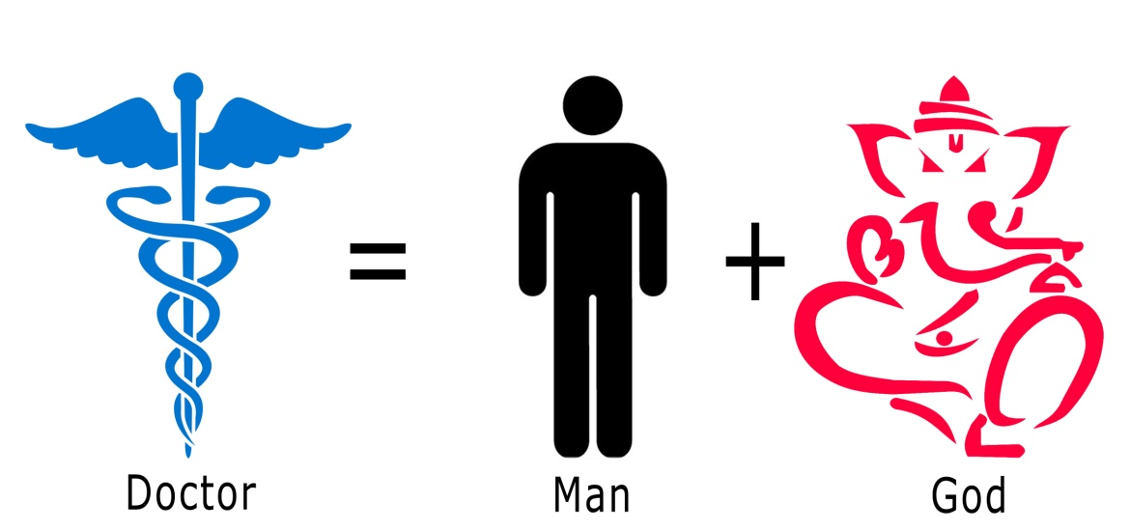
Figure 1 Doctor is above human?
The association said that the strike was also called to express opposition to introduce a three and a half year course to train rural people as healthcare providers for village health centres.^{2, 3} “Nowhere in the world does anyone get trained in modern medicine in such a short time”.
ETHICAL ASPECTS OF MEDICAL PRACTICE
Why talk about medical ethics?
Principles of modern ethics are autonomy (respecting patient’s wishes and freedom to choose), beneficence (acting in patient’s best interest), non-malfeasance (avoiding harm) and justice (treating equal problems equally). Medical ethics has three corners, viz., doctor, patient and society. The centre is the doctor patient relationship. Doctors have too much of power and influence. Hence, the abuses are very likely. Medical Etiquette is the duty of doctors to each other, rules of conducts growing the relationship of the medical profession and includes the following:
1. A doctor ought to behave to his or her colleagues, as he would have them behave to him.
2. A doctor must not entice patients from his colleagues.
3. A doctor must observe the rules enshrined in Chapter IV of code of Ethics Regulations, 2002.⁴
UNETHICAL PRACTICE AND CONDUCTS
It encompasses a variety of behaviors, including fraud, corruption, dishonesty, greed, and exploitation of patients, omission and commission from company and laboratories, etc. Physicians may behave in an unethical manner either because they are unaware of specific professional standards, which they are expected to observe, or they may, through deliberate and conscious decisions, disregard such standards.
Backbiting from same professional colleagues: When a patient is referred to a specialist, by the attending physician the referred consultant should never doubt the competence of the referring doctor or try to show his superiority. One should never try to underestimate the referring doctor.
Backbiting of different issues can be traumatic when it is false. Colleague falsely charged often face numerous problems of his or her own. In highly publicized cases, the general public has a strong tendency to assume the accused is guilty, leading to very serious social stigma.
Gradual erosion of the ethical principles (Figure 2): Medicine, historically considered a noble profession, has become a money spinning enterprise capitalising on human suffering.
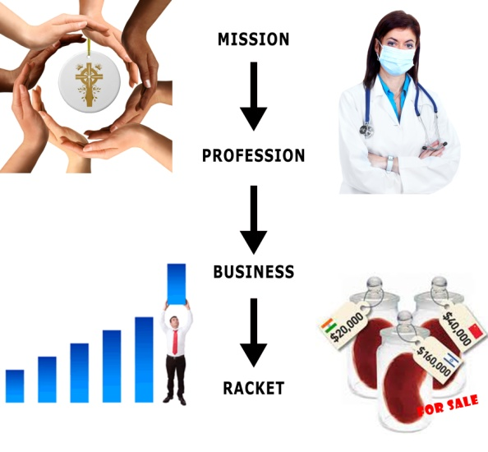
Figure 2 Erosion of the ethical principles
Omission and commission (Figure 3): The Hippocratic Oath taken for ethical conduct by doctors appears to have lost its relevance these days. Gifts, drinks, dinners, bonus, hotel accommodation, etc, are made available under circumstances where frequently there is no educational program.
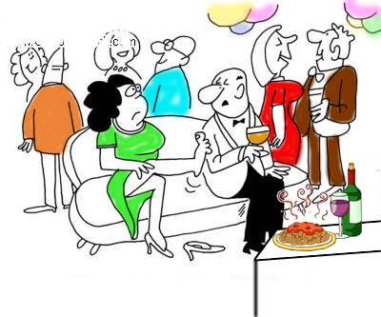
Figure 3 Sponsored meet with no educational program
The tacit understanding between diagnostic centers and a large pool of physicians for referring patients for a variety of diagnostic tests has become a standard practice. Many conscientious medical practitioners themselves concede that many a time, tests, which are not required, are also prescribed to improve business of diagnostic centers. These doctors get hefty commissions from these diagnostic centers and it is an open secret that diagnostic centers survive mostly on doctor’s prescription. ⁵
Advertising: Soliciting of patients directly or indirectly by a physician or a group of physicians or by institutions and organizations is an unethical practice. A physician shall not make use of his / her name as subject of any form or manner of advertising or publicity through any mode either alone or in conjunction with others which is of such a character as to invite attention for himself or to his professional position, skill, qualification, achievements, attainments, specialties, appointments, associations, affiliations or honors and/or of such character as would ordinarily result in his self aggrandizement.
Commercialization of medical profession: Many people believe that medical profession is now in a commercialized health care market. The exaggerated laboratory investigations and operative procedures, MRI abdomen, unnecessary exploratory laparotomy, fetal sex determination, nexus between doctors and diagnostic centers and pharmaceutical companies and ‘cut backs' for investigations or services are some examples of commercialized medical service.
A group of 10 doctors – all neurologists – with wives and relatives holidayed in England and Scotland on a trip allegedly financed by Intas Pharmaceuticals, Ahmedabad..⁵
However, very recently govt. has accepted the code of ethics for drug makers that no freebies will be permitted for docs. Pharmaceutical industry will no longer be able to induce doctors to promote the drugs they manufacture. In a move that will help curb unethical practices by the sector, the government finalized the first-ever voluntary code of ethics for enforcement on drug makers. Such a code already exists for doctors and the SMC (State Medical Council) enforces it. The “Uniform Code for Pharmaceuticals Marketing Practices”, is approved by the industry representatives, bars pharma firms from offering gifts, travel facilities, hospitality and monetary grants to doctors and their families in return for expansion of business through drug prescription. The code provides punitive measures for errant firms.⁶
No one to keep tabs on drug prices, patient’s suffers⁷
Manohar Lal of Panchkula needs frequent protein plasma transfusions. His family used to buy plasma (Human Albumin), manufactured by Synergy Diagnostics, from the pharmacy of a private hospital for Rs 5,000 per 100 ml dose (MRP of Rs 6,030). One day, they found that the same product was available for Rs 2,050 at a chemist shop in Chandigarh.
Sushila Rani was undergoing treatment for food poisoning at a Ludhiana hospital. A cannula and an IV set were used to administer her medicines intravenously, including Tazect injection. The hospital pharmacy charged Rs 72 for a cannula and Rs 70 for an IV set (both manufactured by Romsons), while the cost of Tazect injection was Rs 650 (all on MRP). Later, the family came to know that the three things were available for Rs 30, Rs 30 and Rs 350, respectively, in the market.
These are not the isolated cases where patients were forced to shell out more to buy drugs. With over 300% difference between the production cost and the MRP fixed by drug manufacturers, most of the medicines have gone out of reach of the common man.

In another case a newborn dies, as father couldn’t pay Rs. 200 for incubator:⁸

A five-day-old baby girl died at the government-run civil hospital in Jalandhar as the staff stopped treatment when her father could not deposit Rs.200 charged for use of an incubator. The incident came to light when Sanjeev Kumar, a daily wage painter, and his wife Anita accused the staff of “killing” the baby born prematurely in the hospital on July 20. The child required special medical assistance as it developed complications, including jaundice, immediately after birth.⁷ The staff asked Sanjeev to deposit Rs.200 for using the incubator, which he was not able to arrange. Apparently, the staff withdrew all treatment and handed over the baby to the mother, who pleaded for some more time. Within hours, the condition of the baby deteriorated and later on succumbed in the arms of the hapless mother.
When the shocking incident came under media spotlight, local health authorities went overdrive to shift blame. Witnesses said that some hospital officials even tried to argue that a written request was necessary from the child’s parents to allow use of the incubator. Sanjeev, an illiterate was not aware of such regulations. Finally, the Chief Minister took “cognizance” of the situation and ordered a fast track inquiry into the incident.
Euthanasia: As per Indian Medical Council regulations, practicing voluntary euthanasia shall constitute unethical conduct. ⁹ Know and obey relevant laws and institutional and governmental policies.¹⁰
Drunkenness and medical practice: Whenever, medical practitioners consume alcohol during practice, it will constitute rash and negligent act under Section 304(A) IPC. It can also be categorised as infamous conduct, which may lead to erasure of his name from the register. ¹¹ In applying the law under sec. 304(A), it is fair to apply the rule of resipsa loquitur with due care, and having regard to the fatal frequency of rash driving of heavy vehicles and of speeding menaces - Rattan Singh V State AIR 1980, Cr. L.J. II. ¹²
Patent and copyrights: A physician may patent surgical instruments, appliances and medicine or copyright applications, methods and procedures. However, it shall be unethical if the benefits of such patents or copyrights are not made available in situations where the interest of large population is involved.
Plagiarism in medical research: Plagiarism is perhaps the commonest ethical issue blighting medical writing. The health care research community is confronted with plagiarism that threatens the integrity of academic research and publishing. Arising evidence shows that plagiarism handicaps the legitimate findings.
Engaging touts or agents for procuring patients: A physician shall not use touts or agents for procuring patients.
Rebates and commission: A physician shall not give, solicit, or receive nor shall he offer to give, solicit or receive, any gift, gratuity, commission or bonus in consideration of or return for the referring, recommending or procuring of any patient for medical, surgical or other treatment. A physician shall not directly or indirectly, participate in or be a party to act of division, transference, assignment, subordination, rebating, splitting or refunding of any fee for medical, surgical or other treatment.
The doctor-patient relationship is of utmost faith, which is tapering off and is being replaced by monetary gains. It has become a flourishing business and patients are treated as mere customers. Trade in human organs, though illegal, is booming. False post mortem reports and blatant corruption in purchases, postings and transfers, recommending poor for free blood or free investigation against fee, writing prescription for false test or insurance claim, false fitness certificate in medico legal cases, certifying false psychiatric illnesses, performing surgeries in which one is not trained, cuts to general practitioners and quacks for referral, keeping dead bodies as captive for payment of hospital bills, operating on patients who can be treated conservatively, false disablement certificate, etc., are other common unethical practices ailing medical profession.
PUNISHMENT AND DISCIPLINARY ACTION
Different punishments are cited in chapter 8 of ‘code of ethics regulation, 2002 of Medical Council of India’ against the unethical practices of the doctors. It must be clearly understood that instances of offences and professional misconduct which are given above do not constitute and are not intended to constitute a complete list of the infamous acts which calls for disciplinary action, and that by issuing this notice the MCI or State Medical Councils are in no way precluded from considering and dealing with any other form of professional misconduct on the part of a registered practitioner.
SUGGESTIONS TO IMPROVE SITUATION
- The Medical Council is empowered to take action against doctors involved in unethical medical practices, but it seldom exercises this power. Frequent and effective use of such power can help in eliminating many unethical practices.
- Strict action by Medical Council and Government should be taken against doctors involved in unethical practices so that it can act as a deterrent and also revive the faith of the general public in the system.
- Surprise visit by Medical Council of all clinics and hospitals should be organized at regular intervals to check the registration of doctors with a view to eradicate the menace of quackery.
- Effective steps should be taken by Medical Council to increase awareness among consumers about medical ethics as also their rights and responsibilities.
- Doctors should be updated with latest medical technologies through CME with mandatory presence of medical professionals conducted by Medical Council time to time. Ethics should be an integral part of all such programs.
CONCLUSION
Medical ethics is required to improve the situation. Therefore, let’s not be afraid to think twice. There may well be more than one correct answer but do not be afraid to discuss ethical issues or to seek advice from your fellow colleagues or from a medico-legal expert. Record ethical conditions just as you would record clinical practice. Keep the welfare of your patient to the fore. Talk and communicate with the patient. A patient has the right to refuse or to make a bad decision. They are permitted to follow adverse lifestyles and a sane person may refuse effective, even life-saving treatment. Medical practitioners should be broad-minded. Everyone does not share doctors views and values and have a right to differ with doctors decisions. Doctors may not have the right to prevent a patient from acting in a way doctor consider to be inappropriate, but that does not mean that doctor should excuse it. Doctors has a right to express his views, but not to impose on patients. Medical professional should always be prepared to justify their position. Loose talk is more dangerous than loose anastomosis, so, better avoid it. Ignorance can lead to negligence that may either be civil or criminal and ignorance can’t be the defense in the court, so it is advised to avoid.
As a forensic medicine expert, we have had occasions to talk many personalities related with alleged medical negligence cases. There were those some cases that, in our opinion, warranted further action, there were also many cases where lack of communication between the parties gave rise to the suspicion that something was wrong, whereas in reality it was not. Thus, it appears that many potential cases could be avoided through proper communication.
REFERENCES
1. Ganapati Mudur. Doctors criticize Indian Medical Association for ignoring unethical practices. BMJ 2012 June 26; 344:e4256. [cited 2013 Dec 10]; Available from: URL:www.http://dx.doi.org/10.1136/bmj.e4256
2. Mudur G. India decides to train non-medical rural healthcare providers. BMJ2010;340:c817.
3. Mudur G. Indian Medical Association tries to stall rural health course. BMJ2010;341:c6199.
4. Medical Council of India. Code of Ethics Regulations, 2002 (amended upto 26th April 2016). [cited 2012 Dec 25]; Available from: URL:http://mciindia.org/RulesandRegulations/CodeofMedicalEthicsRegulations2002.aspx
5. Staff Reporter. Doctors and their money-making mantra. The Hindu 2011 Nov 8; Hyderabad. [cited 2012 Dec 25]; Available from: URL:http://www.thehindu.com/news/cities/Hyderabad/doctors-and-their-moneymaking-mantra/article2608616.ece
6. Aditi Tandon/TNS. No freebies for docs, Govt. okays code of ethics for drug makers. The Tribune, Chandigarh, India 2012 July 18; New Delhi. [cited 2012 Dec 25]; Available from: URL:http://www.tribuneindia.com/2012/20120719/nation.htm
7. Ruchika M Khanna/TNS. No one to keep tabs on drug prices, patients suffer. The Tribune, Chandigarh July 15. [cited 2012 Dec 25]; Available from: URL:http://www.tribuneindia.com/2012/20120716/main5.htm
8. Newborn dies as father couldn’t pay Rs. 200 for incubator: [cited 2012 Dec 25]; Available from: URL:http://http://www.thehindu.com/news/national/newborn-dies-as-father-couldnt-pay-rs-200-for-incubator/article3688092.ece
9. P Dev, Mahanta Putul. Euthanasia. In: Modern Textbook of Forensic Medicine and Toxicology. 1st ed. New Delhi: Jaypee Brothers Medical Publishers (P) Ltd; 2014. p. 65-68.
10. Mahanta P. Medico legal Issues in health Research are Over Challenging Now (Editorial). Intl J of Health Research and ML Practice 2015;1(1):1-2.
11. Das Gunajit, Mahanta Putul. Alcohol and alcoholism. In: Modern Textbook of Forensic Medicine and Toxicology. 1st ed. New Delhi: Jaypee Brothers Medical Publishers (P) Ltd; 2014. p. 632-646.
12. T.D. Dogra, Sudhir Gupta. Medico-Legal Aspect of Health Care Delivery. Journal of the Academy of Hospital Administration 2005;17(2).

