ORIGINAL PAPER
Bacteriological profile and drug-resistance in Urinary Tract Infection from a rural area of Northeast India
Kalita D¹, Deka S², Sarma R³, Rasul E S⁴, Talukdar B⁵, Hazarika N K⁶
ABSTRACT
Community-acquired Urinary Tract Infection (CA-UTI) is a very common condition and often treated by empirical antibiotic therapy. This has led to the problem of drug resistance in the community pathogens. As Information on profile and antibiotic resistance, especially from rural areas is very hard to come by, this study was carried out on adult CA-UTI subjects presenting in a rural tertiary care teaching hospital of lower Assam. Outdoor patients were included and urine samples were tested by standard microbiological methods. Isolated organisms were processed for antibiotic susceptibility and MIC (selected cases). Out of 1436 samples 27.1% was found to have significant bacteriuria by single agents with more infection in female than in male. E coli was the predominant agent (62.2%) followed by Coagulase Negative Staphylococcus (CONS) at 11.8%, Klebsiella (11.3%) and Entercocci (6.3%). High prevalence of drug resistance amongst the isolates was observed, especially against common agent of empirical treatments like Ciprofloxacin, Amoxycalv etc. MIC level of Ciprofloxacin in E coli seemed to be rising and in few cases, level has reached beyond 32mcg/ml. This is alarming for a community pathogen from a rural area. Urgent necessity for an evidence based antibiotic policy cannot be ruled out.
Keyword: Urinary Tract Infection, UTI, Community-acquired Urinary tract infection, Antibiotic misuse, Drug resistance, Multi drug resistance, Fluroquinolone resistance, Ciprofloxacin resistant E Coli, CA-UTI, MIC, E-test
Address for correspondence and reprint:
¹Associate Professor of Microbiology (Corresponding Author)
FAAMC, Barpeta-01, Mobile: 9864064072, Email: dkalita@gmail.com
²Assistant Professor of Microbiology, FAAMC; ³Junior Research Fellow of Dept. of Biotechnology research project no HC 201, GMC; ⁴Professor of Microbiology, FAAMC, ⁵Assistant Professor of Obs. and Gynecology, FAAMC; ⁶ Professor of Microbiology, Gauhati Medical College, Guwahati

INTRODUCTION
After respiratory tract infection, Urinary tract infection (UTI) is the second commonest community-acquired infection especially rural set up. It is a major public health problem with an estimated 150 million cases per annum worldwide and financial burden in excess of US $ 6 billion.¹ About 50% of women experience at least one episode of UTI at some point of their lifetime with 20% - 40% ultimately developing recurrent infection.^{2, 3} Only 20% of all UTIs occur in men.⁴ UTI is defined as significant bacteriuria with or without urinary symptoms.^{5, 6, 7} It may involve only the lower urinary tract or both the upper and lower tract.⁸
Malnutrition, poor hygiene, low socio economic status are associated with UTI especially in rural settings.⁹ Escherichia coli has been found to be the predominant isolate causing UTI, though there are reports of changing patterns.^{10, 11}
The introduction of antimicrobial therapy has contributed significantly to the management of UTIs. In almost all cases of community-acquired UTI (CA-UTI), empirical antimicrobial treatment is practiced before the laboratory results of urine culture-sensitivity are available; thus, if evidence based empirical treatment protocol is not followed, a risk of misuse or abuse of antibiotic exists with consequent emergence of drug resistant uropathogens. ¹²
The resistance pattern of community-acquired uropathogens from North East India, especially from rural areas, is yet to be reported extensively. To the best of our knowledge, no such data from this area has been published till date. Since most CA-UTIs are treated empirically, the selection of appropriate antimicrobial agents should be determined by the most likely pathogen and its expected resistance pattern in a geographic area. Therefore there is need for periodic monitoring of etiologic agents of UTI, and their resistance pattern in the community, especially in rural backdrop.
This study was undertaken keeping in view of filling up the gap in information.
METHODS
Current study was carried out in a newly established tertiary care medical Institute situated in an interior rural area of lower Assam. The study lasted from January 2013 to December 2014.
A total of 1463 (657 male and 806 female) subjects attending outdoors (OPDs) of the hospital were recruited. Recorded age ranged from 18 to 79 yrs (mean 31 years). Exclusion criteria were i) Age below 18 yrs ii) History of hospital admission/catheterization at least 1 week previously iii) Prior antibiotic use if any iv)Urban patients.
Informed consent from subjects and Ethical clearance from Institutional Ethical Committee was obtained.
Freshly voided, clean catch midstream urine sample was collected from each patient into sterile screw-capped universal container in the Outdoor. The specimen was labeled and transported to the microbiology laboratory for processing within 2 h. Semi quantitative urine culture in Cysteine lactose electrolyte deficient (CLED) medium using a 0.001mL calibrated loop was performed. Colony forming units (cfu) per milliliter (ml) was determined and a single species colony count of 10⁵ cfu/ml urine was taken as significant bacteriuria i.e. UTI. Associated microscopy findings of >10 white blood cells (WBCs) per high power field was considered supportive.¹³ Isolates were identified using standard biochemical tests described elsewhere. ^{14, 15} After identification, antibiotic susceptibility testing was performed by Kirby-Bauer disc diffusion technique strictly as per CLSI guidelines. ¹⁵
Minimum Inhibitory Concentration (MIC) of Ciprofloxacin was estimated in few selected E coli isolates employing E-test (Epsilometer-Test of biomerieux Ltd) technique at DBT project research laboratory.¹⁵ Suggestive isolates were preserved at -70⁰C for future molecular testing.
The data were analyzed using Chi-square (χ2) test, confidence interval (CI), odds ratio (OR) analysis and P-value estimation etc, by standard utilities.
RESULTS
Age distribution of subjects was between 18 to 82 yrs (mean: 37 yrs). Out of a total of 1463 urine samples, 397 (27.1%) yielded significant growth while 1066 samples (72.9%) were either without growth or with non-significant growth. [see Table 1]
Table 1. Positive samples and gender distribution
Gender | Total no of urine specimen |  |  | Odds ratio | 95% CI | p-value
Gender | Tested | Not infected (%) | Infected (%) | Odds ratio | 95% CI | p-value
Male | 657 | 558 (85) | 99 (15) | 3.306 | 2.56-4.28 | <0.0001
Female | 806 | 508 (63) | 298 (37)
Total | 1463 | 1066 (72.9) | 397 (27.1)

806 (55.1%) cases were female and among these 298 (37%) showed significant bacteriuria. Out of 657 (44.9%) male patients, only 99 (15%) had CA-UTI. Female gender was a significant risk factor for acquiring CA-UTI (OR = 3.306, 95% CI = 2.56 to 4.28, and it was statistically significant (p- value of <0.0001) [See Table 1]
Table 2. Effect of age
Age group in years | Female infected | % | Males infected | % | p-value
18-27 | 92 | 30.9 | 8 | 8.1 | <0.0001
28-37 | 82 | 27.5 | 11 | 11.1
38-47 | 41 | 13.8 | 9 | 9.1
48-57 | 28 | 9.4 | 12 | 12.1
58-67 | 31 | 10.4 | 18 | 18.2
68 & above | 24 | 8.1 | 41 | 41.4

The prevalence of CA-UTI was maximum in 18-27 years of age group (30.9%), followed by 28-37 yrs (27.5%), in female patients. Whereas in males, majority of the isolates (41.4%) were from patients aged ≥68 years [Table 2].
Table 3. Profile of uropathogen
Isolate | Frequency | %
E coli | 247 | 62.2
Klebsiella sp | 45 | 11.3
Proteus sp | 16 | 4.0
Enterobacter sp | 3 | 0.8
Citrobacter sp | 2 | 0.5
Pseudomonas | 2 | 0.5
Enterococcus sp | 25 | 6.3
Coagulase negative Staphylococcus (CONS) | 47 | 11.8
Staphylococcus aureus | 10 | 2.5

Table 3 illustrates the overall frequency of isolates. Escherichia coli (see Fig-1) was the most predominant isolate (62.2%), followed by CONS (11.8%), Klebsiella spp (11.3%) and Enterococcus spp (6.3%). Other species were much lesser in frequency.
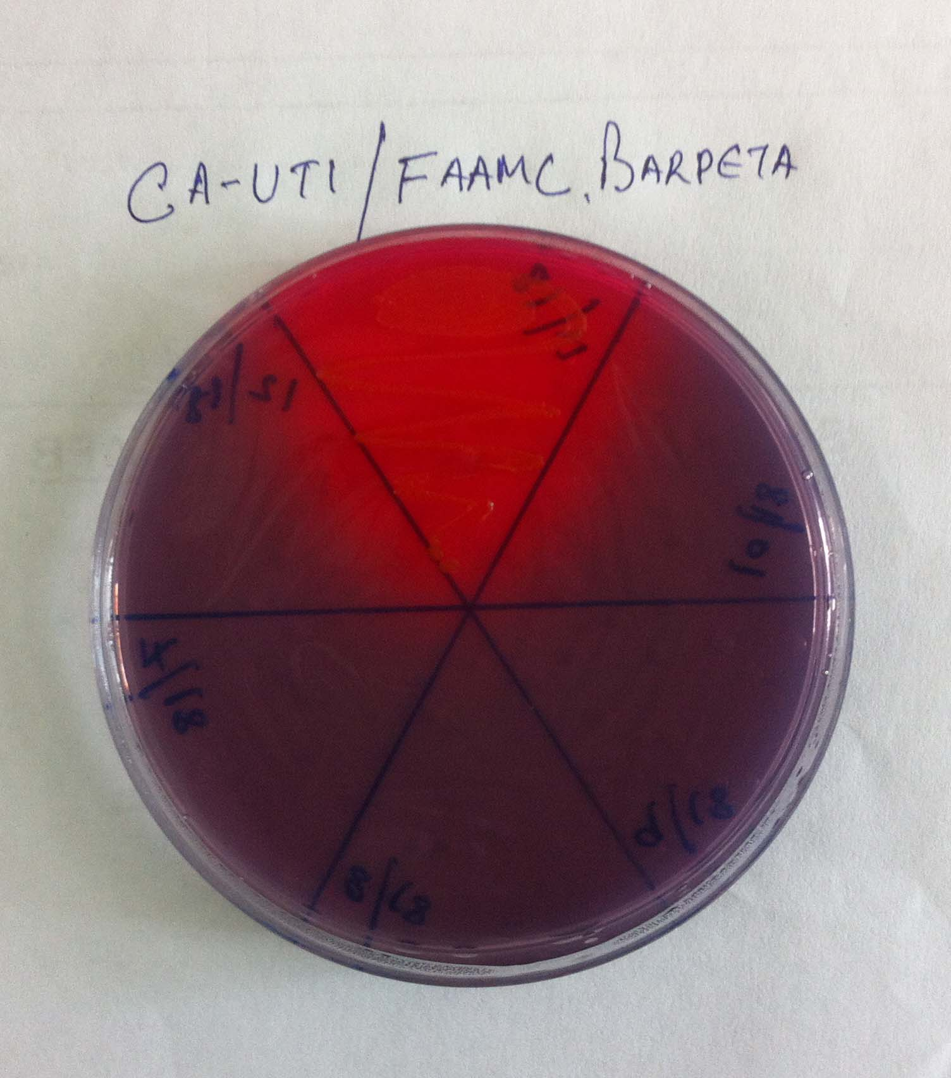
Fig-1. Growth of E coli in CLED agar

Table 4: Drug resistance in Gram negative isolates
Isolate | Antibiotic Group/ Antibiotic disc (resistant to) | Frequency | Percentage
E coli | Fluoroquinolone resistance  (Ciprofloxacin) | 146 | 59.1
 | 3rd Gen Cephalosporin  (Cefotaxime/ Ceftazidime) | 5 | 2.0
 | Co-trimoxazole | 201 | 81.4
 | Nitrofurantoin | 49 | 19.8
 | Amoxyclav | 129 | 52.2
 | Aminoglycosides (Gentamicin) | 45 | 18.2
 | Meropenem | 0 | 0
Klebsiella spp | Fluoroquinolone resistance  (Ciprofloxacin) | 26 | 57.8
 | 3rd Gen Cephalosporin  (Cefotaxime/ceftazidime) | 2 | 4.4
 | Co-trimoxazole | 29 | 64.4
 | Nitrofurantoin | 0 | 0
 | Amoxyclav | 28 | 62.2
 | Aminoglycosides (Gentamicin) | 8 | 17.8
 | Meropenem | 0 | 0
Proteus spp | Fluoroquinolone resistance  (Ciprofloxacin) | 6 | 37.5
 | 3rd Gen Cephalosporin  (Cefotaxime/ceftazidime) | 0 | 0
 | Co-trimoxazole | 7 | 43.8
 | Nitrofurantaoin | 1 | 6.3
 | Amoxyclav | 12
 | Aminoglycosides (Gentamicin) | 4 | 75
 | Meropenem | 0 | 0

Table 5. Drug resistance in Gram positive isolates
Isolate | Antibiotic Group/ Antibiotic disc (resistant to) | Frequency | Percentage
CONS | Penicillin | 43 | 91.5
 | Oxacillin 1 mcg / Cefoxitin 30mcg | 0 | 0
 | Vancomycin | 0 | 0
 | Linezolid | 0 | 0
 | Erythromycin | 3 | 6.4
 | Cefazolin | 23 | 48.9
 | Amoxyclav | 21 | 44.7
S aureus | Penicillin | 10 | 100
 | Oxacillin 1 mcg/Cefoxitin 30mcg | 0 | 0
 | Vancomycin | 0 | 0
 | Linezolid | 0 | 0
 | Erythromycin | 4 | 40
 | Cefazolin | 3 | 30
 | Amoxyclav | 3 | 30
Enterococcus sp | Penicillin | 12 | 48
 | Vancomycin | 0 | 0
 | Erythromycin | 5 | 20
 | Aminoglycoside (High strength gentamicin) | 12 | 48
 | Amoxyclav | 9 | 36

Antimicrobial resistance profiles of the bacterial isolates are summarized in Table 4 and Table 5. Amongst the Gram negatives the predominant isolates i.e. E coli and Klebsiella showed resistance against Fluoroquinolones (FQs) in more than 59% and 57% isolates respectively. Similar picture emerged in other Gram negatives (e.g. Proteus) as well.
Resistance to Amoxyclav (in Gram negatives), Cefazolin (in CONS and S aureus), Erythromycin, Cotrimoxazole etc were also of significant proportion (see Table 4 & Table 5). Few strains of E coli and Klebsiella showed resistance to 3rd generation cephalosporins (Cefotaxims and Ceftazidims), suggesting probable ESBLs (extended spectrum beta-lactamase producers), but number of such strains were too less, to ascertain if these were purely community acquired or not. Perhaps a more thorough history taking was necessary. No Oxacillin 1mcg/Cefoxitin 30mcg resistant CONS or S aureus (hence no MRSA), neither any Vancomycin resistant Enterococcus were found. Almost half of the Enterococci isolates (48%) were resistant to high strength gentamicin disc.
Table 6. MIC of Ciprofloxacin (E-test strip of biomerieux i.e. CIPROFLOXACIN CI 32 WW B30) in 26 selected isolates of E Coli
Isolate (number) | Result of Disc diffusion  (CLSI 2013 guidelines) | MIC (mcg/ml) in E test strip | Frequency
E coli (n=22) | Resistant (i.e. zone diameter <15 mm) | 0.002 – 0.75 | 0
 |  | 1.0 | 1
 |  | 1.5 | 0
 |  | 2 | 0
 |  | 3 | 3
 |  | 4 | 7
 |  | 6 | 4
 |  | 8 | 4
 |  | 12 | 1
 |  | 16 | 0
 |  | >32 | 2
E coli (n=4) | Intermediate (Zone Diameter 16-20mm) | 0.002 – 0.75 | 0
 |  | 1.0 | 3
 |  | 1.5 | 0
 |  | 2 | 1
 |  | 3 | 0

Selected E coli isolates were tested for Ciprofloxacin MIC (Minimum Inhibitory Concentration) by E test technique as per CLSI guidelines 2013.¹⁵ (See Fig-2)Out of 22 resistant phenotype, 18 isolates yielded Ciprofloxacin MIC in pure resistant range i.e.>4mcg/ml out of which two (2) isolates showed MIC>32mcg/ml. (see Fig-3 and Fig-4)
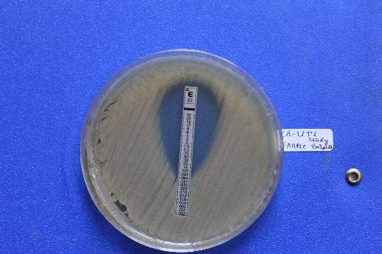
Fig-2.MIC by E test on E.coli reference strain (ATCC25922)
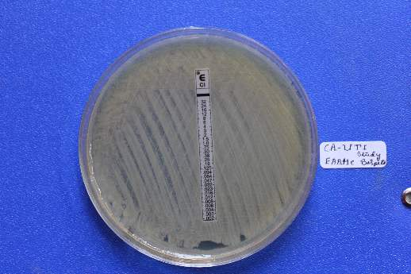
Fig-3.MIC of Ciprofloxacin >32mcg/ml (Highly resistant E.coli)
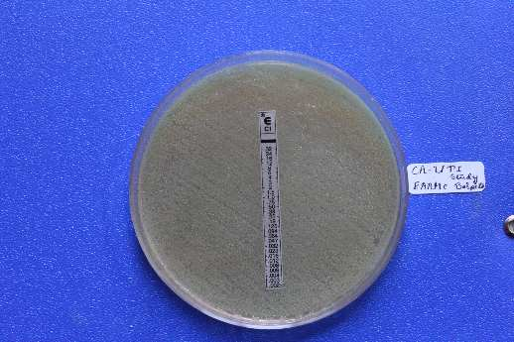
Fig-4. Second strain of E. coli with MIC of Ciprofloxacin >32mcg/ml

Three isolates showed Ciprofloxacin MIC of 3mcg/ml,which is above the intermediate sensitivity value i.e.2 mcg/ml.¹⁵ One isolate surprisingly yielded a MIC value in sensitive range (=1 mcg/ml). This may be due to some discrepancy in disc diffusion testing earlier. [See Table 6]
Four (4) E coli strains in intermediate zone (16-20 mm), were also tested for Ciprofloxacin MIC, and 3 of them had MIC in sensitive range (1mcg/ml) while a single strain had intermediate value. [Table 6]
DISCUSSION
From total 1463 urine samples collected from CA-UTI patients 397 (27.1%) yielded significant pathogens. Similar result was obtained by Oladeinde et al. in rural community of Nigeria and Dash et al in rural Odisha (Orissa).^{16,17} But lower rates were estimated by studies conducted in Jaipur, India (17.19%) and Aligarh, India (10.86%).^{18,19} Orrett et al and Garcia‑Morŭa et al. had obtained higher significant uropathogens.^{20, 21} Geographical location may be the explanation for this difference. This Study showed higher prevalence of UTI in females (37%) than in males (15%) which agrees with findings of earlier studies.^{16, 17, 19, 22} The age group analysis showed that young female patients in the range of 18-37 years had highest prevalence rate (58.4%) of CA-UTI. This result is in agreement with previous studies.^{18, 19, 23, 24} Elderly males (≥68 years) had a higher incidence of CA-UTI (41.4%) compared to elderly females (8.1%). This corroborates with Sood et al.¹⁹ Explanation probably lies in the fact that with advancing age, the incidence of UTI increases in males due to prostate enlargement, neurogenic bladder etc.²⁵In our study Gram negatives (79.3%) dominated, and E. coli was the overwhelmingly predominant isolate (62.2%). CONS (11.8%), Klebsiella sp (11.3%) and Enterococcus spp (6.3%) were some next common isolates. The finding was similar to those described in some previous studies. ^{19, 26, 27} Garcia-Morŭa et al., found out that E. coli was the commonest organism in UTI (24.7%), followed by Candida albicans (23.7%).²¹ The data collected from around the world, also showed that E. coli and Klebsiella spp. are still the commonest isolates in CA-UTI patients ^{18, 28, 29, 30}. Two (2) pseudomonas spp isolates were probably linked with colonization or not community acquired.
Generally, uncomplicated UTIs are treated empirically in the community with short courses of oral antibiotics. In most cases, microbiological evaluation of UTI cases were conducted only following treatment failure, recurrent or relapsing infection. This study has revealed that isolates especially E coli have developed alarming level of resistance to commonly used empirical antibiotics e.g. fluoroquinolones, Amoxyclav, cotrimoxazole etc. Similar finding was noted down by previous studies carried out elsewhere in India. ^{17, 19, 28, 31} It is a matter of concern that the high MIC level is being attained by E coli against fluoroquinolones (Ciprofloxacin). Four (4/26) strains had MIC level of 8mcg/ml while another isolate (1/26) showed MIC level of 12 mcg/ml. Most importantly Two (2/26) isolates had MIC of Ciprofloxacin above 32mcg/ml. Situation is alarming as quinolones are first line drug in empirical therapy of CA-UTI. It is worth mentioning that due to selection pressure mutant (in DNA gyrase/Topoisomerase etc.) strain can quickly establish predominance in a population, resulting in widespread drug resistance. ³² Ciprofloxacin resistant uropathogens could also be highly resistant to Amoxyclav, Ceftriaxone, Cefuroxime etc. ³³
These high resistant rates among uropathogens from a rural population with poor access to health care raises question about selection pressures that generate, maintain and spread resistant strains in the community. It is also possible that due to poor access to health care services, irrational prescription of antimicrobials which are available over the counter in India, has contributed to this alarming situation. Unqualified practitioners, untrained pharmacists and nurses may use antimicrobials indiscriminately.³⁴ Similar practices have also been reported from other developing countries. ^{35, 36} The widespread use of antimicrobials in veterinary practice may be another possible factor for the emergence of resistant strains.
CONCLUSION
Escherichia coli are most likely the commonest pathogen causing CA-UTI in the rural population. Due to misuse of antibiotic in the empirical therapy, it is leading to selection of high resistant phenotypes. MIC level (e.g. Ciprofloxacin against E coli) is going up even in rural setup, pausing a great public health challenge in developing and 3rd world countries.
Poverty, inadequate access to drugs, increased use and misuse of antibacterial drugs, over the counter availability of antibacterial drugs are the major forces in the development of resistance.³⁷ A proper evidenced based antibiotic policy is the need of the day to stem the emergence of resistant strains in community acquired UTI.
Conflict of Interest: None
REFERENCE
1. Gonzalez CM, Schaeffer AJ. Treatment of urinary tract infection: What’s old, what’s new, and what works. World J Urol 1999;17:372‑82.
2. Rock W, Colodner R, Chazan B, Elias M, Raz R. Ten years surveillance of antimicrobial susceptibility of community‑acquired Escherichia coli and other uropathogens in northern Israel (1995‑2005). Isr Med Assoc J 2007;9:803‑5.
3. Vasquez Y, Hand WL. Antibiotic susceptibility patterns of community acquired urinary tract infection isolates from female patients on the US (Texas)‑Mexico Border. J Appl Res 2004;4:321‑6.
4. Griebling TL. Urinary tract infection in men. In: Litwin MS, Saigal CS. editors. Urology Diseases in America. DHHS, PHS, NIH, NIDDK. Washington DC: GPO; 2007. NIH publication 07‑5512:621‑45.
5. Zelikovic I, Adelman RD, Nancarrow PA. Urinary tract infections in children. An update. West J Med 1992;157:554‑61.
6. Kaas E H. The Meaning of "Significant Bacteriuria". JAMA. 1963;184(9):728-729. doi:10.1001/jama.1963.03700220103026
7 Sobel JD, Kaye D. Urinary tract infections. In: Mandell GL, Bennett JE, Dolin R. editors. Mandell, Douglas and Bennett’s Principles and Practice of Infectious Diseases. 7th ed. Philadelphia: Churchill Livingstone; 2010. p. 957‑85
8. Hanna-Wakim RH, Ghanem ST, El Helou MW, Khafaja SA, Shaker RA, Hassan SA, et al. Epidemiology and characteristics of urinary tract infections in children and adolescents. Front Cell Infect Microbiol. 2015 May 26;5:45. doi: 10.3389/fcimb.2015.00045
9. Ahmed SM, Avasara AK. Urinary tract infections (UTI) among adolescent girls in Karimnagar District, AP K.A.P STUDY. Indian J Pre Soc Med 2008;39:12‑5.
10. Omoregie R, Erebor JO, Ahonkhai I, Isobor JO, Ogefere HO. Observed changes in the prevalence of uropathogens in Benin City, Nigeria. NZJ Med Lab Sci 2008;62:29‑31.
11. Omoregie R, Eghafona NO. Urinary tract infection among asymptomatic HIV patients in Benin City, Nigeria. Br J Biomed Sci 2009;66:190‑3.
12. Tambekar DH, Dhanorkar DV, Gulhane SR, Khandelwal VK, Dudhane MN. Antimicrobial susceptibility of some urinary tract pathogens to commonly used antibiotics. Afr J Biotechnol 2006;5:1562‑5.
13. Kass EH. Bacteriuria and the diagnosis of infections of the urinary tract; with observations on the use of methionine as a urinary antiseptic. AMA Arch Intern Med 1957;100:709‑14.
14. Duguid J P, Collee J G, Fraser A G. Laboratory strategy in the diagnosis of infective syndromes. In: Collee J G, Duguid J P, Fraser A G, Marmion B P, editors. Mackie & McCartney Practical Medical Microbiology. 13th ed. Edinburgh: Churchill Livingstone; 1989. p.600-649
15. Clinical and Laboratory Standards Institute. Performance standards for antimicrobial susceptibility testing: Twenty Third Informational Supplement. CLSI document M100‑S23. Wayne; PA: USA. Clinical and Laboratory Standards Institute, 2013 Jan. Villanova, Pa
16. Oladeinde BH, Omoregie R, Olley M, Anunibe JA. Urinary tract infection in a rural community of Nigeria. N Am J Med Sci 2011;3:75‑7.
17. Dash M, Padhi S, Mohanty I, Panda P, Parida B. Antimicrobial resistance in pathogens causing urinary tract infections in a rural community of Odisha, India. Journal of Family and Community Medicine 2013;20(1):20-26
18. Akram M, Shahid M, Khan AU. Etiology and antibiotic resistance patterns of community‑acquired urinary tract infections in J N M C Hospital Aligarh, India. Ann Clin Microbiol Antimicrob 2007;6:4.
19. Sood S, Gupta R. Antibiotic resistance pattern of community acquired uropathogens at a tertiary care hospital in jaipur, rajasthan. Indian J Community Med 2012;37:39‑44.
20. Orrett FA. Urinary tract infection in general practice in a rural community in south Trinidad. Saudi Med J 2001;22:537‑40.
21. García‑Morúa A, Hernández‑Torres A, Salazar‑de‑Hoyos JL, Jaime‑Dávila R, Gómez‑Guerra LS. Community‑acquired urinary tract infection etiology and antibiotic resistance in a Mexican population group. Rev Mex Urol 2009;69:45‑8.
22. Kashef N, Djavid GE, Shahbazi S. Antimicrobial susceptibility patterns of community‑acquired uropathogens in Tehran, Iran. J Infect Dev Ctries 2010;4:202‑6.
23. Shaifali I, Gupta U, Mahmood SE, Ahmed J. Antibiotic susceptibility patterns of urinary pathogens in female outpatients. N Am J Med Sci 2012;4:163‑9.
24. Hooton TM, Scholes D, Hughes JP, Winter C, Roberts PL, Stapleton AE, et al. A prospective study of risk factors for symptomatic urinary tract infection in young women. N Engl J Med 1996;335:468‑74.
25. Das RN, Chandrashekhar TS, Joshi HS, Gurung M, Shrestha N, Shivananda PG. Frequency and susceptibility profile of pathogens causing urinary tract infections at a tertiary care hospital in western Nepal. Singapore Med J 2006;47:281‑5.
26. Dias Neto JA, Martins AC, Tiraboschi RB, Domingos AL, Cologna AJ, Paschoalin EL, et al. Community acquired urinary tract infection: Etiology and bacterial susceptibility. Acta Cir Bras 2003;18:33‑6.
27. Khameneh ZR, Afshar AT. Antimicrobial susceptibility pattern of urinary tract pathogens. Saudi J Kidney Dis Transpl 2009;20:251‑3.
28. Kothari A, Sagar V. Antibiotic resistance in pathogens causing community‑acquired urinary tract infections in India: A multicenter study. J Infect Dev Ctries 2008;2:354‑8.
29. Selvakumar BN, Jasmine R. Antibiotic Susceptibility of ESBL‑producing urinary isolates at a tertiary care hospital in Tiruchirapalli, South India. J Med Sci 2007;7:443‑6.
30. Bano K, Khan J, Begum RH, Munir S, Akbar N, Ansari JA, et al. Patterns of antibiotic sensitivity of bacterial pathogens among urinary tract infections (UTI) patients in a Pakistani population. Afr J Microbiol Res 2012;6:414‑20.
31. Sabharwal ER. Antibiotic susceptibility patterns of uropathogens in obstetric patients. N Am J Med Sci 2012;4:316‑9.
32. Fu Y, Zhang W, Wang H, Zhao S, Chen Y, Meng F et al. Specific patterns of gyrA mutations determine the resistance difference to ciprofloxacin and levofloxacin in Klebsiella pneumoniae and Escherichia coli. BMC Infect Dis. 2013 Jan 7;13:8. doi: 10.1186/1471-2334-13-8.
33. Jakribettu R P, Ahamed SM, Safeera MI, Faseel P, Shakir VPA, Arya B. Community acquired UTI-minimum inhibitory concentration ciprofloxacin in uropathogens detected resistant to ciprofloxacin by disc diffusion method from rural tertiary care centre in Kerala. Annals of Biological Research, 2013; 4 (8):117-123
34. Rao GG. Risk factors for the spread of antibiotic‑resistant bacteria. Drugs 1998;55:323‑30.
35. Wachter DA, Joshi MP, Rimal B. Antibiotic dispensing by drug retailers in Kathmandu, Nepal. Trop Med Int Health 1999;4:782‑8.
36. Larsson M, Kronvall G, Chuc NT, Karlsson I, Lager F, Hanh HD, et al. Antibiotic medication and bacterial resistance to antibiotics: A survey of children in a Vietnamese community. Trop Med Int Health 2000;5:711‑21.
37. Bhargavi P.S, Gopala Rao T.V, Mukkanti K, Dinesh Kumar B, Krishna T.P. International Journal of Microbiology Research, 2010; 2, p. 01-06.

