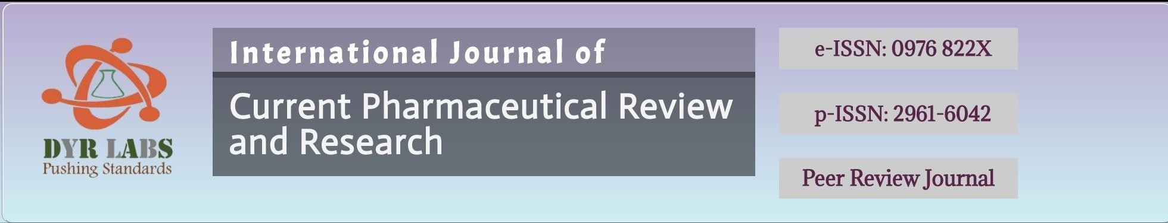



Acceptance letter to Author
Date- 16-March-2026

MANUSCRIPTNO: IJCPR-ASD-2603002

AUTHOR(S): Dr. B. Karishma Munoli, Dr. Ramesh Nadumani, Dr. Goswami Niraj Nagarpuri

Corresponding Author: Dr. B. Karishma Munoli*

TITLE: CLINICAL PROFILE AND SURGICAL OUTCOMES OF SMALL INCISION CATARACT SURGERY IN PATIENTS WITH PSEUDOEXFOLIATION SYNDROME: A RETROSPECTIVE STUDY
Dear Author,
- The Editorial Team of the INTERNATIONAL JOURNAL OF CURRENT PHARMACEUTICAL REVIEW AND
RESEARCH(IJCPR) is pleased to inform you that your manuscript as mentioned above has been accepted for publication and will appear in Volume and Issue: 18(03) YEAR 2026; IJCPR journal is Embase Indexed and as per new Publication Guidelines of NMC (Embase).

Please feel free to contact us in above mentioned address, if you have any question. Visit our website at https://ijcpr.com/ for further information. We look forward to the final steps in the publication of your work.

Best regards,
INTERNATIONAL JOURNAL OF CURRENT PHARMACEUTICAL REVIEW AND RESEARCH (IJCPR)
Website- https://ijcpr.com/
Email- submiteditorialoffice@gmail.com

