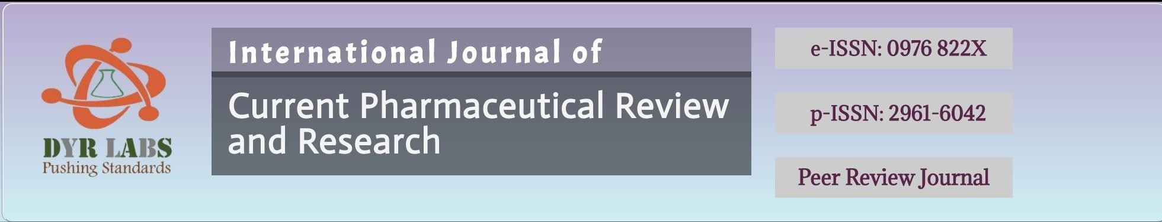



Acceptance letter to Author
Date- 16-March-2026

MANUSCRIPTNO: IJCPR-ASD-2603003

AUTHOR(S): Dr. B. Karishma Munoli, Dr. Goswami Niraj Nagarpuri, Dr. Ramesh Nadumani

Corresponding Author: Dr. B. Karishma Munoli*

TITLE: VISUAL OUTCOMES AND COMPLICATIONS FOLLOWING Nd:YAG LASER POSTERIOR CAPSULOTOMY IN POSTERIOR CAPSULAR OPACIFICATION: A RETROSPECTIVE STUDY
Dear Author,
- The Editorial Team of the INTERNATIONAL JOURNAL OF CURRENT PHARMACEUTICAL REVIEW AND
RESEARCH(IJCPR) is pleased to inform you that your manuscript as mentioned above has been accepted for publication and will appear in Volume and Issue: 18(03) YEAR 2026; IJCPR journal is Embase Indexed and as per new Publication Guidelines of NMC (Embase).

Please feel free to contact us in above mentioned address, if you have any question. Visit our website at https://ijcpr.com/ for further information. We look forward to the final steps in the publication of your work.

Best regards,
INTERNATIONAL JOURNAL OF CURRENT PHARMACEUTICAL REVIEW AND RESEARCH (IJCPR)
Website- https://ijcpr.com/
Email- submiteditorialoffice@gmail.com

