The Interplay Between Oral Rehabilitation, Hearing Performance, and Cognitive Health:
A Scoping Review of Implant-Retained Overdentures
Authors:
Dr Velpula Nagalaxmi, MDS — Professor, Dept. of Oral Medicine & Radiology, Sri Sai College of Dental Surgery, Vikarabad, India
Dr Faisal Taiyebali Zardi, MDS — Professor, Dept. of Oral Medicine & Radiology, Sri Sai College of Dental Surgery, Vikarabad, India
Dr Ravali Talari — Postgraduate Student (Corresponding Author), Dept. of Oral Medicine & Radiology, Sri Sai College of Dental Surgery, Vikarabad, India
Dr Bachanavoni Prathibha Devi — Postgraduate Student, Dept. of Oral Medicine & Radiology, Sri Sai College of Dental Surgery, Vikarabad, India
Dr Mounika Dintakurthi — Postgraduate Student, Dept. of Oral Medicine & Radiology, Sri Sai College of Dental Surgery, Vikarabad, India
Correspondence:
Dr. Ravali Talari
Email: ravalitalari22@gmail.com
Phone: +91-9063716996
Dept. of Oral Medicine & Radiology,
Sri Sai College of Dental Surgery,
Vikarabad, Telangana, India
Author Contributions: All authors contributed equally to the study design, literature review, manuscript drafting, and critical revision.
Conflict of Interest: None declared.
Funding: No external funding.
Acknowledgements: The authors thank the Department of Oral Medicine & Radiology, SSCDS, Vikarabad, for academic support.

Abstract
Background: Edentulism adversely affects mastication, speech, nutrition, and psychosocial well-being. Emerging evidence indicates potential links between oral dysfunction, hearing impairment, and cognitive decline. Implant-retained overdentures (IODs) enhance functional rehabilitation and may influence sensory-neural outcomes.
Objective: To systematically map current evidence on the effects of IODs on auditory and cognitive functions in edentulous individuals.
Methods: A scoping review was conducted in accordance with PRISMA-ScR guidelines. Peer-reviewed studies (2015–2025) reporting auditory and/or cognitive outcomes following IOD rehabilitation in adults were included.
Results: Evidence suggests that IODs can improve bone-conduction sound transmission and enhance cortical activation through masticatory stimulation, supporting neuroplasticity. However, current studies are limited in number and methodological rigour.
Conclusion: Implant-retained overdentures may contribute to improved sensory-neural health beyond oral rehabilitation. High-quality multicenter clinical trials are required to substantiate their auditory and cognitive benefits.
Keywords: Implant-retained overdenture; Bone conduction; Hearing; Cognition; Mastication; Edentulism
MeSH: Dental Implants; Hearing; Cognition; Edentulous Jaw; Prosthodontics

Highlights
• IODs enhance craniofacial bone-conduction of sound.
• Improved mastication promotes cortical sensory-motor activity.
• Oral rehabilitation plays a role in supporting cognitive resilience.
• Promising interdisciplinary opportunities exist across prosthodontics, neurology, and audiology.
• More robust, controlled studies are needed to confirm clinical significance.

Introduction
Edentulism — the complete loss of natural dentition — compromises mastication, speech, dietary quality, and social confidence. While conventional complete dentures offer esthetic replacement, insufficient stability often diminishes neuromuscular feedback and sensory input.
Implant-retained overdentures provide enhanced retention and functional efficiency, supporting better nutrition and patient satisfaction. Recently, attention has shifted toward understanding how improved oral function influences broader systemic health — especially hearing abilities and cognitive performance in ageing populations.
Two key mechanisms have been proposed:
- Bone-conduction sound transmission
- Titanium implants may facilitate mechanical vibrations toward the cochlea.
- Neurocognitive stimulation through mastication
- Chewing activates sensorimotor cortical regions responsible for memory and learning.
This scoping review synthesises available literature exploring the oral-ear-brain connection in IOD recipients.

Methods
A scoping review was conducted following Arksey & O’Malley and PRISMA-ScR frameworks.
Databases searched: PubMed, Scopus, Web of Science, Google Scholar, Cochrane Library.
Period: 2015–2025
Inclusion criteria
✔ Edentulous adults rehabilitated with IODs
✔ Hearing and/or cognitive outcomes reported
✔ Clinical or observational study designs
Exclusion criteria
✘ Non-implant prostheses
✘ Animal studies
✘ Partial edentulism lacks a separate analysis.
✘ Non-English publications
Due to heterogeneity and limited samples, outcomes were narratively synthesised.

Results
A small but growing body of research suggests that IODs may:
• Improve bone-conducted auditory perception
• Enhance cognitive processing via increased masticatory sensory input
Table 1. Summary of Included Studies
Banu et al. | 2020 | Pilot clinical | Edentulous adults | IOD | ↑ Bone-conduction hearing | —
Balinski et al. | 2020 | Experimental | Mixed dentition adults | Skull vibration test | ↑ Vibration transmission | —
Lee et al. | 2021 | Observational | Older adults | Dental implants | ↓ Hearing impairment | —
Banu et al. | 2015 | Pilot | Edentulous adults | IOD vs denture | — | ↑ Cognitive activation
Banu et al. | 2024 | Neuroplasticity | Adults with IOD | Improved mastication | — | ↑ Brain activation

Discussion
Improved occlusal stability with IODs enhances masticatory efficiency, activating periodontal and temporomandibular mechanoreceptors. Increased afferent input to the sensorimotor cortex supports cognitive functions such as attention and memory.
Simultaneously, the osseointegrated implant acts as a conductor, facilitating cranial vibration transmission and potentially improving auditory perception through the cochlea. Better hearing reduces cognitive listening effort — an important factor in preventing cognitive overload and decline.
Despite promising findings, generalisation remains limited due to:
• Small sample sizes
• Short follow-up periods
• Variability in assessment tools
Further research using standardised auditory and neurocognitive test protocols is essential.

Conclusion
Implant-retained overdentures extend their benefits beyond oral rehabilitation, offering a potential avenue to maintain sensory-neural health in the ageing population. Strengthened mastication and improved bone-conducted sound transmission contribute to enhanced auditory and cognitive outcomes.
Future interdisciplinary trials are vital to establishing definitive clinical guidelines supporting this innovative prosthodontic approach.

Figures
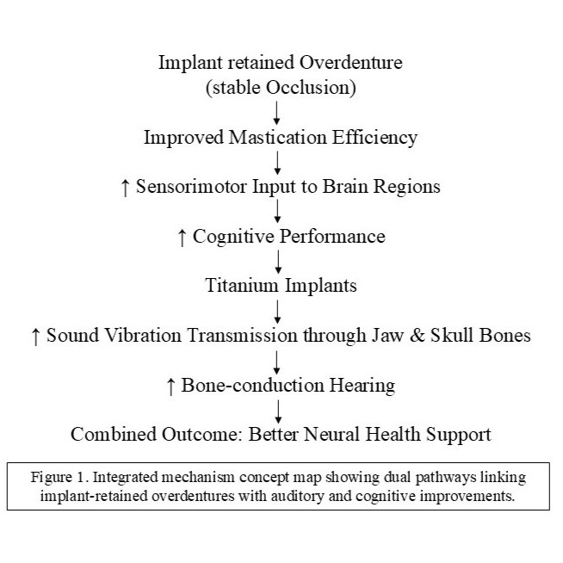
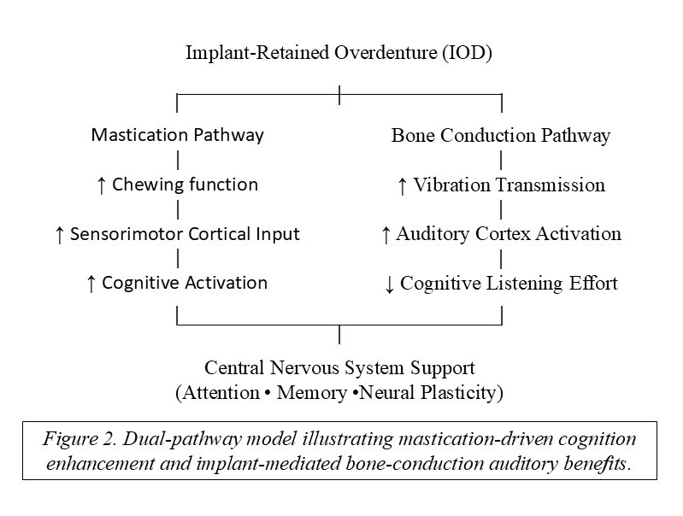

References
- Banu RF, et al. Effect of implant-retained complete overdentures on hearing ability: A pilot study. J Prosthet Dent. 2020;123(5):635-40.
- Balinski S, et al. Dental condition as a factor modifying sound vibration transmission in skull bones. Appl Sci. 2020;10(18):6478.
- Lee JH et al. A higher number of teeth is associated with reduced hearing impairment in older adults. J Am Geriatr Soc. 2021;69(5):1234-41.
- Banu RF, et al. Functional neuroplasticity in denture rehabilitation. Nutrients. 2024;15(7):1577.
- Lee JH, et al. Tooth loss and compensation through dental implants: auditory implications. J Int Adv Otol. 2025;21(1):45-50.

Acknowledgments
The author acknowledges the contributions of the research community in advancing understanding of the multifaceted benefits of implant-retained overdentures. Collaborations across disciplines, including dentistry, audiology, and neurology, are essential for continued progress in this field.

Conflicts of Interest
The author declares no conflicts of interest related to this review.

Funding
This review was conducted without external funding.

