A Prospective Observational Study in the Management of Diabetic Ulcer Using Diabetic Ulcer Severity Score
1Dr Shaunak Chacha, 2Dr Shlok V Shah, 3Dr Karan Kotak, 4Dr Karan Shah, 5Dr Aneri Shah
1Junior Resident Department of General Surgery, GCS Medical College and Hospital and Research Center Ahmedabad, Gujarat University, Ahmedabad, Gujarat
2Junior Resident Department of Orthopedics, GCS Medical College and Hospital and Research Center Ahmedabad, Gujarat University, Ahmedabad, Gujarat.
3Junior Resident Department of General Surgery , GCS Medical College and Hospital and Research Center Ahmedabad, Gujarat University, Ahmedabad, Gujarat
4Junior Resident Department of Orthopedics, GCS Medical College and Hospital and Research Center Ahmedabad, Gujarat University, Ahmedabad, Gujarat
5Junior Resident Department of Radiology, GCS Medical College and Hospital and Research Center Ahmedabad, Gujarat University, Ahmedabad, Gujarat
Corresponding author- Dr Shaunak Chacha*
(Received: 25 October 2025 Revised: 27 November 2025 Accepted: 04 December 2025)

KEYWORDS  Diabetic foot ulcer, Diabetic Ulcer Severity Score, DUSS, ulcer severity, surgical intervention, glycemic control | ABSTRACT:  Background: Diabetic foot ulcers (DFUs) are a common and serious complication of diabetes mellitus, often leading to prolonged hospitalisation, infection, and amputation. Accurate assessment of ulcer severity is essential for guiding management and predicting outcomes. The Diabetic Ulcer Severity Score (DUSS) is a simple clinical tool designed for this purpose.  Objective: To evaluate the ability of DUSS to predict clinical outcomes in patients with diabetic foot ulcers.  Methods: This prospective observational study included 80 patients with DFUs managed at GCS Medical College and Research Centre, Ahmedabad, from January 2023 to January 2025. Patients were assessed using DUSS, and data on demographics, clinical characteristics, comorbidities, glycemic control, microbiological profile, and interventions were collected. Statistical analysis was performed using SPSS version 25, with significance set at p < 0.05.  Results: DUSS scores ranged from 0 to 4, with higher scores correlating with more severe ulcers and increased need for surgical interventions. Poor glycemic control and longer duration of diabetes were associated with higher DUSS scores. Microbiological analysis revealed predominance of Klebsiella and Pseudomonas species, and culture-guided antibiotic therapy was required in most cases. Higher DUSS scores predicted delayed healing, more frequent complications, and a greater likelihood of surgical intervention (p < 0.05).  Conclusion: DUSS is a simple, reliable, and effective tool for assessing DFU severity and predicting clinical outcomes. It can be used in routine clinical practice for early risk stratification, guiding treatment decisions, and improving patient outcomes.

INTRODUCTION
Diabetic foot ulcer (DFU) is a common and serious complication of diabetes mellitus, affecting approximately 15–25% of diabetic patients during their lifetime and often leading to hospitalisation, infection, and lower extremity amputation [1,2]. The pathogenesis of DFU is multifactorial, involving peripheral neuropathy, peripheral arterial disease, and impaired wound healing, which together increase susceptibility to chronic ulceration and infection [3]. DFUs not only significantly impact quality of life but also impose a substantial economic burden on healthcare systems worldwide [4].
Accurate assessment and stratification of ulcer severity are critical for guiding management and predicting outcomes such as healing, surgical intervention, or amputation. Various classification systems exist, including Wagner’s classification and the University of Texas grading system, but these often require complex evaluation or advanced diagnostic tools, limiting their applicability in routine clinical practice [5,6].
The Diabetic Ulcer Severity Score (DUSS) was developed as a simple, clinically practical scoring system based on four parameters: palpable pedal pulses, probing to bone, ulcer location, and the number of ulcers [7]. Each parameter is scored as 0 or 1, with cumulative scores ranging from 0 to 4, allowing for quick risk stratification. Higher DUSS scores have been associated with poorer outcomes, including increased likelihood of surgical intervention, delayed healing, and higher amputation risk [8,9].
Despite its potential utility, limited prospective data is evaluating the predictive accuracy of DUSS in diverse patient populations. This study aims to assess the ability of DUSS to predict clinical outcomes in patients with DFU managed at a tertiary care centre, providing further evidence for its role in clinical decision-making.

MATERIALS AND METHODS
Study Design
This was an observational, prospective study designed to evaluate the ability of the Diabetic Ulcer Severity Score (DUSS) to predict clinical outcomes in patients with diabetic foot ulcers.
Study Setting
The study was conducted at GCS Medical College and Research Centre (GCSMC & RC), Ahmedabad, involving patients managed in the Surgical Outpatient Department (OPD) and Inpatient Department (IPD).
Study Population
The study population comprised patients diagnosed with diabetic foot ulcer who presented to the surgical OPD or IPD of GCSMC & RC during the study period.
Inclusion Criteria
Patients were included in the study if they fulfilled all of the following criteria:
- Patients willing to participate and who provided written informed consent.
- Patients with a confirmed diagnosis of Diabetes Mellitus presenting with a foot ulcer, diagnosed clinically and/or pathologically.
- Age greater than 20 years.
Exclusion Criteria
Patients were excluded from the study if they met any of the following criteria:
- Patients unwilling to participate or refusing to provide informed consent.
- Patients who had already undergone ankle- level or above-knee amputation of the affected limb.
Sample Size
Although a large number of diabetic foot ulcer cases are managed at our institute, the study sample was limited to 80 patients due to feasibility constraints.
Study Duration
The study was carried out over a period of two years, from January 2023 to January 2025.
Data Collection
Patients presenting with diabetic foot ulcer were screened according to the inclusion and exclusion criteria. After obtaining informed consent, data were collected using a structured proforma and hospital records.

- Demographic and Clinical Data: Information regarding age, duration and diagnosis of Diabetes Mellitus, family history of type 2 diabetes, previous surgical history, follow-up compliance, and dressing history was recorded.
- Clinical and Pathological Assessment: Detailed clinical evaluation included assessment of palpable pedal pulses, ulcer characteristics, wound status, healing progress, intraoperative findings, and final wound status following interventions.
- Treatment Details: Data related to treatment modalities such as surgical procedures, repeated surgeries, rehabilitation measures, frequency of dressings, and postoperative complications were documented during hospital stay and follow-up visits.
- DUSS Scoring: Each ulcer was assessed and scored using the Diabetic Ulcer Severity Score (DUSS), and outcomes were correlated with the assigned scores.
Data Analysis
Collected data were entered into Microsoft Excel and analyzed using Statistical Package for the Social Sciences (SPSS) software, version 25.0. Appropriate descriptive and inferential statistical methods were applied. A p-value of <0.05 was considered statistically significant.
Ethical Considerations
- The study protocol was reviewed and approved by the Institutional Review Board (IRB) of GCS Medical College and Research Centre.
- Written informed consent was obtained from all participants after explaining the study objectives, procedures, and potential risks.
- Confidentiality of patient information was strictly maintained by anonymising data and restricting access to authorised personnel only.

RESULTS AND OBSERVATIONS;
Table 1 DIABETIC ULCER SEVERITY SCORE

Parameter | Score 0 | Score 1
Palpable Pedal pulses | Palpable | Not Palpable
Ulcer probing to bone | Not probing | Probing
Location of ulcer | Toe | Foot
Number of ulcers | One | Multiple

Table 2 . Frequency Distribution of DUSS Score

DUSS Score | Count (n) | Percentage (%)
0 | 15 | 18.75%
1 | 21 | 26.25%
2 | 19 | 23.75%
3 | 19 | 23.75%
4 | 6 | 7.5%

Table 3: Sex-wise Distribution of Patients According to DUSS Score (n = 80)
DUSS  Score | Male n (%) | Female n (%) | Total n (%)
0 | 10 (12.5) | 0 (0.0) | 10 (12.5)
1 | 18 (22.5) | 5 (6.3) | 23 (28.8)
2 | 6 (7.5) | 6 (7.5) | 12 (15.0)
3 | 11 (13.8) | 9 (11.3) | 20 (25.0)
4 | 13 (16.3) | 2 (2.5) | 15 (18.8)
Total | 58 (72.5) | 22 (27.5) | 80 (100)

Table 4: Age Group-wise Distribution of Patients According to DUSS Score (n = 80)

DUSS  Score | 30–39 yrs n (%) | 40–49 yrs n (%) | 50–59 yrs n (%) | 60–69 yrs n (%) | 70–79 yrs n (%) | >80 yrs n (%) | Total n (%)
0 | 0 (0.0) | 2 (2.5) | 3 (3.8) | 3 (3.8) | 2 (2.5) | 0 (0.0) | 10 (12.5)
1 | 1 (1.3) | 3 (3.8) | 7 (8.8) | 9 (11.3) | 1 (1.3) | 2 (2.5) | 23 (28.8)
2 | 2 (2.5) | 1 (1.3) | 5 (6.3) | 2 (2.5) | 1 (1.3) | 1 (1.3) | 12 (15.0)
3 | 3 (3.8) | 4 (5.0) | 7 (8.8) | 3 (3.8) | 3 (3.8) | 0 (0.0) | 20 (25.0)
4 | 0 (0.0) | 1 (1.3) | 4 (5.0) | 8 (10.0) | 1 (1.3) | 1 (1.3) | 15 (18.8)
Total | 6 (7.5) | 11 (13.8) | 26 (32.5) | 25 (31.3) | 8 (10.0) | 4 (5.0) | 80 (100)

Table 5: Literacy Level-wise Distribution of Patients According to DUSS Score (n = 80)

DUSS Score | Primary n (%) | Secondary n (%) | Higher Studies n (%) | Illiterate n (%) | Total n (%)
0 | 3 (3.8) | 3 (3.8) | 3 (3.8) | 1 (1.3) | 10 (12.5)
1 | 11 (13.8) | 9 (11.3) | 1 (1.3) | 2 (2.5) | 23 (28.8)
2 | 4 (5.0) | 4 (5.0) | 1 (1.3) | 3 (3.8) | 12 (15.0)
3 | 12 (15.0) | 4 (5.0) | 3 (3.8) | 1 (1.3) | 20 (25.0)
4 | 8 (10.0) | 3 (3.8) | 3 (3.8) | 1 (1.3) | 15 (18.8)
Total | 38 (47.5) | 23 (28.8) | 11 (13.8) | 8 (10.0) | 80 (100)

Table 6: Distribution of Chief Complaints According to DUSS Score (n = 80)

DUSS Score | Pain n | Ulcer n | Pus Discharge n | Blackening n | Bleeding n | Gangrene n
0 | 12 | 12 | 7 | 6 | 5 | 0
1 | 14 | 16 | 11 | 10 | 3 | 6
2 | 14 | 12 | 11 | 8 | 6 | 5
3 | 11 | 13 | 12 | 9 | 8 | 6
4 | 5 | 3 | 0 | 3 | 2 | 3
Total | 56 | 56 | 41 | 36 | 24 | 20

Table 7: Distribution of DUSS Score According to Duration of Diabetes Mellitus Type II (n = 80)

DUSS Score | 0–5 Years n | 6–10 Years n | 11–15 Years n | 16–20 Years n | 21–25 Years n | Total n
0 | 7 | 2 | 3 | 1 | 2 | 15
1 | 6 | 6 | 6 | 3 | 0 | 21

2 | 5 | 7 | 2 | 3 | 2 | 19
3 | 7 | 6 | 1 | 4 | 1 | 19
4 | 1 | 0 | 5 | 0 | 0 | 6
Total | 26 | 21 | 17 | 11 | 5 | 80
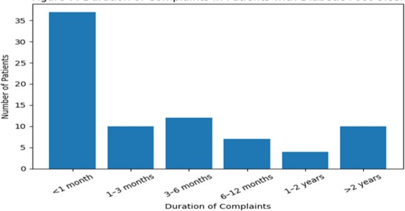
Figure 1: Duration of Complaints in Patients with Diabetic Foot Ulcer
Table 8: Distribution of Patients According to Glycemic Control (HbA1c) and WBC Count Categories (n = 80)

Parameter | Category | Count (n) | Percentage (%)
HbA1c Category | Normal (<5.7%) | 0 | 0.0
 | Pre-diabetes (5.7–6.4%) | 3 | 3.75
 | Controlled Diabetes (6.5–7.0%) | 26 | 32.5
 | Poorly Controlled (>8.0–8.5%) | 30 | 37.5
 | Very Poorly Controlled (>9.0%) | 21 | 26.25
WBC Count Category | Leukopenia (<4,000 cells/μL) | 0 | 0.0
 | Normal (4,000–11,000 cells/μL) | 42 | 52.5
 | Leukocytosis (11,000–20,000 cells/μL) | 33 | 41.25
 | Severe Leukocytosis (>20,000 cells/μL) | 5 | 6.25

Table 9: Distribution of Mean Clinical Markers by DUSS Score and Associated Comorbidities (n = 80)

Parameter | Category / DUSS Score | HbA1c (%) | Mean WBC Count (cells/μL) | Mean Duration of Complaints (Days) | Frequency (n)
Mean Clinical Markers by DUSS Score | DUSS 0 | 9.08 | 10,625 | 4.5 | —
 | DUSS 1 | 8.83 | 11,899.57 | 5.61 | —
 | DUSS 2 | 9.23 | 12,840.0 | 3.25 | —
 | DUSS 3 | 7.92 | 12,191 | 7.5 | —
 | DUSS 4 | 7.91 | 12,582.67 | 5.87 | —
Comorbidity Profile | Hypertension (HTN) | — | — | — | 29
 | CAD / IHD | — | — | — | 8
 | Thyroid Disorder (Hypothyroidism) | — | — | — | 3
 | Diabetic Nephropathy | — | — | — | 1
 | Chronic Kidney Disease (CKD) | — | — | — | 1
 | Parkinson’s Disease | — | — | — | 1
 | None | — | — | — | 40
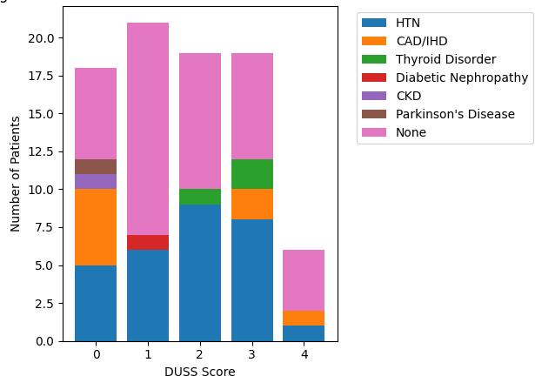

Figure 2: Distribution of Comorbidities Across DUSS Scores

Table 10: Microbiological Profile and Organism Distribution According to DUSS Score (n =80)
  - Organism Identification Rate by DUSS Score

DU  SS Score | Total Patients (n) | Organism Identified n (%)
0 | 15 | 9 (60.0)
1 | 21 | 15 (71.43)
2 | 19 | 15 (78.95)
3 | 19 | 17 (89.47)
4 | 6 | 5 (83.33)
  - Overall Organism Isolated and DUSS-wise Distribution

Organism Isolated | DUSS 0 | DUSS 1 | DUSS 2 | DUSS 3 | DUSS 4 | Total n
Klebsiella | 6 | 7 | 11 | 10 | 3 | 37
Pseudomonas aeruginosa | 2 | 4 | 1 | 5 | 0 | 12
E. coli | 1 | 1 | 0 | 2 | 0 | 4
Morganella morganii | 1 | 2 | 0 | 0 | 1 | 4
Proteus mirabilis | 0 | 1 | 2 | 1 | 0 | 4
Acinetobacter baumannii | 0 | 0 | 1 | 0 | 1 | 2
Staphylococcus aureus | 0 | 2 | 0 | 0 | 0 | 2
Enterococcus faecalis | 0 | 0 | 1 | 0 | 0 | 1
No growth | 6 | 6 | 4 | 2 | 1 | 19
Total | 15 | 21 | 19 | 19 | 6 | 80

Table 11: Antibiotic Sensitivity Pattern and Its Distribution According to DUSS Score (n = 61 culture-positive cases)

Sensitivity Profile | DUSS 0 | DUSS 1 | DUSS 2 | DUSS 3 | DUSS 4 | Total n (%)
Sensitive to most drugs | 4 | 7 | 6 | 9 | 3 | 29 (47.54)
Sensitive to all drugs | 5 | 4 | 5 | 3 | 0 | 17 (27.87)
Resistant to most drugs | 0 | 3 | 4 | 5 | 2 | 14 (22.95)
Resistant to all drugs | 0 | 1 | 0 | 0 | 0 | 1 (1.64)
Total | 9 | 15 | 15 | 17 | 5 | 61 (100)

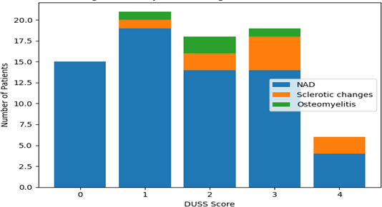

Figure 3: X-ray Foot Findings Across DUSS Scores
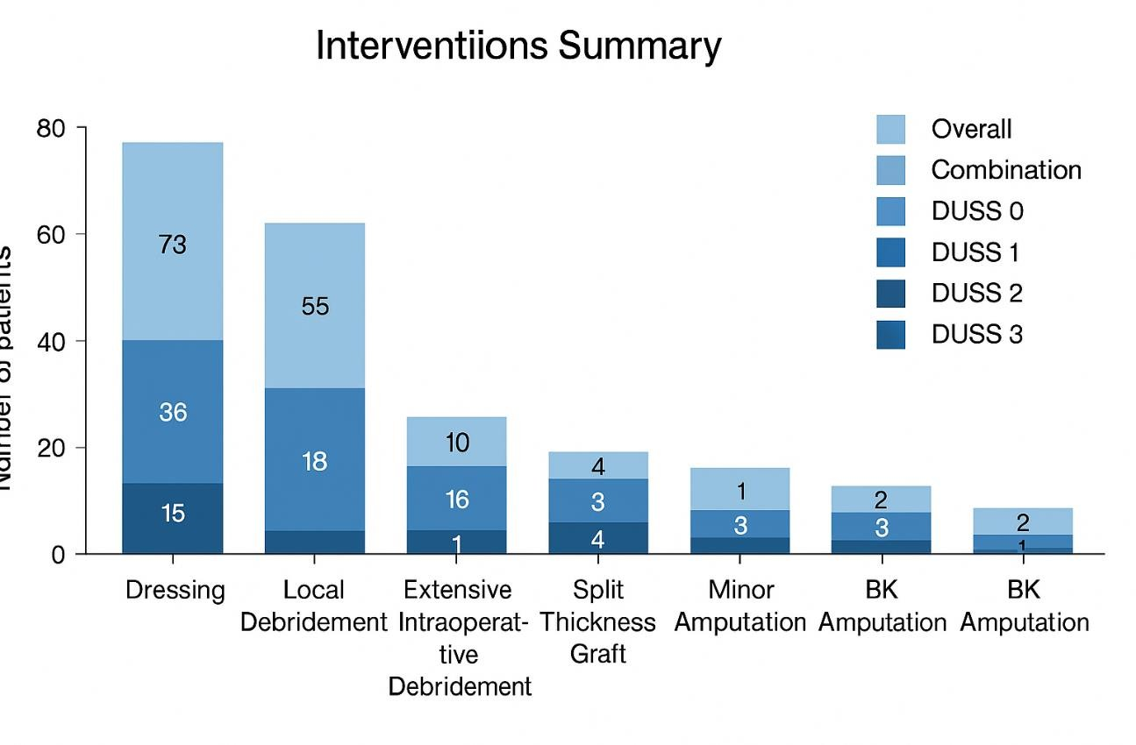
Figure 4: Interventions summary
Table 12: Acetone Summary, DUSS Score vs Acetone Presence, and Correlation with Continuous Variables

Parameter / Variable | Categories / Measure | Count / Pearson r | p- value | Interpretation
Acetone Levels | <10 | 77 | – | Low levels observed

 | ≥10 | 3 | – | Rare occurrence
DUSS Score vs Acetone Presence | 0 | No: 9 / Yes: 1 | – | Minimal ketoacidosis
 | 1 | No: 21 / Yes: 2 | – | Minimal ketoacidosis
 | 2 | No: 12 / Yes: 0 | – | –
 | 3 | No: 20 / Yes: 0 | – | –
 | 4 | No: 15 / Yes: 0 | – | –
Correlation with Continuous Variables | HbA1c | -0.226 | 0.044 | Significant (p < 0.05)
 | WBC Count | 0.103 | 0.364 | Not Significant
 | Duration (Days) | 0.154 | 0.173 | Not Significant

Table 13: Association of DUSS Score, Surgery, and Predictors of Surgery

Analysis | Variable /  Comparison | Statistic / Coef. | p-value | Interpretation
Chi-Square Test (DUSS Score vs Categories) | Intervention Type | 39.27 | 0.000095** | Highly Significant (p < 0.001) – higher DUSS predicts more invasive intervention
 | Organism Isolated | 40.95 | 0.603 | Not Significant
 | Duration of DM-II | 33.06 | 0.033* | Significant (p < 0.05) – longer diabetes duration influences ulcer severity
 | Surgery Timing | 10.44 | 0.843 | Not Significant
T-Test (Surgery vs Continuous Variables) | HbA1c (Surgery vs No Surgery) | 8.21 vs  10.01 | 0.015* | Significant – better-controlled diabetes in surgical patients
 | WBC Count (Surgery vs No Surgery) | 11939.55 vs  12755 | 0.5447 | Not Significant – infection severity similar
 | Duration (Days,  Surgery vs No Surgery) | 350.2 vs  82.14 | 0.013* | Significant – longer complaint duration in surgical patients
Logistic Regression (Predictors of Surgery) | Intercept | 4.367 | 0.002* | Significant baseline effect
 | HbA1c | -0.382 | 0.007* | Significant – lower HbA1c predicts surgery
 | WBC Count | 2.818 | 0.697 | Not Significant

 | Duration (Days) | 0.002 | 0.272 | Not Significant

*p < 0.05 – significant, **p < 0.001 – highly significant

DISCUSSION
Diabetic foot ulcers (DFUs) remain a major complication of diabetes mellitus, contributing significantly to morbidity, hospitalisations, and lower limb amputations worldwide [1,2]. Accurate assessment of ulcer severity is crucial for guiding management, predicting outcomes, and optimising resource allocation. In this context, the Diabetic Ulcer Severity Score (DUSS) serves as a simple, clinically practical tool, incorporating four easily assessable parameters: palpable pedal pulses, bone probing, ulcer location, and number of ulcers [3].
In our study of 80 patients, DUSS scores demonstrated a clear correlation with ulcer severity and clinical outcomes. Patients with higher DUSS scores (3–4) were more likely to require surgical interventions, experienced prolonged healing, and had higher complication rates compared to those with lower scores (0–1). This aligns with prior studies indicating that higher DUSS scores are associated with delayed healing, increased risk of amputation, and more complex wound management [4,5].
The demographic distribution in our cohort revealed a higher prevalence of DFUs among males (72.5%) and patients aged 50–69 years, consistent with previous observations that age and male sex are important risk factors for ulcer development and severity [6]. Comorbidity analysis showed that hypertension and coronary artery disease were common among patients with higher DUSS scores, reflecting the influence of vascular comorbidities on ulcer progression [7].
Our findings also highlight the relationship between glycemic control and ulcer outcomes. Patients with poorly controlled diabetes (HbA1c >8.0%) exhibited higher DUSS scores and were more likely to undergo surgical intervention, reinforcing the established role of hyperglycemia in impaired wound healing [8]. Interestingly, while WBC counts were elevated in patients with severe ulcers, the association between WBC count and surgical intervention was not statistically significant, suggesting that infection severity alone may not predict the need for surgery when considered alongside DUSS [9].

Microbiological assessment demonstrated that Gram- negative organisms, particularly Klebsiella and Pseudomonas, were predominant, consistent with prior studies on diabetic foot infections in hospital settings [10,11]. Antibiotic sensitivity patterns indicated that nearly half of the isolates were sensitive to most drugs, supporting the role of culture-guided therapy in managing infected DFUs.
The utility of DUSS as a prognostic tool is further supported by logistic regression analysis in our study. Lower HbA1c and longer duration of complaints were significant predictors of surgical intervention, suggesting that both metabolic control and chronicity of ulcers influence clinical decision-making. These findings corroborate prior prospective analyses validating DUSS as an effective predictor of outcomes, including need for surgery and risk of amputation [3,5,12].
While DUSS provides a practical framework for early risk stratification, limitations exist. It does not account for wound depth beyond bone probing, peripheral vascular status beyond palpable pulses, or patient- specific factors such as nutritional status and adherence to therapy, which may influence healing. Future studies integrating DUSS with vascular imaging and biochemical markers could enhance predictive accuracy.
Overall, our study confirms that DUSS is a simple, reliable, and clinically relevant tool for assessing DFU severity and guiding management decisions. Its adoption in routine clinical practice may facilitate early intervention, optimise resource utilisation, and ultimately improve patient outcomes.

CONCLUSION
The Diabetic Ulcer Severity Score (DUSS) effectively predicts clinical outcomes in diabetic foot ulcers. Higher DUSS scores were associated with more severe ulcers, greater need for surgical interventions, and delayed healing. DUSS is a practical tool for early risk stratification and guiding management to improve patient outcomes.

REFERENCES;
- Armstrong DG, Boulton AJ, Bus SA. Diabetic foot ulcers and their recurrence. N Engl J Med. 2017;376:2367–75.
- Singh N, Armstrong DG, Lipsky BA. Preventing foot ulcers in patients with diabetes. JAMA. 2005;293:217–28.
- Beckert S, et al. The Diabetic Ulcer Severity Score: a tool for predicting outcome in diabetic foot ulcers. Diabetes Care. 2006;29:1921–5.
- Elanchezhian M, Kesavalingam K. Validity of DUSS in predicting outcomes of DFU patients. J Med Health Res. 2020;8(3):45–51.
- George R, et al. Prospective cohort assessment of DUSS at a tertiary centre. Int Surg J. 2019;6:1234–41.
- Prompers L, et al. Prediction of outcome in individuals with diabetic foot ulcers. Diabetologia. 2008;51:1276–82.
- Apelqvist J, Larsson J. Reducing incidence of amputation in the diabetic foot. Diabetes Metab Res Rev. 2000;16(Suppl 1):S75–83.
- Hicks CW, Selvarajah S, Mathioudakis N, et al. Burden of diabetic foot ulcers for Medicare and private insurers. Diabetes Care. 2016;39:1512–19.
- Jeffcoate WJ, Harding KG. Diabetic foot ulcers. Lancet. 2003;361:1545–51.
- Lavery LA, Armstrong DG, et al. Microbiology of diabetic foot infections. Diabetes Metab Res Rev. 2007;23:148–54.
- Tentolouris N, et al. Bacterial profile in diabetic foot infections. Diabetes Care. 2006;29:1729–35.
- Prompers L, et al. Effectiveness of ulcer classification systems in predicting outcomes. Diabet Med. 2007;24:462–9.

